5. After you enter your data, click on the “Submit Data to BLS” button to finish, or the “Edit” button to return to the previous screen.

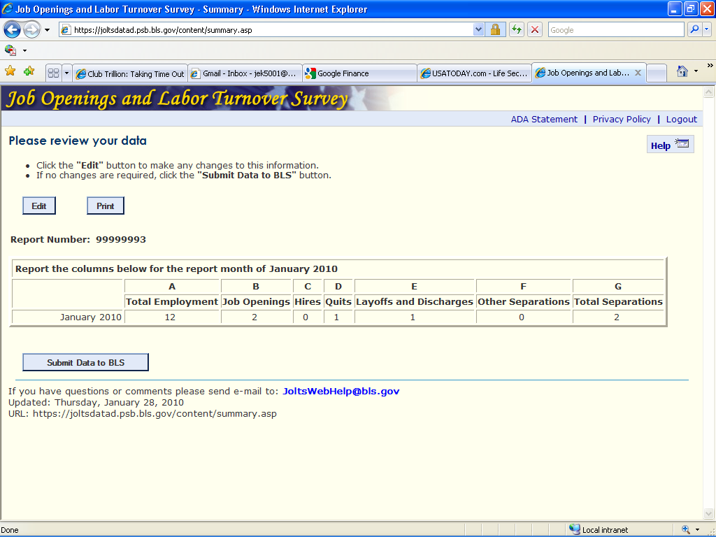

U.S. Department of Labor

Bureau of Labor Statistics
Job Openings and Labor Turnover Survey

JOLTSWebHelp@bls.gov
rev. 01/2010

If you have any questions, please call 1-800-341-4620

Reporting JOLTS Data

on the BLS Internet



U.S. Department of Labor

Bureau of Labor Statistics
Job Openings and Labor Turnover Survey

JOLTSWebHelp@bls.gov
Reporting JOLTS Data on the BLS Internet

1. Link to https://joltsdata.bls.gov Please note that the “s” in “https” is required.

If you experience any difficulties, send an e-mail to JOLTSWebHelp@bls.gov This e-mail link is at the bottom of every page.

2. If you can see the letters, (PFKND in this example) enter the letters and your report number and then click on the “I accept” button. If you can't see the letters, click on the “Can’t see the letters?” link.

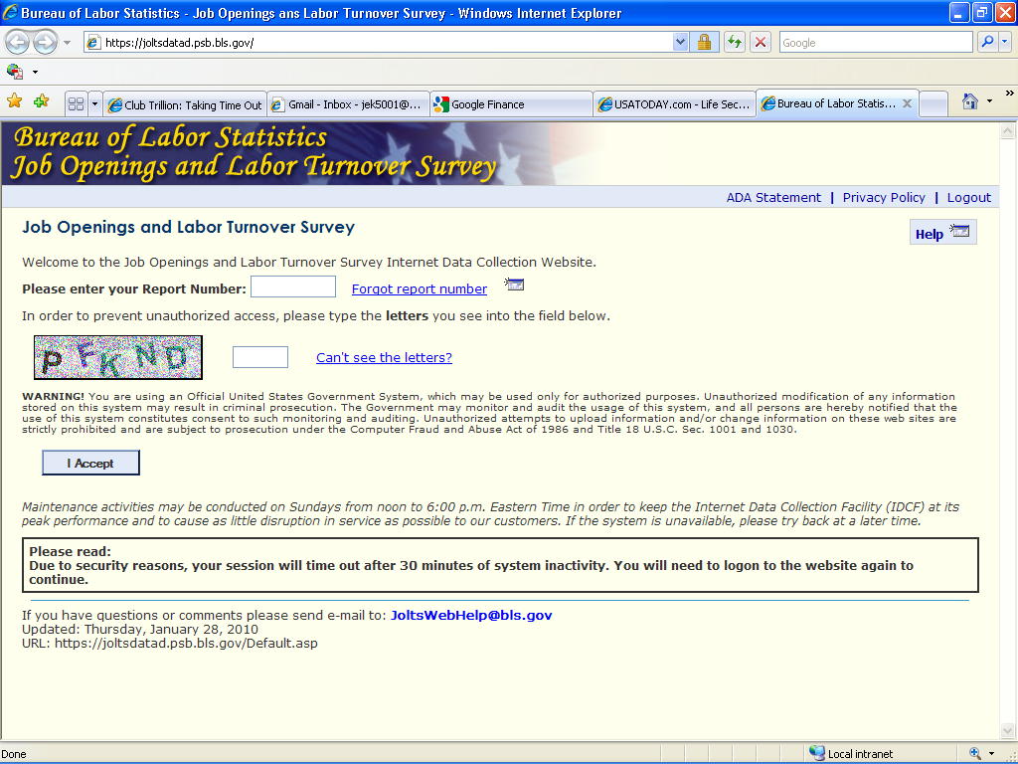

3. The welcome screen is next. Click on “Continue” when you are ready to enter your data.

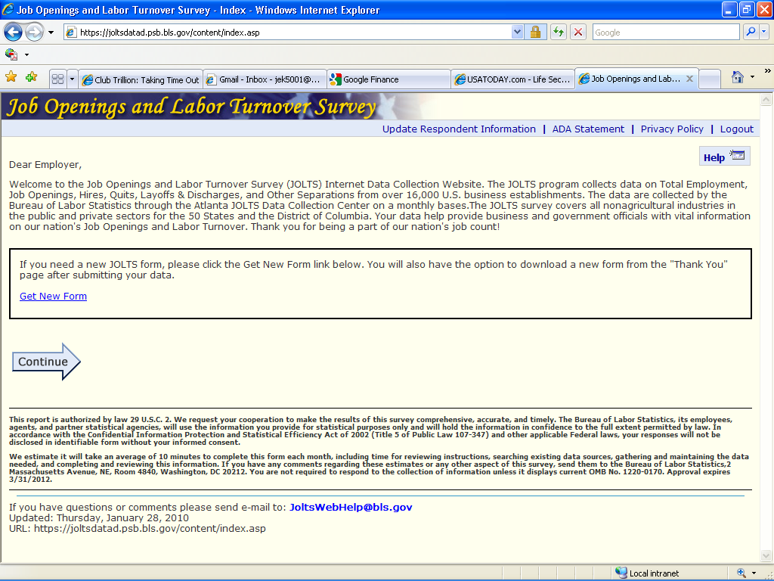
4. Select the reference month and enter your data.

