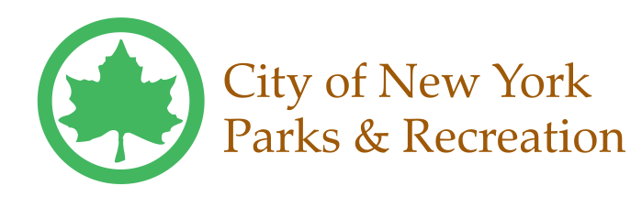
OMB Control #1505-XXXX
SURVEY ABOUT FINANCES

BACKGROUND INFORMATION
1. Last Name: | 2. First Name: | 3. Date of Birth:
4. Are you of Hispanic or Latino origin?  Yes  No  Prefer not to answer  5. Race: (select one or more)  White  Black/African-American  Asian  Native Hawaiian or other Pacific Islander  American Indian or Alaska Native  Prefer not to answer | 6. Living Situation:  Rent  Own  Staying with family/friends  Public housing  Homeless/shelter  Prefer not to answer | 7. Marital Status:  Married  Single (never married)  Divorced/Separated  Widowed  Prefer not to answer
 | 8. How many adults (18 and over), including yourself, are in your household?  ____________ | 9. How many children (under 18) are in your household?  ____________
USE OF FINANCIAL SERVICES
10. Did you have a bank account in the month before starting POP? |  | 11. If you did not have a bank account in the month before starting POP, did you have one in the past?  Yes No  - 11a. IF YES, why did you close it? (check all that apply)  I could not maintain the minimum balance  Fees were too high  I don’t like dealing with banks  I don’t trust banks  I had a negative experience with my bank  I have judgments/liens  It was frozen / garnished  Other reason: _________________________________  ________________________________________________  - 11b. IF NO, why don’t you have a bank account? (check all)  I can’t maintain the minimum balance  Fees are too high  I tried but bank denied me  I don’t have the required identification  I don’t like dealing with banks  I don’t trust banks  I had a negative experience with my bank  I have judgments / liens  I don’t want my wages garnished  Other reason: _________________________________  ________________________________________________
No account | Yes, savings account
Yes, checking account | Yes, both checking and savings account
12. Did you have any of the following in the month before starting POP? (check all that apply)
Prepaid card
Payroll card
EBT/Public Benefits card
Direct deposit to bank account
Direct deposit to payroll card

13. Have you used any of the following in the last month? (check all that apply)
Check-cashers
Money orders
Online bill pay
Pay day lender
Pawn shops

FINANCIAL INFORMATION
14. If you had an unexpected expense or emergency of $500, how confident are you that you could pay it?  Not at all  A little  Somewhat  Very  Extremely | 15. Do you use a budget or spending plan?  Yes No | 16. Have you viewed your credit report in the past 12 months?  Yes No
 | 17. Are you saving regularly?  Yes No  18. Do you have any savings?  Yes No |  | 19. If you have savings, about how much money do you have saved?  $_______________
20. About how often do you contribute to savings?  Weekly  Every two weeks  Monthly  Several times a year  Once per year  Less than once per year  Never, do not contribute to savings | 21. How often is your household able to pay all bills, such as rent /mortgage, utilities, food, etc?  Almost always  Often  Sometimes  Rarely  Never |  |  | 22. Do you trust banks?  Not at all  A little  Somewhat  Very  Extremely
23. How much control do you feel over your finances?  No control  A little control  In control  Very in control  Extremely in control | 24. How would you rate your understanding of money-management?  Very bad  Poor  Fair  Good  Excellent |  |  | 25. How frequently do you pay your bills on time?  Almost always  Often  Sometimes  Rarely  Never

Paperwork Reduction Act Notice

Notwithstanding any other provision of the law, no person is required to respond to, nor shall any person be subject to a penalty for failure to comply with a collection of information subject to the requirements of the Paperwork Reduction Act, unless that collection of information displays a currently valid OMB Control Number. The estimated time to complete this survey is 20 minutes. To provide comment on this survey, please contact Louisa M. Quittman, Director, Community Programs, Office of Financial Education and Financial Access, US Department of the Treasury, 1500 Pennsylvania Ave., NW, Washington, DC 20220. This is an approved information collection under OMB #1505-XXXX

