Appendix G
Letters and Contacting Materials

NPSAS  Endorsed by  American Association of  Collegiate Registrars and  Admissions Officers  American Association of Community Colleges  American Association of State Colleges and Universities  American Council on Education  Association for Institutional Research  Association of American Colleges and Universities  Association of Catholic Colleges and Universities  Association of Private Sector Colleges and Universities  Association of Public and Land-grant Universities  Association of Schools of Allied Health Professions  The Carnegie Foundation for the Advancement of Teaching  The College Board  Council of Graduate Schools  The Council of Independent Colleges  Hispanic Association of Colleges and Universities  Midwestern Higher Education Compact  National Accrediting Commission of Cosmetology Arts and Sciences  National Association of College and University Business Officers  National Association for Equal Opportunity in Higher Education  National Association of Independent Colleges and Universities  National Association of Student Financial Aid Administrators  New England Board of Higher Education  Southern Regional Education Board  State Higher Education Executive Officers  The United Negro College Fund  Western Interstate Commission for Higher Education |  | <date>  «salutation» «fname» «lname»  «Title»  «entity_name»  «phys_addr1»  «phys_addr2»  «phys_city», «phys_state» «phys_zip»  Your IPEDS UNITID: «entity_id»  Your password: «password»  Student Records Data Due: «expected_Date_curr»  Dear «salutation» «lname»,  Thank you for your continued participation in the 2011-12 National Postsecondary Student Aid Study (NPSAS). We have finished processing the student enrollment file you provided, and have selected a random sample of [# sampled] students from your institution for participation in NPSAS. We now need to ask that you provide student record data for your sampled students using the secure Web application developed for NPSAS. Please complete the record abstraction and provide the requested data for these students on or before [DUE DATE]. We will send separate correspondence to the sampled students asking that they complete the NPSAS survey either online or by telephone interview.  We have developed an Internet-based NPSAS Student Records System through which you (or someone on your staff) will be able to provide data for your selected students. The Student Records System is located on the same secure website that you have used for prior components of the study: https://surveys.nces.ed.gov/NPSASschool.  To assist you with the process of providing student record data, we have enclosed a Quick Guide to Providing Student Records Data describing how to access and use the Student Records software. You can find details on what data NPSAS needs to obtain for each sampled student from the Forms/Instructions link on the NPSAS website. A list of your sampled students can be found on the NPSAS website, and you can easily print a hardcopy if you would like one.  There are four different methods available for providing the student data through the NPSAS Student Records System:  - Case-mode – enter data for one student at a time.  - Grid-mode – enter data for multiple students in a format resembling a spreadsheet.  - Upload data files created from our template - download an Excel template, fill in the requested data for all students, and upload the completed files.  - Upload data files created by an institution programmer - create and upload data files following the specifications on the study website.  Regardless of the method you choose, you will be able to review and edit the
provided data on screen in the Student Records System.
Please be assured that the security of your students’ data is of the utmost importance, and the Student Records software has been developed with this in mind. The system encrypts all data, with the latest technologies, before transmitting them over the Internet to NCES. In addition, access to the list of students (and to the forms used to enter their data) will require authentication using your IPEDS UNITID and unique password. They are printed near the top of this letter for your convenience. Please ensure that access is given only to those at your institution who will provide student records data.
Soon, we will call you to confirm your receipt of this material and the completion date for providing student records data. Help Desk staff will be available from 9:00 a.m. to 7:00 p.m. ET, Monday through Friday, to answer any questions you may have about the study or about using the Student Records System. You may contact the NPSAS Help Desk at 1-888-677-2741, toll-free, or via e-mail at NPSASrecords@rti.org.

Again, thank you for your continued participation in this important study.
Sincerely,
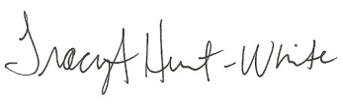
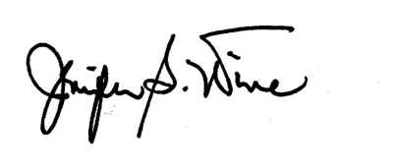
Jennifer Wine, Ph.D. Tracy Hunt-White, Ph.D.
Project Director, NPSAS Project Officer, NPSAS
RTI International National Center for Education Statistics
jennifer@rti.org tracy.hunt-white@ed.gov
877-225-8470 202-502-7438

Your institution’s response to the National Postsecondary Student Aid Study may be completed online at:

https://surveys.nces.ed.gov/NPSASschool

To access the NPSAS Student Records System, go to the
Log in link on the Home page. Then enter the IPEDS
UNITID below as your Username and enter the password below.

Your IPEDS UNITID: «entity_id»
Your password: «password»

NPSAS Student Records
Frequently Asked Questions (FAQs)

- What are the system requirements for using the NPSAS Student Records System?

To use the Web-based NPSAS Student Records System, your computer must possess (at a minimum):

- An Internet connection (high-speed cable is optimum).
- A web browser, such as Microsoft Internet Explorer 6.5 or higher, Firefox 3.0 or higher, Chrome 3.0 or higher, or Safari 3.0 or higher with the following:
  - 128-bit encryption. You may have to adjust your browser settings or download an update to activate 128-bit encryption.
  - JavaScript enabled. JavaScript is the programming language of the interactive sections of our website and must be enabled for many pages to work properly.
  - Secure Sockets Layer (SSL) enabled. SSL is used to provide additional security for our website and your data.
  - Session cookies enabled. Session cookies are small text files temporarily stored in your RAM until you close your browser. Session cookies are not stored on your hard drive and are automatically removed at the end of the browsing session.

- How confidential is this website?

For this and all other web-based data collections that are part of NPSAS, proven methods of protection for online sessions and data security over the Internet are being used. Secure Sockets Layer (SSL) protocol is used to encrypt the data over the Internet. The study website is password protected and requires the user to log in to the site before accessing confidential data. The system will automatically log the user out after 20 minutes of inactivity on the session, preventing unauthorized user access to the site.

- What about confidentiality of the data collected?

Both NCES and RTI follow strict procedures to protect the privacy and confidentiality of study participants. The Confidentiality Fact Sheet on the NPSAS website describes our security systems and procedures, and provides more details on how data are maintained. Any data released to the public will be in aggregate form (for example, statistical tables). Restricted use data files (which contain record-level data, but no identifying information) are available only to a limited number of qualified researchers, who must pledge, under penalty of law with severe fines and imprisonment, to maintain the confidentiality of the data.

- Do we need to have the student’s permission before providing this information?

No. The data request for NPSAS fully conforms to the requirements of the Family Educational Rights and Privacy Act of 1974 (FERPA) [20 United States Code 1232g; 34 CFR Part 99]. FERPA is designed to protect the privacy rights of students and their families by providing consistent standards for the release of personally identifiable student and family information. The National Center for Education Statistics (NCES) and its agent, RTI International (RTI), are permitted by the provisions of FERPA to obtain student-level data from institutions. These data are subject to strict confidentiality protections, which must be adhered to by both NCES and RTI.

Student or parental consent is not required for release of information to NCES. FERPA explicitly states in 34 CFR 99.31 that an educational institution may disclose personally identifiable information from an education record of a student without prior consent if the disclosure is to authorized representatives of the Secretary of Education, which includes RTI as contractor for this research. A definition of personally identifiable information can be found in 34 CFR 99.3. Personal identifiers, such as Social Security number and student number, are included in the definition. You may review this legislation on the U.S. Department of Education’s website: http://www.ed.gov/policy/gen/reg/ferpa.

- By what authority does RTI collect this information?

NPSAS is sponsored by the National Center for Education Statistics (NCES), United States Department of Education. It is conducted under the authority of the Higher Education Opportunity Act of 2008 (HEOA) (20 U.S.C. § 1015) and the Education Sciences Reform Act of 2002 (ESRA) (20 U.S.C. § 9512) which authorizes NCES, within the Department of Education’s Institute of Education Sciences, to collect and disseminate information about education in the United States.

- Where do I go for the information requested?

The information needed for each of the sampled students is typically collected from three distinct (document or online) sources at your institution: the Admissions or Registrar’s Office; the Bursar’s or Business Office; and the Financial Aid Office. If you require assistance after reviewing the enclosed Quick Guide to Providing Student Records Data, please contact the Help Desk with your questions at 1-888-NPSAS411
(1-888-677-2741), toll-free, or via e-mail at NPSASrecords@rti.org.

- How long does it take to collect student records data for NPSAS?

Because NPSAS needs information from students’ files (electronic or hard copy), and institutions have different methods of record keeping, our estimates indicate that providing the requested student records data will take about [{if field test}13 / {if full-scale} 20] hours on average. If you have any concerns with the amount of time it is taking you to provide the requested data, please call the Help Desk at 1-888-NPSAS411 (1-888-677-2741), toll-free. RTI will work with you to ensure you have the support needed to successfully complete this data collection effort.

- Can I provide a data file instead of using the case-mode or grid-mode data entry options?

Yes. You can download an Excel template to create the four files we need, or a programmer can create each file according to the specifications available on the Student Records Data page of the NPSAS website. After the files are uploaded, your data can be reviewed and edited online using the NPSAS Student Records System. If you have questions, please contact RTI's Help Desk at 1-888-NPSAS411 (1-888-677-2741) or e-mail NPSASrecords@rti.org.

- Do I need to supply the student’s Social Security Number (SSN) in NPSAS Student Records if we already provided it on the student enrollment list?

No. If your institution provided each student’s SSN on the student enrollment list, it will be displayed in the NPSAS Student Records System so that the user can be sure he/she is entering data for the correct student. Please correct the SSN if needed. The student’s SSN is needed to perform file matches to other data sources, including the Central Processing System (CPS).

Additional FAQs can be found on the NPSAS website: https://surveys.nces.ed.gov/NPSASschool.

DISCLOSURE NOTICE FOR NPSAS

Information from student records for this individual has been provided to RTI International, an agent for the U.S. Department of Education. This disclosure statement fulfills the requirement of 34 CFR 99.32(a)(6) pursuant to the Family Educational Rights and Privacy Act of 1974 [20 United States Code 1232g].
This individual is included in the sample for the 2011-12 National Postsecondary Student Aid Study (NPSAS). Strict protection of all information obtained from individuals selected for participation in NPSAS is assured by current federal laws and regulations. All responses that relate to or describe identifiable characteristics of individuals may be used only for statistical purposes and may not be disclosed or used in identifiable form for any other purpose, unless otherwise compelled by law.
January 2012
OMB # 1850-0666
Expiration Date: (insert date)
NPSAS  Endorsed by  American Association of  Collegiate Registrars and  Admissions Officers  American Association of Community Colleges  American Association of State Colleges and Universities  American Council on Education  Association for Institutional Research  Association of American Colleges and Universities  Association of Catholic Colleges and Universities  Association of Private Sector Colleges and Universities  Association of Public and Land-grant Universities  Association of Schools of Allied Health Professions  The Carnegie Foundation for the Advancement of Teaching  The College Board  Council of Graduate Schools  The Council of Independent Colleges  Hispanic Association of Colleges and Universities  Midwestern Higher Education Compact  National Accrediting Commission of Cosmetology Arts and Sciences  National Association of College and University Business Officers  National Association for Equal Opportunity in Higher Education  National Association of Independent Colleges and Universities  National Association of Student Financial Aid Administrators  New England Board of Higher Education  Southern Regional Education Board  State Higher Education Executive Officers  The United Negro College Fund  Western Interstate Commission for Higher Education |  | student records follow-up letter to institution coordinator who requests field visit  <date>  «salutation» «fname» «lname»  «Title»  «entity_name»  «phys_addr1»  «phys_addr2»  «phys_city», «phys_state» «phys_zip»  Your IPEDS UNITID: «entity_id»  Your password: «password»  Dear «salutation» «lname»,  Thank you for your participation in the 2011-12 National Postsecondary Student Aid Study (NPSAS). We finished processing the student enrollment file you provided and have selected a random sample of «tot_cnt» students from your institution for participation in NPSAS. We now need to collect institutional record data for these students. Our records show that your institution has requested assistance in performing the record abstractions. RTI can send a trained staff member to your institution to enter the student record data for your institution.  Our staff member will be calling you soon to discuss their visit. To help you prepare for this visit and better understand the data requested, we have enclosed a list of the types of data we would like to obtain for each sampled student. The list of sampled students can be found on the secure study website where you can easily print a hardcopy if you would like one: https://surveys.nces.ed.gov/NPSASschool. This website is the same one that you have used for prior components of the study.  Please be assured that the security of the data is of the utmost importance, and our study procedures and applications have been developed with this in mind. The software application encrypts all data with the latest technologies, before they are transmitted to RTI. In addition, access to the list of sampled students and the NPSAS Student Records System on the study website requires user authentication, using your IPEDS UNITID and unique password (listed above for your convenience). Please ensure that access to the list of sampled students is given only to those at your institution who will provide the requested data.  The RTI staff member who contacts you will serve as your point of contact for this activity. If you are ever unable to reach him/her, you may contact the NPSAS Student Records manager, Tiffany Mattox, at 1-800-334-8571 ext. 27791, toll-free, or via e-mail at tmattox@rti.org. You may also direct questions about the study to me at 919-541-6870 (Jennifer@rti.org) or to NCES by contacting Tracy Hunt-White, Ph.D. at 202-502-7438 (Tracy.Hunt-White@ed.gov).
Again, thank you for your continued participation in this important study.
Sincerely,
Jennifer Wine, Ph.D.
Project Director, NPSAS
RTI International

To access the list of sampled students or the
NPSAS Student Records System:

1. Go to: https://surveys.nces.ed.gov/NPSASschool
2. Click Log in on the Home page.
3. Enter your IPEDS UNITID as your username and your unique
password (listed below) and click Login.
4. From the Data Entry Tasks menu, click Provide Student Records
Data.

Your IPEDS UNITID: «entity_id»
Your password: «password»

Student Records Reminder Email to Institution Coordinator

Dear «salutation» «lname»:

I am writing as a follow-up to the package you should have received recently that included a letter from me about NPSAS Student Records data collection, which is the final institutional component of the 2011-12 National Postsecondary Student Aid Study (NPSAS). The letter requests that you log on to the secure NPSAS website and provide student records data for sampled students through the NPSAS Student Records System. Please find below a link to the NPSAS website as well as the username and password needed to access the site and provide data.

NPSAS website: https://surveys.nces.ed.gov/NPSASschool
Your IPEDS UNITID: «entity_id»
Your PASSWORD: «password»

NPSAS is being conducted for the National Center for Education Statistics, U.S. Department of Education by RTI International, a not-for-profit research organization. The data your institution provides are very important to the success of the study.

If you have any questions about the study or procedures involved, please contact the Help Desk at 1-888-NPSAS411 (1-888-677-2741) or via e-mail at NPSASrecords@rti.org.

Thank you again for your cooperation.

Sincerely,

Jennifer Wine, Ph.D.
Project Director, NPSAS
RTI International

Field Test Brochure
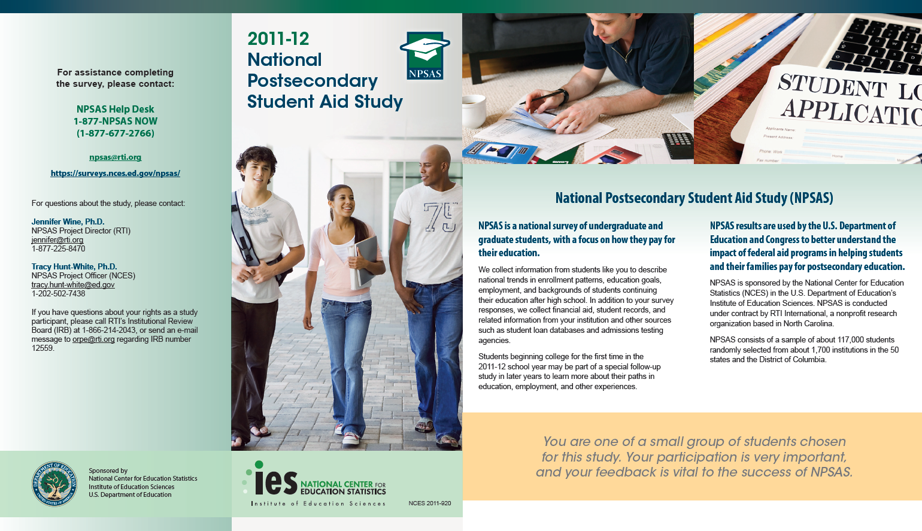

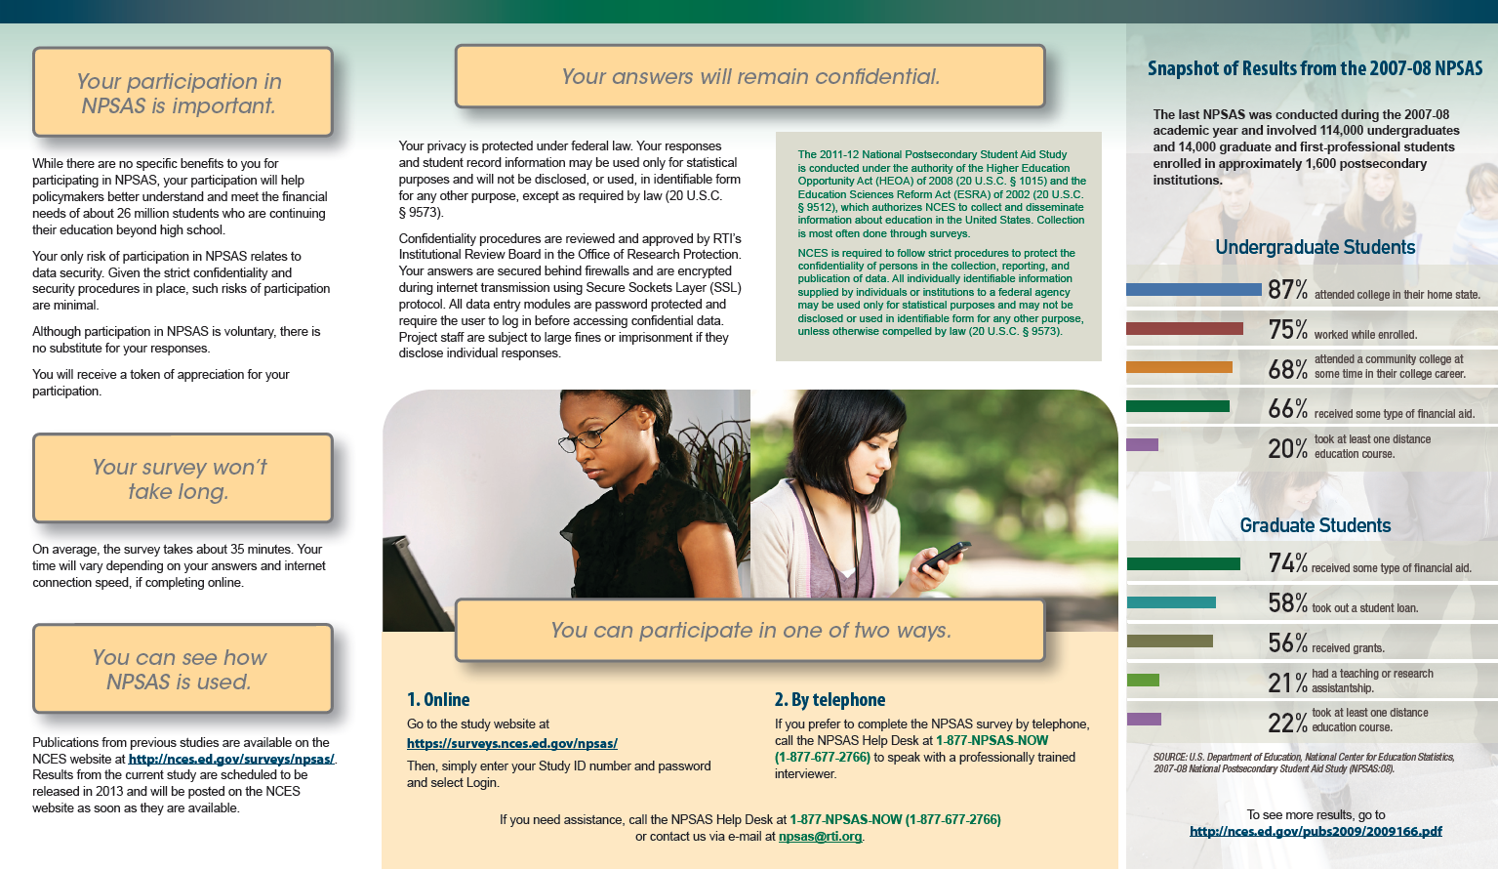

Lead Letter
NPSAS  Endorsed by  American Association of  Collegiate Registrars and  Admissions Officers  American Association of Community Colleges  American Association of State Colleges and Universities  American Council on Education  Association for Institutional Research  Association of American Colleges and Universities  Association of Catholic Colleges and Universities  Association of Private Sector Colleges and Universities  Association of Public and  Land-Grant Universities  Association of Schools of Allied Health Professions  The Carnegie Foundation for the Advancement of Teaching  The College Board  Council of Graduate Schools  The Council of Independent Colleges  Hispanic Association of Colleges and Universities  Midwestern Higher Education Compact  National Accrediting Commission of Cosmetology Arts and Sciences  National Association of College and University Business Officers  National Association for Equal Opportunity in Higher Education  National Association of Independent Colleges and Universities  National Association of Student Financial Aid Administrators  New England Board of Higher Education  Southern Regional Education Board  State Higher Education Executive Officers  The United Negro College Fund  Western Interstate Commission for Higher Education | February 28, 2012November 7, 2011  «fname» «mname» «lname» «suffix»  Study ID: «caseid»  «panelinfo»  «addr1»  «addr2»  «city», «state» «zip»  Dear «fname» «lname»:  I am writing to ask you to participate in an important study that will help determine how students and their families meet the cost of education beyond high school. For your participation, I would like for you to complete a survey online. On average, the survey takes about 25 minutes to complete, depending on your answers.  When you access the survey online, you will be asked questions about how you paid for your school expenses during the 2011–12 school year, including whether you received financial aid. If you received financial aid, you will be asked whether the amount of aid was enough to meet your educational expenses. If you did not receive financial aid, you will be asked about how you met your school expenses. Please watch our informational YouTube video featuring ED to learn more about NPSAS: <<videolink>>.  Students from all types of institutions and all financial situations have been randomly selected to participate in the 2012 National Postsecondary Student Aid Study (NPSAS). Your responses will represent responses of all students enrolled in postsecondary education. Therefore, your participation in this study is critical.  To complete the survey online:  - Go to: https://surveys.nces.ed.gov/npsas/.  - Type the Study ID and password (provided below) on the Home/Login page.  - Click “Login” to begin the survey.  RTI International, an independent, nonprofit research organization based in North Carolina, is conducting the study for the National Center for Education Statistics in the U.S. Department of Education’s Institute of Education Sciences. To express our appreciation for your participation, a $30 check will be mailed to you if you complete the survey by «EarlyIncDate». If you are unable to complete the survey by that date, an RTI interviewer will call you to complete the survey by telephone.  Participation in this study is voluntary and will not affect any aid or other benefits you receive.  The enclosed brochure answers many common questions about the study and contains additional information on laws and procedures that protect the confidentiality of your responses. If you have questions about the study, you can visit the study web site at https://surveys.nces.ed.gov/npsas/, call the NPSAS help desk at 1-877-NPSAS-NOW (1-877-677-2766), or send an e-mail to npsas@rti.org.  I thank you in advance for your participation in this important study. Your cooperation is greatly appreciated.  Sincerely,  Go to: https://surveys.nces.ed.gov/npsas/  Your Study ID: «caseid»  Your password: «password»m  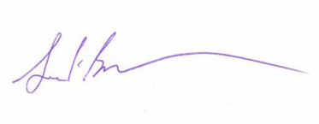  Jack Buckley, Ph.D.  Commissioner  National Center for Education Statistics  Enclosures
According to the Paperwork Reduction Act of 1995, no persons are required to respond to a collection of information unless it displays a valid OMB control number. The valid OMB control number for this voluntary information collection is 1850–0666. The time required to complete this information collection is estimated to average 25 minutes to complete, depending on your answers, including the time to review instructions, gather the data needed, and complete and review the information collection. If you have any comments concerning the accuracy of the time estimate or suggestions for improving this survey, please write to: U.S. Department of Education, Washington, DC 20202–4537. If you have any comments or concerns regarding the status of your individual submission of this survey, write directly to: The 2011-12 National Postsecondary Student Aid Study (NPSAS:12), National Center for Education Statistics, 1990 K Street, NW, Washington, DC 20006.
Announcement Letter – Sent to Parents

February 28, 2012

«Cpfname» «Cpmname» «Cplname» Study ID: «caseid»
«CAddr1» «panelinfo»
«CAddr2»
«Ccity», «Cstate» «CZip» «CZip4»

Dear «Cpfname» «Cplname»:
Your student, «fname» «lname», has been selected to participate in the National Postsecondary Student Aid Study (NPSAS), which is being conducted by RTI International for the National Center for Education Statistics (NCES) in the U.S. Department of Education’s Institute of Education Sciences. We are now conducting interviews. You can help make the study a success by encouraging «pronoun2» to complete the NPSAS interview by «EarlyIncDate». If «pronoun1» completes the interview by «EarlyIncDate», «pronoun1» will receive $30 as a token of our appreciation.
Data collected from NPSAS will help educators, researchers, and policymakers better understand how students and their families meet the cost of education beyond high school. The interview covers topics such as enrollment patterns, education goals, employment, and background.
Enclosed you will find a brochure that provides an overview of NPSAS, findings from the past NPSAS studies, and confidentiality procedures. «fname»’s participation in this study, while voluntary, is critical to the study’s success.
If you have any questions or concerns about the study itself, please contact the NPSAS Project Director, Dr. Jennifer Wine, toll-free, at 1-877-225-8470 (e-mail: jennifer@rti.org) or the NCES Project Officer, Dr. Tracy Hunt-White, at 1-202-502-7438 (e-mail: tracy.hunt-white@ed.gov).
We sincerely appreciate your assistance and thank you in advance for helping us conduct this important study.

Sincerely,

Jack Buckley, Ph.D.
Commissioner
National Center for Education Statistics

Enclosure

According to the Paperwork Reduction Act of 1995, no persons are required to respond to a collection of information unless it displays a valid OMB control number. The valid OMB control number for this voluntary information collection is 1850–0666. The time required to complete this information collection is estimated to average 25 minutes to complete, depending on your answers, including the time to review instructions, gather the data needed, and complete and review the information collection. If you have any comments concerning the accuracy of the time estimate or suggestions for improving this survey, please write to: U.S. Department of Education, Washington, DC 20202–4537. If you have any comments or concerns regarding the status of your individual submission of this survey, write directly to: The 2011-12 National Postsecondary Student Aid Study (NPSAS:12), National Center for Education Statistics, 1990 K Street, NW, Washington, DC 20006.

Parent Consent Letter
February 28, 2012

Parent or Guardian of «fname» «lname»
«addr1»
«addr2»
«city», «state» «zip»

Dear Parent or Guardian,
We are pleased to inform you that your student, «fname» «lname», has been selected to participate in an education study sponsored by the National Center for Education Statistics (NCES), in the U. S. Department of Education’s Institute of Education Sciences. The purpose of the 2012 National Postsecondary Student Aid Study (NPSAS:12) is to provide Congress, researchers, and policymakers with information about financial aid in postsecondary education. However, because «fname» is less than 18 years old, we need your permission for «fname» to participate.

Approximately 117,000 students from approximately 1,700 schools across the nation have been selected to participate in NPSAS. Students are being asked to complete a web or telephone survey that takes about 25 minutes to complete, depending on answers, about their enrollment during the 2011-12 academic year, including questions about degree, field of study, financial aid, employment while enrolled, educational experiences, and background characteristics. Once the survey is completed, «fname» will receive a $30 check as a token of our appreciation.

NCES is authorized by federal law (Public Law 107-279) to conduct NPSAS. RTI International, an independent nonprofit research organization based in North Carolina, is conducting the study for NCES. Responses and student record information may be used only for statistical purposes and will not be disclosed, or used, in identifiable form for any other purpose, except as required by law. Data will be combined to produce statistical reports for Congress and others. No individual data (e.g., names or addresses) will be reported.

Participation is voluntary. «fname» may withdraw from the study at any point. However, I do need your help. «fname» was selected to represent many other students. «fname»’s responses are necessary to make the results of this important study accurate and timely. «fname» may refuse to answer any particular question. While there are neither significant risks nor direct benefits to «fname» for participating, the survey may benefit the nation’s college students by providing timely data relevant to educational policymaking.

If you would rather not provide permission for «fname» to participate, please fill out the enclosed form and return it by (date) in the postage-paid envelope provided. Otherwise, we will accept non-response as passive consent for participation.

The enclosed brochure provides more information about the study. If you have any questions about NPSAS or «fname»’s participation in the study, please call the NPSAS Help Desk toll-free at 1-877-677-2766. If you have questions about the rights of study participants, you may call RTI’s Office for Research Protection toll-free at 1-866-214-2043.

I thank you in advance for your cooperation in this important research.
Sincerely,
Jack Buckley, Ph.D.
Commissioner
National Center for Education Statistics
Enclosures

According to the Paperwork Reduction Act of 1995, no persons are required to respond to a collection of information unless it displays a valid OMB control number. The valid OMB control number for this voluntary information collection is 1850–0666. The time required to complete this information collection is estimated to average 25 minutes to complete, depending on your answers, including the time to review instructions, gather the data needed, and complete and review the information collection. If you have any comments concerning the accuracy of the time estimate or suggestions for improving this survey, please write to: U.S. Department of Education, Washington, DC 20202–4537. If you have any comments or concerns regarding the status of your individual submission of this survey, write directly to: The 2011-12 National Postsecondary Student Aid Study (NPSAS:12), National Center for Education Statistics, 1990 K Street, NW, Washington, DC 20006.

National Postsecondary Student Aid Study (NPSAS:12) Permission Denial Form

The information RTI will collect from the students includes enrollment patterns, education goals, employment, and backgrounds of students continuing their education after high school.

IF YOU GRANT PERMISSION FOR YOUR STUDENT TO PARTICIPATE IN NPSAS, YOU DO NOT NEED TO RETURN THIS FORM.

IF YOU DO NOT GRANT PERMISSION FOR YOUR STUDENT TO PARTICIPATE, PLEASE RETURN THIS FORM TO RTI IN THE ENCLOSED ENVELOPEBY <DATE>.

Parents of a participating youth under age 18: if you wish to deny permission for your student to participate, you should fill in your son/daughter’s name and sign and date this form below.

PARENTS OF YOUTH PARTICIPANT UNDER AGE 18:

As a parent of a youth participant under age 18, I DO NOT GRANT PERMISSION for my son/daughter, _____________________________________________, to participate in the National Postsecondary Student Aid Study (NPSAS:12)

_______________________________ __________________
(Signature of parent or guardian) (Date of signature)

PLEASE CORRECT THE INFORMATION BELOW, IF NEEDED:

Student name: «studentName»

Address: «Address1» «Address2» «City», «State» «Zip»

Telephone number: «PhoneNumber»

FOR OFFICE USE ONLY:
Consent Form ID: «UniqueID»
Student ID: «CaseID»
Institution Name: «SchoolName»

Reminder/Thank You Postcard
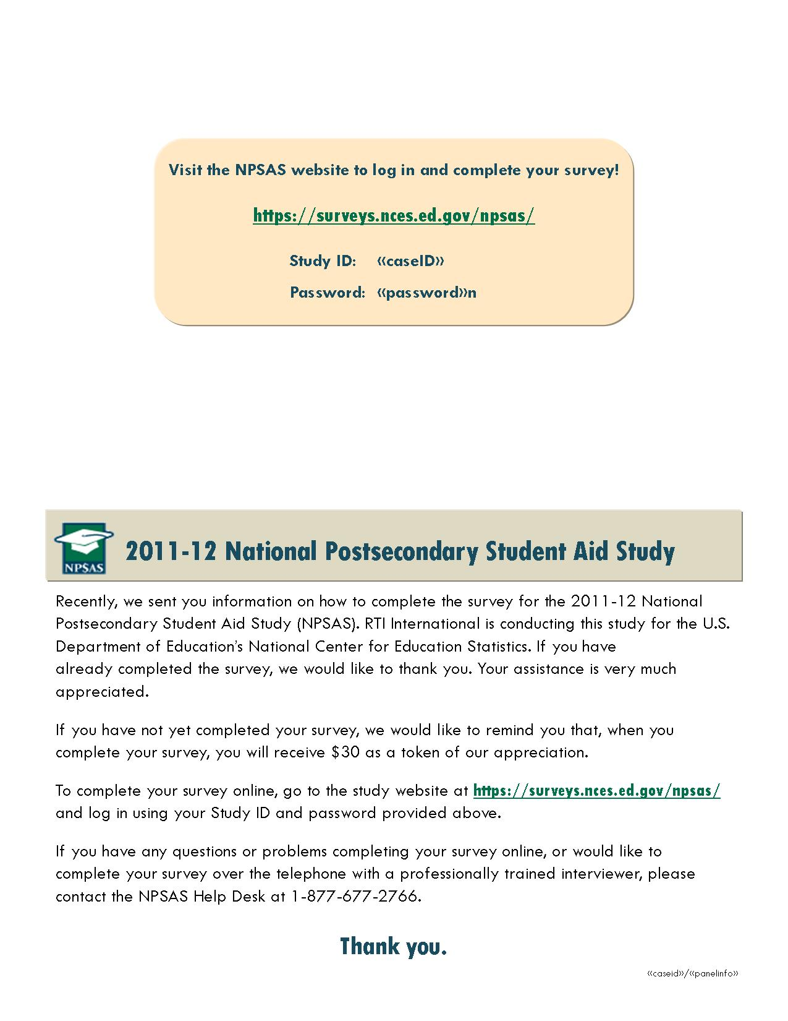

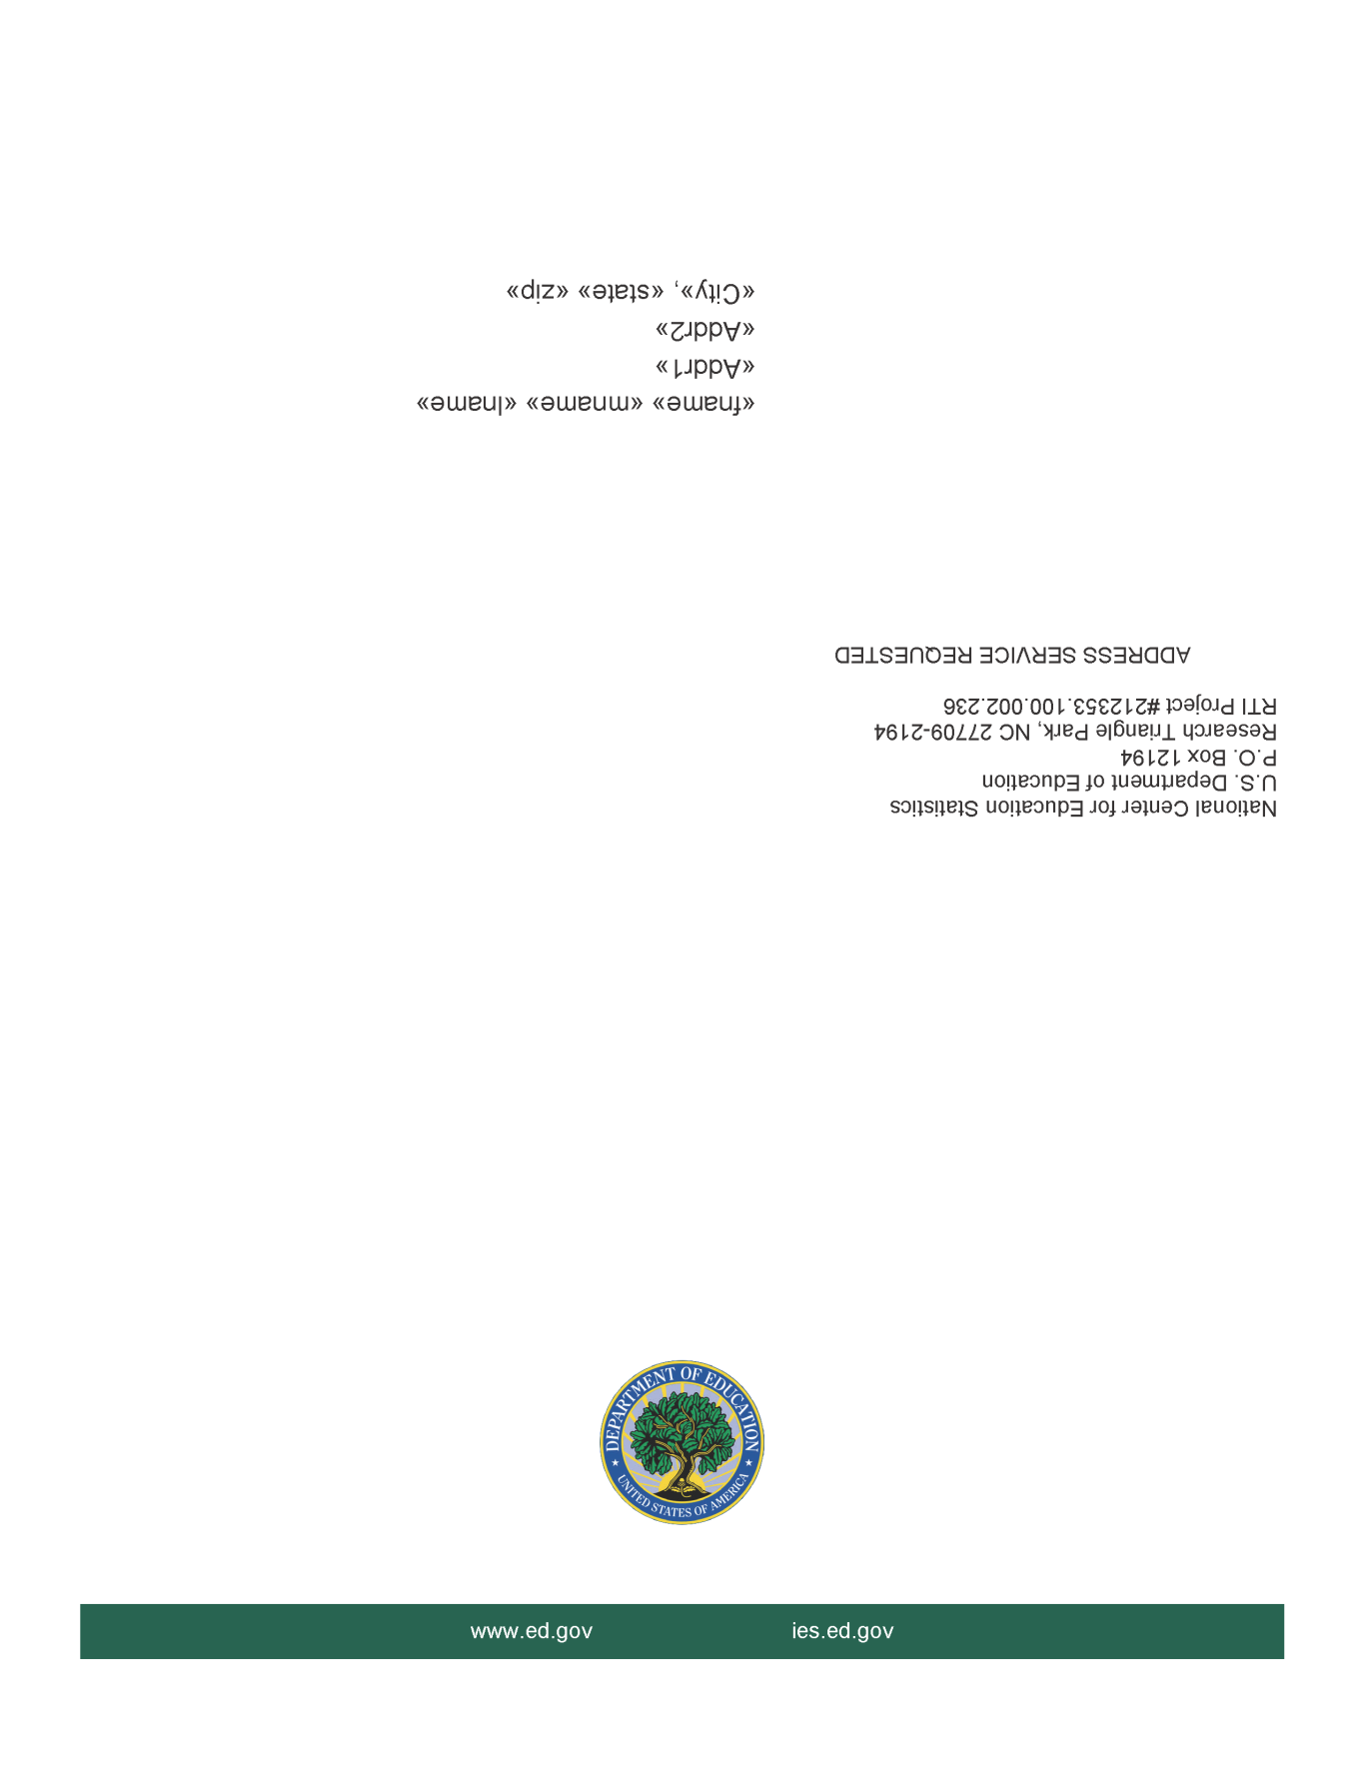

CATI Requested Remail Letter

February 28, 2012

«name» | Study ID: «caseid»
«address» | «panelinfo»
«address2»
«city_state»«state», «zip»

Dear «name»:

Per your request, we are providing you with more information on the 2012 National Postsecondary Student Aid Study (NPSAS:12) that is now being conducted for the National Center for Education Statistics in the U.S. Department of Education’s Institute of Education Sciences. Enclosed you will find a brochure that includes a brief description of NPSAS, findings from prior NPSAS studies, and our strict confidentiality procedures. Once you complete your NPSAS survey, you will receive a check for $30 as a token of our appreciation.

To make participating as easy as possible, we offer two options for completing it. You may complete the survey over the telephone with one of our professionally trained interviewers, or you may complete the survey online.

Please call us at 1-877-677-2766 to complete the survey by phone, or, if you wish to complete the survey on our secure website, log on to https://surveys.nces.ed.gov/npsas/. You will need the Study ID and password provided below to access the web survey.

Study ID = «caseid»
Password = «password»p

Federal law requires that we protect your privacy. Your responses will be used only for statistical purposes and will not be disclosed, or used, in identifiable form for any other purpose, except as required by law.

You can learn more about the study by visiting our website at https://surveys.nces.ed.gov/npsas/. Please do not hesitate to contact us directly at 1-877-677-2766 or by e-mail at npsas@rti.org if we can provide any additional information about the study or your survey.
Thank you in advance for your participation in this important study. Your cooperation is greatly appreciated.

Sincerely,
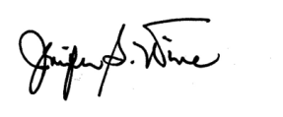
Jennifer Wine, Ph.D. Tracy Hunt-White, Ph.D.
Project Director, NPSAS Project Officer, NPSAS
RTI International National Center for Education Statistics

According to the Paperwork Reduction Act of 1995, no persons are required to respond to a collection of information unless it displays a valid OMB control number. The valid OMB control number for this voluntary information collection is 1850–0666. The time required to complete this information collection is estimated to average 25 minutes to complete, depending on your answers, including the time to review instructions, gather the data needed, and complete and review the information collection. If you have any comments concerning the accuracy of the time estimate or suggestions for improving this survey, please write to: U.S. Department of Education, Washington, DC 20202–4537. If you have any comments or concerns regarding the status of your individual submission of this survey, write directly to: The 2011-12 National Postsecondary Student Aid Study (NPSAS:12), National Center for Education Statistics, 1990 K Street, NW, Washington, DC 20006.
Reminder Folded Postcard
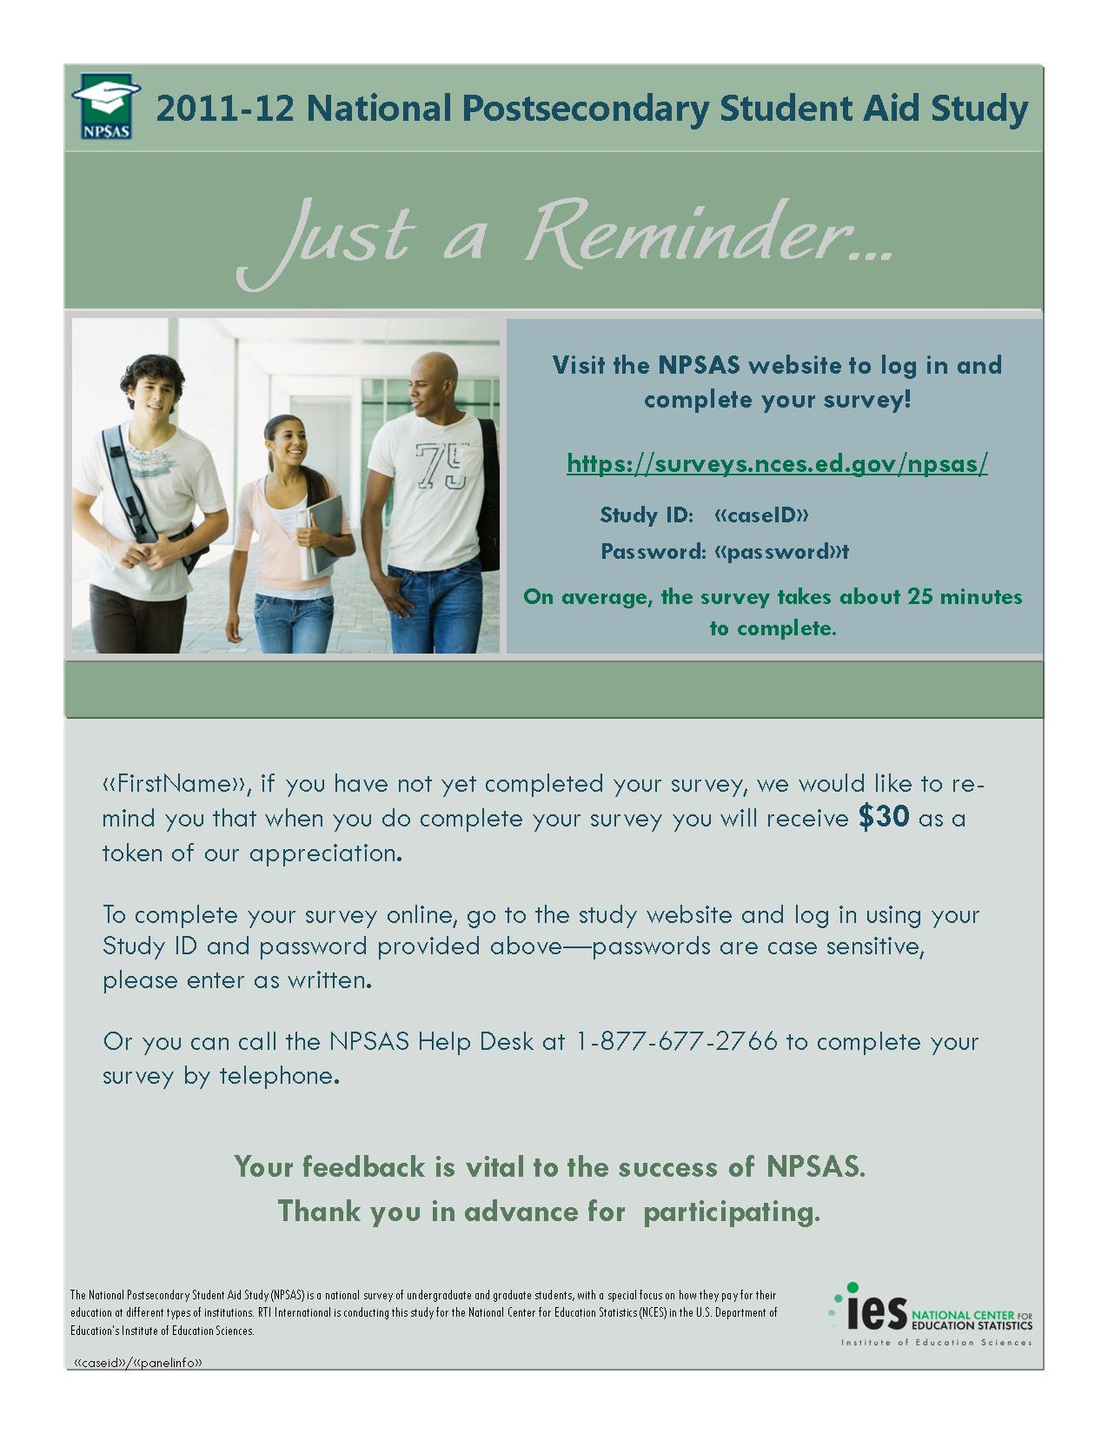

Reminder Letter

April 30, 2012

«stu_name» Study ID: «caseid»
«stu_addr1» «panelinfo»
«stu_addr2»
«stu_city», «stu_state» «stu_zip»

Dear «stu_name»:

We are writing to ask that you take a few moments to complete your survey for the 2012 National Postsecondary Student Aid Study (NPSAS:12), conducted by RTI International for the National Center for Education Statistics in the U.S. Department of Education’s Institute of Education Sciences. By completing the survey, you will make an important contribution to research that will help determine how students and their families meet the cost of education beyond high school. «fill1»

Please call us at 1-877-677-2766 to complete the survey by phone, or, if you wish to complete the survey on our secure website, log on to https://surveys.nces.ed.gov/npsas/. You will need the Study ID and password provided below to access the web survey.

Study ID = «caseid»
Password = «password»r

Interviewers are available Monday through Thursday from 9:00 am to 11:00 pm Eastern time, Friday from 9:00 am to 9:00 pm Eastern time, Saturday from 10:00 am to 6:00 pm Eastern time, and Sunday from 1:30 pm to 9:30 pm Eastern time.

The survey only takes about 25 minutes to complete, depending on your answers. Participation in this study is voluntary and will not affect any aid or any benefits you receive. If you have any questions about the study, you can visit the NPSAS website at https://surveys.nces.ed.gov/npsas, or you can e-mail us at npsas@rti.org. If you have any questions about your rights as a study participant, you can call RTI’s Office of Research Protection at 1-866-214-2043.

Thank you in advance for making NPSAS a success.

Sincerely,
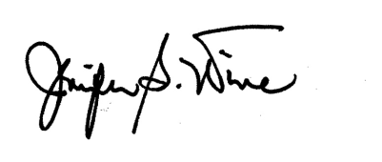
Jennifer Wine, Ph.D. Tracy Hunt-White, Ph.D.
Project Director, NPSAS Project Officer, NPSAS
RTI International National Center for Education Statistics
Final Letter

June 30, 2012

«stu_name» Study ID: «caseid»
«stu_addr1» «panelinfo»
«stu_addr2»
«stu_city», «stu_state» «stu_zip»

Dear «stu_name»:
We have been trying to contact you in recent weeks to ask you to complete a survey for the 2012 National Postsecondary Student Aid Study (NPSAS:12), conducted by RTI International on behalf of the National Center for Education Statistics in the U.S. Department of Education’s Institute of Education Sciences. NPSAS collects information on how students and their families pay for their education beyond high school.
Time is running out. Data collection for NPSAS ends on <<date>>. If you complete the survey before then, you will receive a check for $30. On average, the survey takes about 25 minutes to complete, depending on your answers.
You may call us at 1-877-677-2766 to complete the survey with one of our telephone interviewers. Or, you can complete the survey at any time via the NPSAS website:
https://surveys.nces.ed.gov/npsas/
Enter your study ID: «caseid»
Enter your password: «password»y
Please enter uppercase and lowercase letters as they appear.
Your responses will be used only for statistical purposes and may not be disclosed, or used, in identifiable form for any other purpose, except as required by law. If you have questions about the study, you can visit the NPSAS:12 website at https://surveys.nces.ed.gov/npsas/ , or e-mail us at npsas@rti.org. If you have questions about your rights as a study participant, you can call RTI’s Office of Research Protection toll-free at 1-866-214-2043.
Thank you in advance for your participation in this important study. With input from individuals like you, we can improve our ability to help others receive an education beyond high school.

Sincerely,

Jennifer Wine, Ph.D. Tracy Hunt-White, Ph.D.
Project Director, NPSAS Project Officer, NPSAS
RTI International National Center for Education Statistics

Thank You/Incentive Letter

April 30, 2012

«name» | Study ID: «CaseID»
«address» | NP12 «panelinfo»
«address2»
«city_state» «zip»

Dear «name»:

On behalf of the National Center for Education Statistics in the U.S. Department of Education’s Institute of Education Sciences and the staff of the 2012 National Postsecondary Student Aid Study (NPSAS), I would like to thank you for completing your NPSAS survey. Your participation in this study is very important to its success. Enclosed you will find a check for $30 as a token of our appreciation for your time completing the survey.

Please do not hesitate to contact us directly at 1-877-677-2766 if we can provide any additional information or assistance.

Again, thank you for your time and willingness to participate.

Sincerely,

Jennifer Wine, Ph.D. Tracy Hunt-White, Ph.D.
Project Director, NPSAS Project Officer, NPSAS
RTI International National Center for Education Statistics

Announcement E-Mail

Dear [FNAME],
Surveys for the 2012 National Postsecondary Student Aid Study (NPSAS:12) are now being conducted. The survey will take about 25 minutes to complete, depending on your answers. The data collected from it will help educators, researchers, and policymakers better understand how students and their families meet the cost of education beyond high school. <<You can learn more about NPSAS by watching our brief informational video, featuring, our animated Lego character, ED, on YouTube: >> <<videolink>>.
To access the web survey, log in to our secure website at https://surveys.nces.ed.gov/npsas/ using the Study ID and password provided below.
Study ID = [CASEID]
Password = [PASSWORD]e

The password is case sensitive; you will need to enter it exactly as it appears.
If you have questions or problems completing your survey online, please call the NPSAS Help Desk at 1-877-NPSAS-NOW (1-877-677-2766) or visit the study website at https://surveys.nces.ed.gov/npsas/.
If you complete your NPSAS survey by [EARLYINCDATE], you will receive a check for $30 as a token of our appreciation.
Your participation, while voluntary, is critical to the study’s success. Your responses will be secured behind firewalls and will be encrypted during internet transmission. Federal law requires that we protect your privacy. Your responses will be used only for statistical purposes and will not be disclosed, or used, in identifiable form for any other purpose, except as required by law.
RTI International is conducting NPSAS on behalf of the National Center for Education Statistics (NCES) in the U.S. Department of Education’s Institute of Education Sciences. Please contact us at the information listed below if you have any questions about the study.
Thank you for helping to make NPSAS a success.
Jennifer Wine, Ph.D. Tracy Hunt-White, Ph.D.
Project Director, NPSAS Project Officer, NPSAS
RTI International National Center for Education Statistics
jennifer@rti.org tracy.hunt-white@ed.gov
877-225-8470 202-502-7438

Reminder E-Mail

Dear [FNAME] [LNAME]:

Surveys for the 2012 National Postsecondary Student Aid Study (NPSAS:12) are now being conducted. To express our appreciation, a $30 check will be mailed to you if you complete the survey by [EARLYINCENTDATE].

To access the survey online, log in to our secure website at https://surveys.nces.ed.gov/npsas/ using the Study ID and password provided below.
Study ID = [CASEID]
Password = [PASSWORD]a (upper/lower case letters must be entered exactly as they appear)

Your responses may be used only for statistical purposes and may not be disclosed, or used, in identifiable form for any other purpose, except as required by law. If you have questions or problems completing your survey online, simply call the NPSAS Help Desk at 1-877-677-2766.

If you have questions about the study, you can visit our website at https://surveys.nces.ed.gov/npsas/, you can call toll-free at 1-877-NPSAS-NOW (1-877-677-2766), or send an e-mail to npsas@rti.org.

I sincerely appreciate your participation and thank you in advance for helping us conduct this very important study.

Jennifer Wine, Ph.D.
Project Director, NPSAS
RTI International

Prompt E-Mail

[FNAME],

I am writing to ask that you take a few moments to complete your survey for the 2012 National Postsecondary Student Aid Study (NPSAS:12), conducted by RTI International for the National Center for Education Statistics in the U.S. Department of Education's Institute of Education Sciences. By completing the survey, you will make an important contribution to research that will help determine how students and their families meet the cost of education beyond high school. Please note that once you complete the survey, we will mail you a check for $30 as a token of our appreciation.

You may call 1-877-NPSAS-NOW (1-877-677-2766) to complete the survey with one of our professional telephone interviewers. Interviewers are available Monday through Thursday from 9:00 am to 11:00 pm Eastern time, Friday from 9:00 am to 9:00 pm Eastern time, Saturday from 10:00 am to 6:00 pm Eastern time, and Sunday from 1:30 pm to 9:30 pm Eastern time. You can also complete the survey at any time via the NPSAS website by entering the login information below:

https://surveys.nces.ed.gov/npsas/
Your Study ID: [CASEID]
Your password: [PASSWORD]k

Please enter uppercase and lowercase letters as they appear.

The survey only takes about 25 minutes to complete, depending on your answers. Participation in this study is voluntary and will not affect any aid or any benefits you receive. If you have any questions about the study, you can visit the NPSAS website at https://surveys.nces.ed.gov/npsas/, or send an e-mail to npsas@rti.org. If you have any questions about your rights as a study participant, you can call RTI’s Office of Research Protection at 1-866-214-2043.

Thank you in advance for making NPSAS a success.

Jennifer Wine, Ph.D.
Project Director, NPSAS
RTI International

CATI-Requested E-Mail

Dear [FNAME] [LNAME]:

Per your request, we are providing you with more information on the 2012 National Postsecondary Student Aid Study (NPSAS:12) that is now being conducted for the National Center for Education Statistics in the U.S. Department of Education’s Institute of Education Sciences. An example of the brochure that provides a brief description of NPSAS, findings from prior NPSAS studies, and confidentiality procedures can be found at https://surveys.nces.ed.gov/npsas/pdf/NPSAS_student_brochure.pdf.

To make the process as easy as possible, you may either complete the survey on the Web or over the telephone with one of our professionally trained interviewers.

Please call us at 1-877-677-2766 to complete the survey by phone or, if you wish to complete the survey on our secure website, log on to https://surveys.nces.ed.gov/npsas/. You will need the Study ID and password provided below to access the survey online.

Study ID = [CASEID]
Password = [PASSWORD]c

Please enter upper/lower case letters as they appear.

Your answers will be kept confidential and protected to the fullest extent allowable under law.

Please do not hesitate to contact me directly at 1-877-225-8470 or by e-mail at jennifer@rti.org if I can provide any additional information about the study.

Thank you in advance for your participation in this important study. Your cooperation is greatly appreciated.

Jennifer Wine, Ph.D.
Project Director, NPSAS
RTI International

Final E-Mail

Dear [FNAME] [LNAME]:

We have been trying to contact you in recent weeks to ask you to complete a survey for the 2012 National Postsecondary Student Aid Study (NPSAS:12), conducted by RTI International on behalf of the National Center for Education Statistics in the U.S. Department of Education’s Institute of Education Sciences. NPSAS collects information on how students and their families pay for their education beyond high school.

Time is running out. Data collection for NPSAS ends on <<date>>. If you complete the survey before then, you will receive a check for $30. On average, the survey takes about 25 minutes to complete, depending on your answers.

You may call us at 1-877-677-2766 to complete the survey with one of our telephone interviewers. Or, you can complete the survey at any time via the NPSAS:12 website:

https://surveys.nces.ed.gov/npsas/
Enter your study ID: [CASEID]
Enter your password: [PASSWORD]f
Please enter uppercase and lowercase letters as they appear.
Your responses will be used only for statistical purposes and may not be disclosed, or used, in identifiable form for any other purpose, except as required by law. If you have questions about the study, you can visit the NPSAS:12 website at https://surveys.nces.ed.gov/npsas, or e-mail us at npsas@rti.org. If you have questions about your rights as a study participant, you can call RTI’s Office of Research Protection toll-free at 1-866-214-2043.
Thank you in advance for your participation in this important study. With input from individuals like you, we can improve our ability to help others receive an education beyond high school.

Jennifer Wine, Ph.D.
Project Director, NPSAS
RTI International
Script For ED Video

Script for NPSAS:12 Lego Video

Text in [brackets] describes scenes:

[Sample member (SM) goes to the mailbox and gets out a letter]

SM: “The National Postsecondary Student Aid Study? What do they need me for? This is going in the trash…”

[Helicopter with Ed on the side]

“Ed: Sounds like I’m needed!”

[Ed lowers into view, starts conversation with SM]

Ed: “Before you throw that away, I’ve got a few things I’d like to tell you.”

SM: “Who are you?”

Ed: “I’m Ed, from the U.S. Department of Education. We want you to complete our survey so we can learn more about how students and their families finance their education.

SM: “What kind of things will you ask me?”

Ed: “We’re interested in your education after high school [student throwing mortarboard].

The kind of degree or certificate you are studying for. [classroom scene with teacher]

Whether or not you received scholarships, loans, or help from family to pay for school. [show a Lego figure hand and arm holding a Financial Aid Form]

Whether you are working while you’re in school? [Lego figure working as a cashier]

The number of people in your household? [scene of one Lego figure, then several others appear]

We can offer you $30 to thank you for your time. [Lego character with money appearing in his hand]

[Scene back in front of house]

SM: “Well, I’m pretty busy…”

Ed: “We make it easy for you. You can complete the survey by phone [Lego character using phone], or on the web using your own computer. [Lego character at computer] It won’t take long.

[Scene back in front of house]

SM: “OK, but one more question. How do I know my answers will stay confidential?

Ed: “Federal law requires that we protect all data collected. Protecting your data is our number one concern.” [Lego policeman closes a vault/safe]

[Scene back in front of house]

SM: “That sounds pretty good. I’ll do it!

[Ed turns and talks to the camera]

Ed: “You, too, can help us make the National Postsecondary Student Aid Study a success!

[Lego people appearing, holding hands, and swaying back and forth]

Ed: You’re in a special position to provide us vital information on your experiences attending school and paying for your education. With your participation this study will help Congress evaluate federal aid policies and programs to help students like you find success in college and beyond.

[Back in front of house]

SM: “Thanks, ED!!”

Ed: “Thank you for taking our survey!”

Display contact screen:

ED (speaking over the final “credit” slide with the info below typed on it):

“Call us toll free at 1-XXX-XXX-XXXX to complete your interview today! “

“And don’t forget to check your e-mail for more information about your participation in this study.”

Informed Consent – Telephone
Recently, we sent you material about a study we are conducting for the U.S. Department of Education about how students and their families pay for education beyond high school. As a token of our appreciation, you will receive a $30 check once you complete the survey. Have you had a chance to read the material?
{If minor:}
Recently, we sent material to you and your parents about a study we are conducting for the U.S. Department of Education about how students and their families pay for education beyond high school. As a token of our appreciation, you will receive a $30 check once you complete the survey. Your parents have reviewed the material and given permission for you to participate in this study. Have you had a chance to read the material?

If yes, received material:

(Ok great.) On average, the survey takes about 25 minutes to complete, depending on your answers. This call may be monitored or recorded for quality assurance purposes. You may decline to answer any questions or stop the survey at any time. May we begin the survey now?

(If you have any questions about this study, you may contact the study's director, Dr. Jennifer Wine, or for questions about your rights as a study participant, you may contact RTI’s Office of Research Protection. If you would like their contact information I can give it to you. To contact Dr. Wine, call toll free at 1-877-225-8470; to contact RTI’s Office of Research Protection, call toll free at 1-866-214-2043.)

If no, did not receive material:

The survey takes about 25 minutes to complete, depending on your answers, and may be monitored or recorded for quality assurance purposes. Your responses, combined with student record information, may be used only for statistical purposes and may not be disclosed, or used, in personally identifiable form for any other purpose, except as required by law. (You are one of approximately 117,000 students who will be taking part in this study.) In addition to your survey responses, we collect financial aid, student records and related information from your school and sources such as student loan databases and admissions testing agencies. {DISPLAY IF UNDERGRADUATE AND FTB FLAG = 1} Students who enrolled in college for the first time between July 1, 2011 and June 30, 2012 will also be part of a special follow-up study in future years that will help us learn about their education and employment experiences since completing this 2012 survey.} Your participation is voluntary and will not affect any aid or other benefits that you may receive. You may decline to answer any question or stop the survey at any time. The risk of participating in this study is small and relates to data security. However, your information will be kept in secure and protected data files.

If you would like us to re-mail the material to you, please let me know. May we begin the survey now?

(You may contact the study's director, Dr. Jennifer Wine, toll free at 1-877-225-8470. For questions about your rights as a study participant, please contact RTI's Office of Research Protection toll free at 1-866-214-2043.)

NPSAS:12 Informed Consent – Web
[If respondent is a minor]
Recently, we sent material to you and your parents about a study we are conducting for the U.S. Department of Education about how students and their families pay for education beyond high school. As a token of our appreciation, you will receive a $30 check once you complete the survey. Your parents have reviewed the material and given permission for you to participate in this study. Have you had a chance to read the material?
[Else]
Recently, we sent you material about a study we are conducting for the U.S. Department of Education about how students and their families pay for education beyond high school. As a token of our appreciation, you will receive a $30 check once you complete the survey. Have you had a chance to read the material?

If yes, read material:

Great. If you have any questions about this study, you may contact the study's director, Dr. Jennifer Wine, at 1-877-225-8470. For questions about your rights as a study participant, you may contact RTI’s Office of Research Protection toll free at 1-866-214-2043.
To review the letter that we mailed, click here (PDF letter, 36KB).
To review the study brochure, click here (PDF brochure, 839KB).
On average, the survey takes about 25 minutes to complete, depending on your answers. You may decline to answer any question or stop the survey at any time. Do you want to begin the survey now?

If no, did not receive material:

The survey takes about 25 minutes to complete, depending on your answers.
Your responses, combined with student record information, may be used only for statistical purposes and may not be disclosed, or used, in personally identifiable form for any other purpose, except as required by law (20 U.S.C. § 9573). You are one of approximately 117,000 students who will be taking part in this study. In addition to your survey responses, we collect financial aid, student records and related information from your institution and sources such as student loan databases and admissions testing agencies.
[If level is undergraduate and student is a first time beginner]:
Students who were enrolled in college for the first time between July 1, 2011 and June 30, 2012 will also be part of a special follow-up study in future years that will help us learn about their education and employment experiences since completing this 2012 survey.
[all students get]:
Your participation is voluntary and will not affect any aid or other benefits that you may receive. You may decline to answer any question or stop the survey at any time. The risk of participating in this study is small and relates to data security. However, your information will be kept in secure and protected data files.
If you have any questions about the study, you may contact the study's director, Dr. Jennifer Wine, at 1-877-225-8470. For questions about your rights as a study participant, please contact RTI’s Office of Research Protection toll free at 1-866-214-2043. Please call the NPSAS Help Desk at 1-877-NPSAS-NOW (1-877-677-2766) if you would like to have the materials sent to you.
To review the letter that we mailed, click here. (PDF letter, 36KB)
To review the study brochure, click here. (PDF brochure, 839KB)
Do you want to begin the survey now?

