**#1) WELCOME**

Thanks for being willing to participate in our usability feedback survey! We greatly appreciate your participation and we thank you in advance for your time.

Your response will **help us to organize the content on our consumer education website.** Find out how on the next page . . .

**#2) INSTRUCTIONS**

Your task is to **organize a list of items into groups that belong together**.

On the next screen you'll see the list of items. Grouping them is easy (and maybe even a bit of fun).

1. Click on an item from the list on the left
2. Drag it into the category it most closely matches
3. Repeat for all of the items

This is what it will look like:  
  
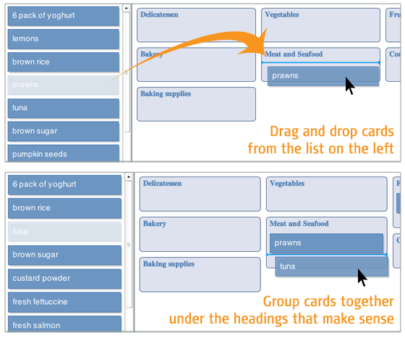

Easy enough? Time to get started!

**#3) CARD SORT**

**Topics areas:**

Home Loans

Saving Energy & Going Green

Home Improvement

Credit & Loans

Dealing With Debt

Shopping & Saving

Resolving Problems

Buying & Owning A Car

**Cards:**

Your Access to Free Credit Reports

Buying a Used Car

10 Things You Can Do to Avoid Fraud

Looking for the Best Mortgage

Shopping for a Home Equity Loan

Mortgage Relief Scams

Sorting Out 'Green' Advertising Claims

Your Rights When Buying Funeral Goods and Services

Dealing with Debt Collectors

Tips on Heating Your Home

Understanding Vehicle Financing

Credit Repair: How To Help Yourself

Looking for the Best Mortgage

Solving Consumer Problems

Gas-Saving Products: Proceed with Caution

"Free Trials" Aren’t Always Free

Avoiding Credit and Charge Card Fraud

Payday Loans Are Costly

Negative Credit Can Squeeze a Job Search

Choosing a Credit Counselor

Shopping Tips: Is That Deal for Real?

Resolving Consumer Disputes: Mediation and Arbitration

Taking the Scare Out of Auto Repair

How to Buy an Energy-Efficient Home Appliance

After a Disaster: Repairing Your Home

Warranties for Newly Built Homes: Know Your Options

Reverse Mortgages: Get the Facts First

**#4) ALMOST FINISHED**

Were there any items that you had trouble sorting because you weren't sure what they were? If so, which ones?

*(check boxes)*

**#5) THANKS**

All done, awesome! Thanks again for your participation. Your feedback is incredibly useful in helping to determine how our content should be organized, so we can make our website easier to use.

You may now close this window or navigate to another web page.