Study to Explore Early Development

Date

Name
Address
Address

Dear Ms. Last Name:
The national Centers for Disease Control and Prevention is conducting the Study to Explore Early Development (SEED). SEED is one of the largest studies about child development and the causes of autism spectrum disorders. It is taking place in six sites in the United States. To make this study a success, we need children both with and without an autism spectrum disorder and their mothers to take part. We hope you will join us.
If you agree to take part in SEED, you will be interviewed over the telephone a couple of times about your child’s development and your health during your pregnancy with your child. After these interviews, we will ask you and your child to meet with our study staff in person, either at our study clinic or your home. We will evaluate your child’s development and complete several other study activities. A complete list of all study steps can be found in the enclosed brochure.
We know your time is valuable. We offer several incentives to thank you for your participation.
- If you contact us and answer a few questions to see if you and your child qualify for SEED, we will send you a $10 gift card even if you decide not to take part in SEED.
- If you do agree to take part, you will receive additional gift cards for each of the study steps.
- If you complete all parts of the study you will receive $200 in total.
- You will also receive the results of your child’s developmental evaluation.

All parts of the study are voluntary. If you enroll in SEED we ask you to do as much as you can. But, you can choose to do some parts and not others. Please know that any information that you give us about you or your child will be kept private. Only SEED staff will be able to look at any information you give us.
Please contact us to learn more about SEED. You can mark the “yes” box on the enclosed reply card and mail it back to us. You can also call us at 404-498-0058, or email us at gaseed@cdc.gov. If you email us, please be sure to provide your name and information on how we can contact you. If you return the reply card with a “no” response, you will not be contacted again. If we do not hear from you in 14 days and a recent phone number is available for you, someone from our staff will try to call you to make sure you received this information.

Thousands of families are taking part in this national study. We hope you will help us with this important research. Thank you for considering this request.

Sincerely yours,
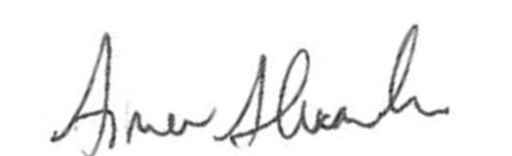

AimAimee Anido-Alexander
Project Coordinator
Centers for Disease Control and Prevention

