_______________________________________

OBSSR Card Sort
Screen-by-Screen

OMB No.: 0925-0648
Exp. Date: 1/31/2015

Public reporting burden for this collection of information is estimated to average 10 minutes per response, including the time for reviewing instructions, searching existing data sources, gathering and maintaining the data needed, and completing and reviewing the collection of information. An agency may not conduct or sponsor, and a person is not required to respond to, a collection of information unless it displays a currently valid OMB control number. Send comments regarding this burden estimate or any other aspect of this collection of information, including suggestions for reducing this burden, to: NIH, Project Clearance Branch, 6705 Rockledge Drive, MSC 7974, Bethesda, MD 20892-7974, ATTN: PRA (0925-0684). Do not return the completed form to this address.

#1) WELCOME
Thanks for be willing to participate in our usability feedback survey! We greatly appreciate your participation and we thank you in advance for your time.
Your responses will help us organize the content of our website. Find out how on the next page...

#2) INSTRUCTIONS
Your task is to organize a list of items into groups that make sense to you.
On the next screen you'll see the list of items. Grouping them is easy (and maybe a bit of fun):
- Click on an item from the list on the left
- Drag it into the category it most closely matches
- Repeat for all of the items
This is what it will look like:
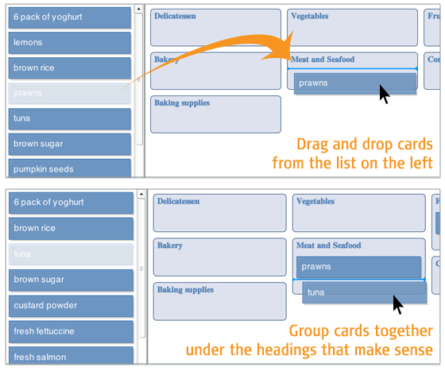
Remember, there are no wrong answers because we aren’t testing you. We’re just learning from you so we can make our website better and easier to use.
Easy enough? Time to get started!

#3) CARD SORT

Categories:
Funding
Scientific Areas
Education and Training
News and Events
About OBSSR

Cards:

Our History
Our Mission
Strategic Planning
BSSR Coordinating Committee
Staff Directory
Publications
Types of funding
Funding Opportunity Announcements
Apply for Grants
FAQs
Guide to Grants Newsletter
Biopsychosocial Interaction
Gene, behavior and environment
Health and Behavior
Scientific Methodology
Social and Cultural Factors
Lectures and Seminars
Lectures and Seminars
BSSR News
Press Releases
Videocast/Podcasts
Calendar of Events
Archive
Publications
Archive

Translation
Educational Programs
Training Institutes
#4) ALMOST FINISHED
Were there any items that you had trouble sorting because you weren't sure what they were? If so, which ones?

(open text field)

#5) THANKS
All done, awesome! Thanks again for your participation. Your feedback is incredibly helpful.
You may now close this window or navigate to another web page.

