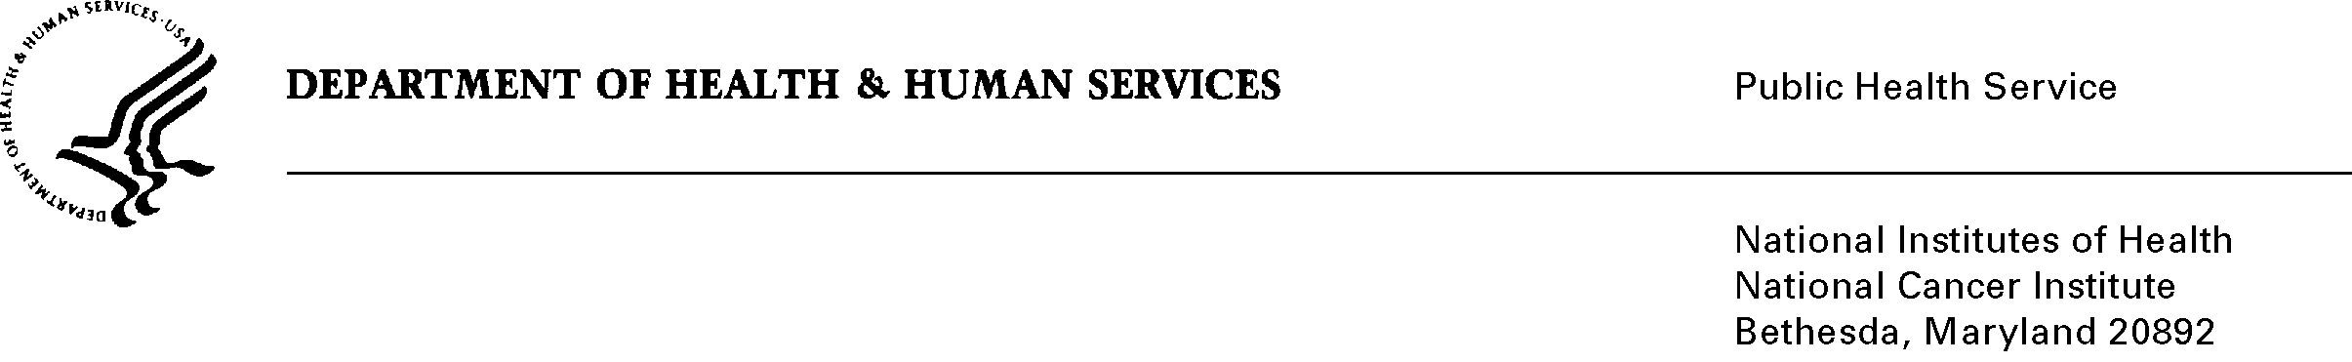
Date: November 22, 2011

TO: Office of Management and Budget (OMB)

Through: Mary Forbes, Reports Clearance Officer, HHS
Seleda Perryman, Program Clearance Officer, OPERA, NIH
Vivian Horovitch-Kelley, PRA OMB Project Clearance Liaison, OMAA, NCI

FROM: Michele M. Doody, Radiation Epidemiology Branch,
National Cancer Institute (NCI)/NIH

SUBJECT: Cancer Risk in U.S. Radiologic Technologists: Fourth Survey (NCI),
OMB No. 0925-0405, expiration 02/28/2011.

Though this is a “new” IC, it is unofficially a reinstatement with change of a previously approved collection (OMB No. 0925-0405, expired 02/28/2011). ROCIS could not accept a change in submission from a generic to non-generic type. For a more detailed explanation about the generic, refer to SSA, Section A.15.

By conducting a fourth cohort follow-up survey in an ongoing cohort study of U.S. Radiologic Technologists (USRT), updated information will be collected on cancer and other medical outcomes, personal medical radiation procedures, and other risk factors from all participants, plus detailed employment data from subgroups of participants who performed or assisted with fluoroscopically-guided or radioisotope procedures.

Researchers at the National Cancer Institute and The University of Minnesota have followed a nationwide cohort of 146,000 radiologic technologists since 1982, of whom 110,000 completed at least one of three prior questionnaire surveys and 23,454 are deceased. This cohort is unique because estimates of cumulative radiation dose to specific organs (e.g. breast) are available and the cohort is largely female, offering a rare opportunity to study effects of low-dose radiation exposure on breast and thyroid cancers, the two most sensitive organ sites for radiation carcinogenesis in women.

The fourth survey will be administered by mail to approximately 93,000 living and located cohort members who completed at least one of the three previous surveys to collect information on new cancers and other disease outcomes, detailed work patterns and practices from technologists who worked with radioisotopes and interventional radiography procedures, and new or updated risk factors that may influence health risks. New occupational and medical radiation exposure information will be used to improve radiation dose estimates.

