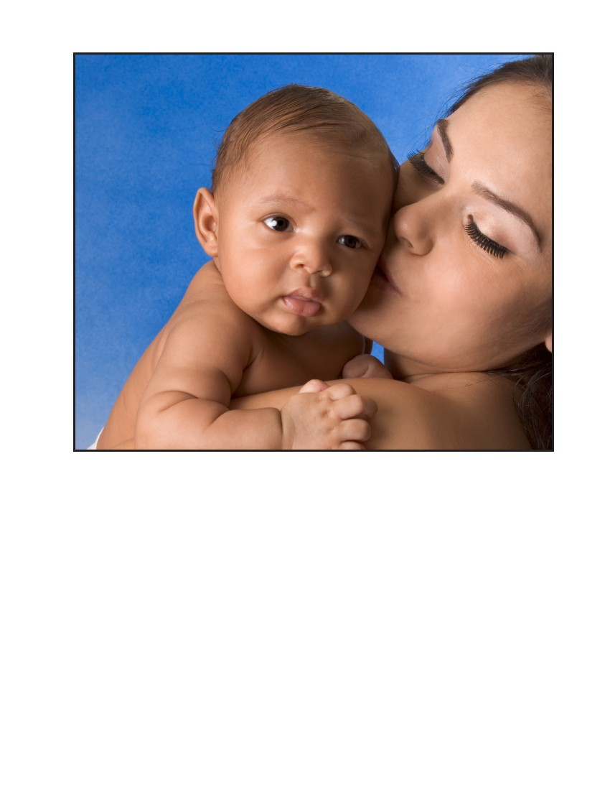
Breast feeding Research Study
We are looking for breast feeding mothers with a one month
old baby to participate in a research study.
• Mothers will be asked to answer a brief survey and provide breast
milk samples collected in their home up to 4 times.
• All participating mothers will receive a cash incentive to thank them for their time.
Call 813-396-9577 or look for our study staff at the clinic.

