1. Link to the LEARS Handbook added to the first screen after the EBSS Log-in.

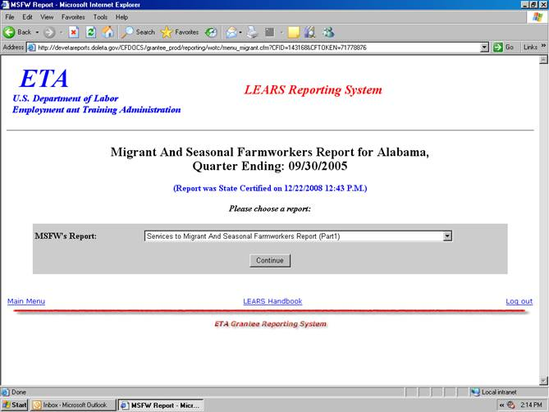

2. Update to the OMB Expiration Date to 01-31-2009
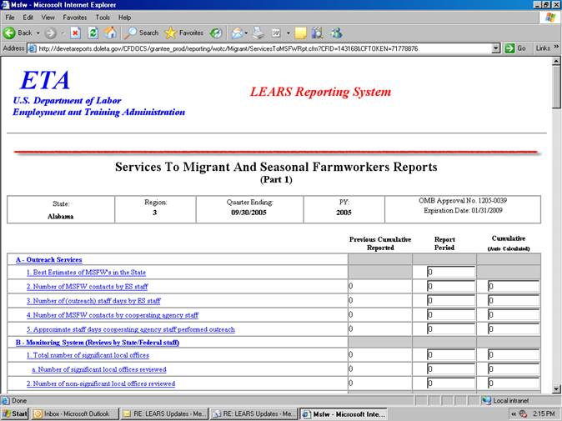

3. Public Burden Statement was already on Part 1.

