Appendix 20: Online Survey Introductory Pages Screenshots
Screenshot of Survey Entry Page Requiring Awardee/Center Unique PIN

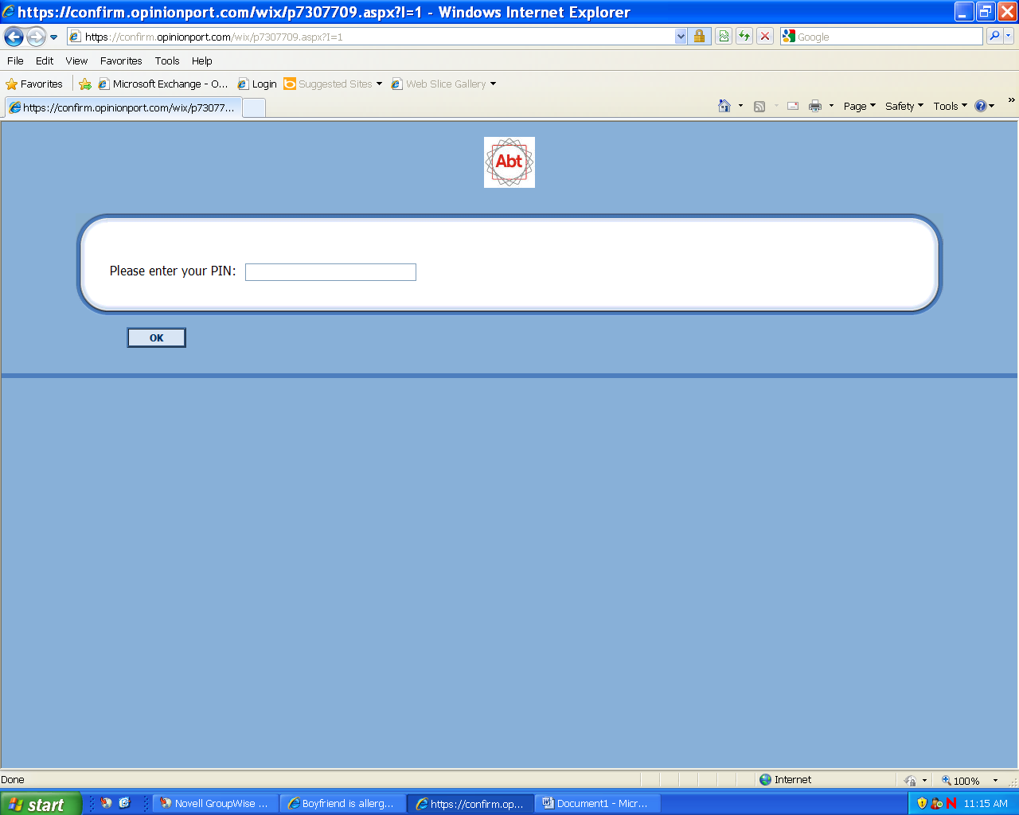

Screenshot of Participation Agreement Template

