Instruments for the Michigan State University Extension Impact Evaluation

Administered First OMB No. 0584-0554
◻ MSUE Expiration date: XX/XX/20XX
◻ RTI See OMB statement on inside cover
Pre-Survey: Intervention and Control Groups

Survey on What You Eat



Thank you for taking part in this important study!

Public reporting burden for this collection of information is estimated to average 15 minutes per response, including the time for reviewing instructions, searching existing data sources, gathering and maintaining the data needed, and completing and reviewing the collection of information.

An agency may not conduct or sponsor, and a person is not required to respond to, a collection of information unless it displays a currently valid OMB control number.

Send comments regarding this burden estimate or any other aspect of this collection of information, including suggestions for reducing this burden, to: U.S. Department of Agriculture, Food and Nutrition Services, Office of Research and Analysis, Room 1014, Alexandria, VA 22302 ATTN: PRA (0584-0554). Do not return the completed form to this address.

If you have questions regarding your rights as a research participant, you may contact RTI’s Office of Research Protection toll-free at 866-214-2043.

This survey asks about what you eat. This study is being sponsored by the U.S. Department of Agriculture’s Food & Nutrition Service and conducted by RTI International, a non-profit research organization. The survey will take about 15 minutes to complete. You will receive $10 for completing this survey and $15 for filling out the second survey in about a month.
All of your answers to the survey will be kept private. We will not share your answers with anyone, except as otherwise required by law. You may skip any questions you do not want to answer. If you have any questions, please call Matthew Bensen at RTI International at
1-866-800-9176.

Questions on Whether Certain Foods Are Available at Home
- Were any of these foods in your home during the past week? Include fresh, frozen, canned, and dried foods. (Circle Yes or No for each food.)
a. Bananas | Yes | No
b. Apples | Yes | No
c. Grapes | Yes | No
d. Oranges | Yes | No
e. Melons | Yes | No
f. Raisins or prunes | Yes | No
g. Carrots | Yes | No
h. Celery | Yes | No
i. Broccoli | Yes | No
j. Potato chips, tortilla chips, corn chips, or other chips | Yes | No
k. Regular soft drinks or sodas | Yes | No

Questions on the Fruits and Vegetables You Eat
For the next questions, think about what you ate during the past week, or the past 7 days. Do NOT tell us what you think you should eat or what you usually eat.
- How many days during the past week did you eat fruit or vegetables as snacks or between meals? Do NOT include juice. (Circle one.)
1. None
2. 1 to 2 days
3. 3 to 4 days
4. 5 to 6 days
5. Every day
- How many days during the past week did you eat more than one kind of fruit each day? Do NOT include fruit juice. (Circle one.)
1. None
2. 1 to 2 days
3. 3 to 4 days
4. 5 to 6 days
5. Every day
- Think about what you ate during the past week. About how many cups of fruit did you eat on a typical day? Do NOT include fruit juice. (Circle one.)
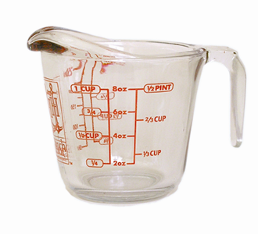  None | 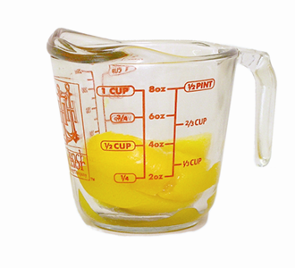  ½ cup |  | 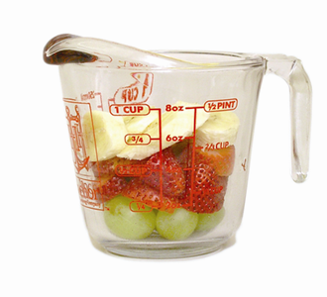  1 cup
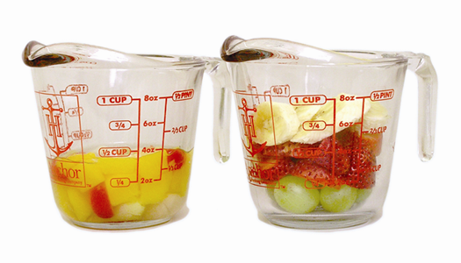  1½ cups |  | 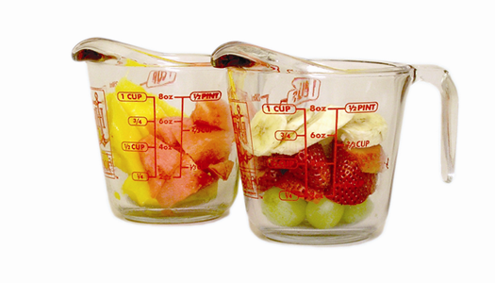  2 cups
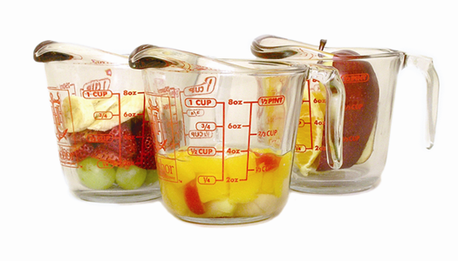  2½ cups |  | 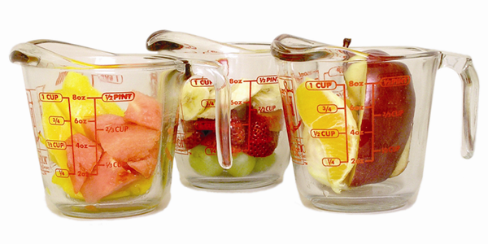  3 cups or more

Note: Graphics courtesy of Dr. Marilyn Townsend and Kathryn Sylva, University of California, Davis.
- How many days during the past week did you eat more than one kind of vegetable each day? Do NOT include white potatoes, French fries, or vegetable juice. (Circle one.)
1. None
2. 1 to 2 days
3. 3 to 4 days
4. 5 to 6 days
5. Every day
- Think about what you ate during the past week. About how many cups of vegetables did you eat on a typical day? Do NOT include white potatoes, French fries, or vegetable juice. (Circle one.)
None | 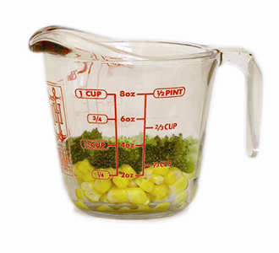  ½ cup |  | 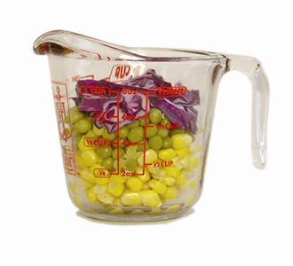  1 cup
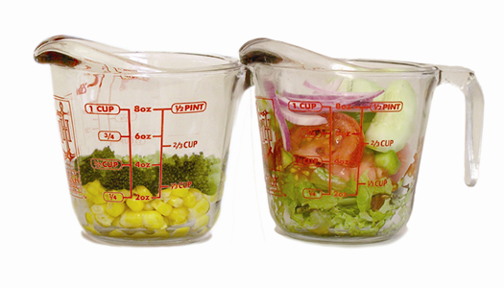  1½ cups |  | 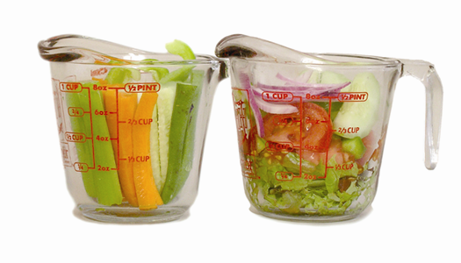  2 cups
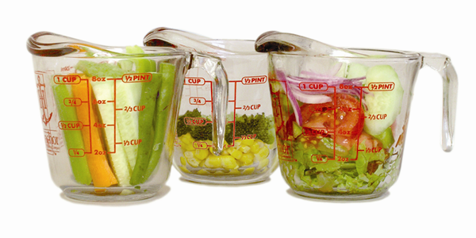  2½ cups |  | 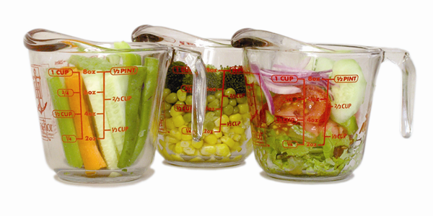  3 cups or more
Note: Graphics courtesy of Dr. Marilyn Townsend and Kathryn Sylva, University of California, Davis.

Questions on Your Shopping, Meal Preparation, and Eating Habits
- How strongly do you agree or disagree with each statement? (Circle one for each statement.)
a. I usually eat at least one fruit or vegetable at each meal. | Strongly agree | Agree | Disagree | Strongly disagree
b. I usually eat fruit for dessert instead of having cookies, cake, pie, or ice cream. | Strongly agree | Agree | Disagree | Strongly disagree
- During the past week, how many days did you eat lunch at home? (Circle one.)
1. None [Go to Question 10]
2. 1 to 2 days
3. 3 to 4 days
4. 5 to 6 days
5. Every day
- Who usually prepares MOST of the lunches you eat at home? (Circle one.)
1. I do
2. My spouse
3. Other person
4. Lunches are usually delivered (for example, Meals on Wheels)
- During the past week, how many days did you eat your evening meal (dinner or supper) at home? (Circle one.)
1. None [Go to Question 12]
2. 1 to 2 days
3. 3 to 4 days
4. 5 to 6 days
5. Every day
- Who usually prepares MOST of the evening meals you eat at home? (Circle one.)
1. I do
2. My spouse
3. Other person
4. Meals are usually delivered (for example, Meals on Wheels)
- How many days during the past week did you eat your evening meal with the TV on? (Circle one.)
1. None
2. 1 to 2 days
3. 3 to 4 days
4. 5 to 6 days
5. Every day
- Who usually does MOST of the grocery shopping in your household? (Circle one.)
1. I do by myself or with another person
2. My spouse
3. Other person
4. All meals are prepared outside the home so no one in the household shops for groceries [Go to Question 15]
- How strongly do you agree or disagree with each of these statements? (Circle one for each statement.)
a. It is easy to buy fresh fruits or vegetables where I live. | Strongly agree | Agree | Disagree | Strongly disagree
b. There is a large selection of fresh fruits or vegetables where I live. | Strongly agree | Agree | Disagree | Strongly disagree
c. I do not usually buy fresh fruits or vegetables because they spoil quickly. | Strongly agree | Agree | Disagree | Strongly disagree
d. I sometimes ask friends or family members to help me shop for food. | Strongly agree | Agree | Disagree | Strongly disagree
e. I can afford fruits or vegetables in the store where I shop for most of my food. | Strongly agree | Agree | Disagree | Strongly disagree
f. Buying more fruits or vegetables than I do already would be hard on my budget. | Strongly agree | Agree | Disagree | Strongly disagree
g. I add fruits or vegetables as ingredients to the meals I make to help me eat more fruits or vegetables. | Strongly agree | Agree | Disagree | Strongly disagree
Questions about You and Your Household
- From which of these programs did you get food or food assistance during the past four weeks? (Circle all that apply.)
1. Food Stamp Program—gives Bridge cards or EBT cards to help people buy food
2. Food Commodity Program—offers food packages to some older adults
3. Senior Project Fresh—gives some older adults coupons that can be used to get food at farmers’ markets, roadside stands, and other places
4. Food bank or pantry
5. Other (Describe):
6. None of the above
- Does anyone in your household currently get Women, Infants, and Children (WIC) program benefits? (Circle one.)
1. No
2. Yes
- During the past four weeks, how did you get to the store to buy food? (Circle all that apply.)
1. Drove myself
2. Family member or friend drove me
3. Used public transportation
4. Walked
5. Used community van service
6. Other (Describe):
7. Did not go to store to buy food
- During the past year, did you go to classes or workshops on any of these topics? (Circle all that apply.)
1. Food safety
2. Exercise
3. Nutrition
4. Diabetes
5. Other (Describe):
6. None of the above
- In general, would you say your health is …? (Circle one.)
1. Poor
2. Fair
3. Good
4. Very good
5. Excellent
- What is your gender? (Circle one.)
1. Male
2. Female
- How many people under 18 years of age live in your household?
____
- Including yourself, how many people 18 years of age or older live in your household?
____
- What is your age? (Circle one.)
1. Less than 60
2. 60 to 64
3. 65 to 69
4. 70 to 74
5. 75 to 80
6. 81 to 90
7. 91 or older
Please answer the next two questions about your ethnicity and race.
- What is your ethnicity? (Circle one.)
1. Hispanic or Latino
2. Not Hispanic or Latino
- What is your race? (Circle one or more.)
1. American Indian or Alaska Native
2. Asian
3. Black or African American
4. Native Hawaiian or other Pacific Islander
5. White
- What is the highest level of school you completed? (Circle one.)
1. Did not complete high school
2. High school graduate or GED
3. Some college or 2-year degree
4. College degree or higher
- What is your marital status? (Circle one.)
1. Married or living with a partner
2. Separated or divorced
3. Widowed
4. Never married
- Which of the following best describes your work status? (Circle one.)
1. Employed full time
2. Employed part time
3. Unemployed
4. Retired
5. Disabled
6. A student
7. A homemaker
8. Other (Describe):________________________________

Thank you for completing our survey.
We appreciate your time and opinions.
OMB No. 0584-0554
Expiration date: XX/XX/20XX
See OMB statement on inside cover
Post-Survey: Intervention Group

Survey on What You Eat

Thank you for taking part in this important study!

Please fill out and return the survey in the enclosed envelope within the next week. If you have any questions about the Survey on What You Eat, please send an e-mail to USDA@sna.rti.org or call toll-free
at 1-866-800-9176.

Public reporting burden for this collection of information is estimated to average 15 minutes per response, including the time for reviewing instructions, searching existing data sources, gathering and maintaining the data needed, and completing and reviewing the collection of information.

An agency may not conduct or sponsor, and a person is not required to respond to, a collection of information unless it displays a currently valid OMB control number.

Send comments regarding this burden estimate or any other aspect of this collection of information, including suggestions for reducing this burden, to: U.S. Department of Agriculture, Food and Nutrition Services, Office of Research and Analysis, Room 1014, Alexandria, VA 22302 ATTN: PRA (0584-0554). Do not return the completed form to this address.

If you have questions regarding your rights as a research participant, you may contact RTI’s Office of Research Protection toll-free at 866-214-2043.
This survey asks about what you eat. You may recall that we asked some of the same questions in the last survey. This study is being sponsored by the U.S. Department of Agriculture’s Food & Nutrition Service and conducted by RTI International, a non-profit research organization. The survey will take about 15 minutes to complete. You will receive $15 for completing this survey.
All of your answers to the survey will be kept private. We will not share your answers with anyone, except as otherwise required by law. You may skip any questions you do not want to answer. If you have any questions, please call Matthew Bensen at RTI International at
1-866-800-9176.
Questions on Whether Certain Foods Are Available
- Were any of these foods in your home during the past week? Include fresh, frozen, canned, and dried foods. (Circle Yes or No for each food.)
a. Bananas | Yes | No
b. Apples | Yes | No
c. Grapes | Yes | No
d. Oranges | Yes | No
e. Melons | Yes | No
f. Raisins or prunes | Yes | No
g. Carrots | Yes | No
h. Celery | Yes | No
i. Broccoli | Yes | No
j. Potato chips, tortilla chips, corn chips, or other chips | Yes | No
k. Regular soft drinks or sodas | Yes | No

Questions on the Fruits and Vegetables You Eat
For the next questions, think about what you ate during the past week, or the past 7 days. Do NOT tell us what you think you should eat or what you usually eat.
- How many days during the past week did you eat fruit or vegetables as snacks or between meals? Do NOT include juice. (Circle one.)
1. None
2. 1 to 2 days
3. 3 to 4 days
4. 5 to 6 days
5. Every day
- How many days during the past week did you eat more than one kind of fruit each day? Do NOT include fruit juice. (Circle one.)
1. None
2. 1 to 2 days
3. 3 to 4 days
4. 5 to 6 days
5. Every day
- Think about what you ate during the past week. About how many cups of fruit did you eat on a typical day? Do NOT include fruit juice. (Circle one.)
None | ½ cup |  | 1 cup
1½ cups |  | 2 cups
2½ cups |  | 3 cups or more

Note: Graphics courtesy of Dr. Marilyn Townsend and Kathryn Sylva, University of California, Davis.
- How many days during the past week did you eat more than one kind of vegetable each day? Do NOT include white potatoes, French fries, or vegetable juice. (Circle one.)
1. None
2. 1 to 2 days
3. 3 to 4 days
4. 5 to 6 days
5. Every day
- Think about what you ate during the past week. About how many cups of vegetables did you eat on a typical day? Do NOT include white potatoes, French fries, or vegetable juice. (Circle one.)
None | ½ cup |  | 1 cup
1½ cups |  | 2 cups
2½ cups |  | 3 cups or more

Note: Graphics courtesy of Dr. Marilyn Townsend and Kathryn Sylva, University of California, Davis.
Questions on Your Shopping, Meal Preparation, and Eating Habits
- How strongly do you agree or disagree with each statement? (Circle one for each statement.)
a. I usually eat at least one fruit or vegetable at each meal. | Strongly agree | Agree | Disagree | Strongly disagree
b. I usually eat fruit for dessert instead of having cookies, cake, pie, or ice cream. | Strongly agree | Agree | Disagree | Strongly disagree
- During the past week, how many days did you eat lunch at home? (Circle one.)
1. None [Go to Question 10]
2. 1 to 2 days
3. 3 to 4 days
4. 5 to 6 days
5. Every day
- Who usually prepares MOST of the lunches you eat at home? (Circle one.)
1. I do
2. My spouse
3. Other person
4. Lunches are usually delivered (for example, Meals on Wheels)
- During the past week, how many days did you eat your evening meal (dinner or supper) at home? (Circle one.)
1. None [Go to Question 12]
2. 1 to 2 days
3. 3 to 4 days
4. 5 to 6 days
5. Every day
- Who usually prepares MOST of the evening meals you eat at home? (Circle one.)
1. I do
2. My spouse
3. Other person
4. Meals are usually delivered (for example, Meals on Wheels)
- How many days during the past week did you eat your evening meal with the TV on? (Circle one.)
1. None
2. 1 to 2 days
3. 3 to 4 days
4. 5 to 6 days
5. Every day
- Who usually does MOST of the grocery shopping in your household? (Circle one.)
1. I do by myself or with another person
2. My spouse
3. Other person
4. All meals are prepared outside the home so no one in the household shops for groceries [Go to Question 15]
- How strongly do you agree or disagree with each of these statements? (Circle one for each statement.)
a. It is easy to buy fresh fruits or vegetables where I live. | Strongly agree | Agree | Disagree | Strongly disagree
b. There is a large selection of fresh fruits or vegetables where I live. | Strongly agree | Agree | Disagree | Strongly disagree
c. I do not usually buy fresh fruits or vegetables because they spoil quickly. | Strongly agree | Agree | Disagree | Strongly disagree
d. I sometimes ask friends or family members to help me shop for food. | Strongly agree | Agree | Disagree | Strongly disagree
e. I can afford fruits or vegetables in the store where I shop for most of my food. | Strongly agree | Agree | Disagree | Strongly disagree
f. Buying more fruits or vegetables than I do already would be hard on my budget. | Strongly agree | Agree | Disagree | Strongly disagree
g. I add fruits or vegetables as ingredients to the meals I make to help me eat more fruits or vegetables. | Strongly agree | Agree | Disagree | Strongly disagree
Questions on the “Eat Smart, Live Strong” program
- How did you hear about the “Eat Smart, Live Strong” program? (Circle all that apply.)
1. Friend or relative
2. Senior center
3. County Assistance Office
4. Place of worship
5. Doctor, nurse, or other health care provider
6. Other (Describe):
7. Don’t remember
- Why did you sign up for the “Eat Smart, Live Strong” program? (Circle all that apply.)
1. To lose weight
2. To eat healthier foods
3. To improve my health
4. To cook healthier foods for me and/or my family
5. To manage my food budget better
6. To exercise more
7. Other reason (Describe):
- The “Eat Smart, Live Strong” program had six sessions. How many sessions did you go to? (Circle all that apply.)
1. None [Go to Question 24]
2. One
3. Two
4. Three
5. Four
6. Five
7. Six [Go to Question 19]
8. Don’t remember
- Why didn’t you go to all of the sessions? (Circle all that apply.)
1. The sessions were not useful
2. The sessions were not interesting
3. The sessions were hard to understand
4. It was hard to get to the sessions
5. The sessions were too long
6. I was too busy with other things, like hobbies or family
7. I did not feel well enough
8. Other reason (Describe):
- How strongly do you agree or disagree with this statement? “The information I learned at the sessions helped me to eat more fruits or vegetables.” (Circle one.)
1. Strongly agree
2. Agree
3. Disagree
4. Strongly disagree
- At the end of each session, you got a sheet that asked you to set goals and to track how much fruits or vegetables you ate each day. How many sheets did you fill out? (Circle one.)
1. None [Go to Question 22]
2. One
3. Two
4. Three
5. Four
6. Don’t remember
- How strongly do you agree or disagree with this statement? “Filling out the sheets helped me to eat more fruits or vegetables.” (Circle one.)
1. Strongly agree
2. Agree
3. Disagree
4. Strongly disagree
- Now that you have finished the “Eat Smart, Live Strong” program, how likely are you to start or keep eating more fruits or vegetables each day? (Circle one.)
1. Not at all likely
2. Not very likely
3. Somewhat likely
4. Likely
5. Very likely
- Please share any comments on the “Eat Smart, Live Strong” program. [Then Go to Question 25]

- Why didn’t you go to any of the sessions? (Circle all that apply.)
1. I changed my mind
2. It would have been hard for me to get to the sessions
3. I was too busy with other things, like hobbies or family
4. I got sick or had to go to the hospital
5. Other reason (Describe):
Questions about You
- During the past four weeks, did you see your doctor or other health care provider? (Circle one.)
1. No [Go to Question 27]
2. Yes
- During the past four weeks, did you talk with your doctor or other health care provider about any of these topics? (Circle all that apply.)
1. Why it is important to eat more fruits or vegetables each day
2. Fruits or vegetables I should not eat
3. Why it is important to get more exercise each day
4. Precautions to take during exercise
5. None of the above
- During the past four weeks, did you talk with friends or family about any of these topics? (Circle all that apply.)
1. How to eat more fruits or vegetables each day
2. How to get more exercise each day
3. What I learned from the “Eat Smart, Live Strong” program
4. None of the above

Thank you for completing our survey.
Please return the survey to RTI in the enclosed envelope.
If you have misplaced the envelope, call 1-866-800-9176
for a replacement or mail the survey to
RTI INTERNATIONAL
ATTN: Data Capture (0212343.001.008.002)
PO Box 12194
Research Triangle Park, NC 27709-9779
OMB No. 0584-0554
Expiration date: XX/XX/20XX
See OMB statement on inside cover
Post-Survey: Control Group

Survey on What You Eat

Thank you for taking part in this important study!

Please fill out and return the survey in the enclosed envelope within the next week. If you have any questions about the Survey on What You Eat, please send an e-mail to USDA@sna.rti.org or call toll-free
at 1-866-800-9176.

Public reporting burden for this collection of information is estimated to average 15 minutes per response, including the time for reviewing instructions, searching existing data sources, gathering and maintaining the data needed, and completing and reviewing the collection of information.

An agency may not conduct or sponsor, and a person is not required to respond to, a collection of information unless it displays a currently valid OMB control number.

Send comments regarding this burden estimate or any other aspect of this collection of information, including suggestions for reducing this burden, to: U.S. Department of Agriculture, Food and Nutrition Services, Office of Research and Analysis, Room 1014, Alexandria, VA 22302 ATTN: PRA (0584-0554). Do not return the completed form to this address.

If you have questions regarding your rights as a research participant, you may contact RTI’s Office of Research Protection toll-free at 866-214-2043.
This survey asks about what you eat. You may recall that we asked some of the same questions in the last survey. This study is being sponsored by the U.S. Department of Agriculture’s Food & Nutrition Service and conducted by RTI International, a non-profit research organization. The survey will take about 15 minutes to complete. You will receive $15 for completing this survey.
All of your answers to the survey will be kept private. We will not share your answers with anyone, except as otherwise required by law. You may skip any questions you do not want to answer. If you have any questions, please call Matthew Bensen at RTI International at
1-866-800-9176.
Questions on Whether Certain Foods Are Available at Home
- Were any of these foods in your home during the past week? Include fresh, frozen, canned, and dried foods. (Circle Yes or No for each food.)
a. Bananas | Yes | No
b. Apples | Yes | No
c. Grapes | Yes | No
d. Oranges | Yes | No
e. Melons | Yes | No
f. Raisins or prunes | Yes | No
g. Carrots | Yes | No
h. Celery | Yes | No
i. Broccoli | Yes | No
j. Potato chips, tortilla chips, corn chips, or other chips | Yes | No
k. Regular soft drinks or sodas | Yes | No

Questions on the Fruits and Vegetables You Eat
For the next questions, think about what you ate during the past week, or the past 7 days. Do NOT tell us what you think you should eat or what you usually eat.
- How many days during the past week did you eat fruit or vegetables as snacks or between meals? Do NOT include juice. (Circle one.)
1. None
2. 1 to 2 days
3. 3 to 4 days
4. 5 to 6 days
5. Every day
- How many days during the past week did you eat more than one kind of fruit each day? Do NOT include fruit juice. (Circle one.)
1. None
2. 1 to 2 days
3. 3 to 4 days
4. 5 to 6 days
5. Every day
- Think about what you ate during the past week. About how many cups of fruit did you eat on a typical day? Do NOT include fruit juice. (Circle one.)
None | ½ cup |  | 1 cup
1½ cups |  | 2 cups
2½ cups |  | 3 cups or more

Note: Graphics courtesy of Dr. Marilyn Townsend and Kathryn Sylva, University of California, Davis.
- How many days during the past week did you eat more than one kind of vegetable each day? Do NOT include white potatoes, French fries, or vegetable juice. (Circle one.)
1. None
2. 1 to 2 days
3. 3 to 4 days
4. 5 to 6 days
5. Every day
- Think about what you ate during the past week. About how many cups of vegetables did you eat on a typical day? Do NOT include white potatoes, French fries, or vegetable juice. (Circle one.)
None | ½ cup |  | 1 cup
1½ cups |  | 2 cups
2½ cups |  | 3 cups or more

Note: Graphics courtesy of Dr. Marilyn Townsend and Kathryn Sylva, University of California, Davis.
Questions on Your Shopping, Meal Preparation, and Eating Habits
- How strongly do you agree or disagree with each statement? (Circle one for each statement.)
a. I usually eat at least one fruit or vegetable at each meal. | Strongly agree | Agree | Disagree | Strongly disagree
b. I usually eat fruit for dessert instead of having cookies, cake, pie, or ice cream. | Strongly agree | Agree | Disagree | Strongly disagree
- During the past week, how many days did you eat lunch at home? (Circle one.)
1. None [Go to Question 10]
2. 1 to 2 days
3. 3 to 4 days
4. 5 to 6 days
5. Every day
- Who usually prepares MOST of the lunches you eat at home? (Circle one.)
1. I do
2. My spouse
3. Other person
4. Lunches are usually delivered (for example, Meals on Wheels)
- During the past week, how many days did you eat your evening meal (dinner or supper) at home? (Circle one.)
1. None [Go to Question 12]
2. 1 to 2 days
3. 3 to 4 days
4. 5 to 6 days
5. Every day
- Who usually prepares MOST of the evening meals you eat at home? (Circle one.)
1. I do
2. My spouse
3. Other person
4. Meals are usually delivered (for example, Meals on Wheels)
- How many days during the past week did you eat your evening meal with the TV on? (Circle one.)
1. None
2. 1 to 2 days
3. 3 to 4 days
4. 5 to 6 days
5. Every day
- Who usually does MOST of the grocery shopping in your household? (Circle one.)
1. I do by myself or with another person
2. My spouse
3. Other person
4. All meals are prepared outside the home so no one in the household shops for groceries [Go to Question 15]
- How strongly do you agree or disagree with each of these statements? (Circle one for each statement.)
a. It is easy to buy fresh fruits or vegetables where I live. | Strongly agree | Agree | Disagree | Strongly disagree
b. There is a large selection of fresh fruits or vegetables where I live. | Strongly agree | Agree | Disagree | Strongly disagree
c. I do not usually buy fresh fruits or vegetables because they spoil quickly. | Strongly agree | Agree | Disagree | Strongly disagree
d. I sometimes ask friends or family members to help me shop for food. | Strongly agree | Agree | Disagree | Strongly disagree
e. I can afford fruits or vegetables in the store where I shop for most of my food. | Strongly agree | Agree | Disagree | Strongly disagree
f. Buying more fruits or vegetables than I do already would be hard on my budget. | Strongly agree | Agree | Disagree | Strongly disagree
g. I add fruits or vegetables as ingredients to the meals I make to help me eat more fruits or vegetables. | Strongly agree | Agree | Disagree | Strongly disagree
Questions about You
- During the past four weeks, did you see your doctor or other health care provider? (Circle one.)
1. No [Go to Question 17]
2. Yes
- During the past four weeks, did you talk with your doctor or other health care provider about any of these topics? (Circle all that apply.)
1. Why it is important to eat more fruits or vegetables each day
2. Fruits or vegetables I should not eat
3. Why it is important to get more exercise each day
4. Precautions to take during exercise
5. None of the above
- During the past four weeks, did you talk with friends or family about any of these topics? (Circle all that apply.)
1. How to eat more fruits or vegetables each day
2. How to get more exercise each day
3. What I learned from attending nutrition education classes
4. None of the above

Thank you for completing our survey.
Please return the survey to RTI in the enclosed envelope.
If you have misplaced the envelope, call 1-866-800-9176
for a replacement or mail the survey to
RTI INTERNATIONAL
ATTN: Data Capture (0212343.001.008.002)
PO Box 12194
Research Triangle Park, NC 27709-9779

OMB No. 0584-0554
Expiration date: XX/XX/20XX

Survey on What You Eat
Telephone Questionnaire for Nonrespondents to Mail Survey
(Post-Survey, Intervention and Control Groups)
Instrument for MSUE Impact Evaluation

- To begin the survey, I’m going to read a list of foods. For each food, please tell me if it was available in your home during the past week. Please include fresh, frozen, canned, and dried foods. Answer yes or no for each food. The first food is…
a. Bananas | YES | NO | DK | RF
b. Apples | YES | NO | DK | RF
c. Grapes | YES | NO | DK | RF
d. Oranges | YES | NO | DK | RF
e. Melons | YES | NO | DK | RF
f. Raisins or prunes | YES | NO | DK | RF
g. Carrots | YES | NO | DK | RF
h. Celery | YES | NO | DK | RF
i. Broccoli | YES | NO | DK | RF
j. Potato chips, tortilla chips, corn chips, or other chips | YES | NO | DK | RF
k. Regular soft drinks or sodas | YES | NO | DK | RF

For the next questions, think about what you ate during the past week, or the past 7 days. Do not tell us what you think you should eat.
- How many days during the past week did you eat fruit or vegetables as snacks or between meals? Do not include juice. Would you say…? SELECT ONE.
1. None
2. 1 to 2 days
3. 3 to 4 days
4. 5 to 6 days, or
5. Every day
-4. DON’T KNOW
-7. REFUSAL
- How many days during the past week did you eat more than one kind of fruit each day? Do not include fruit juice. Would you say…? SELECT ONE.
1. None
2. 1 to 2 days
3. 3 to 4 days
4. 5 to 6 days, or
5. Every day
-4. DON’T KNOW
-7. REFUSAL
- Think about what you ate during the past week. About how many cups of fruit did you eat on a typical day? Do not include fruit juice. Would you say you had…? SELECT ONE.
1. No fruit
2. ½ cup
3. 1 cup
4. 1 ½ cups
5. 2 cups
6. 2 ½ cups, or
7. 3 cups or more
-4. DON’T KNOW
-7. REFUSAL
- How many days during the past week did you eat more than one kind of vegetable each day? Do not include white potatoes, French fries, or vegetable juice. Would you say…? SELECT ONE.
1. None
2. 1 to 2 days
3. 3 to 4 days
4. 5 to 6 days, or
5. Every day
-4. DON’T KNOW
-7. REFUSAL
- Think about what you ate during the past week. About how many cups of vegetables did you eat on a typical day? Do not include white potatoes, French fries, or vegetable juice. Would you say you had…? SELECT ONE.
1. No vegetables
2. ½ cup
3. 1 cup
4. 1 ½ cups
5. 2 cups
6. 2 ½ cups, or
7. 3 cups or more
-4. DON’T KNOW
-7. REFUSAL
- For the next two questions, I’m going to read you a statement. For each statement, please tell me whether you strongly agree, agree, disagree, or strongly disagree with the statement. The first/next statement is… How strongly do you agree or disagree with this statement? SELECT ONE FOR EACH STATEMENT.
a. I usually eat at least one fruit or vegetable at each meal. | Strongly agree | Agree | Disagree | Strongly disagree | DK | RF
b. I usually eat fruit for dessert instead of having cookies, cake, pie, or ice cream. | Strongly agree | Agree | Disagree | Strongly disagree | DK | RF
- During the past week, how many days did you eat lunch at home? Would you say…? SELECT ONE.
1. None [Go to Question 10]
2. 1 to 2 days
3. 3 to 4 days
4. 5 to 6 days, or
5. Every day
-4. DON’T KNOW
-7. REFUSAL
- Who usually prepares most of the lunches you eat at home? Would you say…? SELECT ONE.
1. You do
2. Your spouse does
3. Another person does, or that
4. Lunches are usually delivered, for example, Meals on Wheels
-4. DON’T KNOW
-7. REFUSAL
- During the past week, how many days did you eat your evening meal, that is, dinner or supper, at home? Would you say…? SELECT ONE.
1. None [Go to Question 12]
2. 1 to 2 days
3. 3 to 4 days
4. 5 to 6 days, or
5. Every day
-4. DON’T KNOW
-7. REFUSAL
- Who usually prepares most of the evening meals you eat at home? Would you say…? SELECT ONE.
1. You do
2. Your spouse does
3. Another person does, or that
4. Your meals are usually delivered, for example, Meals on Wheels
-4. DON’T KNOW
-7. REFUSAL
- How many days during the past week did you eat your evening meal with the TV on? Would you say…? SELECT ONE.
1. None
2. 1 to 2 days
3. 3 to 4 days
4. 5 to 6 days, or that
5. Every day
-4. DON’T KNOW
-7. REFUSAL
- Who usually does most of the grocery shopping in your household? Would you say…? SELECT ONE.
1. You do by yourself or with another person
2. Your spouse
3. Another person, or
4. All meals are prepared outside the home so no one in the household shops for groceries [Go to Question 15]
-4. DON’T KNOW
-7. REFUSAL
- For the next few questions, I’m going to read you a statement. For each statement, please tell me whether you strongly agree, agree, disagree, or strongly disagree with the statement.
The first/next statement is… How strongly do you agree or disagree with this statement? Would you say strongly agree, agree, disagree, or strongly disagree? SELECT ONE FOR EACH STATEMENT. REPEAT AFTER EVERY THIRD STATEMENT.
a. It is easy to buy fresh fruits or vegetables where I live. | Strongly agree | Agree | Disagree | Strongly disagree | DK | RF
b. There is a large selection of fresh fruits or vegetables where I live. | Strongly agree | Agree | Disagree | Strongly disagree | DK | RF
c. I do not usually buy fresh fruits or vegetables because they spoil quickly. | Strongly agree | Agree | Disagree | Strongly disagree | DK | RF
d. I sometimes ask friends or family members to help me shop for food. | Strongly agree | Agree | Disagree | Strongly disagree | DK | RF
e. I can afford fruits or vegetables in the store where I shop for most of my food. | Strongly agree | Agree | Disagree | Strongly disagree | DK | RF
f. Buying more fruits or vegetables than I do already would be hard on my budget. | Strongly agree | Agree | Disagree | Strongly disagree | DK | RF
g. I add fruits or vegetables as ingredients to the meals I make to help me eat more fruits or vegetables. | Strongly agree | Agree | Disagree | Strongly disagree | DK | RF

[IF CONTROL GROUP, GO TO Q25.]
The last set of questions asks about your opinions on the “Eat Smart, Live Strong” program.
- How did you hear about the “Eat Smart, Live Strong” program? You can select more than one answer. Did you hear about the program from…? SELECT ALL THAT APPLY.
1. Friend or relative
2. Senior center
3. County Assistance Office
4. Place of worship
5. Doctor, nurse, or other health care provider
6. Other (Describe):
7. DON’T REMEMBER
-4. DON’T KNOW
-7. REFUSAL
- Why did you sign up for the “Eat Smart, Live Strong” program? You can select more than one answer. Was it because you wanted …? SELECT ALL THAT APPLY.
1. To lose weight
2. To eat healthier foods
3. To improve your health
4. To cook healthier foods for you and/or your family
5. To manage your food budget better
6. To exercise more
7. Other (Describe):
-4. DON’T KNOW
-7. REFUSAL
- The “Eat Smart, Live Strong” program had six sessions. How many sessions did you go to? SELECT ONE.
1. NONE [Go to Question 24]
2. ONE
3. TWO
4. THREE
5. FOUR
6. FIVE
7. SIX [Go to Question 19]
8. DON’T REMEMBER
-4. DON’T KNOW
-7. REFUSAL
- Why didn’t you go to all of the sessions? Was it because…? SELECT ONE.
1. The sessions were not useful
2. The sessions were not interesting
3. The sessions were hard to understand
4. It was hard to get to the sessions
5. The sessions were too long
6. You were too busy with other things, like hobbies or family
7. You did not feel well enough, or
8. Some other reason (Describe):
-4. DON’T KNOW
-7. REFUSAL
- How strongly do you agree or disagree with this statement? “The information I learned at the sessions helped me to eat more fruits or vegetables.” Would you say…? SELECT ONE.
1. Strongly agree
2. Agree
3. Disagree, or
4. Strongly disagree
-4. DON’T KNOW
-7. REFUSAL
- At the end of each session, you got a sheet that asked you to set goals and to track how much fruits or vegetables you ate each day. How many sheets did you fill out? SELECT ONE.
1. NONE [Go to Question 22]
2. ONE
3. TWO
4. THREE
5. FOUR
6. DON’T REMEMBER
-4. DON’T KNOW
-7. REFUSAL
- How strongly do you agree or disagree with this statement? “Filling out the sheets helped me to eat more fruits or vegetables.” Would you say…? SELECT ONE.
1. Strongly agree
2. Agree
3. Disagree, or
4. Strongly disagree
-4. DON’T KNOW
-7. REFUSAL
- Now that you have finished the “Eat Smart, Live Strong” program, how likely are you to start or keep eating more fruits or vegetables each day? Would you say…? SELECT ONE.
1. Not at all likely
2. Not very likely
3. Somewhat likely
4. Likely, or
5. Very likely
-4. DON’T KNOW
-7. REFUSAL
- Please share any comments on the “Eat Smart, Live Strong” program. [Then Go to Question 25]

- Why didn’t you go to any of the sessions? Was it because…? SELECT ONE.
1. You changed your mind
2. It would have been hard for you to get to the sessions
3. You were too busy with other things, like hobbies or family
4. You got sick or had to go to the hospital, or
5. Some other reason (Describe):
-4. DON’T KNOW
-7. REFUSAL
- During the past four weeks, did you see your doctor or other health care provider? SELECT ONE.
1. NO [Skip Question 26]
2. YES
-4. DON’T KNOW [Skip Question 26]
-7. REFUSAL [Skip Question 26]
- During the past four weeks, did you talk with your doctor or other health care provider about any of these topics? You can select more than one answer. SELECT ALL THAT APPLY.
1. Why it is important to eat more fruits or vegetables each day
2. Fruits or vegetables you should not eat
3. Why it is important to get more exercise each day
4. Precautions to take during exercise
5. NONE OF THE ABOVE
-4. DON’T KNOW
-7. REFUSAL

[IF CONTROL GROUP, GO TO Q27B.]
27A.During the past four weeks, did you talk with friends or family about any of these topics? You can select more than one answer. The topics are: SELECT ALL THAT APPLY.
1. How to eat more fruits or vegetables each day
2. How to get more exercise each day
3. What you learned from the “Eat Smart, Live Strong” program
4. NONE OF THE ABOVE
-4. DON’T KNOW
-7. REFUSAL

[IF INTERVENTION GROUP, GO TO Q28.]
27B.During the past four weeks, did you talk with friends or family about any of these topics? You can select more than one answer. The topics are: SELECT ALL THAT APPLY.
1. How to eat more fruits or vegetables each day
2. How to get more exercise each day
3. What I learned from attending nutrition education classes
4. NONE OF THE ABOVE
-4. DON’T KNOW
-7. REFUSAL
28. That is all the questions I have. Thank you for completing our survey. Before saying goodbye, I’d like to confirm that I have your correct name and address for sending your cash incentive in appreciation for completing this survey. I have [RESPONDENT NAME] spelled _____________________. Is this correct?
1. YES
2. CORRECT NAME [PROGRAMMER – SET UP TO ENTER CORRECTIONS]
-7. REFUSAL
29. For your street address, I have [RESPONDENT STREET ADDRESS] Is this correct (IF NO APT NUMBER: or is there an apartment or unit number)?
1. YES
2. NO [PROGRAMMER – SET UP TO ENTER CORRECT ADDRESS]
-7. REFUSAL
30. For your city, state, and zip code, I have [RESPONDENT CITY, STATE, and ZIP CODE] Is this correct?
1. YES
2. CORRECT CITY
3. CORRECT STATE
4. CORRECT ZIPCODE [PROGRAMMER – SET UP TO ALLOW FOR GENERATION OF ADDRESS LABELS FOR INCENTIVE LETTERS]
-7. REFUSAL

Thank you again. Have a nice (day/evening).

To help minimize respondent burden, we will obtain responses to Questions 20–22 and 24–28 from the MSUE study enrollment form, which will be a carbonless copy form in order to provide copies for MSUE and RTI.

