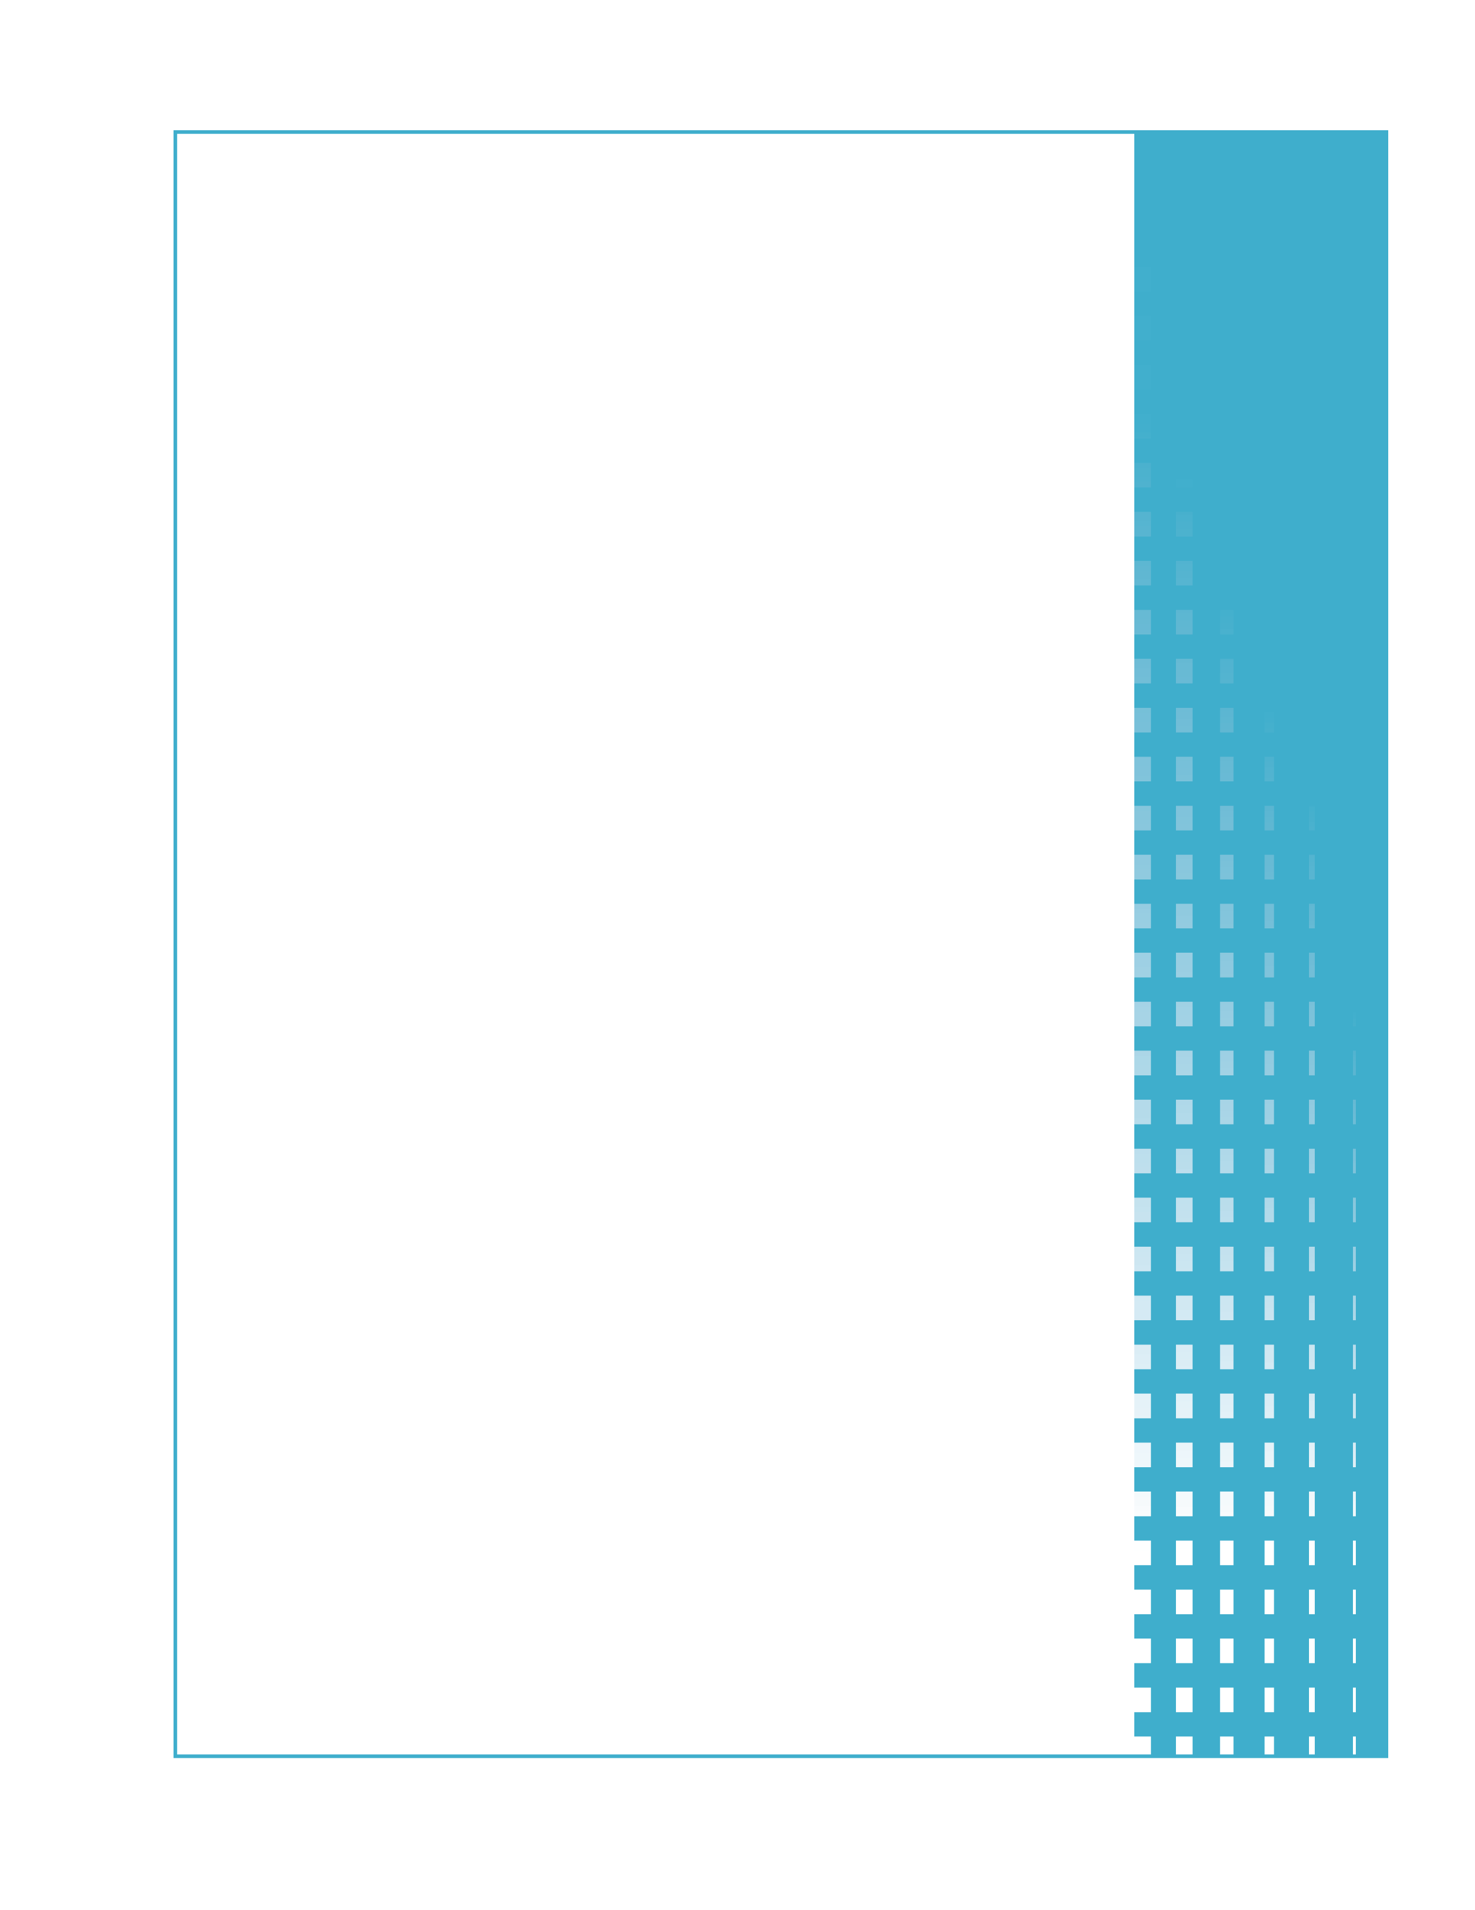

Appendix F9  
  
Round 3  
DTA Technical Team HIP Interview Guide

DTA Technical Team HIP Interview Guide

# Round 3: Mature Operations and Feasibility of HIP Expansion

The Massachusetts Department of Transitional Assistance (DTA) is supporting the Healthy Incentives Pilot (HIP) by:

* Dedicating technical staff to support HIP. These staff will dedicate a percentage of their time to HIP.
* Hiring a technical support contractor.

HIP technical staff is located at the central DTA office in Boston. The purpose of Round 3 interviews with HIP technical staff is to document mature HIP operations. The interviews will take place approximately 11-12 months after HIP start up.

Key technical staff and their primary HIP responsibilities include[1]:

|  |  |  |  |
| --- | --- | --- | --- |
| **Position** | **Location** | **Primary Responsibility** | **FTE** |
| **MIS Systems Analyst** | DTA Central Office - Boston | Analyzes user requirements; develops business requirements documentation. | 0.25 |
| **MIS Application Developer** | DTA Central Office - Boston | Designs, codes, and tests applications that support HIP | 0.25 |
| **MIS QA Tester** | DTA Central Office - Boston | Tests applications that support HIP | 0.25 |
| **Technology Consultant** | Contractor  Site | Provides technical support to the DTA HIP Team | TBD |

Other technical staff not billed to HIP grant that may be interviewed include:

* EOHHS Data Analyst
* EOHHS Business Relationship Managers

Interviews will be scheduled at least two weeks in advance. It is anticipated that interviews will take place at DTA facilities in Boston.

Interviews will include the questions starting on the following page. Additional, follow-up questions are anticipated, to clarify or expand responses.

Public reporting burden for this collection of information is estimated to average 85 minutes per response, including the time for reviewing instructions, searching existing data sources, gathering and maintaining the data needed, and completing and reviewing the collection of information. An agency may not conduct or sponsor, and a person is not required to respond to, a collection of information unless it displays a currently valid OMB control number. Send comments regarding this burden estimate or any other aspect of this collection of information, including suggestions for reducing this burden, to: U.S. Department of Agriculture, Food and Nutrition Service, Office of Research and Analysis, 3101 Park Center Drive, Room 1014, Alexandria, VA 22302 ATTN: PRA (0584-xxxx). Do not return the completed form to this address.

**GENERAL INFORMATION**

1. Date and Time of Interview
2. Location of Interview
3. Name(s) of Respondent(s)
4. Have your job description and/or HIP responsibilities changed since the last interview? If no, skip to question 6.
5. New Job Description and/or Responsibilities

**HIP MANAGEMENT AND COORDINATION**

1. Do you have a role in managing or coordinating activities between HIP team members and/or stakeholders? If no, please skip to question 7.
   1. If your role in managing or coordinating HIP activities has changed since the previous interview, please describe.
   2. With which HIP team members do you primarily interact in management and coordinating HIP activities and how frequently does this interaction occur?
   3. What issues, if any, have you encountered in managing and coordinating HIP activities and how have these issues been resolved?
   4. Do you have any suggestions to improve HIP management and coordination between team members and/or stakeholders?

**HIP SYSTEM AND TECHNICAL SUPPORT**

1. Describe your role in providing systems or technical support for HIP since the previous interview. Check all that apply.

🞎 IT support (please define)

🞎 BEACON 3 operations and maintenance

🞎 BEACON 3 modifications

🞎 BEACON 3 testing

🞎 EBT contractor (ACS) support and liaison

🞎 Retailer/third party processor support

🞎 HIP reporting, i.e., route or ad hoc reports from HIP data

🞎 Other stakeholder technical support (please define)

🞎 Technology consulting support (please define)

🞎 Other (please define)

1. Has your role changed in providing system and technical support changed since the previous interview? If so, please describe.
   1. With which individuals/stakeholders do you interact most frequently in providing system or technical support for HIP? Have these changed since the previous interview?
   2. Which system or technical support activities are/have been most and least time consuming?
   3. Which system or technical support activities would you describe as most and least important?
   4. In providing system and technical support, what, if any, issues have been encountered and how were these issues resolved?
2. What changes could be made to improve HIP system or technical support?

**HIP EVALUATION**

1. Do you have any role in supporting the HIP evaluation? If no, please skip to question 12.
   1. Has your role changed since the previous interview? If so, please describe.
   2. Please describe the evaluation processes in which you are involved (data transfers, data collection, data analysis, reporting, other).
   3. What are your primary sources of data to support the evaluation?
   4. In addition to yourself, who else is supporting the evaluation?
   5. What, if any, evaluation issues have been encountered and how have they been resolved?
2. Do you have any suggestions to improve the evaluation?

**ISSUES/LESSONS LEARNED**

1. Other than previously discussed, what issues, if any, have you encountered during operations and how were these issues resolved?
   1. What impact did they have on HIP operations?
2. What changes could be made to improve HIP operations?
3. What lessons learned can be derived from your experiences to date?
4. Do you think HIP should be expanded to other areas of Massachusetts?
5. What changes would you make before expanding HIP in Massachusetts or other states?
6. What advice would you have for other states considering the implementation of a healthy food incentive?

**EXPENDITURES**

1. What additional activities and related costs would you expect to incur if HIP were implemented statewide? (Examples include additional system changes or expansion of the UPC database0
2. Were there activities/costs that you did not anticipate that might impact another state if HIP were deployed nationally?

1. Staffing breakdown based on the Massachusetts DTA HIP Grant Application, March 2010 and Evaluation Meeting November 2, 2010.