ADVANCE LETTER FOR PARTICIPANT SURVEY Round 2

<< Date>>

<<Name>>
<<Address>>
<<City, State Zip>>
Dear <<Honorific>> <<Last Name>>

This fall we interviewed you for the “What Hampden County Eats” study. This is a survey of participants in the Supplemental Nutrition Assistance Program (SNAP). Thank you for your participation!
Now it is time for the second interview. In addition to the types of questions we asked in the first interview, we will also ask you about the foods you eat. This interview will take about 50 minutes.
You will receive a check for $30 as an incentive for your participation. If you use your cell phone to talk to us, we will provide you with an additional $10 in appreciation of your using your cell phone minutes to complete the survey.
Taking part in the survey is up to you. Deciding not to be in the study won’t affect your SNAP benefits. If you do not want to be interviewed, you can tell the interviewer who calls you.
There isn’t much risk from being in the study except that someone could find out you were in the study. We’ll be careful to protect your information and make sure this does not happen. Only some people from USDA and the research team will see your answers. Your name will be kept separate from your answers. Your answers will be put together with answers from the other people in the study and reported as totals and averages. No one’s name will be used. Everyone on the research team has signed a confidentiality form to protect your information, and it will not be shared with anyone outside the researchers for this study, except as otherwise required by law.
Someone from Westat will call you in the next week or so. Our caller ID will show up on your phone as “FOOD SURVEY.” In this packet are some materials to use during the interview. If you want to complete or schedule your interview now, please call Westat at our toll-free telephone number 888-262-4896.

Thank you again for your help in this important study.

Sincerely,
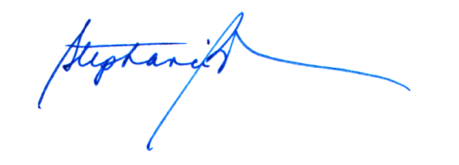
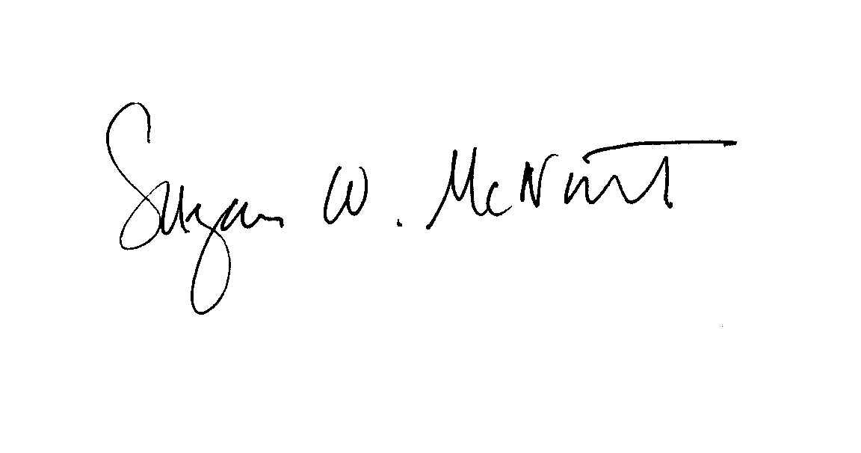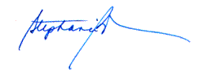
Susie McNutt Stephanie Brown
Westat Project Director Assistant Commissioner for Policy,
Program and External Relations
MA Department of Transitional Assistance

