ADVANCE LETTER FOR PARTICIPANT SURVEY Round 2
TO PARENTS OF MINORS
<< Date>>

<<{Parent of Minor Selected Respondent} Name >>
<<Address>>
<<City, State Zip>>
Dear <<First Name of {Parent}>> <<Last Name of {Parent}>>

This fall we interviewed you and your son, John Doe, for the “What Hampden County Eats” study. This is a survey of participants in the Supplemental Nutrition Assistance Program (SNAP). Thank you for your participation! Now it is time for the second set of interviews.
We want to interview you (or the main grocery shopper in your home if that is not you) and John. We will ask you questions about your family, how you shop for food and how you decide what to buy. We will ask John questions about his diet. Your/the main shopper interview will take about 10 minutes. The interview with John will take about 40 minutes. You (or the main shopper) and John will each receive $30 as an incentive for participating in the survey. If you use your cell phone to talk to us, we will provide you with an additional $10 in appreciation of your using your cell phone minutes to complete the survey.
Taking part in the survey is up to you. Deciding not to be in the study won’t affect your SNAP benefits. If you do not want to be interviewed, you can tell the interviewer who calls you. There isn’t much risk from being in the study except that someone could find out you were in the study. We’ll be careful to protect your information and make sure this does not happen.
Only some people from USDA and the research team will see your answers. Your name will be kept separate from your answers. Your answers will be put together with answers from the other people in the study and reported as totals and averages. No one’s name will be used. Everyone on the research team has promised to keep your information private.

Someone from Westat will call you in the next week or so. Our caller ID will show up on your phone as “FOOD SURVEY.” In this packet are some materials to use during the interview. If you and/or John would like to complete or schedule your interview now, please call Westat at our toll-free telephone number 888-262-4896.

Thank you again for your help in this important study.

Sincerely,
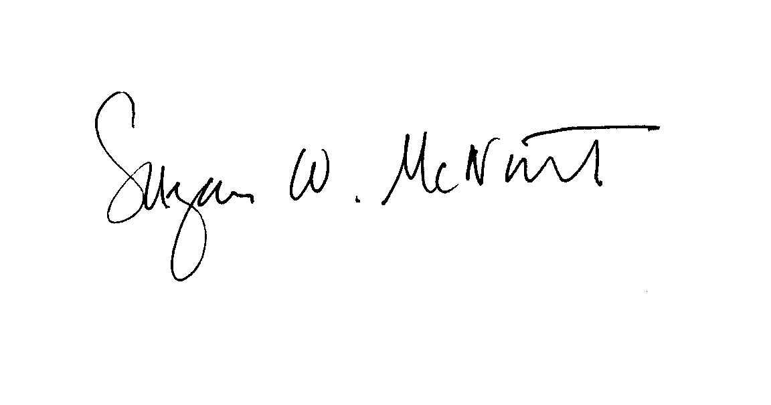
Susie McNutt Stephanie Brown
Westat Project Director Assistant Commissioner for Policy,
Program and External Relations
MA Department of Transitional Assistance

