APPENDIX C-1 CNPP MESSAGING SURVEY - ENGLISH

USDA - CNPP
Messaging Survey
FINAL: August 21, 2015

Audience | Source | Desired Total Completes
General Population (English language) | Online Panel | 1,200

RESPONDENTS MUST TAKE ON A COMPUTER DUE TO HIGHLIGHTER TOOL. PANEL SHOULD SCREEN FOR DEVICE.

INTRODUCTORY QUESTIONS

[After providing consent for the survey, participants respond to 10 introductory questions, presented in Attachment B-1/B-2 Online Survey Screener. Responses to Q7 through Q10 on the screener determine if participant will be included in the Spanish language or English language sample]
Pre-Test Brand Metrics

- How familiar are you with MyPlate?
1 Very familiar
2 Somewhat familiar
3 Not too familiar
4 Not familiar at all or only know the name
5 Never heard of it
6 Not sure

Present image
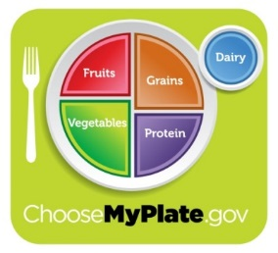
- Before today, had you seen this picture?
1 Yes
2 No

- [IF Q1=3-5 OR Q2=1] How favorable is your impression of MyPlate?
5 Very favorable
4
3 Neutral
2
1 Very unfavorable
6 Never heard of
7 Not sure

- Which statement best describes your understanding of MyPlate? Please choose one.
- Each meal should include fruits, vegetables, grains, proteins and dairy
- You should eat recommended amounts of fruits, vegetables, grains, proteins and dairy throughout the day

DIETARY PATTERN DEFINITION TEST
Here is some additional information about healthy eating. Please read the information carefully and then click ‘Next’ to answer the following questions.

All of the foods and beverages you eat and drink every day over time matter. When you combine the right mix every day, you can live healthfully now and in the future.

HAVE NEXT BUTTON DELAYED 15 SECONDS BEFORE APPEARING.

SHOW TEXT IN BOX ABOVE ON EACH PAGE FOR QUESTIONS 5-6.

- Here is a list of words and phrases that could be used to describe the information you just read. How well does each of these describe what you just read?
3 Describes perfectly
2 Describes somewhat
1 Does not describe
4 Not sure

RANDOMIZE
- Tells me something new
- Is important

- Which of the following phrases do you think best describes the information you just read?
RANDOMIZE
- Healthy eating style
- Healthy eating pattern

HIGHLIGHTER TOOL/MESSAGE PLATFORM TEST
ROTATE ORDER OF MESSAGE PLATFORM TESTS Q7-12 AND Q13-18
- HIGHLIGHTER TOOL: Now you are going to look at something different. Please take a minute to read the information provided on the next page. This time, please use the highlighter tool to highlight words and phrases that you “LIKE” and that stand out for you in a positive way. You can highlight a single word, a phrase, or whole sentences. To select more than one word at a time, click on the highlighter icon on the top of the page. If you change your mind or click on something accidentally, you can unselect it by clicking on it again.
SHOW TEXT IN BOX BELOW AS HIGHLIGHTER (SEE ACCOMPANYING PPT SLIDE FOR PROGRAMMING).

Everyone has their own, unique style when it comes to eating. No matter when, where, or how you eat, you can use your daily eating decisions to create a healthier future. Use MyPlate to improve your style of eating. Choose a healthy mix of fruits, vegetables, grains, dairy, and protein foods within your calorie limit to create your unique combination for success. Go to ChooseMyPlate.gov to find new ways to update your eating style. There, you’ll find suggestions for small, quick changes you can build on over time to achieve a healthy future.

- SHOW TEXT ABOVE AGAIN ABOVE THIS QUESTION. Does any language from the text above stands out to you in a negative way? If so, what do you not like about it? OPEN END. SHOW OPTIONS FOR NONE, NOT SURE.

- Based on the information you just read, how likely are you to do the following?
5 - Very likely
4
3 -Neutral
2
1 -Not all likely
6 --Not sure

RANDOMIZE
- Visit the ChooseMyPlate.gov website
- Make healthier decisions about what you eat and drink
- Seek more information about healthier eating

- How appealing is this paragraph to you personally?
5 – Very appealing
4
3 – Neither appealing nor unappealing
2
1 – Very unappealing
6 -- Not sure

- Based on the information you just read, how easy do you think it would be to start making healthier decisions about what you eat and drink?
5 – Very easy
4
3 Neutral
2
1 – Not all easy
6 -- Not sure

- Here is a list of words and phrases that could be used to describe this paragraph. Based on your impressions, how well does each of these describe this paragraph?
3 Very well
2 Somewhat well
1 Not well
4 Not Sure

[RANDOMIZE ORDER]
- Tells me something new
- Is encouraging
- Gives me a good reason to eat healthier

- HIGHLIGHTER TOOL: Now you are going to look at something different. Please take a minute to read the information provided on the next page. This time, please use the highlighter tool to highlight words and phrases that you “LIKE” and that stand out for you in a positive way. You can highlight a single word, a phrase, or whole sentences. To select more than one word at a time, click on the highlighter icon on the top of the page. If you change your mind or click on something accidentally, you can unselect it by clicking on it again.
SHOW TEXT IN BOX BELOW AS HIGHLIGHTER (SEE ACCOMPANYING PPT SLIDE FOR PROGRAMMING).

Discovering how and what to eat is a lifetime journey, built from the decisions you make each day. Whether you want to improve your health or feel energized, what matters most on your journey is finding the right combination of what to eat and drink over time. Let MyPlate guide your way! Find the variety of fruits, vegetables, grains, dairy and protein that will lead you to a lifetime of health. Visit ChooseMyPlate.gov to find easy shifts to start making healthier, enjoyable choices each day. MyPlate can help to build your path to a healthy, successful future today!

- SHOW TEXT ABOVE AGAIN ABOVE THIS QUESTION. Does any language from the text above stands out to you in a negative way? If so, what do you not like about it? OPEN END. SHOW OPTION FOR NONE, NOT SURE.

- Based on the information you just read, how likely are you to do the following?
5 – Very likely
4
3 Neutral
2
1 – Not all likely
6 -- Not sure
RANDOMIZE
- Visit the ChooseMyPlate.gov website
- Make healthier decisions about what you eat and drink
- Seek more information about healthier eating
- How much would you say this paragraph appealed to you personally?
5 – Very appealing
4
3 – Neither appealing nor unappealing
2
1 – Very unappealing
6 -- Not sure

- Based on the information you just read, how easy do you think it would be to start making healthier decisions about what you eat and drink?
5 – Very easy
4
3 Neutral
2
1 – Not all easy
6 -- Not sure

- Here is a list of words and phrases that could be used to describe this paragraph. Based on your impressions, how well does each of these describe this paragraph?
3 Very well
2 Somewhat well
1 Not well
4 Not Sure
[RANDOMIZE ORDER]
- Tells me something new
- Is encouraging
- Gives me a good reason to eat healthier

- SHOW MESSAGE PLATFORMS 1 AND 2 ON SAME SCREEN
Of the two versions you just read, which one does a better job of making you want to visit ChooseMyPlate.gov for more information?

- [NAME OF PLATFORM 1]
- [NAME OF PLATFORM 2]

- SHOW MESSAGE PLATFORMS 1 AND 2 ON SAME SCREEN And, which one makes you more likely to make healthier decisions about what you eat and drink every day?

- [NAME OF PLATFORM 1]
- [NAME OF PLATFORM 2]

ICON TEST

On the next screen, you will see a picture designed to help share information about healthy eating. Please look at the picture and then answer the questions below.

LABELS SHOULD NOT BE SHOWN, FOR INTERNAL PURPOSES ONLY. FOLLOW-UP QUESTIONS SHOULD ALL APPEAR ON THE PAGE WITH THE PICTURE.

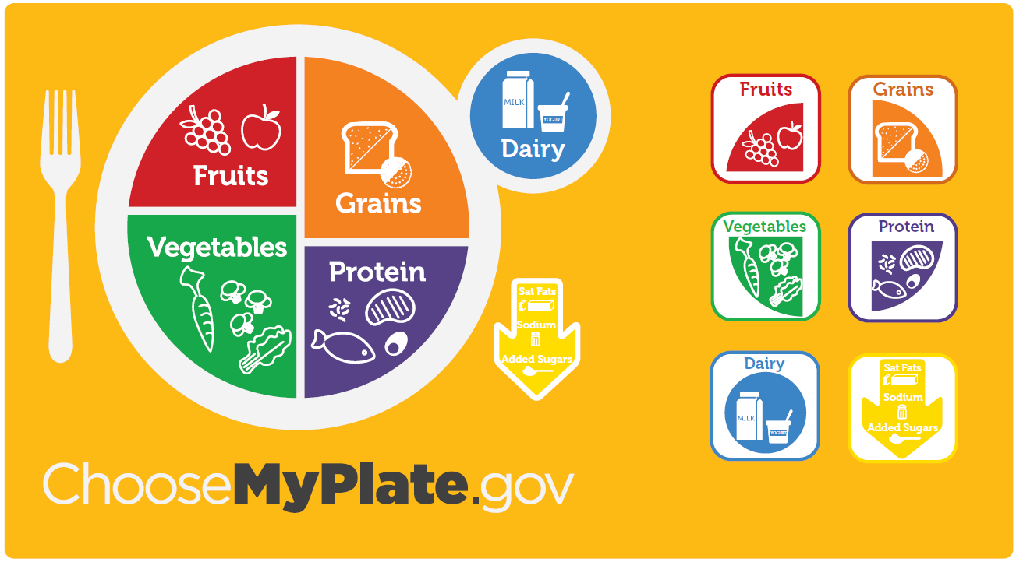

SHOW Q21-22 on same page below picture.
- Before today, had you seen this picture? Please think about the whole picture, and not just part of it.
  - Yes, definitely
  - Yes, maybe
  - No, don’t think so
  - Not sure
- How appealing did you find this picture?
5 – Very appealing
4
3 – Neither appealing nor unappealing
2
1 – Very unappealing
6 -- Not sure

SHOW ON ITS OWN PAGE WITH PICTURE ABOVE.
- In your own words, what is this picture trying to tell you? Please be as specific as you can. [PROGRAM OPEN END; SHOW NOT SURE OPTION]
ROTATE Q24 AND Q25

SHOW ON ITS OWN PAGE WITH PICTURE ABOVE.
- How well does this picture illustrate that all of the food and beverages you eat and drink matter?
3 Very well
2 Somewhat well
1 Not well
4 Not Sure

SHOW ON ITS OWN PAGE WITH PICTURE ABOVE.
- How well does this picture illustrate what a healthy combination of food and beverages looks like?
3 Very well
2 Somewhat well
1 Not well
4 Not Sure

SHOW ON ITS OWN PAGE WITH PICTURE ABOVE.
- Here is a list of words and phrases that could be used to describe this picture. Based on your impressions, how well does each of these describe this picture?
3 Very well
2 Somewhat well
1 Not well
4 Not Sure

[RANDOMIZE ORDER]
- Informative
- Confusing
- Memorable
PSYCHOGRAPHICS

- How motivated are you to live a healthy lifestyle?
4 Very motivated
3 Motivated
2 Neither motivated or unmotivated
1 Not motivated

- How often do you read the nutritional labels on food packages? (select one)
4 Always
3 Frequently
2 Sometimes
1 Never

- Please indicate how much you agree with the following statements:
1 Strongly agree
2 Somewhat agree
3 Neither agree nor disagree
4 Somewhat disagree
5 Strongly disagree

RANDOMIZE
a. Having healthy eating habits is very important to me
b. I am confident in my ability to make healthy eating choices
c. Most people I know have healthy eating habits
d. Most people important to me think I should make healthy eating decisions

- From which of the following programs have you heard any information? Please select all that apply.
- Fruits and Veggies – More Matters
- The Dietary Guidelines for Americans
- Let’s Move
- None of the above

- In the past month have you…
1 Yes
2 No
3 Not sure

RANDOMIZE
a. Searched online for health or wellness information
b. Read a book about health or fitness
c. Watched a television program about health
d. Read a newspaper or magazine article about health
e. Followed or contributed to a discussion about health on social media

- In the past year have you…
1 Yes
2 No
3 Not sure

RANDOMIZE
a. Been advised by a health care provider to change your diet
b. Started a diet to lose weight
c. Begun a fitness regiment

DEMOGRAPHICS
These last few questions are for statistical purposes only.

- Please indicate your height and weight:

Height in feet and inches:
_____ Feet _____Inches

Weight in pounds:
_____ Pounds

- Including yourself, how many household members are there in your home? Exclude any roommates/boarders/etc.
- 1 (yourself only) If yes, SKIP to Q37
- 2
- 3
- 4
- 5
- 6
- 7
- 8 or more

- Do you have any children 18 years of age or younger who live with you?
- Yes
- No
- In your household, who is responsible for making choices regarding the food you/your household eats?
- I am primarily responsible for making choices regarding the food I/my household eats
- I share the responsibility equally for making choices regarding the food I/my household eats
- Someone else is primarily responsible for making choices regarding the food I/my household eats

- Thinking of everyone in your household who receives income, what is the total yearly income for your household before taxes, including salaries, Social Security, pension, interest, and investment earnings?
- Under $25,000
- $25,000 to just below $30,000
- $30,000 to just below $37,000
- $37,000 to just below $45,000
- $50,000 to just below $52,000
- $52,000 to just below $60,000
- $60,000 to just below $67,000
- $67,000 to just below $75,000
- $75,000 to just below $100,000
- $100,000 or more

- What is the highest level of education you have completed?
- Less than high school
- High School
- Some College
- College degree
- Graduate degree or above

Thank you for your feedback! This concludes the questionnaire. You may now close the survey window.

