Experimental Study on Consumer Responses to Nutrition Facts Labels with Various Footnote Formats and Declaration of Amount of Added Sugars

0910-NEW
SUPPORTING STATEMENT

List of Appendices

Appendix A. List of Footnotes and Sample Food Labels 2
Appendix B. Sample Food Label: Added Sugars Declaration 5
Appendix C. Cognitive Interview Screener 6
Appendix D. Questionnaire 8
Appendix E. Invitation E-mail (Pretest and Experimental Study) 19
Appendix F. Product Nutrition Profiles 20
Appendix G. Reminder E-mail 23

Appendix A. List of Footnotes and Sample Food Labels

In the experimental conditions, each of the following nine footnotes will appear in the footnote area beneath the list of vitamins and minerals and will be preceded by an asterisk, as shown below in the sample label for a hypothetical frozen meal product.

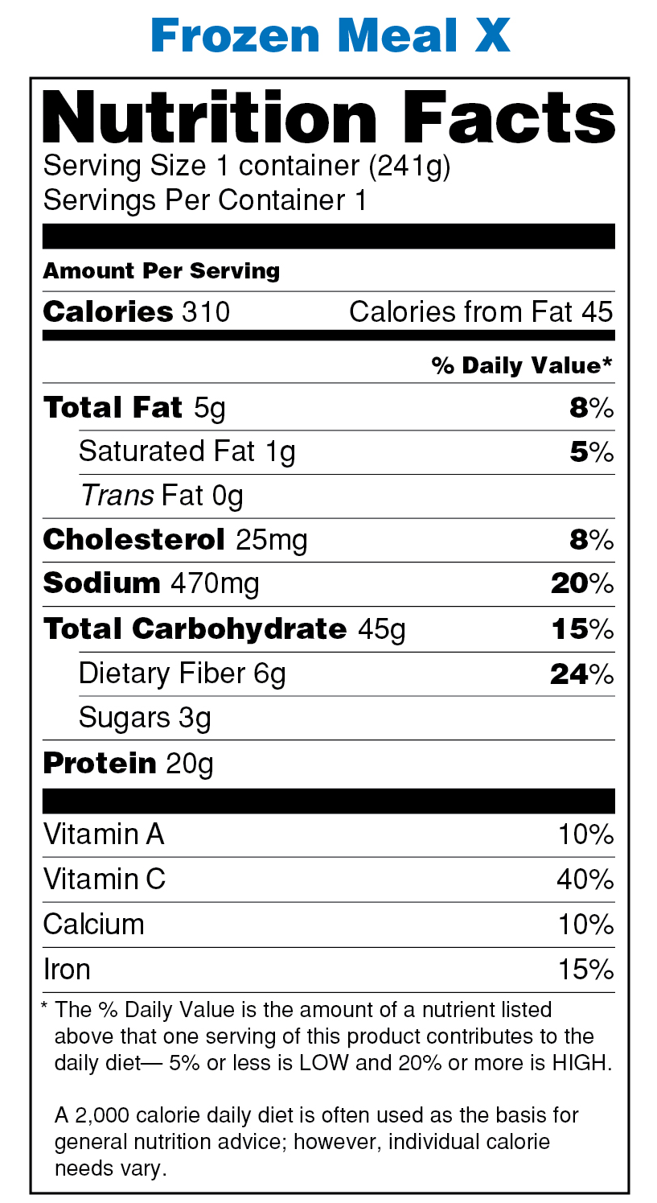

Footnote 1 (shown in the example above):
The % Daily Value is the amount of a nutrient listed above that one serving of this product contributes to the daily diet— 5% or less is LOW and 20% or more is HIGH.
A 2,000 calorie daily diet is often used as the basis for general nutrition advice; however, individual calorie needs vary.

Footnote 2:
The % Daily Value is the amount of a nutrient listed above that one serving of this product contributes to the daily diet— 5% or less is LOW and 20% or more is HIGH.

Footnote 3:
The % Daily Value is the amount of a nutrient listed above that one serving of this product contributes to the daily diet.

Footnote 4:
5% or less is LOW and 20% or more is HIGH.

Footnote 5:
FDA considers 5% or less as LOW and 20% or more as HIGH.

Footnote 6:
The % Daily Value is the amount of a nutrient listed above that one serving of this product contributes to the daily diet— FDA considers 5% or less as LOW and 20% or more as HIGH.
A 2,000 calorie daily diet is often used as the basis for general nutrition advice; however, individual calorie needs vary.

Footnote 7:
Same text as Footnote 1 with formatting modifications (shown in the example below)
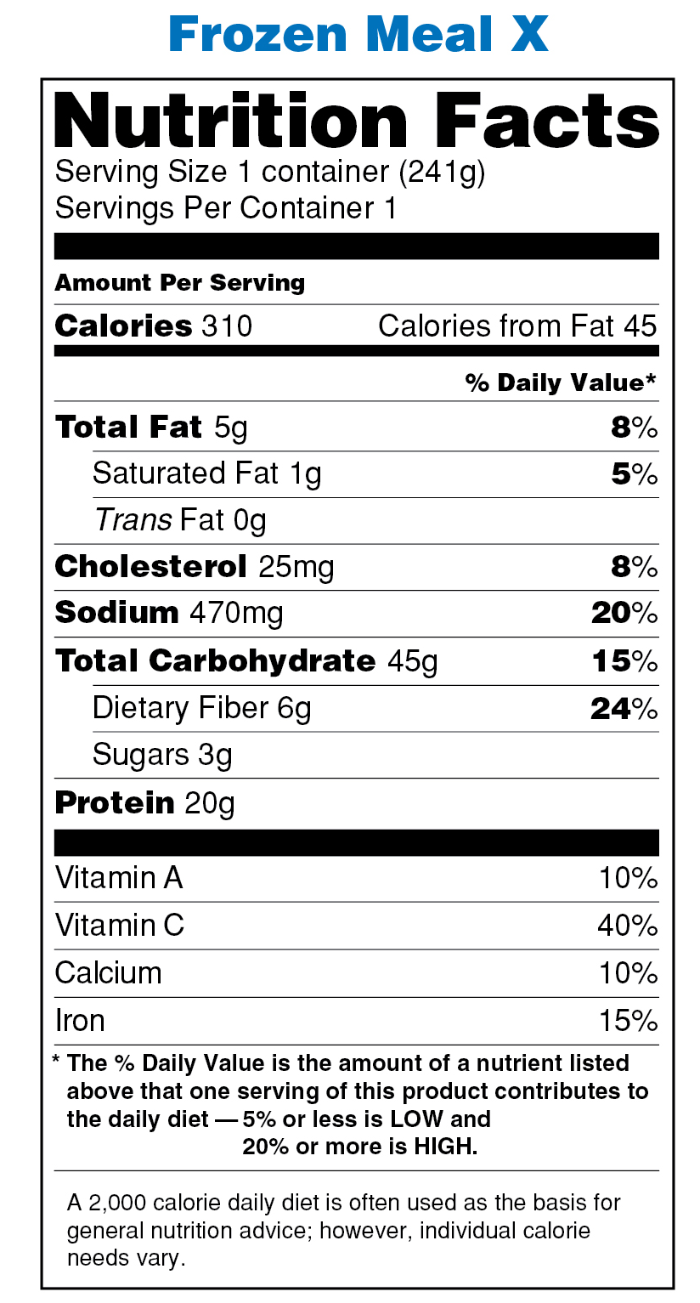

Footnote 8 (Control 1, the current footnote, per 21 CFR § 101.9(d)(9)(i)):
Percent Daily Values are based on a 2,000 calorie diet. Your daily values may be higher or lower depending on your calorie needs.

 | Calories: | 2,000 | 2,500
Total Fat | Less than | 65g | 80g
Sat Fat | Less than | 20g | 25g
Cholesterol | Less than | 300mg | 300mg
Sodium | Less than | 2,400mg | 2,400mg
Total Carbohydrate |  | 300g | 375g
Dietary Fiber |  | 25g | 30g

Footnote 9 (Control 2):
No footnote (i.e., no asterisk or text).

Appendix B. Sample Food Label: Added Sugars Declaration

The label format that includes an added sugars declaration is shown below.

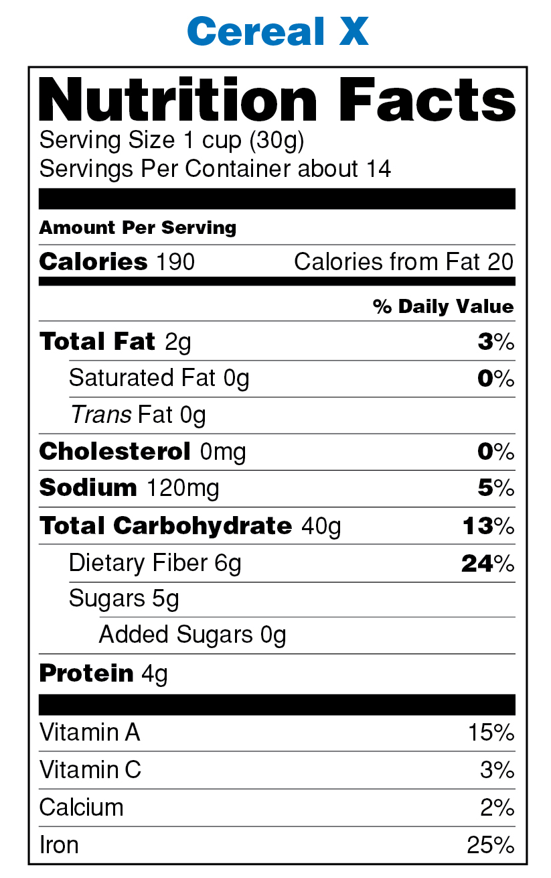

Appendix C. Cognitive Interview Screener

Hello, my name is xxx and I work for Synovate, a local research firm. We’re doing research for the Food and Drug Administration about food labels and nutrition. If you are eligible and you agree to participate, we will give you $75 to complete an in-person interview that should last about an hour. In order to find out if you are eligible to be interviewed, I’d like to get some background information.

Before I proceed, I must make sure that you are at least 18 years old.

UNDER 18 :___: [THANK AND END]
18 OR OLDER :___:

1. Do you work either full- or part-time in health services research, or for a food or nutrition company?
YES :___: [THANK AND END]
NO :___:

2. In an average week, how many hours would you say you use the Internet?
NONE: : [THANK AND END]
1 HOUR AND MORE : :
DON’T KNOW :___: [THANK AND END]

3. [RECORD GENDER. IF NOT OBVIOUS, ASK; RECRUIT 4-5 OF EACH]
Are you male or female?
FEMALE :___:
MALE :___:

4. What is your age? [CODE INTO ONE OF THE FOLLOWING CATEGORIES]
18-24 :___:
25-39 :___:
40-54 :___:
55-64 :___:
65 OR OLDER :___:
[RECRUIT A MIX]

5. What is the highest level of education that you have completed? [CODE INTO ONE OF THE FOLLOWING CATEGORIES]
LESS THAN A HIGH SCHOOL DIPLOMA :___:
HIGH SCHOOL GRADUATE OR GED :___:
SOME COLLEGE, ASSOCIATES DEGREE :___:
COLLEGE GRADUATE :___:
ADVANCED DEGREE :___:
[RECRUIT 2 WITH HIGH SCHOOL DIPLOMA OR LESS]

6. Are you of Hispanic or Latino origin?
YES: :
NO: :

7. What is your race? You may choose one or more categories as they apply.
WHITE :___:
BLACK OR AFRICAN AMERICAN :___:
ASIAN:___:
NATIVE HAWAIIAN OR OTHER PACIFIC ISLANDER:___:
AMERICAN INDIAN OR ALASKA NATIVE
SOME OTHER RACE (specify)_______________________________________
[RECRUIT 3-4 WHO ARE NOT WHITE]

7. What is your occupation?
______________________________________________________________________

INVITATION

[IF ELIGIBLE AND QUOTA REMAINS UNFILLED]

Thank you for answering all my questions. I’d like to invite you to participate in an in-person interview that will take about an hour to complete. We’ll pay you $75 for your time with us. Let me give you some available times and you tell me what would be best for you.

INTERVIEW DATE AND TIME:
The interview will be held at (location). I would like to send you directions. Where can I send them? Also, may I please have your phone number in case we need to get hold of you for any reason?

COLLECT RESPONDENT NAME, ADDRESS (AND EMAIL ADDRESS, IF APPLICABLE) AND PHONE
Name: _____________________________________________________________
Address: _____________________________________________________________
City: _________________________________ State: ______ Zip Code: __________
Phone: ________________________________________
E-mail: ________________________________________

In case you need to contact me for any reason, you can reach me at 1-800-xxx-xxxx.

Appendix D. Questionnaire

FDA Experimental Study on Consumer Responses to Nutrition Facts Labels with Various Footnote Formats and Disclosure of Amounts of Micronutrients
Draft Questionnaire
As of October 2011

Form Approved: OMB No. 0910-xxxx
Expiration Date: xx/xx/201x

PUBLIC Disclosure Burden Statement

Public reporting burden for this collection of information is estimated to average 15 minutes per response, including the time for reviewing instructions, searching existing data sources, gathering and maintaining the data needed, and completing and reviewing the collection of information. An agency may not conduct or sponsor, and a person is not required to respond to, a collection of information unless it displays a currently valid OMB control number. Send comments regarding this burden estimate or any other aspect of this collection of information, including suggestions for reducing this burden, to:
Department of Health and Human Services
Food and Drug Administration
CFSAN/PRA Comments/HFS-24
5100 Paint Branch Parkway
College Park, MD 20740-3835.

Study Introduction:
Thank you for agreeing to participate. The following questions are about common food products and nutrition labels you might see on these products. It usually takes about 15 minutes to answer all the questions. The information you provide will be kept strictly confidential.

Please click the “NEXT” button to begin the study.

[Time will be recorded by section and/or item once the respondent begins the survey. Please note that the section headings, question numbering, and bracketed comments included in this proposed questionnaire will not be seen by the respondent.]

Section A. Two-Product Comparison Task

Please take a moment to look at the nutrition labels for these two <cereals/yogurts>.

[SHOW A PAIR OF NUTRITION FACTS LABELS FOR TWO CEREALS OR TWO YOGURTS]

- Based on what you see on these labels, which one of these <cereals/yogurts> is healthier?

_______[Food - Left]
_______[Food - Right]
_______I see no difference

Section B. Single-Product Task

Now, please take a moment to look at this next product. This is a different product from the ones you saw on the previous screen.

[SHOW A SINGLE NUTRITION FACTS LABEL]

The following questions are about <this cereal/yogurt/frozen meal> [OR] <these crackers>. You will be able to view the label while answering these questions.

- Based on what you see on the label, how healthy would you say <this cereal/yogurt/frozen meal> is [OR] <these crackers are>? Use a scale of 1 to 5, where 1 means “Not at all healthy” and 5 means “Very healthy.”

Not at all healthy |  |  |  | Very  healthy | Don’t know
1 | 2 | 3 | 4 | 5

- If you were trying to avoid heart disease, how likely would you be to include this product as part of your diet? [ROTATE B2-B5]

Not at all likely |  |  |  | Very  likely | Don’t know
1 | 2 | 3 | 4 | 5

- If you were trying to avoid diabetes, how likely would you be to include this product as part of your diet?

Not at all likely |  |  |  | Very  likely | Don’t know
1 | 2 | 3 | 4 | 5

- If you were trying to avoid gaining weight, how likely would you be to include this product as part of your diet?

Not at all likely |  |  |  | Very  likely | Don’t know
1 | 2 | 3 | 4 | 5

- If you were trying to avoid tooth decay or cavities, how likely would you be to include this product as part of your diet?

Not at all likely |  |  |  | Very  likely | Don’t know
1 | 2 | 3 | 4 | 5

- How much of each of the following things would you say this product has? [ROTATE ITEMS]

 | None or very little  1 | 2 | 3 | 4 | A lot  5
Calories
Saturated Fat
Sodium
Sugars
Calcium

Section C. Comprehension – Percent Daily Value
[CONTINUE TO SHOW SAME NUTRITION FACTS LABEL AS IN PREVIOUS SECTION]

- How would you rate this product as a source of Vitamin A?

___Excellent
___Good
___Fair
___Poor
___Don’t know

- How would you rate this product as a source of Vitamin C?

___Excellent
___Good
___Fair
___Poor
___Don’t know

- How would you rate this product as a source of Dietary Fiber?

___Excellent
___Good
___Fair
___Poor
___Don’t know

- Would you agree or disagree with the following statements about this product?

 | Agree | Disagree | Neither agree nor disagree | Don’t know
This product could be described as “low-fat”
This product could be described as “low in sodium”

Section D. Comprehension – Sugars

Next, we’d like to ask a couple of questions about this beverage.

[SHOW LABEL. ROTATE ORDER OF E1 AND E2.]

- How many grams of Sugars are in one serving of this beverage?

______ grams
◻ Don’t know

- How many grams of Total Carbohydrate are in one serving of this beverage?

______ grams
◻ Don’t know

SECTION E. LABEL RATINGS

The next questions are about the food label itself.

When answering these questions, please focus on the part of the label that is inside the blue box shown below.

[INSERT ONE ASSIGNED IMAGE. TWO EXAMPLES INCLUDED BELOW.]

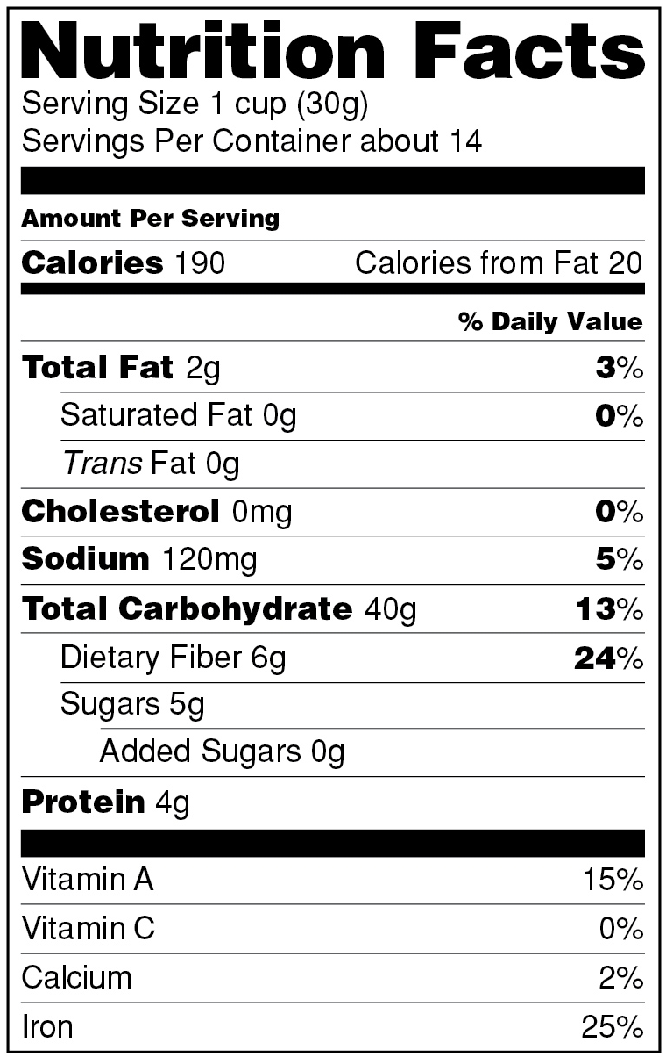
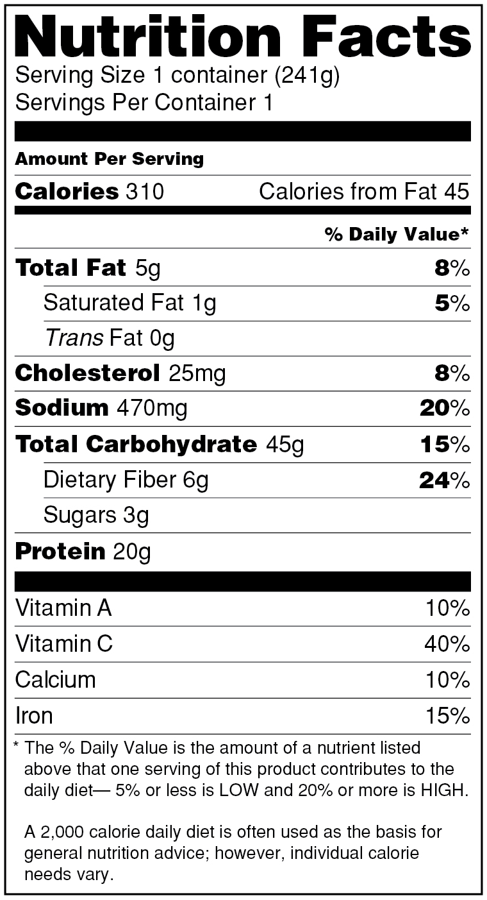

 | Not at all  1 | 2 | 3 | 4 | Very  5 | Don’t know
- How hard is it to understand the information shown in the blue box?
- How useful is the information in the blue box to you personally?
- How believable is the information in the blue box?

[CONTINUE TO DISPLAY IMAGE]

- Thinking about the information shown in the blue box, how helpful is this information for doing the following things?

 | Not at all helpful  1 | 2 | 3 | 4 | Very helpful  5 | Don’t know
For planning a healthy diet?
For determining the healthfulness of the food?
For deciding how much of this food you should eat?
[Skip if footnote condition has been assigned] For determining the amount of sugar in the food?

Section F. Consumption/Purchase of Foods and Typical Food Label Use

The following questions are not based on the nutrition labels shown in the previous questions.

- During the past 30 days, about how often did you eat these types of foods? Please select one answer for each food.

 | Not at all | 1-2 times per week | 3-4 times per week | 5 or more times per week | Don’t know
Yogurt
Cereal
Frozen meals
Crackers

- During the past 30 days, about how often did you yourself BUY these types of foods?

 | Not at all | Less than once a week | Once a week | More than once a week | Don’t know
Yogurt
Cereal
Frozen meals
Crackers

- When you buy a food product for the first time, how often do you read the Nutrition Facts label?

___ Often
___ Sometimes
___ Rarely
___ Never [Skip next question grid]
___ Don’t know

- When you look at Nutrition Facts labels, how often, if at all, do you use the labels in the following ways?

 | Often | Sometimes | Rarely | Never | Don’t know
To see how high or low the food is in things like calories, salt, vitamins, or fat
To compare different types of foods to each other
To compare similar types of food with each other
To see if something said in advertising or on the package is actually true
To figure out how much of the food product you or your family should eat

- In the last two weeks, has there been any instance where you changed your decision to buy or eat a food product because you read the nutrition label?

___Yes
___No
___Don’t know

- How much do you agree or disagree with each of the following statements? Please select one answer for each statement.

 | Strongly Agree | Somewhat Agree | Neither Agree nor Disagree | Somewhat Disagree | Strongly Disagree | No opinion
I am confident that I know how to choose healthy foods.
The information on the food label is hard for me to understand.
It takes too much time to read the food label.
I’m not that interested in the nutrition information on the food label.
When I use food labels, I make better food choices.
The nutrition information on food labels is useful to me.

- The list below includes the ingredients that might be found in a dessert product. Which of these ingredients would you consider to be added sugars? You may mark one or more ingredients. [ROTATE ORDER EXCEPT LAST THREE.]

___ Enriched Flour
___ Vegetable Oil
___ Brown Sugar
___ Corn Syrup
___ Dextrose
___ High Fructose Corn Syrup
___ Salt
___ Honey
___ Molasses
___ Cinnamon
___ Baking Soda
___ All of the above
___ None of the above
___ Don’t know

Section G. Dietary Awareness and Interests

We have one final set of questions about you and your health, since this is a survey about nutrition and health.

- Do you consider yourself to be overweight, underweight, or about the right weight?

____Overweight
____Underweight
____About the right weight
____Prefer not to answer

- Have you ever been told by a doctor or other healthcare professional that you have any of the following health conditions -- high blood pressure, diabetes, high cholesterol, heart disease, obesity, overweight, or cancer? We don’t need to know which condition, just whether you have ANY of them.

____Yes
____No
____Prefer not to answer

- During the past 3 months, have you been trying to limit or cut down on these things in your diet?

 | Yes | No | Prefer not to answer
Fat
Carbs or carbohydrates
Sodium or salt
Calories
Cholesterol
Sugar

- About how many calories do you think a person of your age, gender, and physical activity needs to consume in a day to maintain your weight?

___Less than 500 calories
___500-1000 calories
___1001-1500 calories
___1501-2000 calories
___2001-2500 calories
___2501-3000 calories
___More than 3000 calories
___Don’t know

- In a typical week during the past 30 days, about how many days per week did you do moderate or vigorous physical activities such as brisk walking, jogging, biking, aerobics, or yard work for at least 30 minutes?

Please enter a number ranging from 0 to 7: ____ Days per week
____ Prefer not to answer

Section H. Health Status and Demographics

- In what year were you born?

__________
____Prefer not to answer

- Are you male or female?

____Male
____Female
____Prefer not to answer

- How tall are you without your shoes on? Please enter your height in the spaces below

Feet _____ Inches ____ ____Prefer not to answer

- How much do you weigh without your shoes on? Please enter your weight in the space below.

Pounds ______ ____Prefer not to answer

- What is the highest degree or level of school you have COMPLETED? Please select one.

_____Less than 9th grade
_____9th grade to 12th grade, NO DIPLOMA
_____High school graduate - DIPLOMA or GED
_____Some college or Associate degree
_____Bachelor’s degree
_____Graduate or professional degree
_____Prefer not to answer

- Are you of Hispanic or Latino origin? Please select one.

_____Yes
_____No
_____Prefer not to answer

- What race do you consider yourself to be? Please select one or more.

_____American Indian or Alaska Native
_____Asian
_____Black or African American
_____Native Hawaiian or other Pacific Islander
_____White
_____Other
_____Prefer not to answer

FOR PRETESTS ONLY

P1. If you have any comments about this survey, please provide them in the space below.

[PROVIDE SPACE FOR OPEN-END RESPONSE]

_____ I have no comments

P2. Is there anything specific that you would suggest changing about this survey?

[PROVIDE SPACE FOR OPEN-END RESPONSE]

_____ I have no suggestions

You have reached the end of the survey. Thank you very much for your participation in this research.

Information about how to understand and use the Nutrition Facts label is available at http://www.fda.gov/Food/LabelingNutrition/ConsumerInformation/default.htm

Appendix E. Invitation E-mail (Pretest and Experimental Study)

New Food Survey

Dear [Panel Member’s first name],

The next opportunity for you to share your opinions with me is here!
Link not working? Copy and paste this into your browser:

[link]

Points: Earn up to <#ProjectVersion[CompletedPoints]> reward points, plus an entry into our monthly sweepstakes (with 200+ prizes totaling $5,000).
Time: About 15 minutes.
How do I log in?
Username: <#DubKnowledge[1200/Username]>
Password Hint: <#DubKnowledge[26327/Password hint]>
Have fun!
Marie Brighton
Panel Director

**The survey is completely voluntary and your answers will be kept strictly confidential and you don’t have to answer any questions that you don’t want to.

Appendix F. Product Nutrition Profiles

Frozen Meal Nutrition Profiles

Amount per serving | Frozen meal 1 |  | Frozen meal 2
 |  | %DV |  | %DV
Calories | 420 |  | 310
Calories from fat | 140 |  | 45
Total Fat | 15g | 23% | 5g | 8%
Saturated Fat | 5g | 25% | 1g | 5%
Trans Fat | 0g |  | 0g
Cholesterol | 75mg | 25% | 25mg | 8%
Sodium | 600mg | 25% | 470mg | 20%
Total Carbohydrate | 45g | 15% | 45g | 15%
Dietary Fiber | 3g | 12% | 6g | 24%
Sugars | 4g |  | 3g
Protein | 25g |  | 20g
Vitamin A |  | 5% |  | 10%
Vitamin C |  | 5% |  | 40%
Calcium |  | 8% |  | 10%
Iron |  | 5% |  | 15%

Crackers Nutrition Profiles

Amount per serving | Crackers - Type 1 |  | Crackers -Type 2
 |  | %DV |  | %DV
Calories | 130 |  | 140
Calories from fat | 30 |  | 45
Total Fat | 3g | 5% | 5g | 8%
Saturated Fat | 0g | 0% | 1g | 5%
Trans Fat | 0g |  | 0g
Cholesterol | 0mg | 0% | 5mg | 2%
Sodium | 85mg | 4% | 240mg | 10%
Total Carbohydrate | 22g | 7% | 20g | 7%
Dietary Fiber | 5g | 20% | 1g | 4%
Sugars | 0g |  | 1g
Protein | 3g |  | 3g
Vitamin A |  | 25% |  | 2%
Vitamin C |  | 25% |  | 0%
Calcium |  | 2% |  | 0%
Iron |  | 10% |  | 6%

Yogurt Nutrition Profiles

Amount per serving | Yogurt 1 |  | Yogurt 2 |  | Yogurt 3
 |  | %DV |  | %DV |  | %DV
Calories | 90 |  | 130 |  | 160
Calories from fat | 0 |  | 0 |  | 14
Total Fat | 0g | 0% | 0g | 0% | 1.5g | 2%
Saturated Fat | 0g | 0% | 0g | 0% | 1g | 5%
Trans Fat | 0g |  | 0g |  | 0g
Cholesterol | 5mg | 2% | 5mg | 2% | 10mg | 3%
Sodium | 80mg | 3% | 80mg | 3% | 80mg | 3%
Total Carbohydrate | 8g | 3% | 22g | 7% | 25g | 8%
Dietary Fiber | 0g | 0% | 0g | 0% | 0g | 0%
Sugars | 7g |  | 20g |  | 21g
Added Sugars | 0g* |  | 14g |  | 8g*
Protein | 14g |  | 11g |  | 11g
Vitamin A |  | 15% |  | 10% |  | 2%
Vitamin C |  | 0% |  | 0% |  | 0%
Calcium |  | 30% |  | 30% |  | 30%
Iron |  | 0% |  | 0% |  | 0%
*For the single-product evaluations only: The profiles for Yogurts 1 and 3 will be varied to include different amounts of added sugars (5g for the alternate Yogurt 1 and 4g for the alternate Yogurt 3).

Cereal Nutrition Profiles

Amount per serving | Cereal 1 |  | Cereal 2 |  | Cereal 3
 |  | %DV |  | %DV |  | %DV
Calories | 130 |  | 190 |  | 230
Calories from fat | 10 |  | 20 |  | 45
Total Fat | 1g | 2% | 2g | 3% | 4g | 8%
Saturated Fat | 0g | 0% | 0g | 0% | 1g | 5%
Trans Fat | 0g |  | 0g |  | 0g
Cholesterol | 0mg | 0% | 0mg | 0% | 0mg | 0%
Sodium | 120mg | 5% | 120mg | 5% | 120mg | 5%
Total Carbohydrate | 25g | 8% | 40g | 13% | 44g | 12%
Dietary Fiber | 7g | 28% | 6g | 24% | 2g | 8%
Sugars | 4g |  | 5g |  | 12g
Added Sugars | 4g* |  | 0g |  | 10g*
Protein | 4g |  | 4g |  | 4g
Vitamin A |  | 25% |  | 15% |  | 5%
Vitamin C |  | 50% |  | 3% |  | 0%
Calcium |  | 2% |  | 2% |  | 2%
Iron |  | 50% |  | 25% |  | 25%
*For the single-product evaluations only: The profiles for Cereals 1 and 3 will be varied to include different amounts of added sugars (0g for the alternate Cereal 1 and 5g for the alternate Cereal 3).

Beverage Nutrition Profiles

Amount per serving | Beverage 1 |  | Beverage 2 |  | Beverage 3
 |  | %DV |  | %DV |  | %DV
Calories | 125 |  | 125 |  | 125
Total Fat | 0g | 0% | 0g | 0% | 0g | 0%
Sodium | 0mg | 0% | 0mg | 0% | 0mg | 0%
Total Carbohydrate | 31g | 10% | 31g | 10% | 31g | 10%
Sugars | 31g |  | 31g |  | 31g
Added Sugars | 31g |  | 0g |  | 15g

Appendix G. Reminder E-mail

Dear [Panel member’s first name],
We're still interested in your opinions. Your survey is waiting for you! Link not working? Copy and paste this into your browser:
[Link]
Points: Earn up to <#ProjectVersion[CompletedPoints]> reward points, plus an entry into our monthly sweepstakes (with 200+ prizes totaling $5,000).
Time: About 15 minutes.
How do I log in?
Username: <#DubKnowledge[1200/Username]>
Password Hint: <#DubKnowledge[26327/Password hint]>
Have fun!
Marie Brighton
Panel Director

**The survey is completely voluntary and your answers will be kept strictly confidential and you don’t have to answer any questions that you don’t want to.

