Form Approved
OMB No. 0990-
Exp. Date XX/XX/20XX

Healthy New Year Video Contest Submission Form

- Create a Video that is less than 2 minutes that shares one health related New Year’s resolution and shows how you will use information technology to achieve the resolution. The video must direct viewers to visit www.HealthIT.gov for more information.

- Register on HealthyNewYear.Challenge.gov between January 4, 2012 at 10:00 a.m. Eastern Daylight Time (“EDT”) and February 20, 2012 at 5:00 p.m. Eastern Standard Time (“EST”) and submit the following items (collectively, the “Submission”):
- The title of your Video;
(a required field in the Challenge.gov platform)
- A link to your Video on YouTube
(a required field in the Challenge.gov platform so you can locate the video)
- A text description of your healthy New Year’s resolution and how you will use health IT to achieve it;
(A required field in the Challenge.gov platform so you can describe what the video is about)
- A transcript of the words spoken or sung in the Video;
(We would like to request a written transcript be submitted along with the video in order to accommodate disabled people who won’t be able to hear the video. Having a transcript (a written version of the exact same content that is submitted as part of the video) would be valuable in meeting these requirements. The America Competes Act does not address the need for 508 compliance, so HHS has published an FAQ on Compliance with Section 508 that encourages Challenge managers to consider ways to accommodate the disabled. This is important for GSA and Challenge.gov. The goal is to enable members of the public who are hearing impaired to vote on videos.
- A choice of category for the type of health resolution;
(We would like to ask entrants to select categories from a drop-down menu for their resolution type and technology used. The menu options for

According to the Paperwork Reduction Act of 1995, no persons are required to respond to a collection of information unless it displays a valid OMB control number. The valid OMB control number for this information collection is 0990- . The time required to complete this information collection is estimated to average 10 minutes per response, including the time to review instructions, search existing data resources, gather the data needed, and complete and review the information collection. If you have comments concerning the accuracy of the time estimate(s) or suggestions for improving this form, please write to: U.S. Department of Health & Human Services, OS/OCIO/PRA, 200 Independence Ave., S.W., Suite 336-E, Washington D.C. 20201, Attention: PRA Reports Clearance Officer

Resolution Type are:
-Start/Increase healthy behavior
-Stop/Reduce unhealthy behavior
-Managing a chronic condition
-Other

This is a common practice across all challenges to categorize incoming submissions to enable the public to sort/filter videos and is necessary for voting and usability of the site (see screen shot for an example of the filtering mechanism which is made possible by the use of categories)

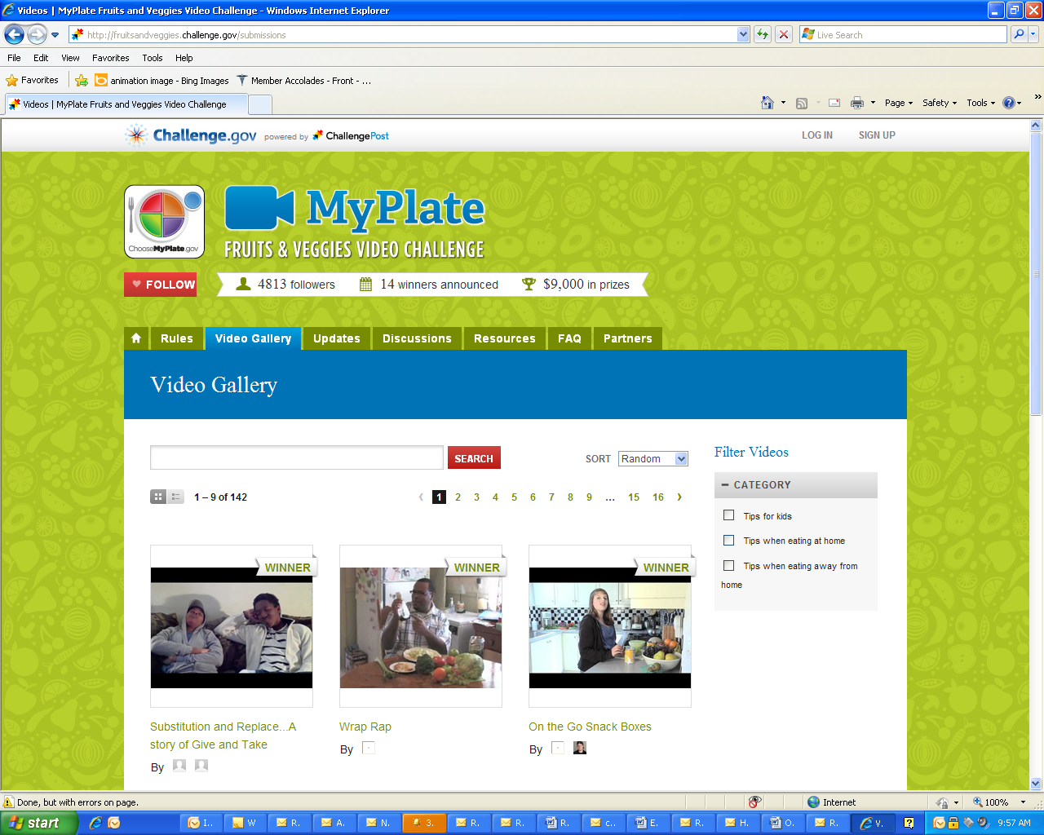Requesting the submitters to identify what challenge category they are submitting to eliminates the need to run several separate challenges [e.g. one based on resolving to stop an unhealthy behavior vs. one based on resolving to start a healthy behavior]. It would be terribly confusing to have several similar challenges that are so similar and a bit antithetical to the purpose of challenge.gov to list them separately. The categories allow us to run several separate challenges in one challenge –i.e. there are several categories of winners versus several challenges that each have one winner. The request of the submitter is to designate which challenge you are participating in by selecting one from the drop-down menu.

- A choice of category for the type of technology they plan to use to achieve their resolution
(The justification is the same for categorizing the video by type of technology as it is for categorizing the video by type of resolution (see previous justification). The categories in the drop-down menu for technology type would be as follows:
-Web tools, desktop or other software
-Mobile apps, email/txt reminders
-Records: EHR/PHR
-Online community or info site
-Other

