Form Approved:
OMB No. 0920-XXXX
Expiration Date: 00/00/20xx

HIV Prevention among Latino MSM: Evaluation of a locally developed intervention

Attachments 6a and 6b

Attachment 6a - Study Advertisement for general population venues (does not refer to study inclusion criterion of potential participants having had sex with
men since age 18 years or older)
(NOTE: The Spanish version of the advertisement will be used in the proposed study; the English version is included solely
for purposes of review.)

Attachment 6b - Study Advertisement for MSM venues (refers to study inclusion criterion of potential study participants having had sex with
men since age 18 years or older)
(NOTE: The Spanish version of the advertisement will be used in the proposed study; the English version is included solely
for purposes of review.)

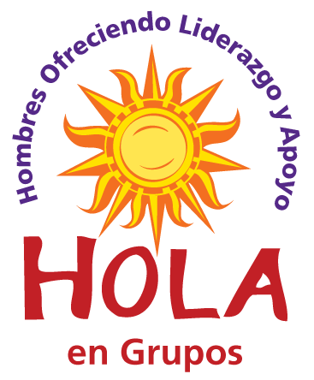
Would you like to:
- Know more about your health?
- Know how to protect your health?
- Know where to go if you need a checkup?

You must be:
- At least 18 years old
- Hispanic/Latino male
- Fluent in Spanish
To find out if you are eligible to participate, call [Fill in with recruiter’s name]
at: 877-560-9705
If you participate in this research study, you will:
Complete 2 questionnaires
Attend 4 health education sessions
Receive up to $250
All your information will be kept private under the Privacy Act.
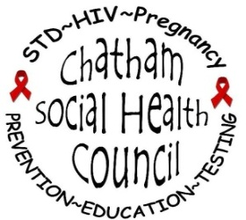
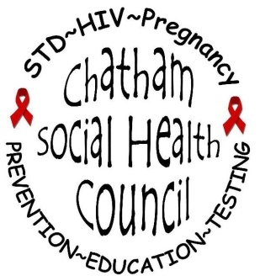
IRB #00013197
IRB #00015789
Te gustaría:
- ¿Saber más sobre tu salud?
- ¿Saber cómo proteger tu salud?
- ¿Saber adónde ir si necesitas un chequeo?

Debes de:
- Tener 18 años o más
- Ser hombre hispano/latino
- Hablar español fluido
Para saber si puedes participar, comunícate con
[Fill in with recruiter’s name] al: 877-742-3762
Si participas en este estudio de investigación:
Completarás 2 cuestionarios
Asistirás a 4 sesiones educativas de salud
Recibirás hasta $250
Toda tu información será mantenida privada bajo
el Acta de Privacidad.
IRB #00013197
IRB #00015789

Would you like to:
- Know more about your health?
- Know how to protect your health?
- Know where to go if you need a checkup?
You must be:
- At least 18 years old
- Hispanic/Latino male
- Fluent in Spanish
- Engage in sexual activity with man since age 18
years or above

To find out if you are eligible to participate, call [Fill in with recruiter’s name]
at: 877-560-9705
If you participate in this research study, you will:
Complete 2 questionnaires
Attend 4 health education sessions
Receive up to $250
All your information will be kept private under the Privacy Act.
IRB #00013197
IRB #00015789
Te gustaría:
- ¿Saber más sobre tu salud?
- ¿Saber cómo proteger tu salud?
- ¿Saber adónde ir si necesitas un chequeo?

Debes de:
- Tener 18 años o más
- Ser hombre hispano/latino
- Hablar español fluido
- Haz tenido actividades sexuales con hombres desde que tenias 18 años o más
Para saber si puedes participar, comunícate con
[Fill in with recruiter’s name] al: 877-742-3762
Si participas en este estudio de investigación:
Completarás 2 cuestionarios
Asistirás a 4 sesiones educativas de salud
Recibirás hasta $250
Toda tu información será mantenida privada bajo
el Acta de Privacidad.
IRB #00013197
IRB #00015789

