Social Security Administration

2012
ERE Screen Shots
For OMB Clearance 0960-0753

Login Screen

ERE Login Screen
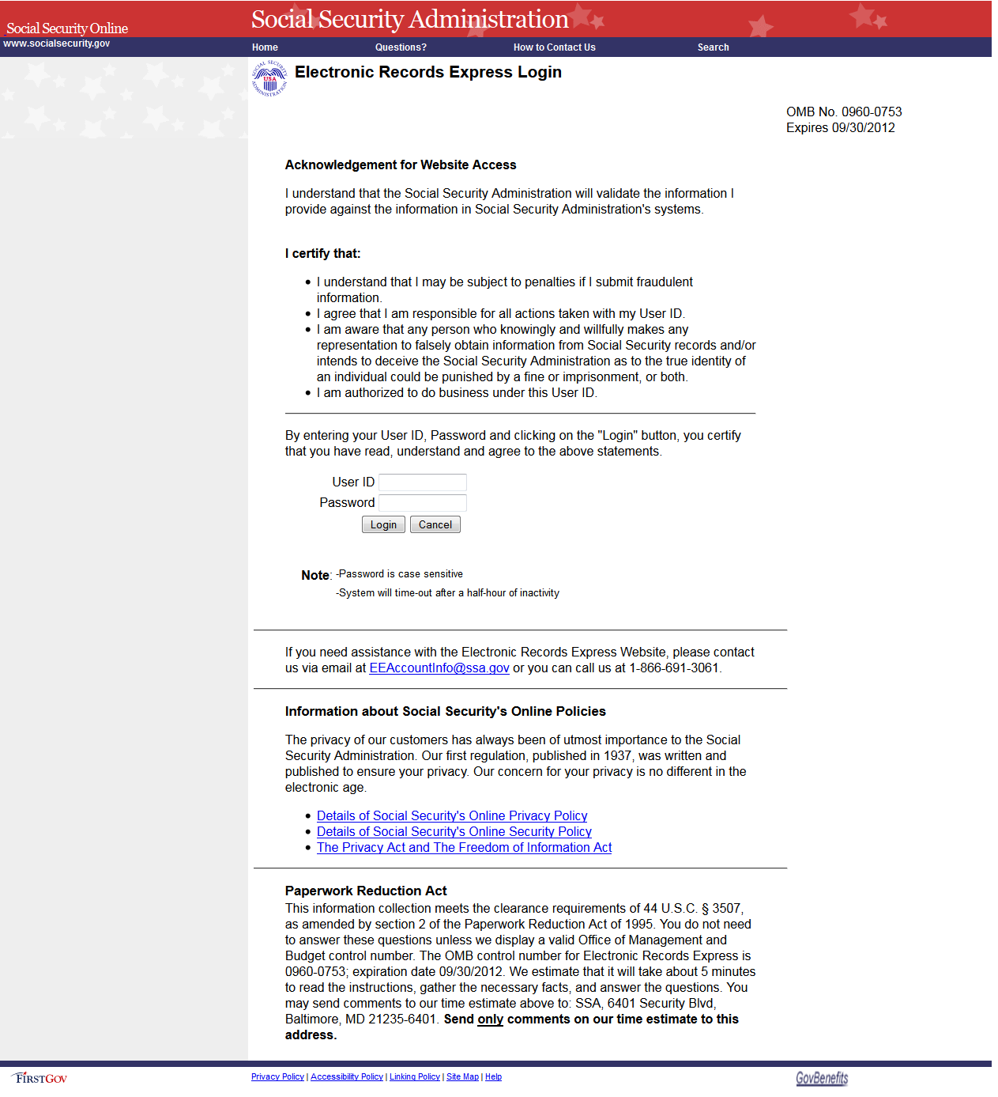

ERE Homepage

Administrator’s homepage view
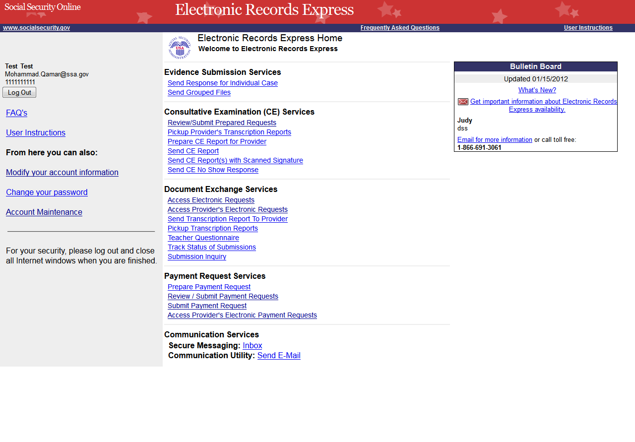

Account Maintenance Screens

Create an Individual End-User Account
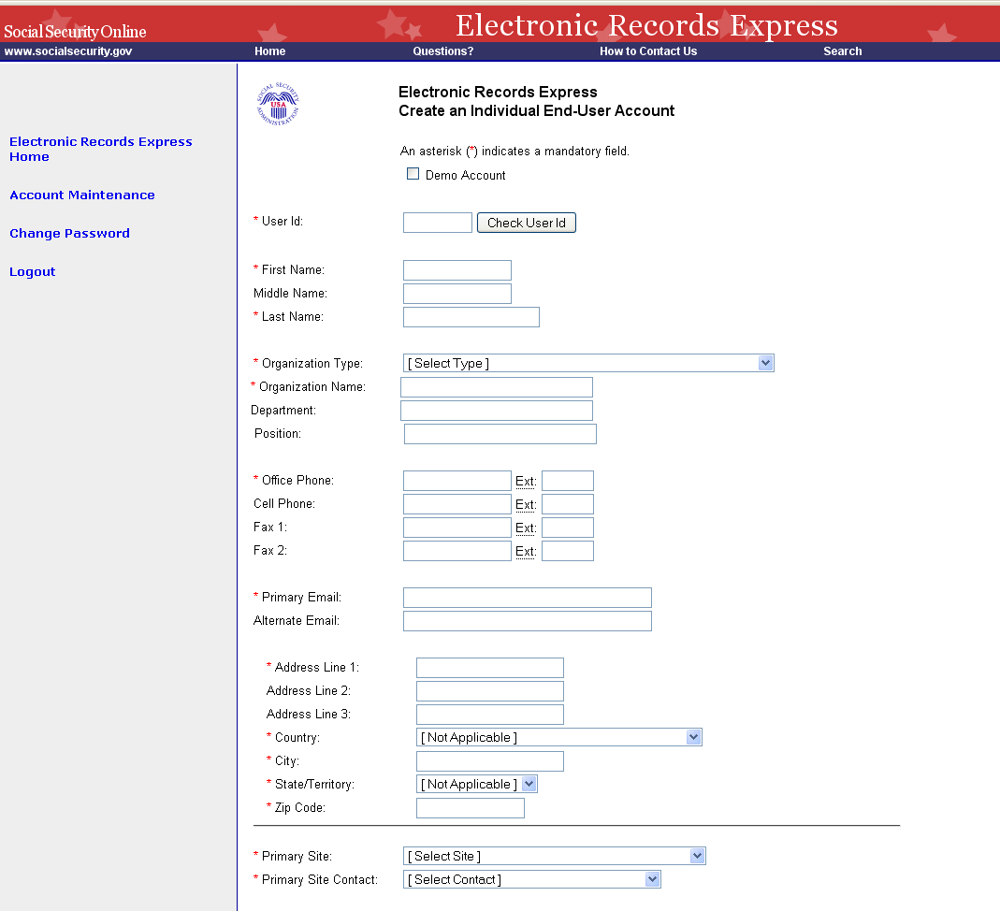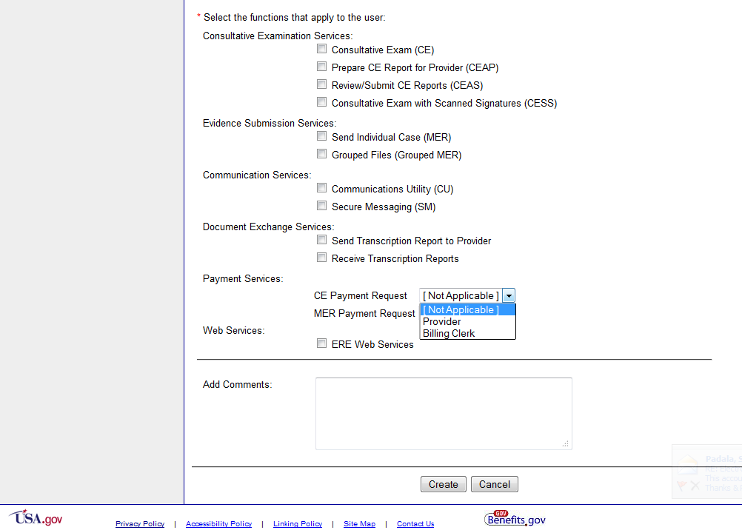

Manage End-User Relationships
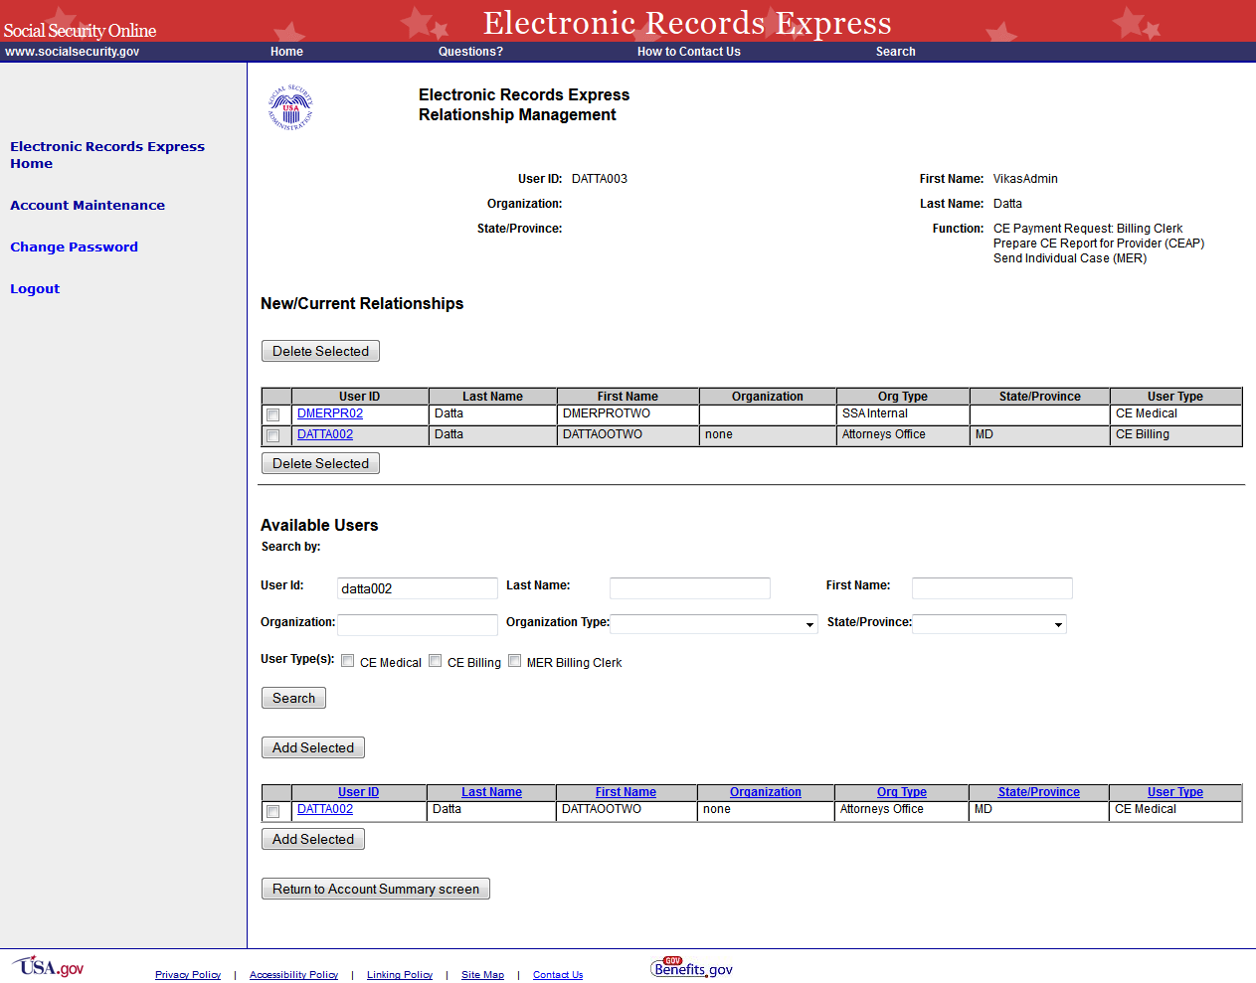

Create Individual End-User Account Summary
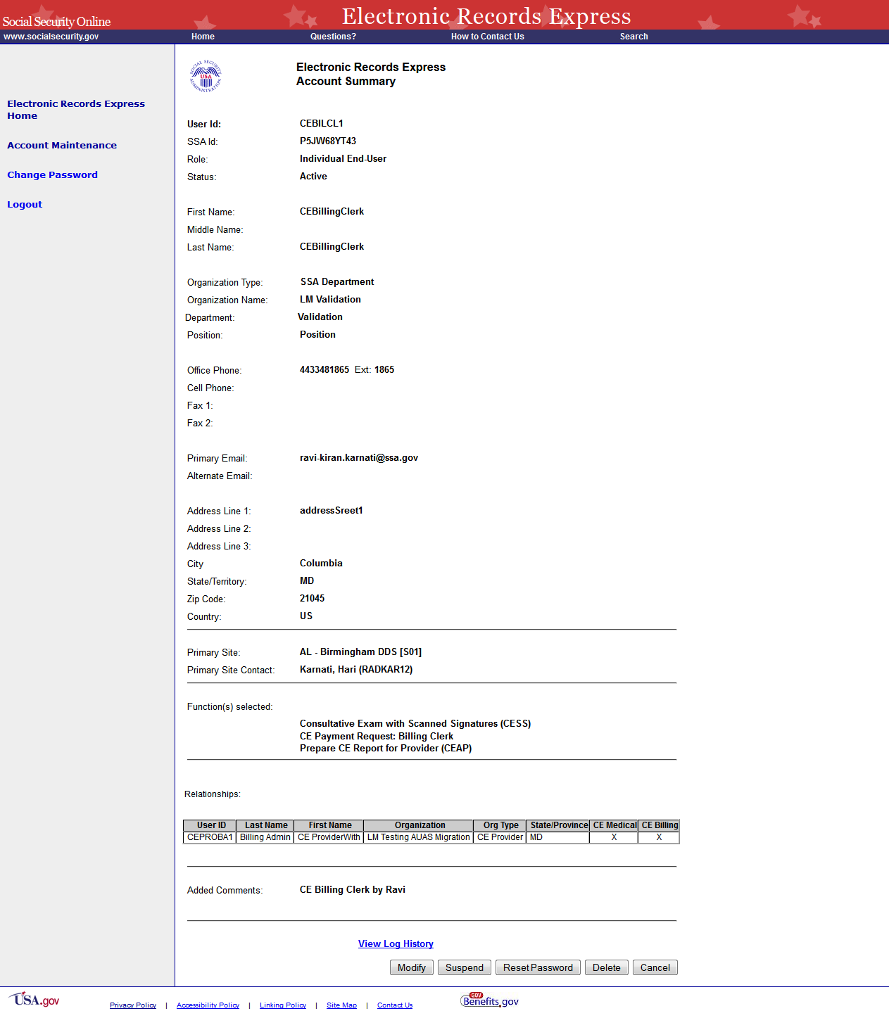

Evidence Submission Services

Send Response for Individual Case

Destination and Request Information
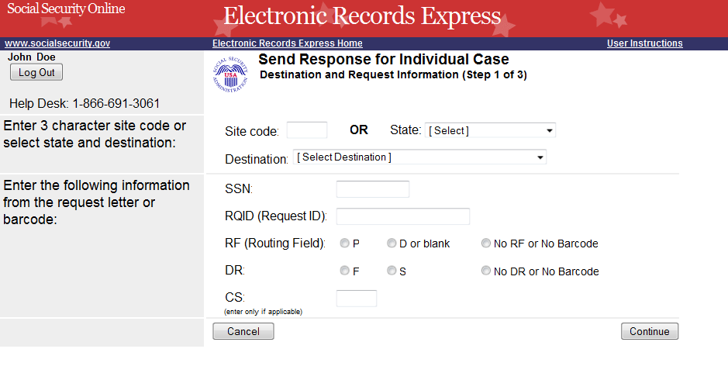

Submit Records
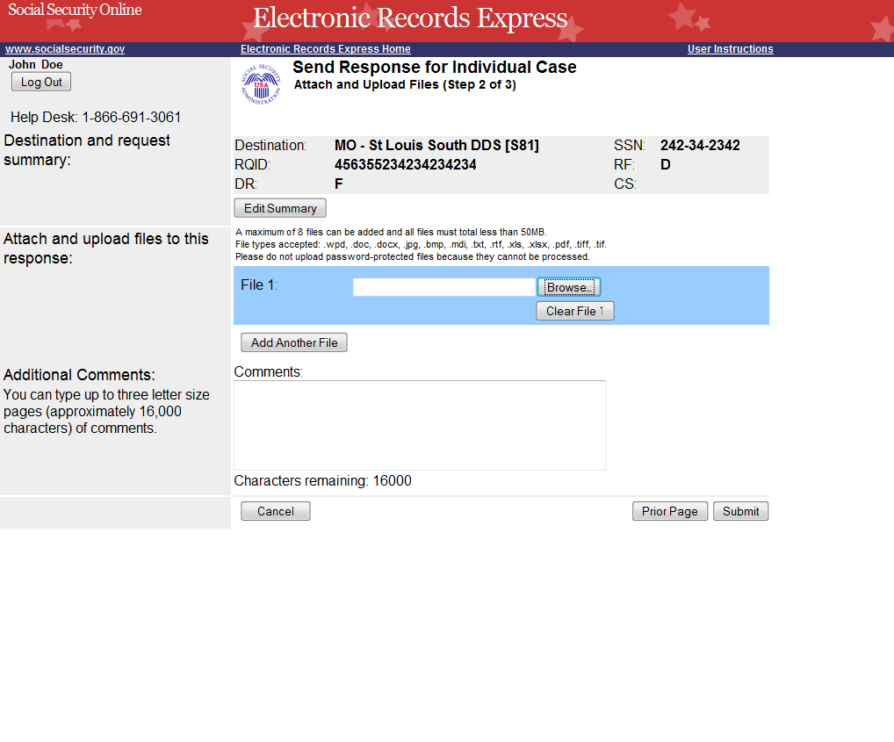

Tracking Page (Site does not do fiscal)
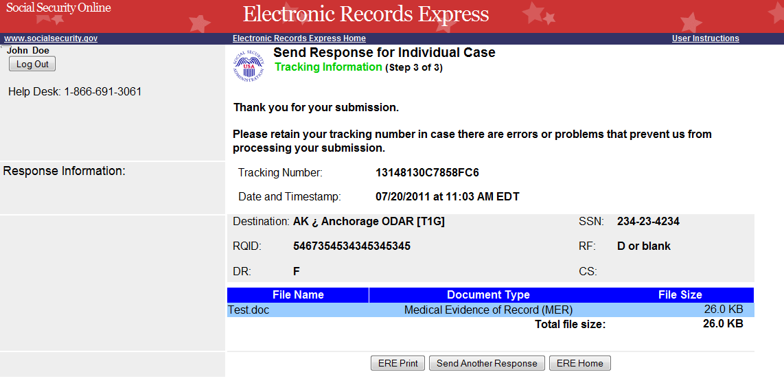

Tracking Page (for site that does fiscal)
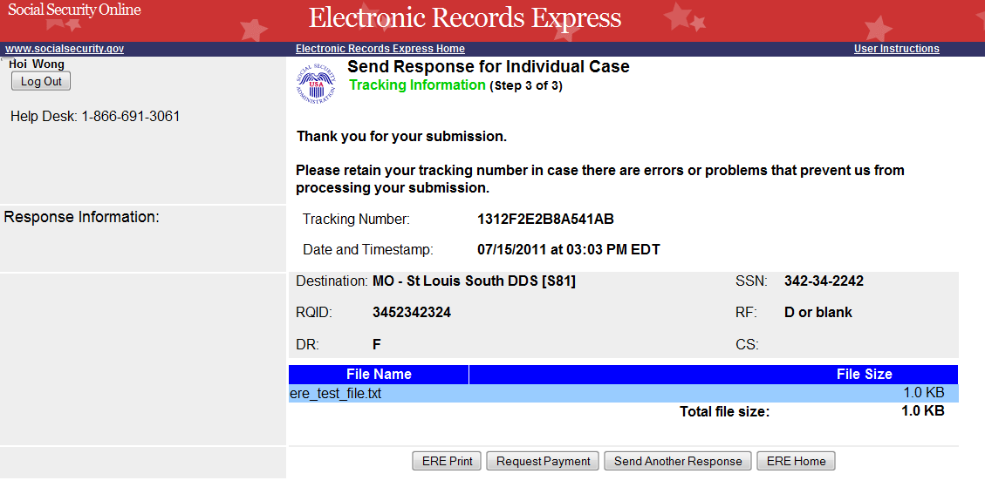

Request Medical Evidence of Record Payment (non-eOR)

Destination and Request Information
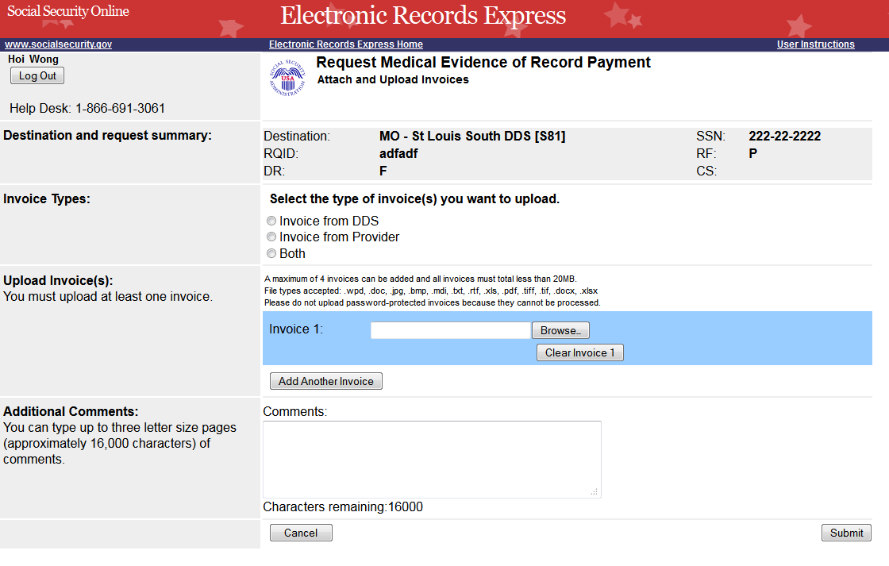

Tracking page
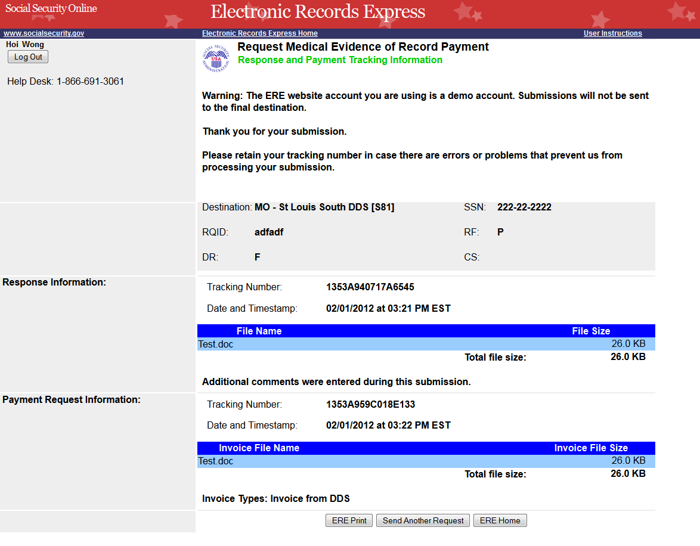

No Records
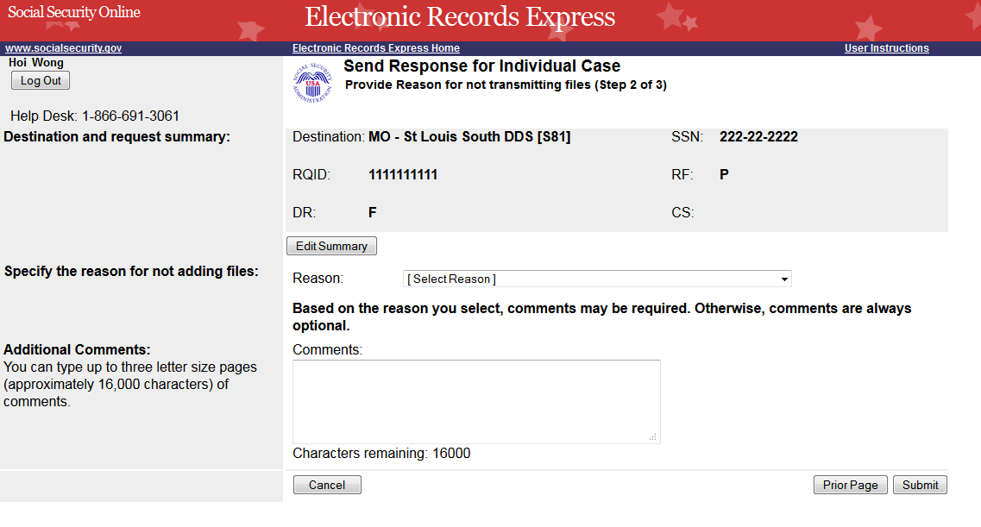

Tracking page
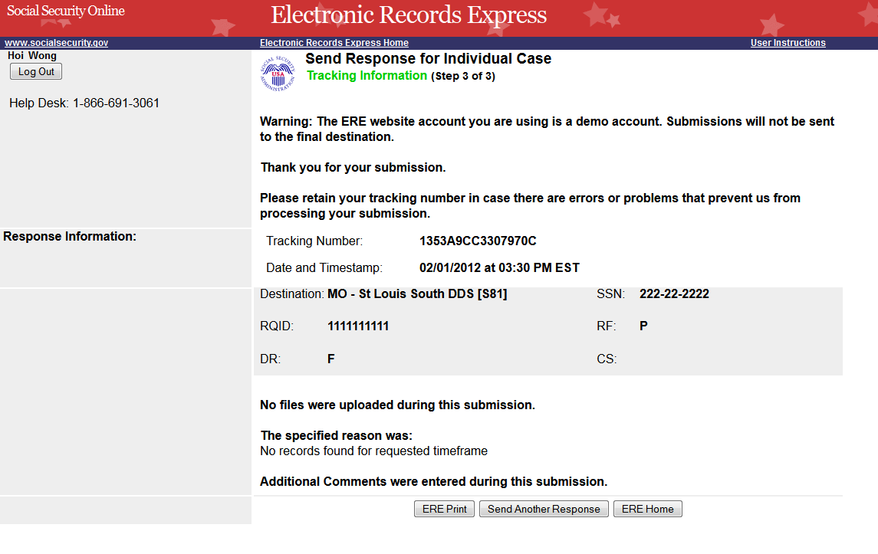

Send Grouped Files

Destination and Documentation Information
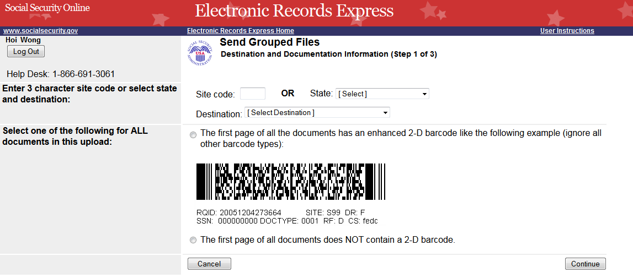

Attach and Upload Files
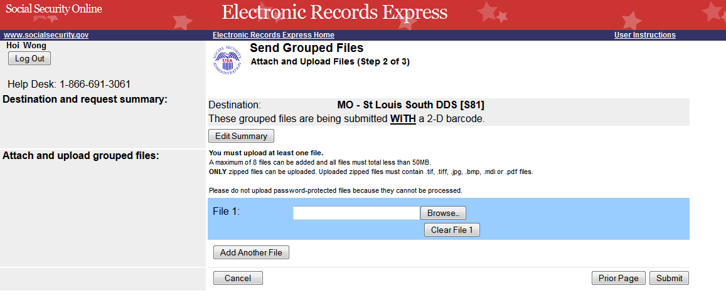

Tracking Page
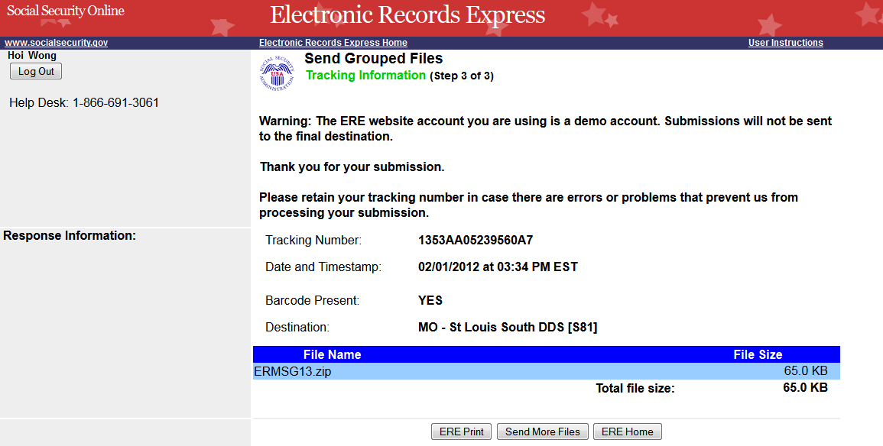

Consultative Examination (CE) Services

Review/Submit Prepared Requests
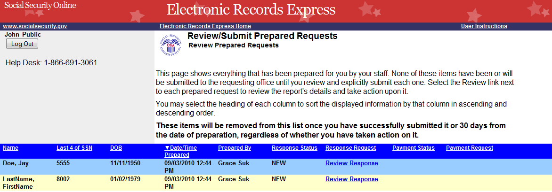

Attach and Upload Files
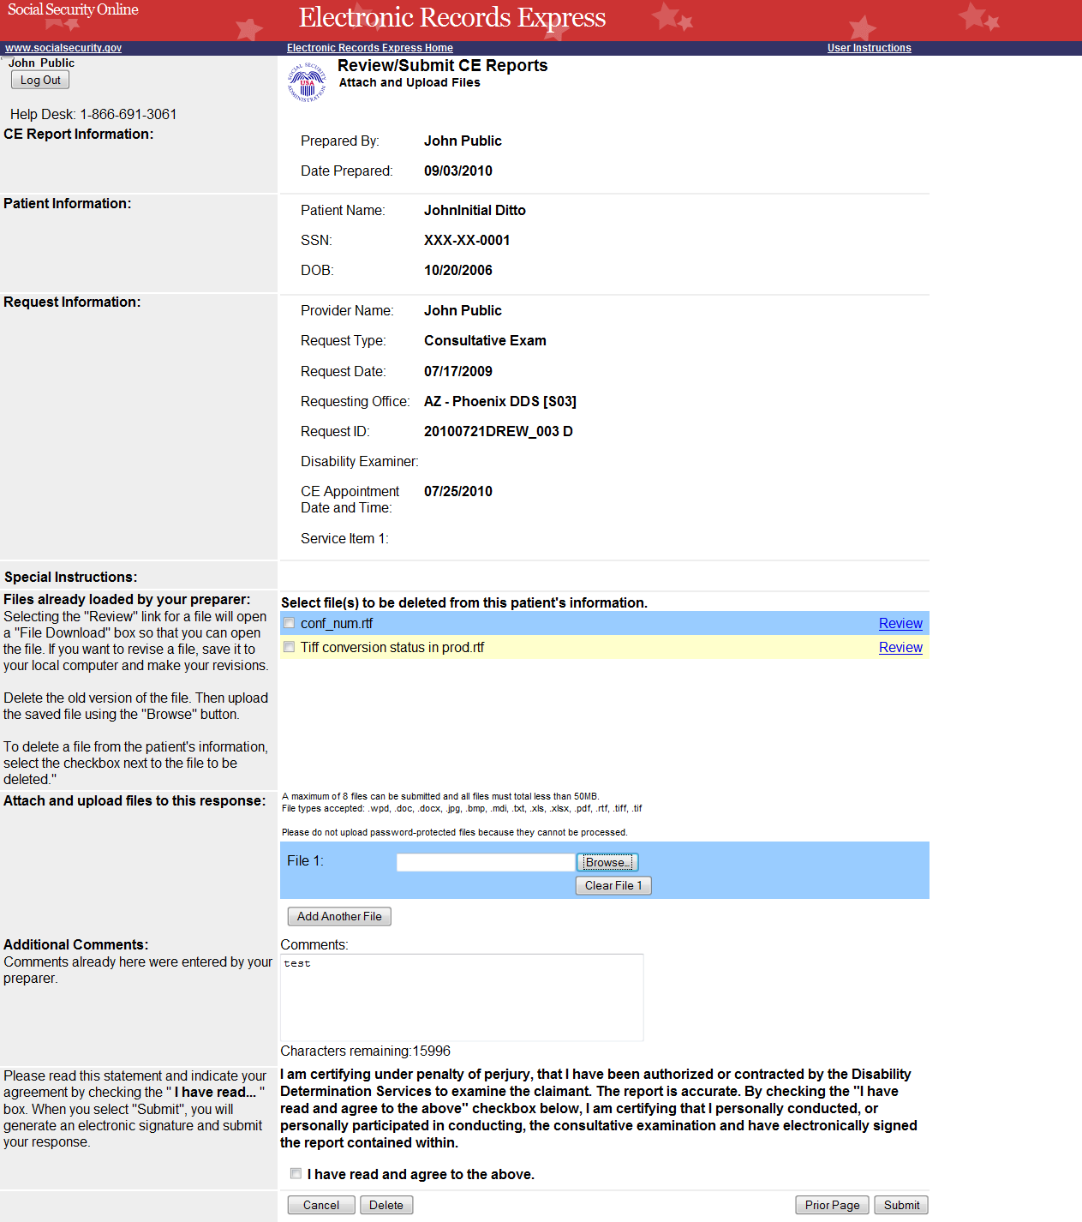

Tracking Information
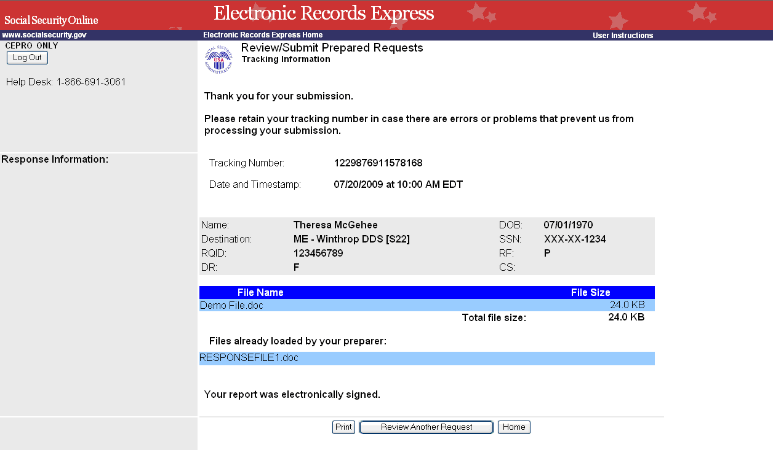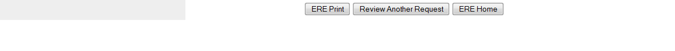

Pickup Provider’s Transcription Reports

Select Provider’s Inbox
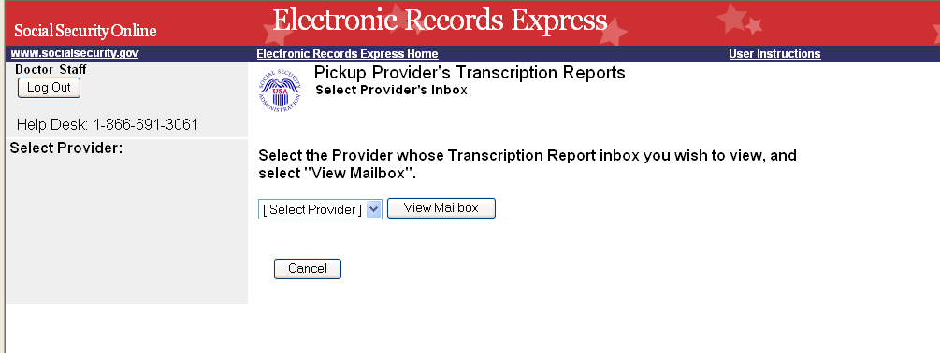

Inbox Folder
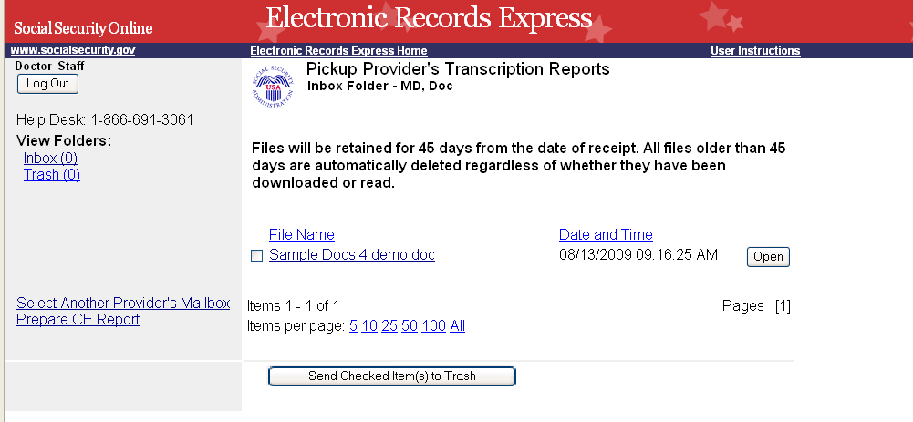

Prepare CE Report for Provider

Preparation
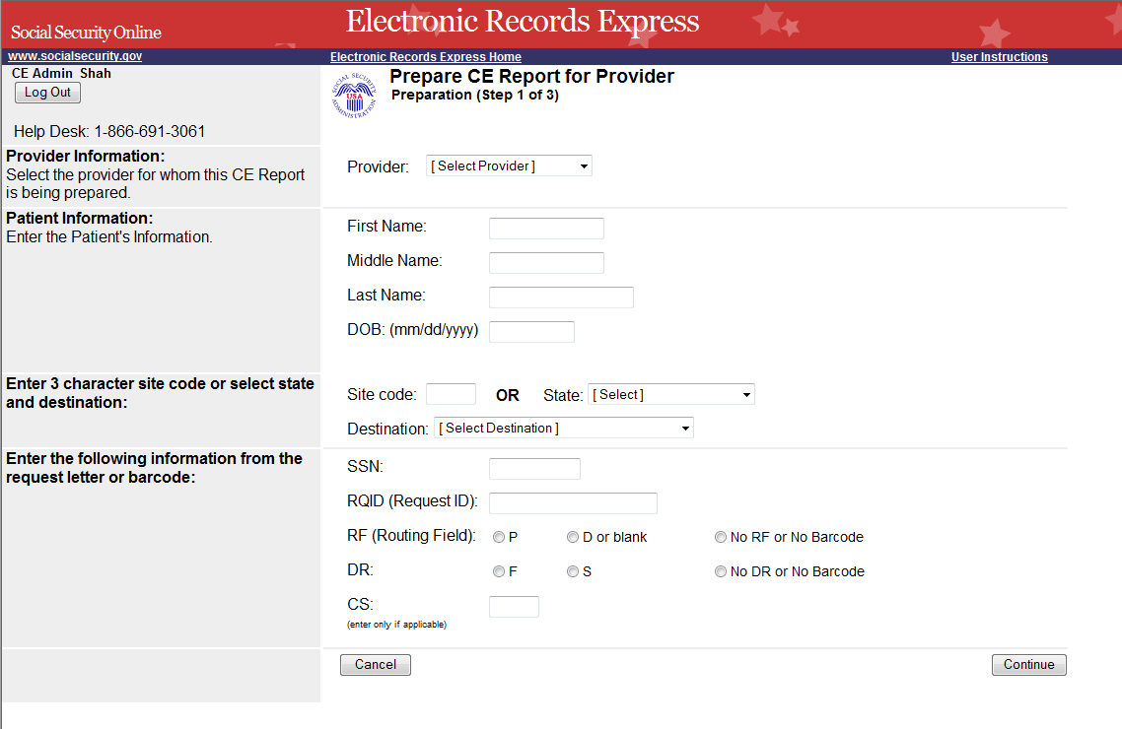

Attach and Upload Files
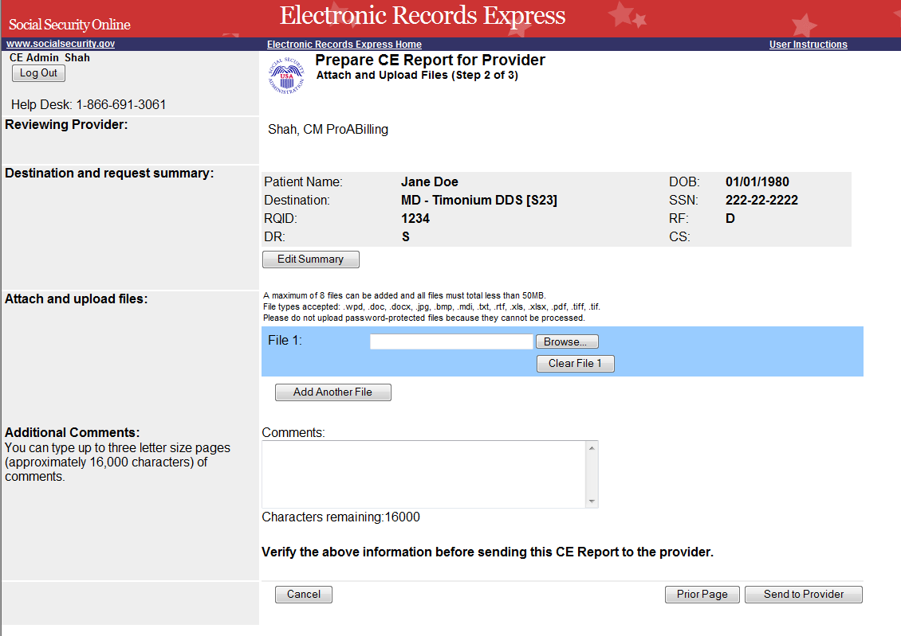

Tracking Information
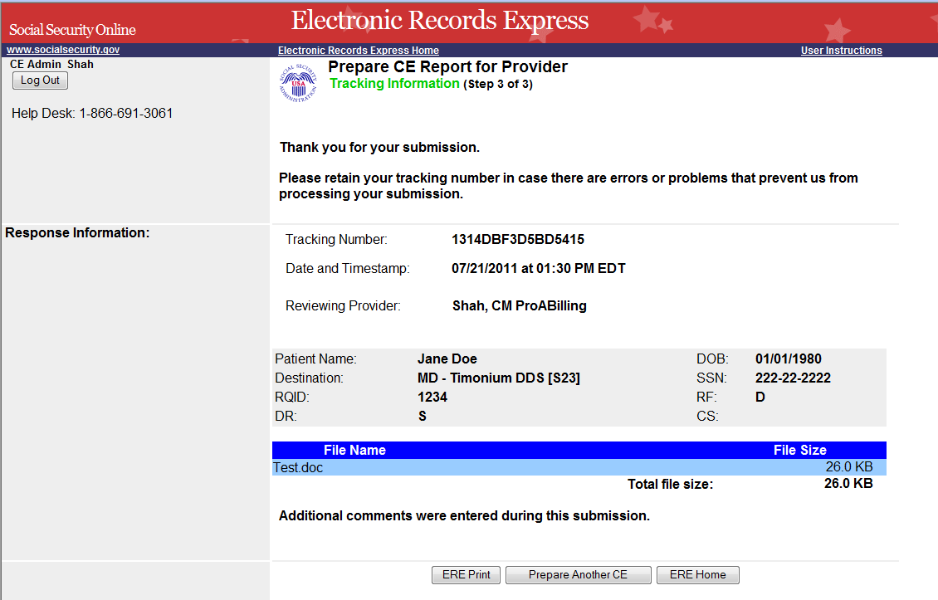

Send CE Report

Destination and Request Information
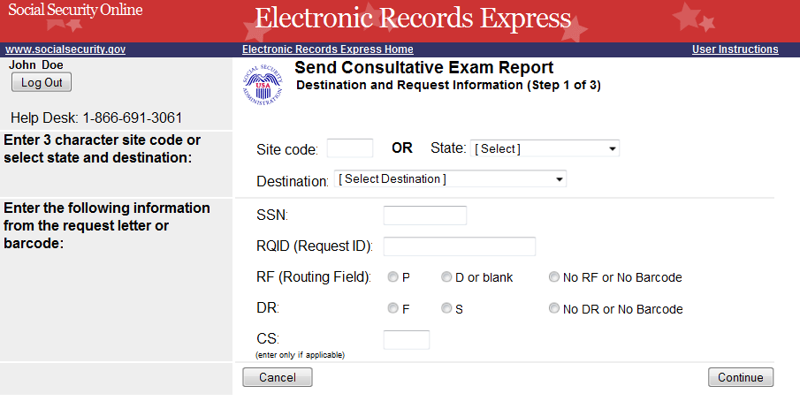

Attach and Upload Files
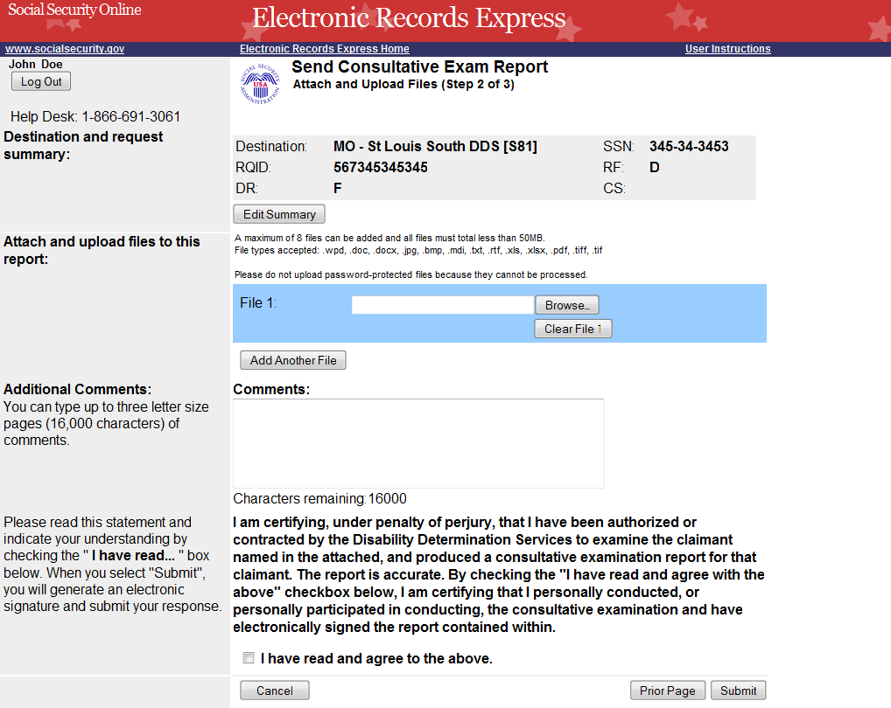

Tracking Information (for site that does fiscal)
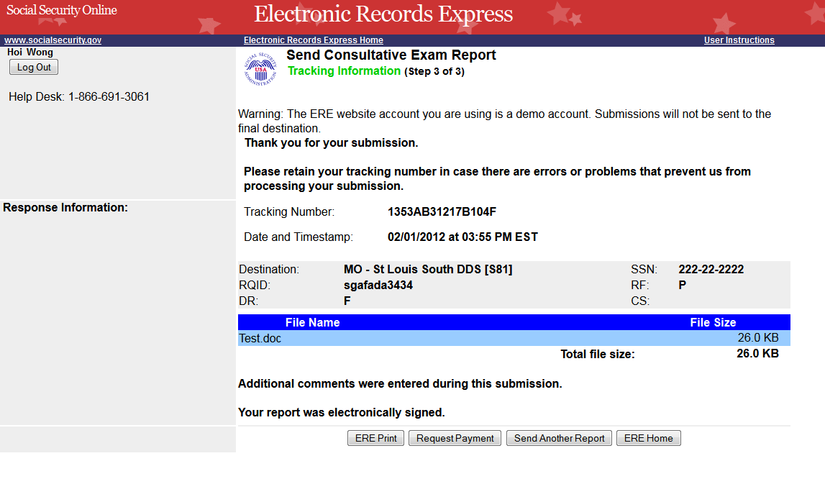

Request Consultative Exam (CE) Payment

Attach and Upload Invoices
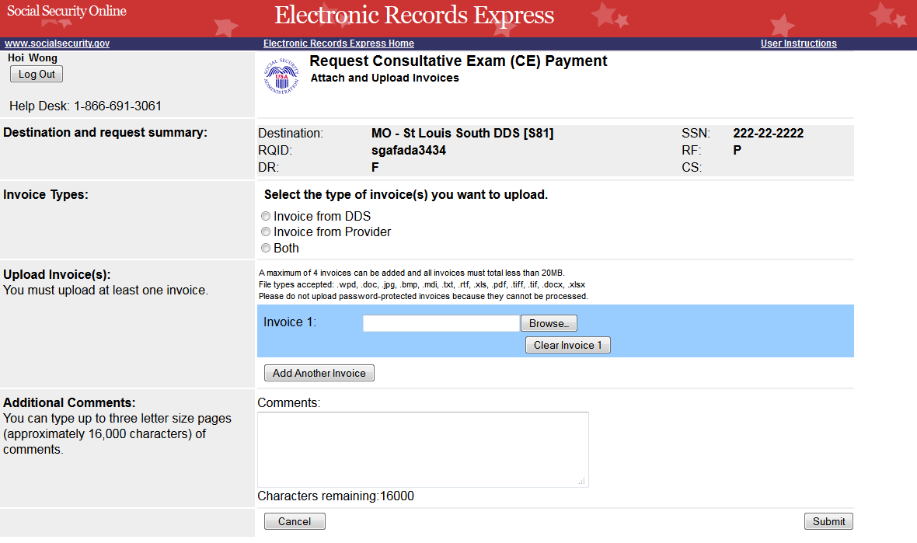

Tracking page
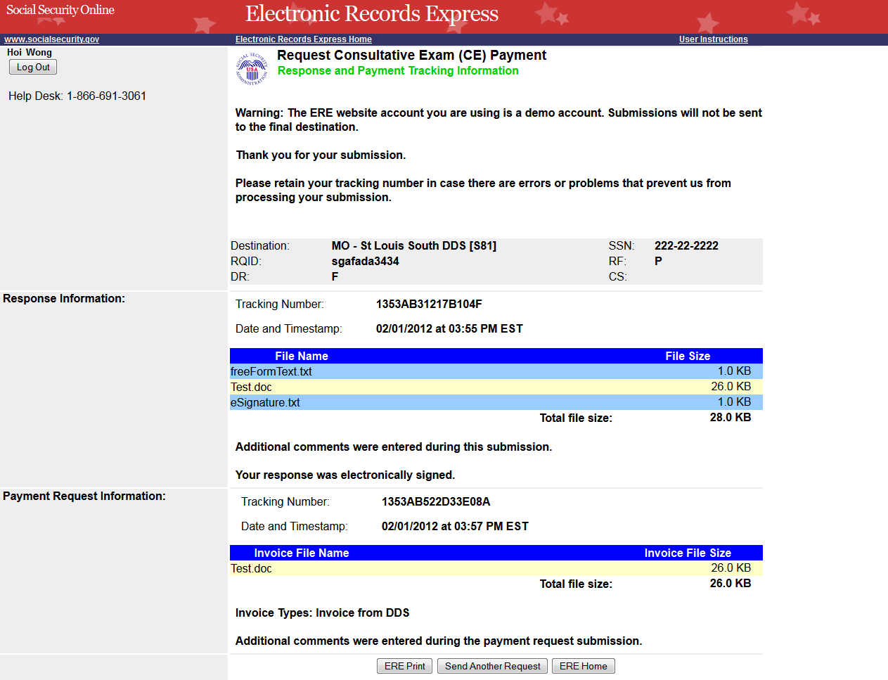

Send CE Report(s) with Scanned Signature

Destination and Documentation Information
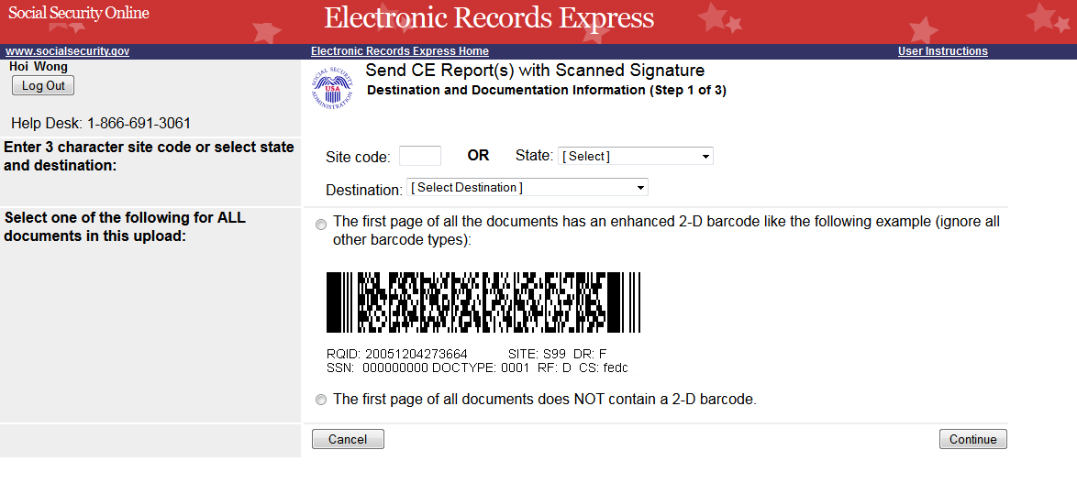

Attach and Upload Files
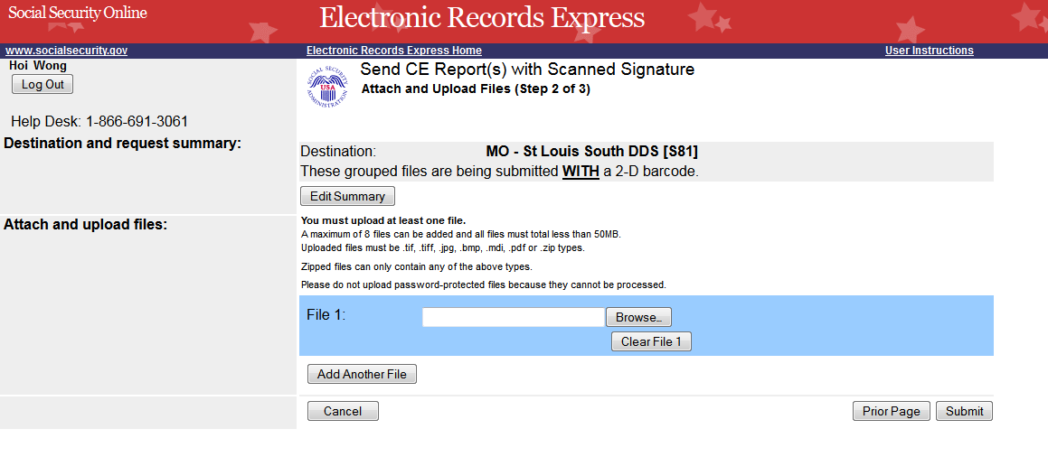

Tracking Information
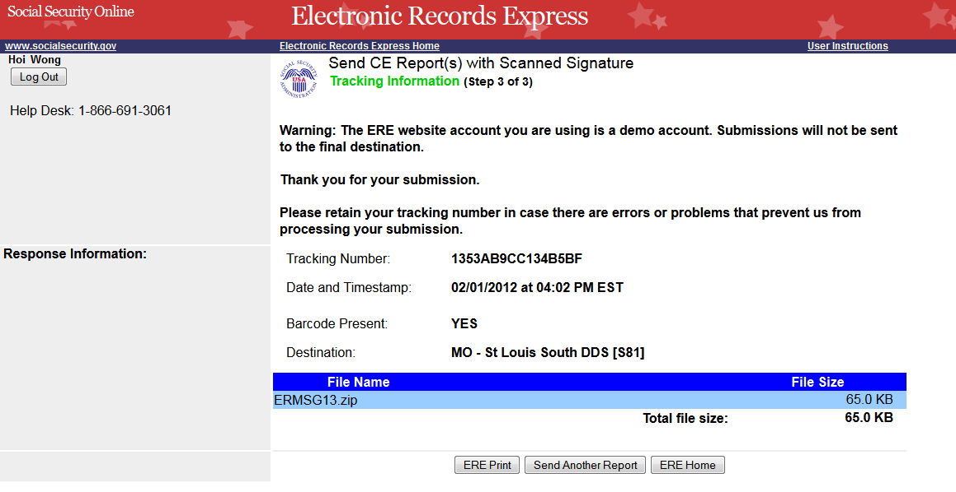

Send CE No Show Response

Destination and Request Information
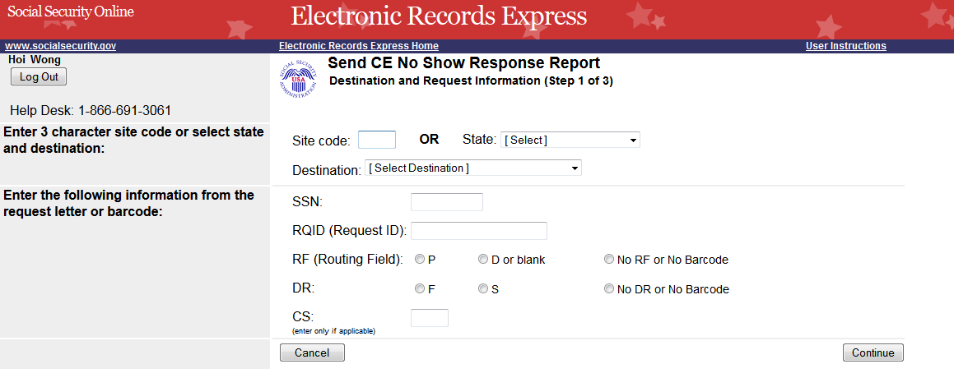

Complete Reason
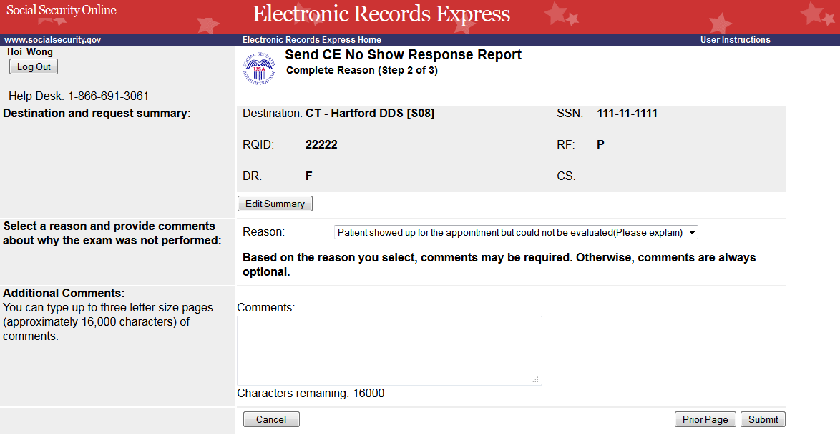

Tracking Information
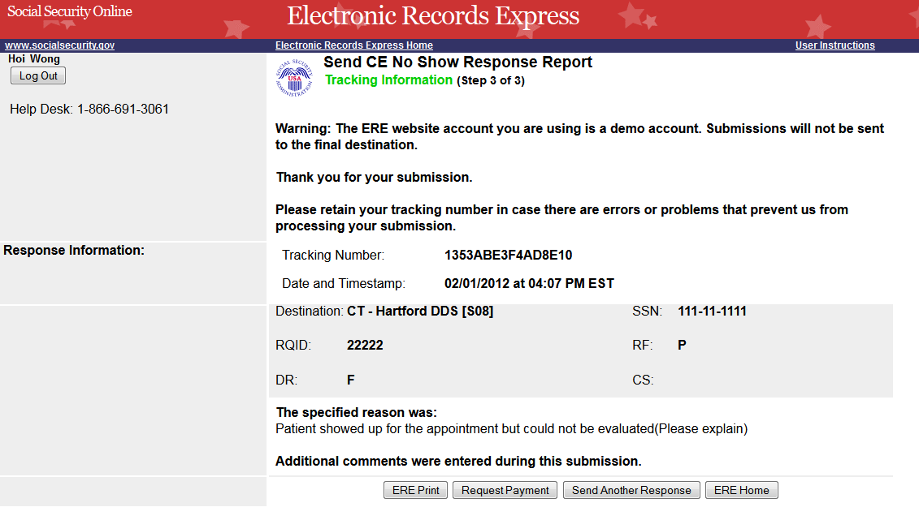

Request Payment for CE No Show Response

Attach and Upload Invoices
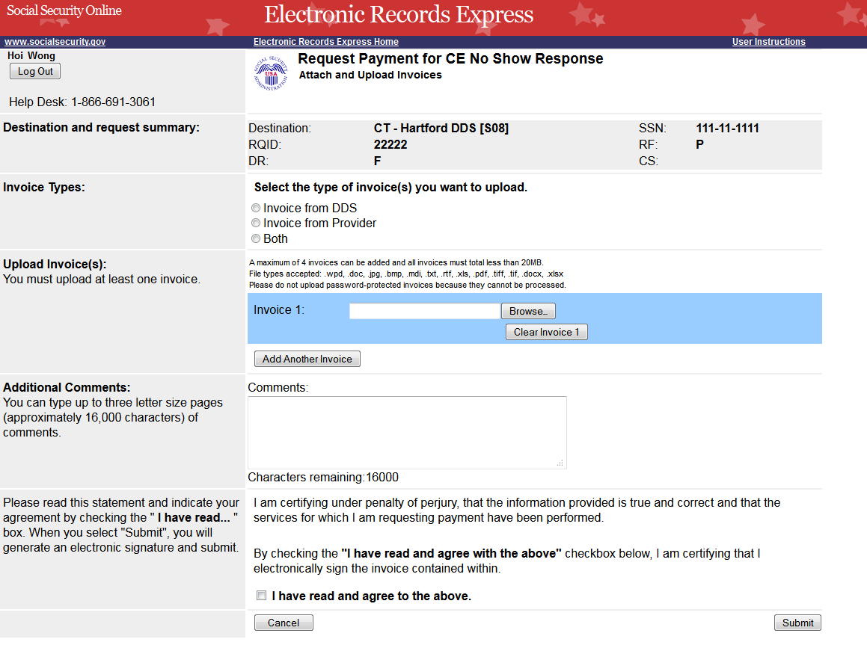

Tracking Information
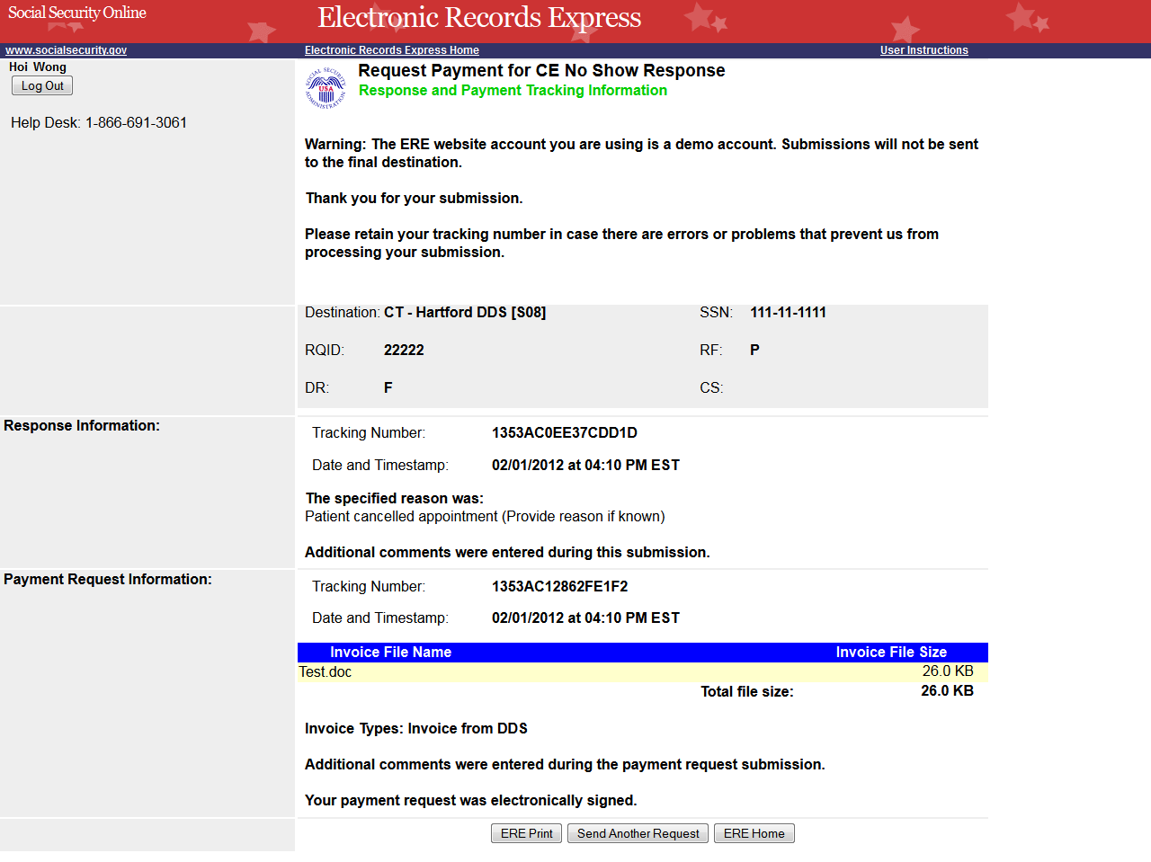

Document Exchange Services

Access Electronic Requests

Open Requests Page
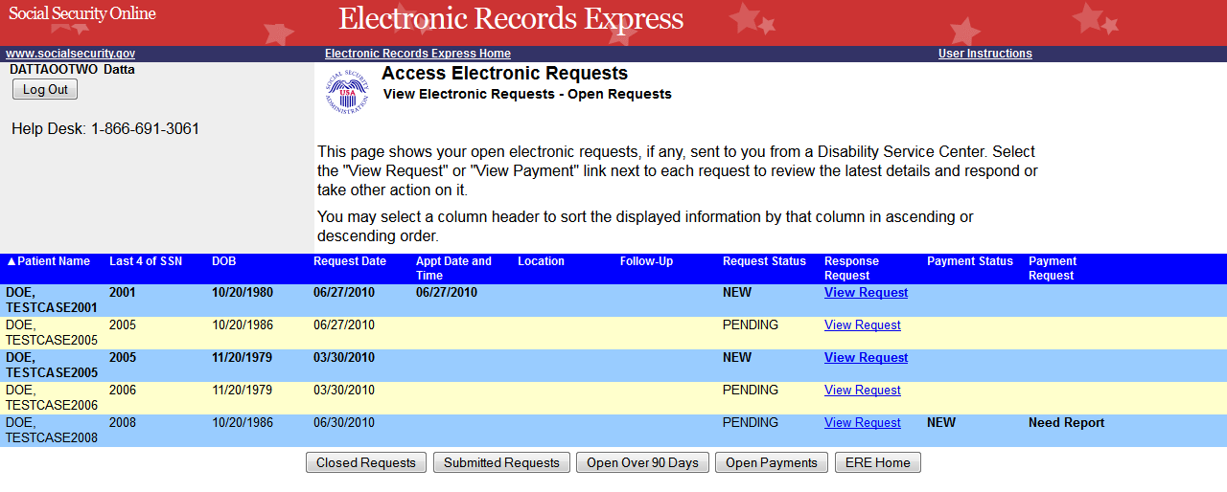

CE Request Details/Upload
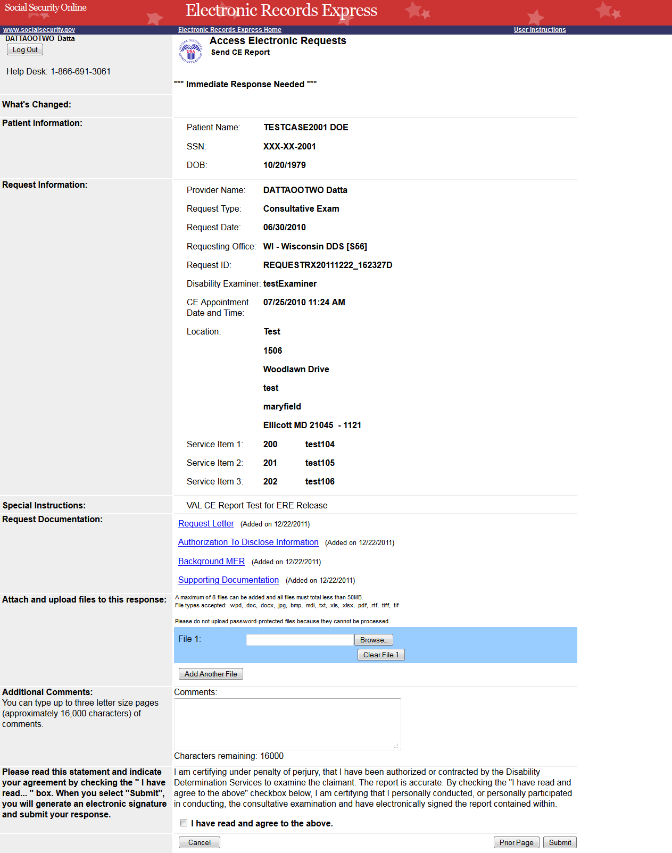

Tracking Information (Site does not do fiscal)
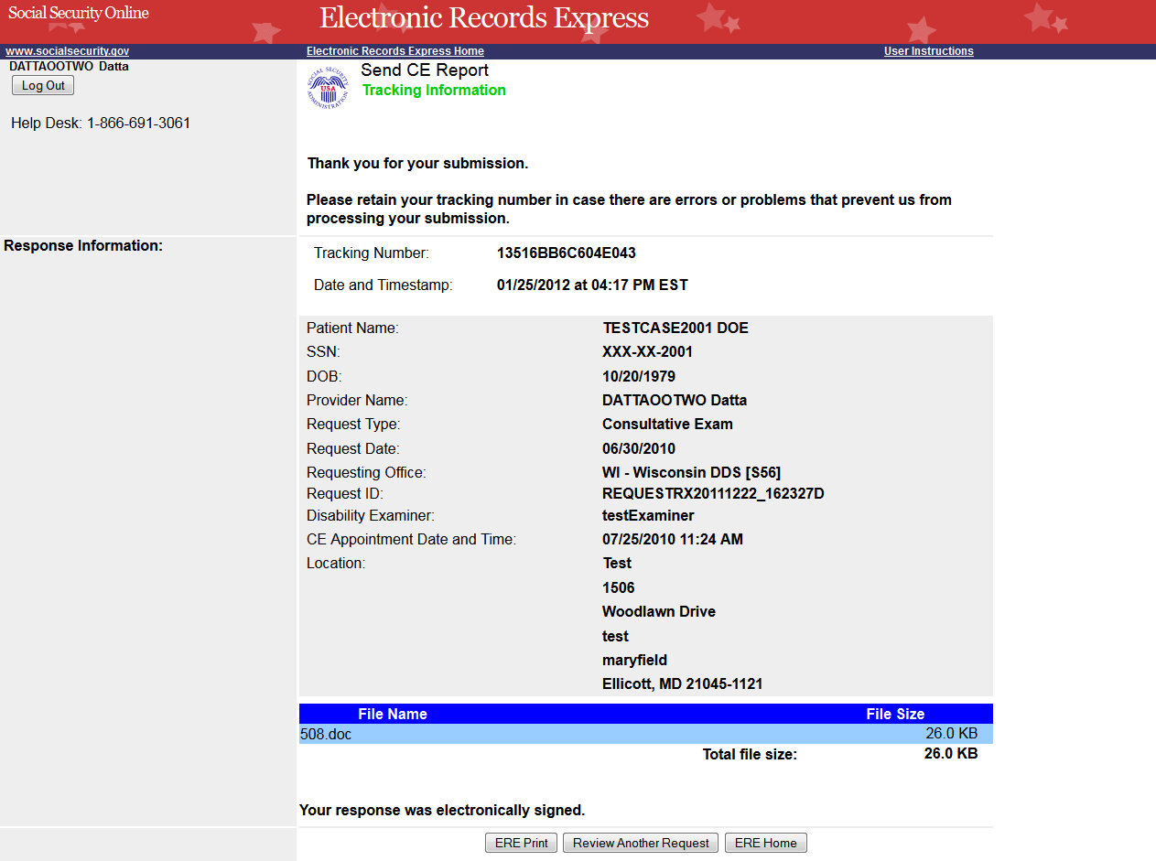

Tracking Information (Site does fiscal)
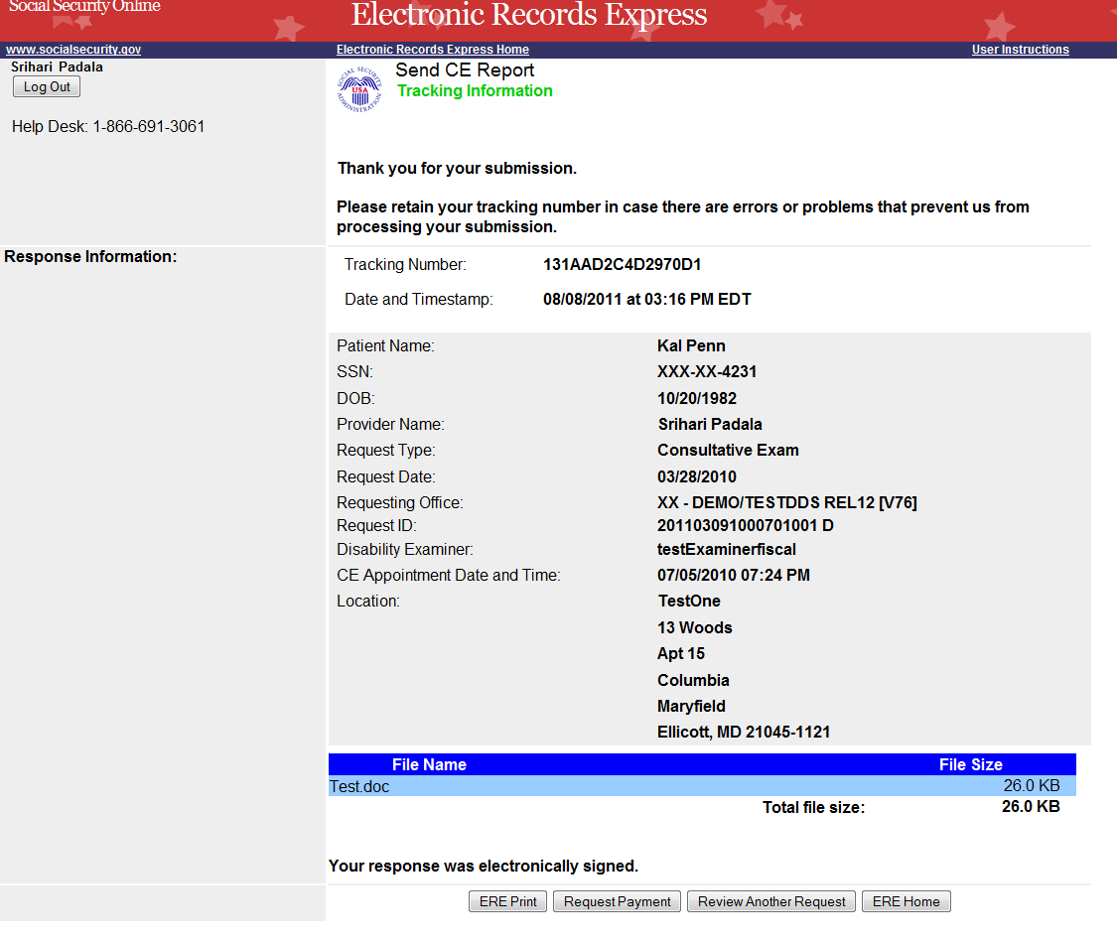

Request Consultative Exam (CE) Payment (eOR)

Payment Information
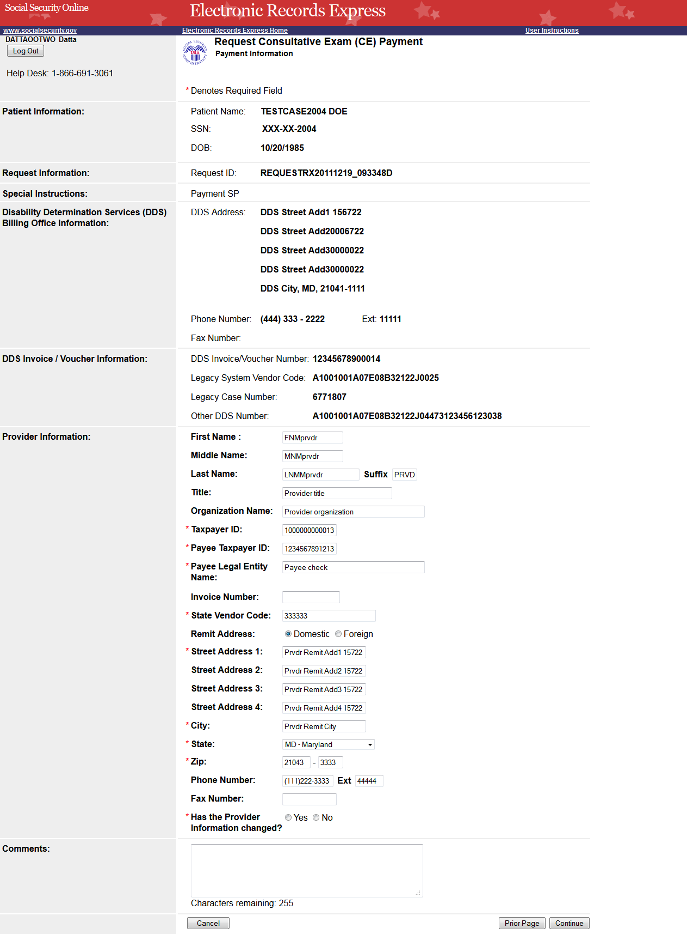

CE Services Performed
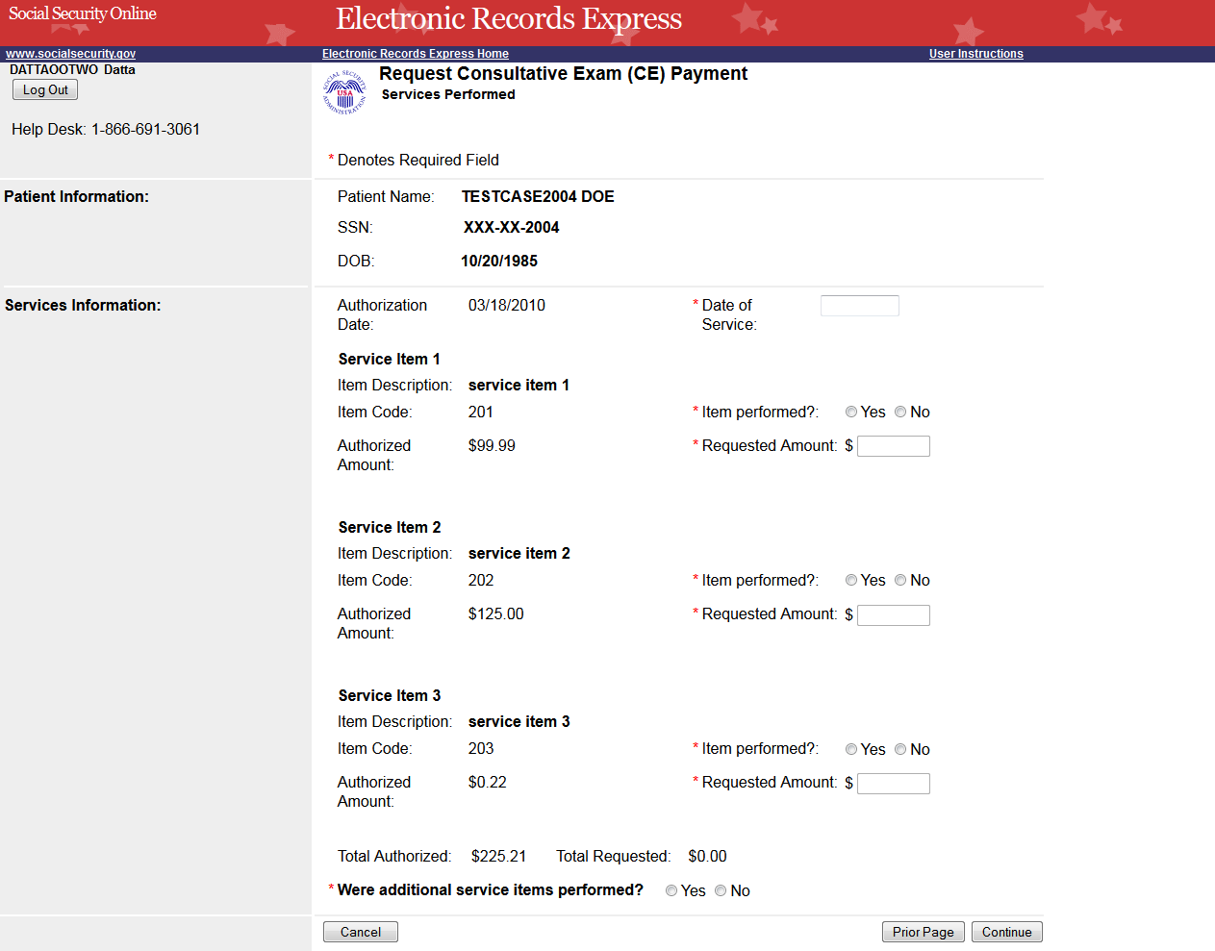

Additional Services
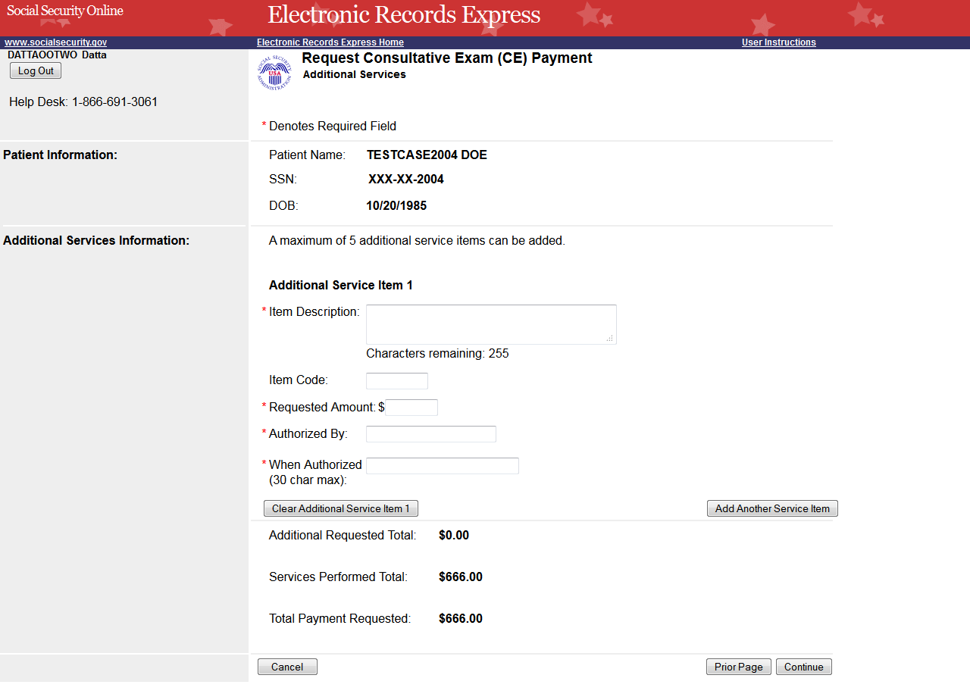

Payment Information Summary
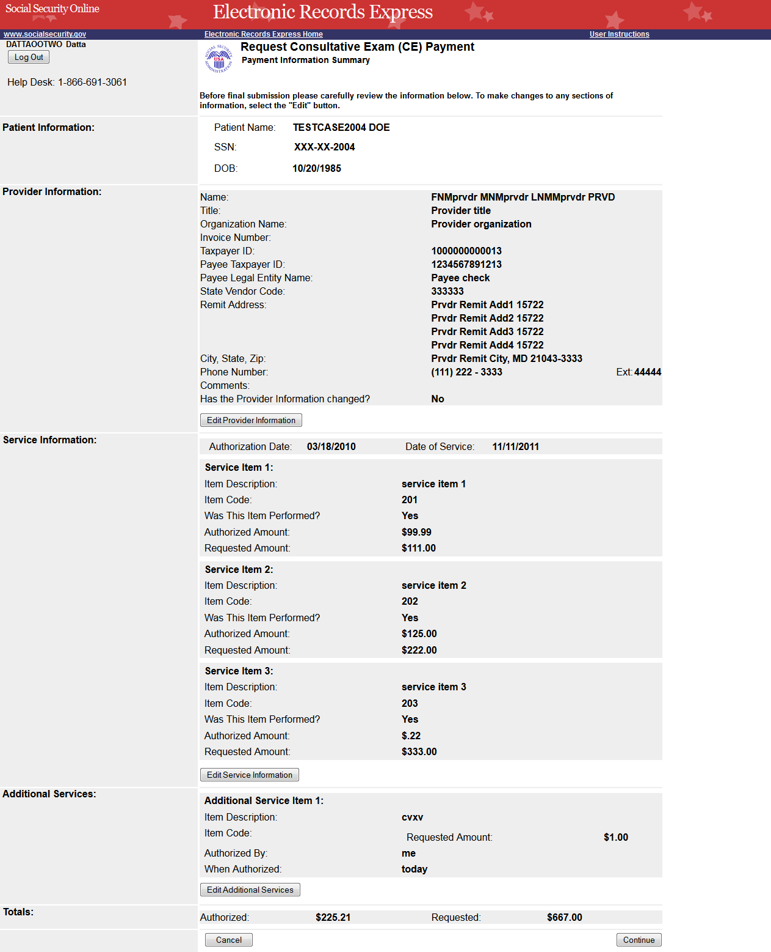

Attach and Upload Invoices
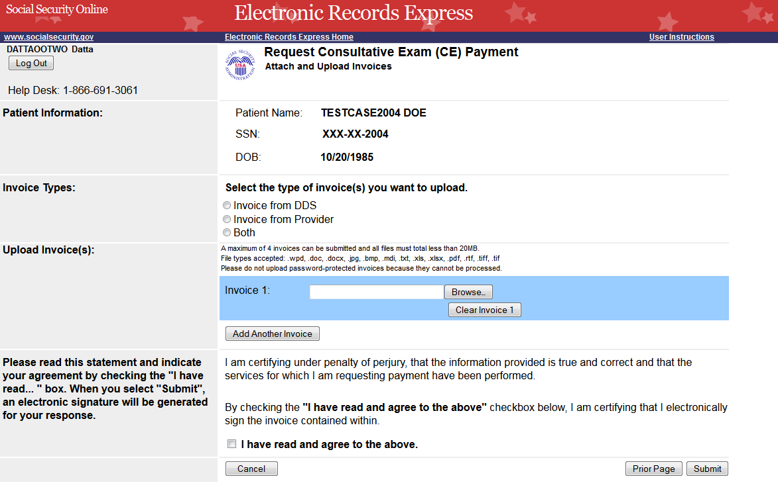

CE Response/Payment Request Tracking Information
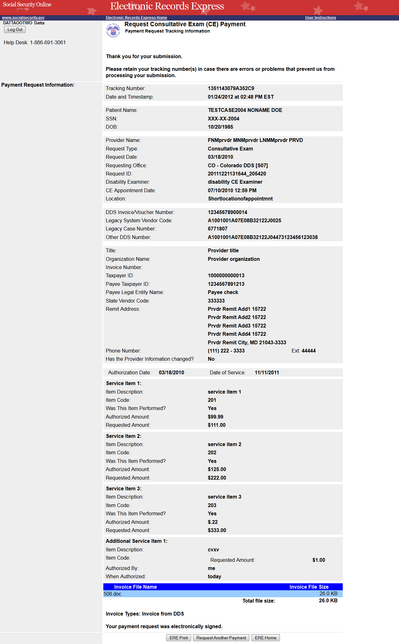

Request Medical Evidence of Record Payment (eOR)

Payment Information
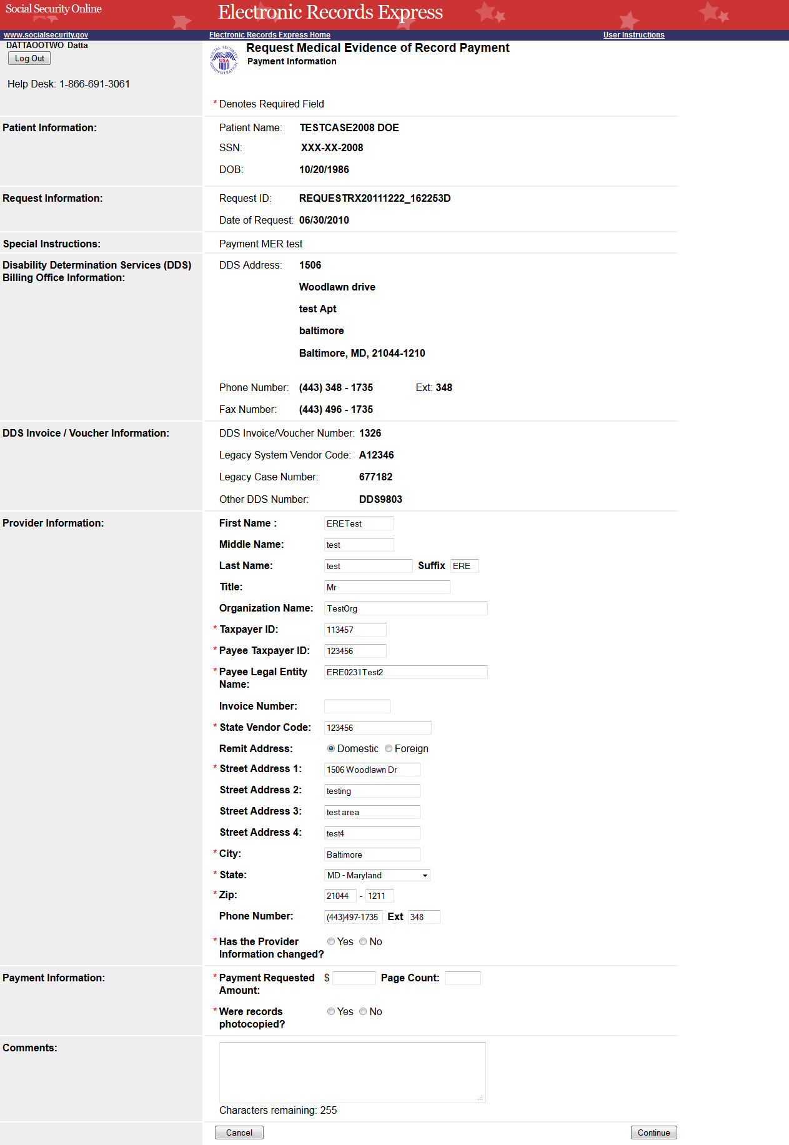

Attach and Upload Invoice
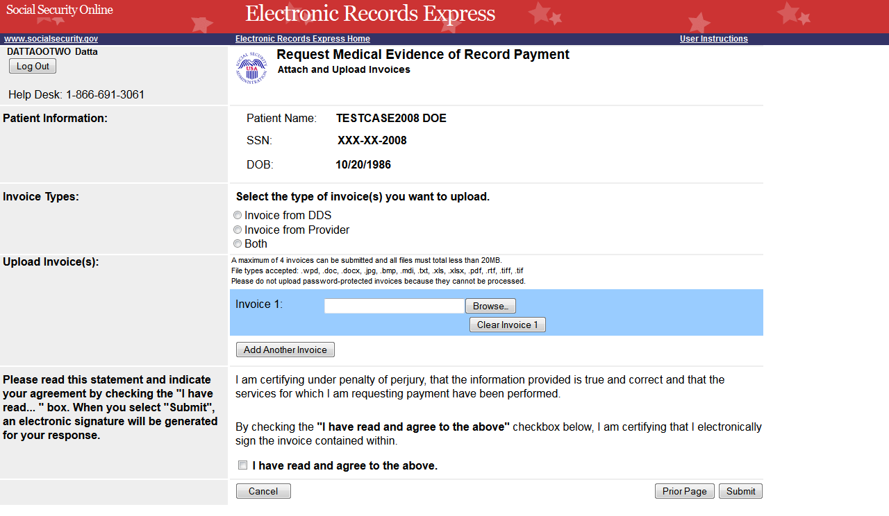

Payment Information Summary
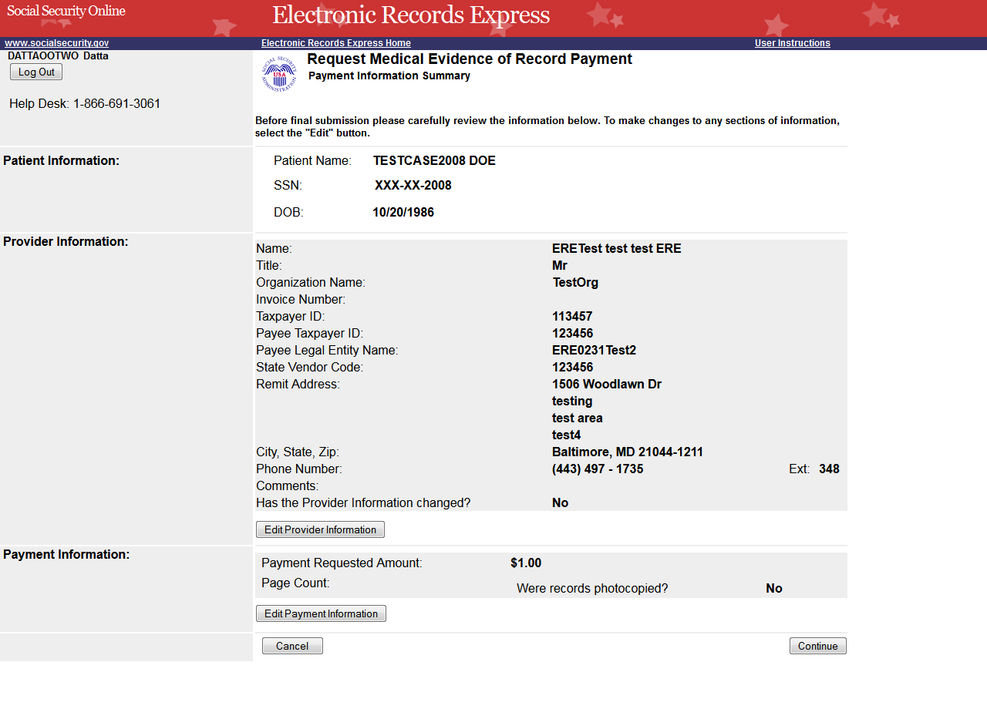

Response and Payment Tracking Information
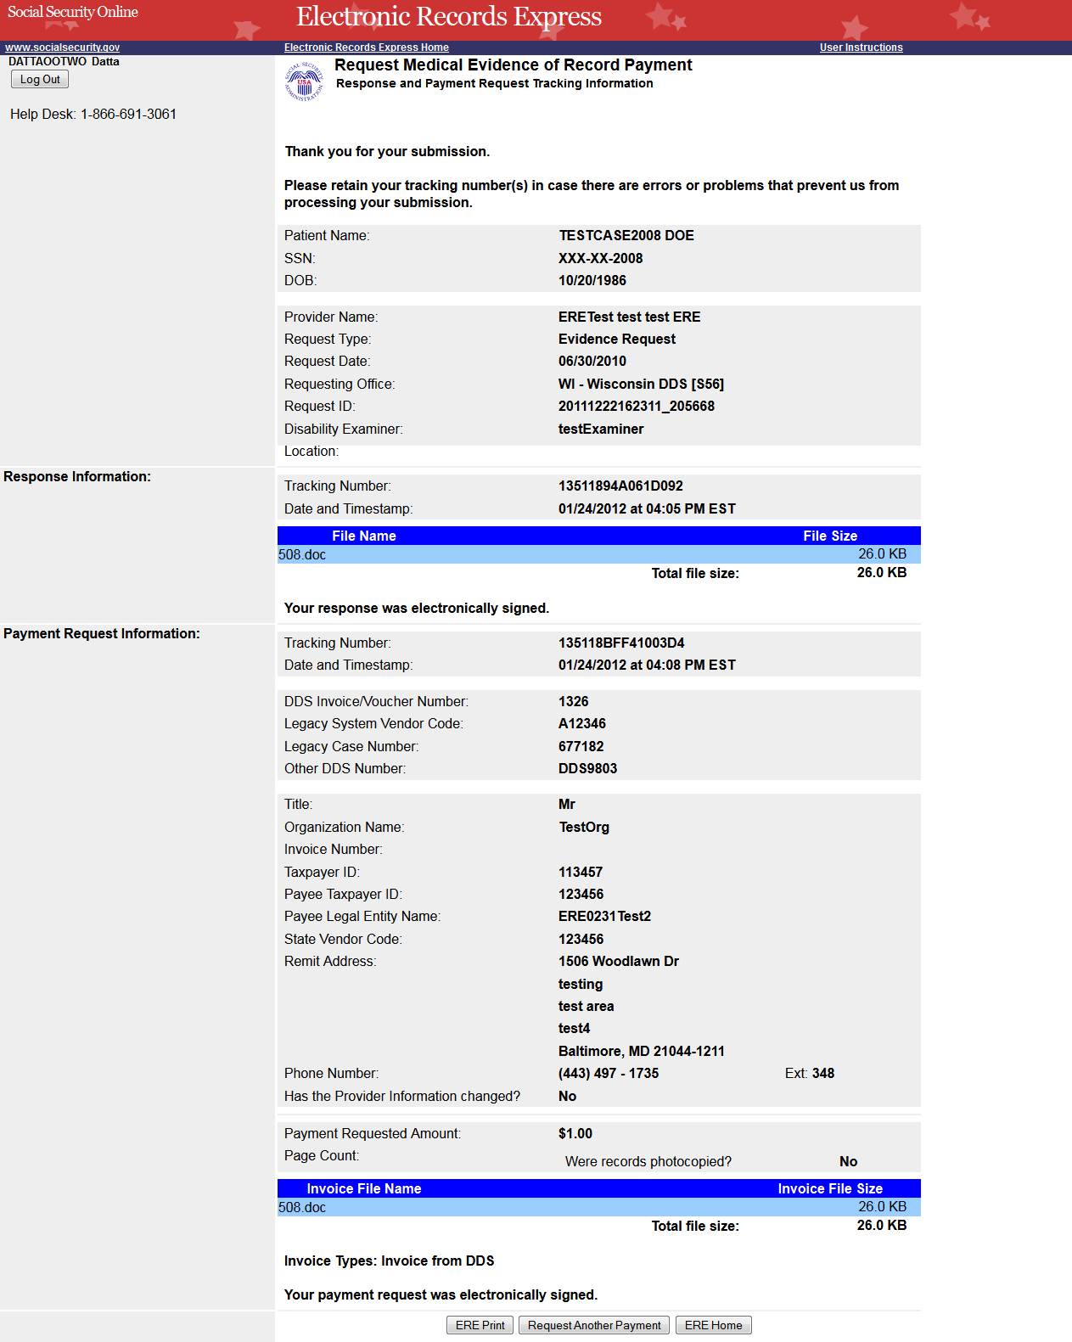

Access Provider’s Electronic Payment Requests

View Provider’s Electronic Requests – Open Requests
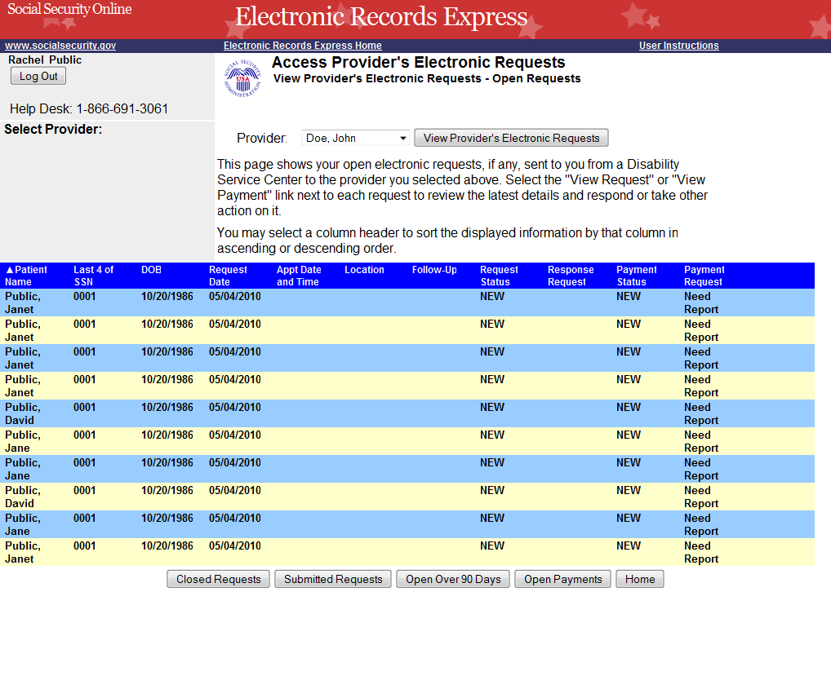

View Provider’s Electronic Requests – Submitted Requests
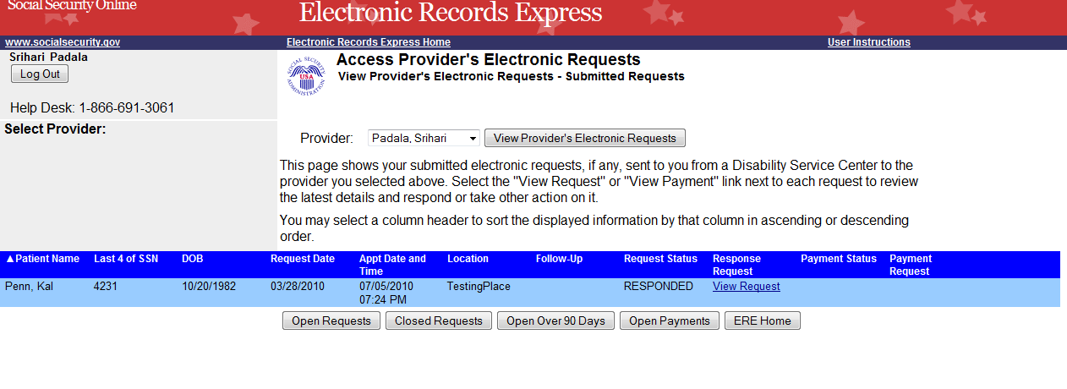

Electronic Request Details
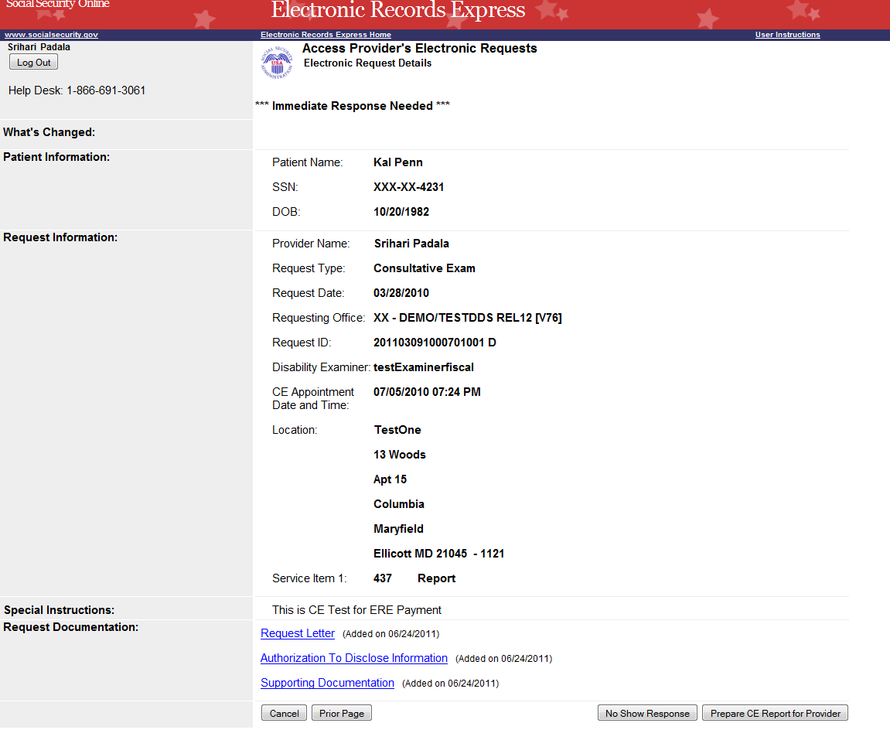

Prepare CE Report for Provider (eOR)
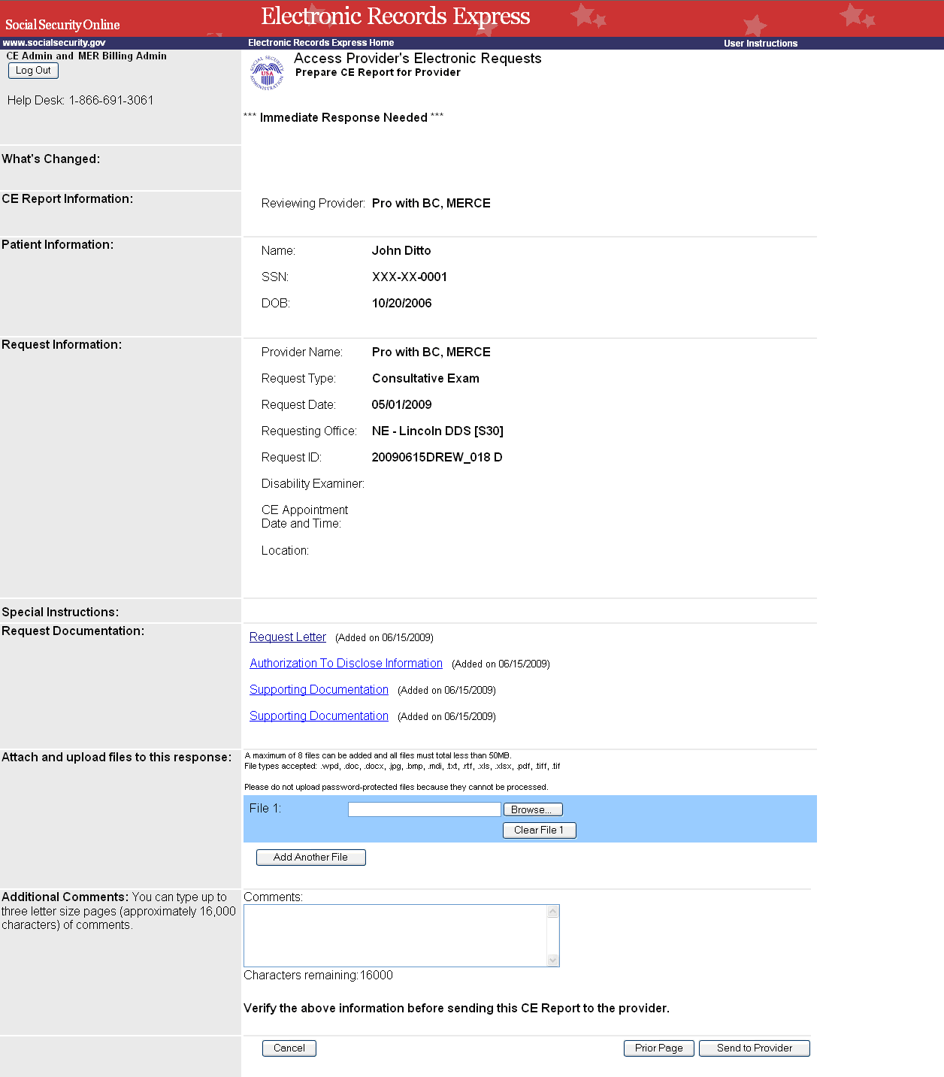

Tracking Information
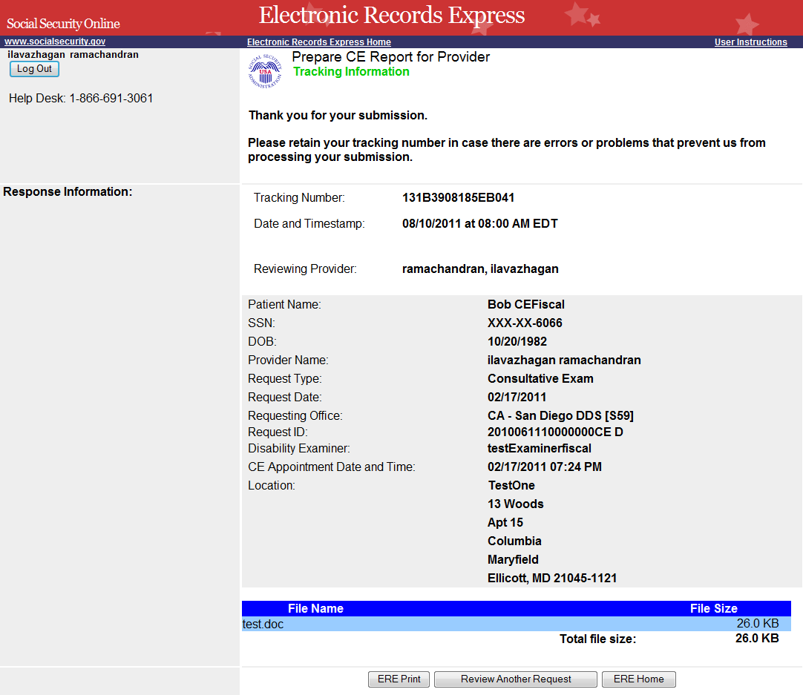

Send Transcription Report to Doctor

Destination and File Attachment
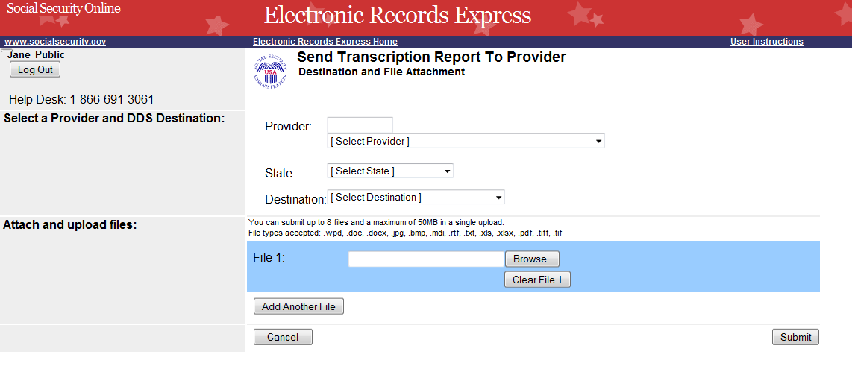

Tracking Information
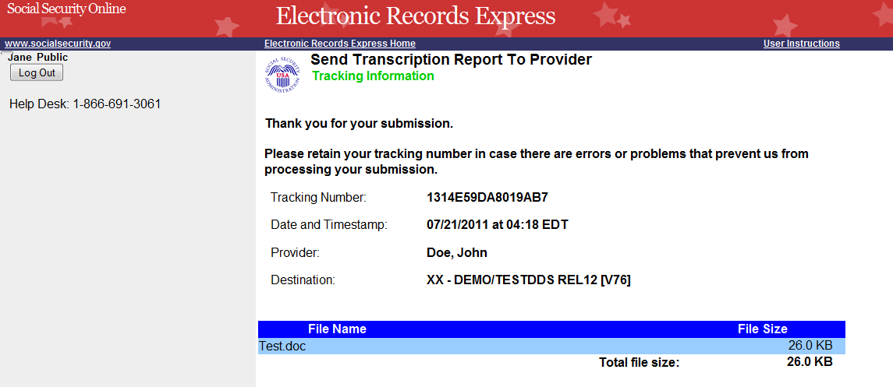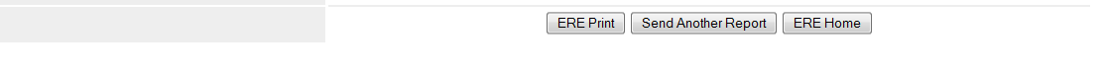

Pickup Transcription Report

Inbox Folder
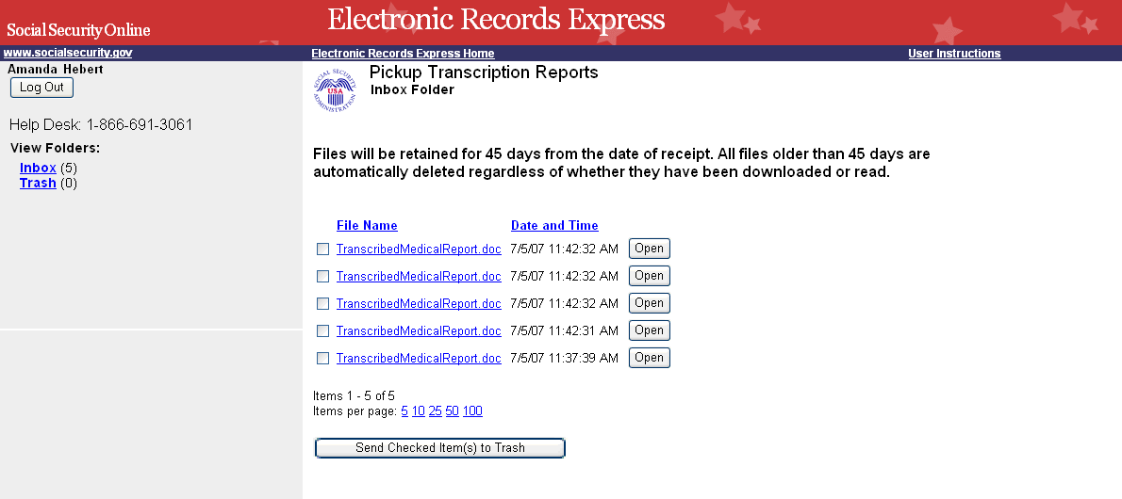

Trash Folder
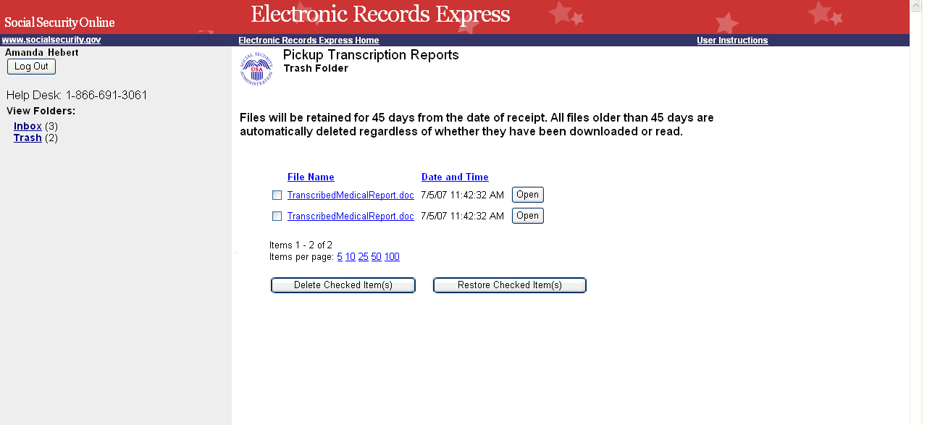

Payment Request Services

Submit Payment Request

Evidence/CE Request Information
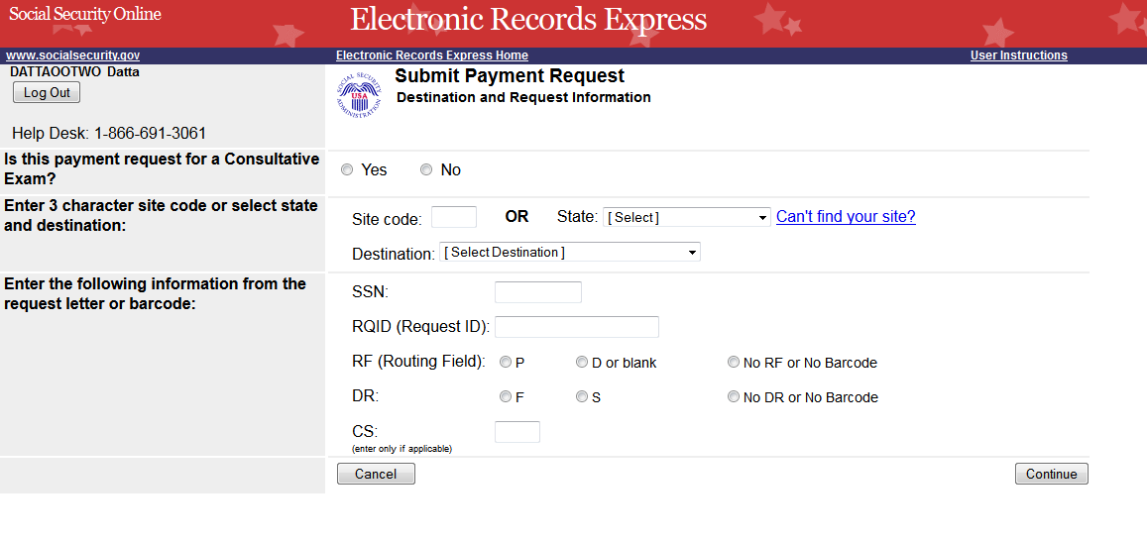

Attach and Upload Invoice
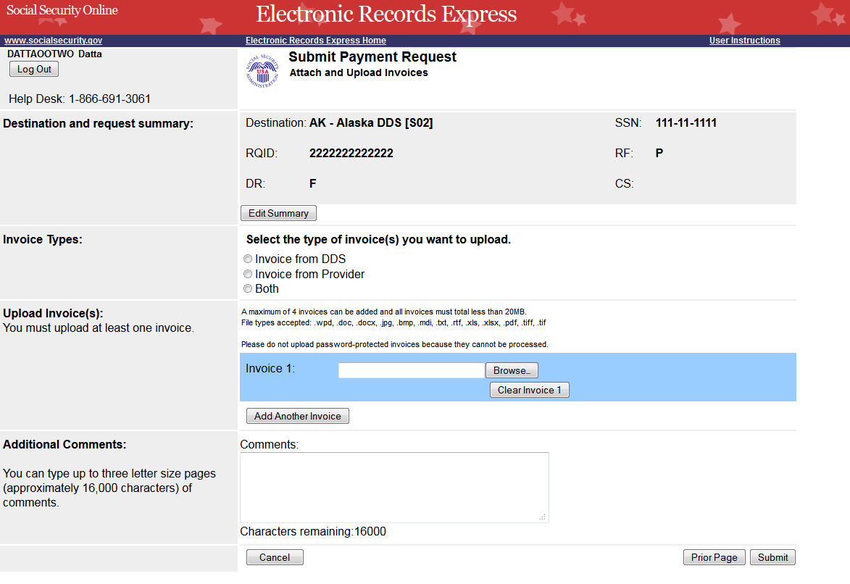

Payment Request Tracking Information
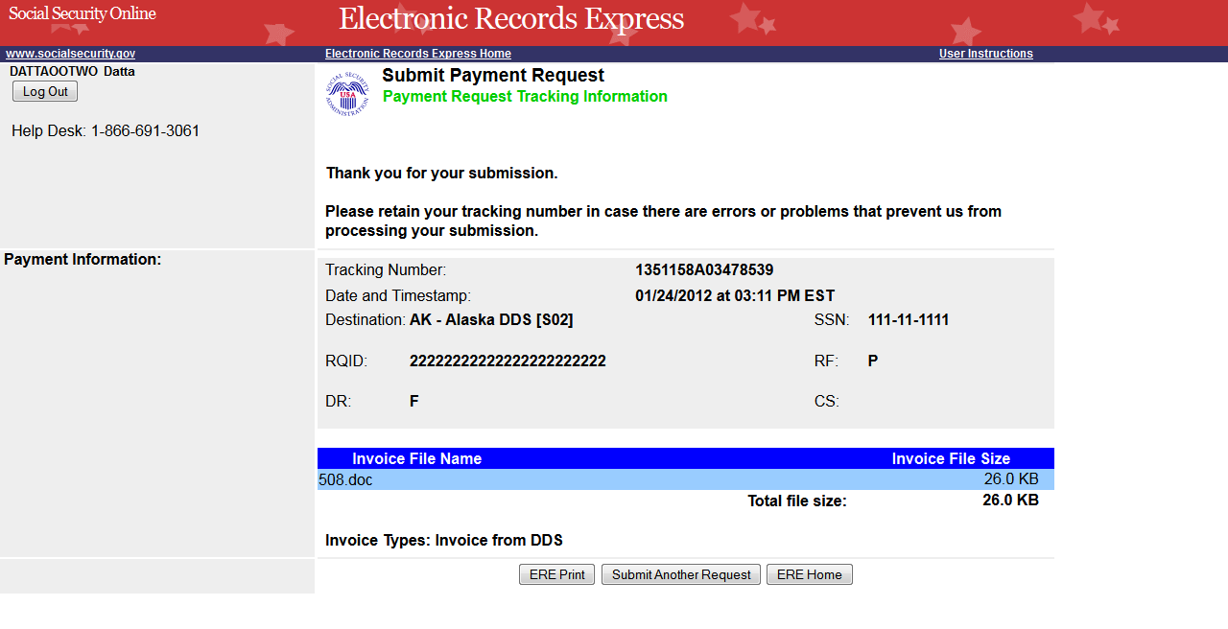

Evidence Submission Failure Screen
If the files the provider is trying to submit do not pass our front end checks, they will be presented with a failure message page. The title of this page has been changed from “Rejection” to “Submission Failure”.

Note: This Submission Failure screen will be presented any time a user tries to submits files that do not pass our front end chekcs for for any function .
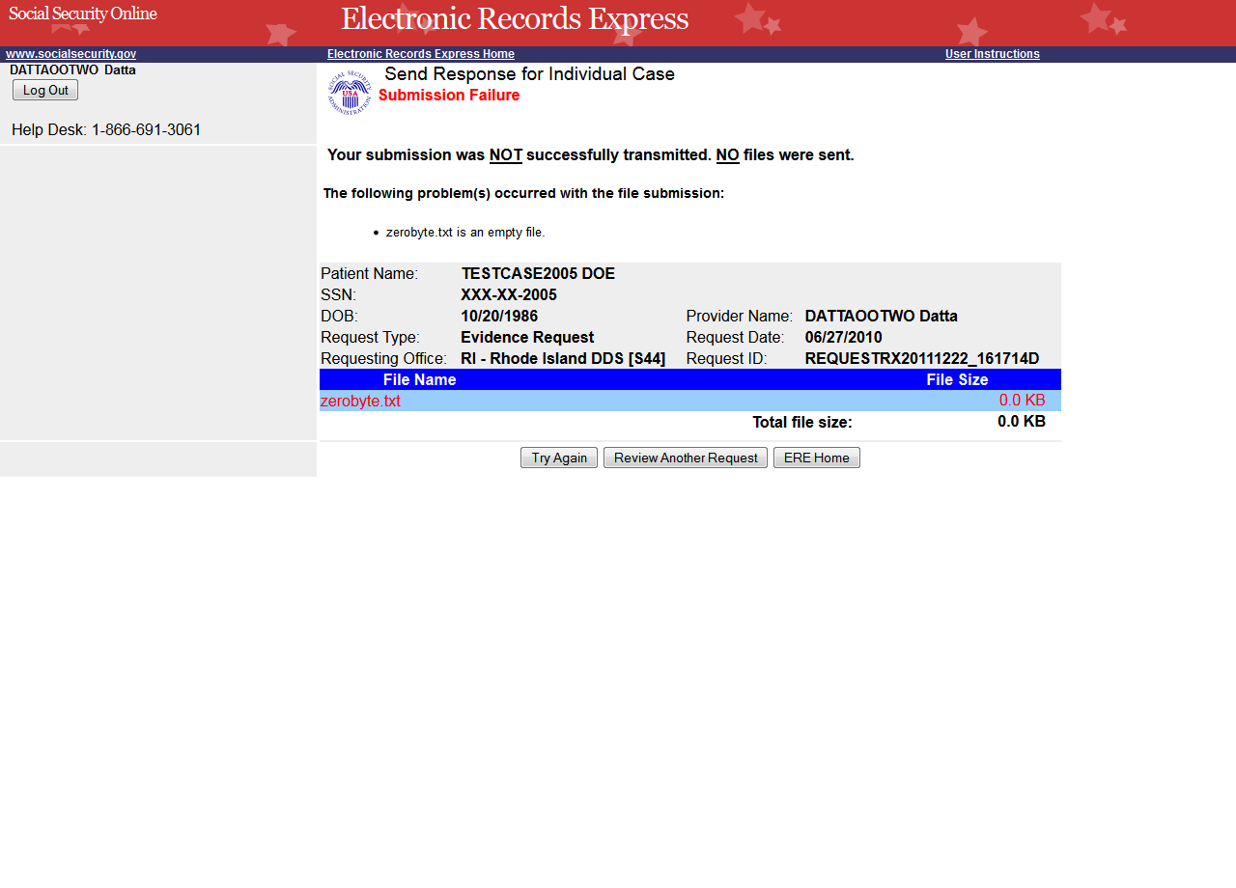
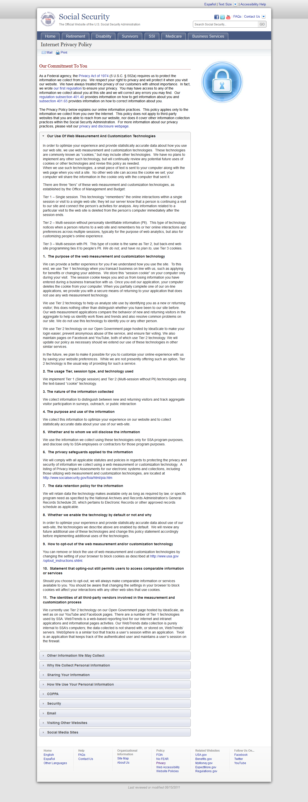
Details of Social Security's Online Security Policy

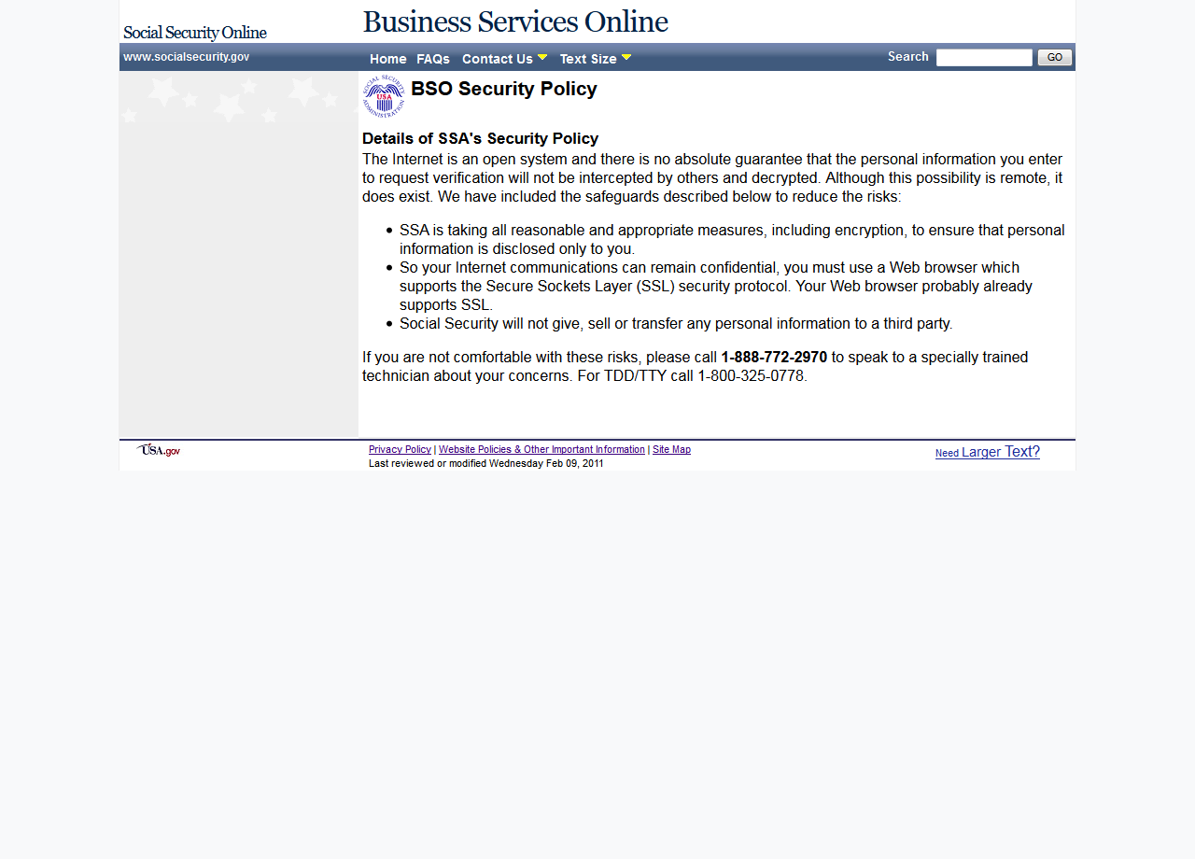
The Privacy Act and the Freedom of Information Act

