Appendix E

Advance Letter

March 16, 2012

Dear Parent:

We thank you for your participation in the Head Start Impact Study, the Third Grade Follow-up to the Head Start Impact Study and the additional yearly parent interviews to keep our contact information for your family current! We are pleased to let you know that the U.S. Department of Health and Human Services is considering a future follow up with the children and families who participated in these studies so we will be in touch with you this spring and each spring through the high school years to keep our contact information current with your family.

We are asking you to participate in a short 15-minute phone interview this spring. We will ask you a few questions about your child’s school and some questions that will help make it possible to contact you in the future. If we can’t reach you by telephone, a study staff member will visit your home. After completing this short interview, we will send you a gift of $20 to thank you.

We'd like to remind you that all information collected will be kept private except as required by law. Your participation is voluntary and very important, and we thank you! Your participation will not result in the loss of any current benefits that you may have. Our study staff will contact you soon, and we look forward to speaking with you. However, if you have any questions or concerns, please don't hesitate to call our toll free phone line at 1-888-280-5081 or your local study Site Coordinator:

Sincerely,
Camilla A. Heid
Westat
Project Director

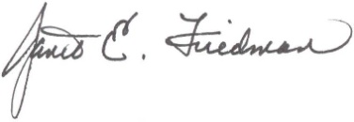
Janet E. Friedman
Westat
Operations Director

