**Computerized Accident/Incident Reporting System (CAIRS)**

**Add New Case – Data Entry**

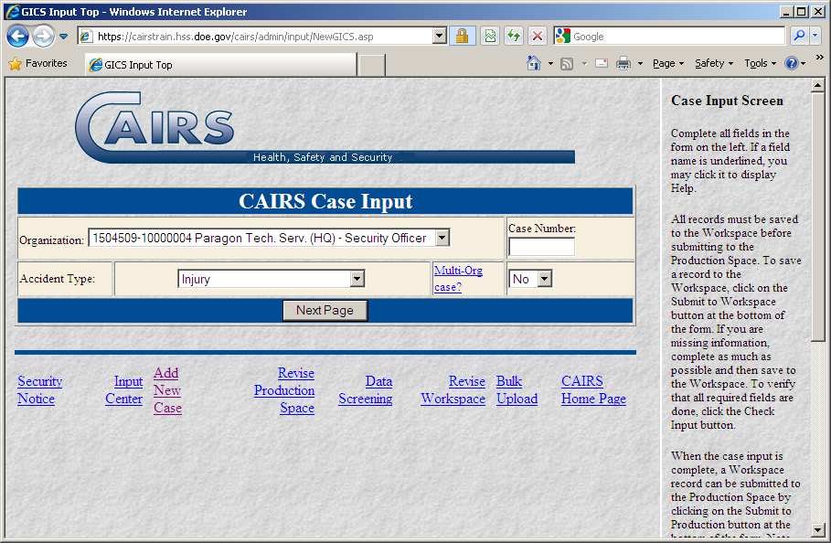

**Case Input - page 1**

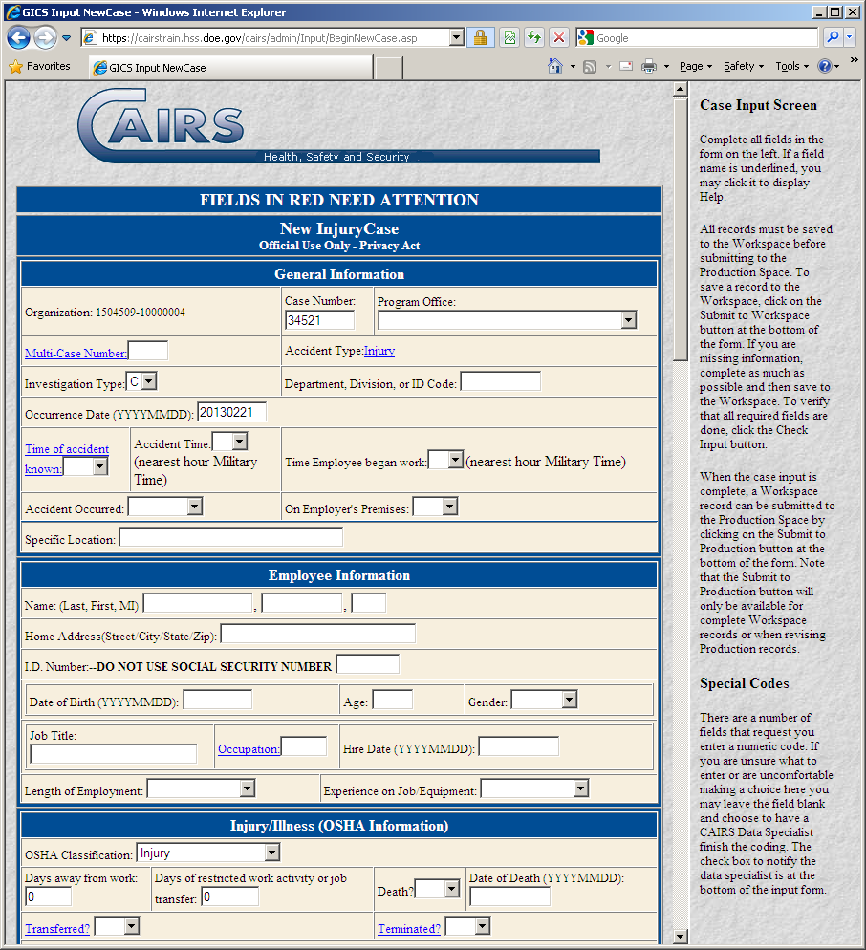

**Case Input - page 2**

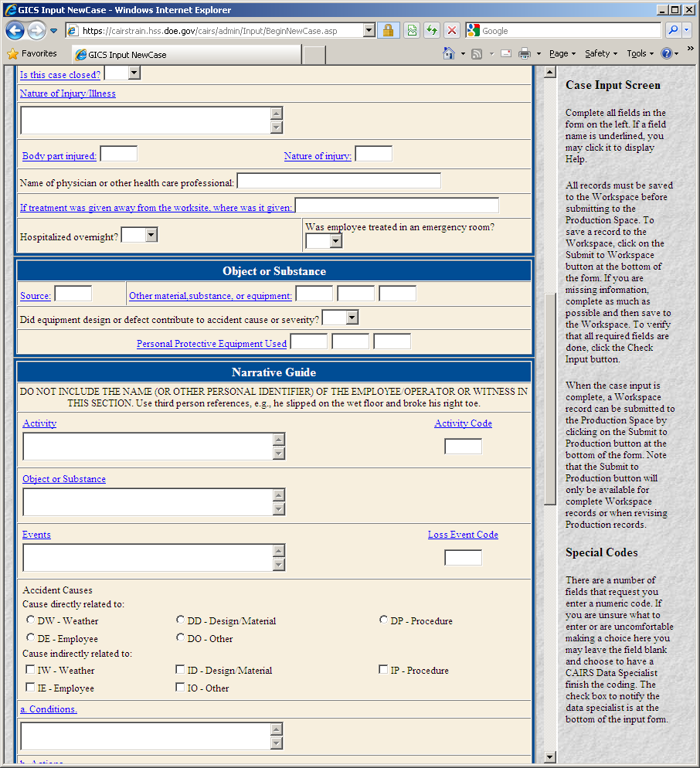

**Case Input - page 3**

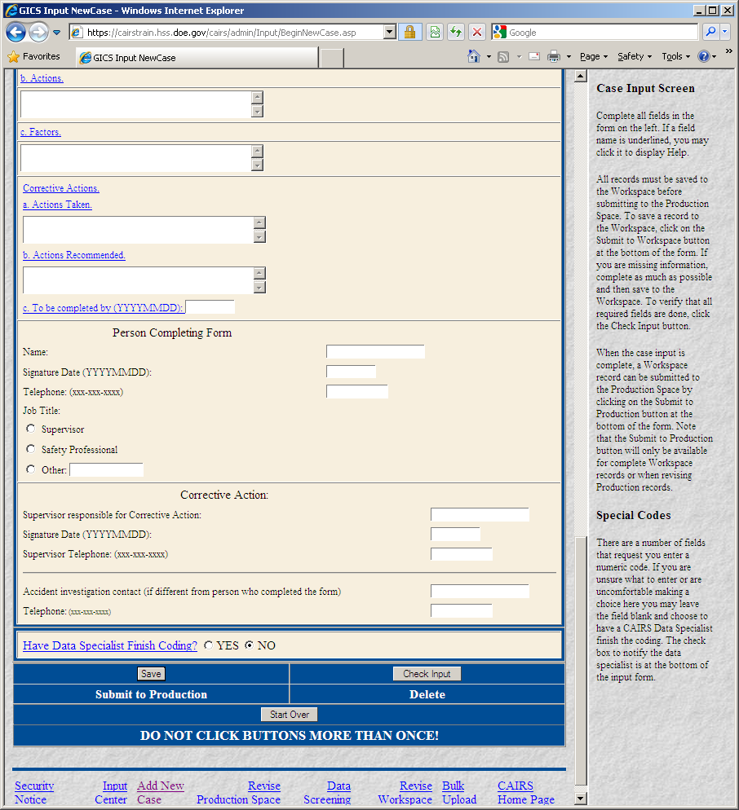

**Revise Case in Workspace – Data Entry Select Case Screen**

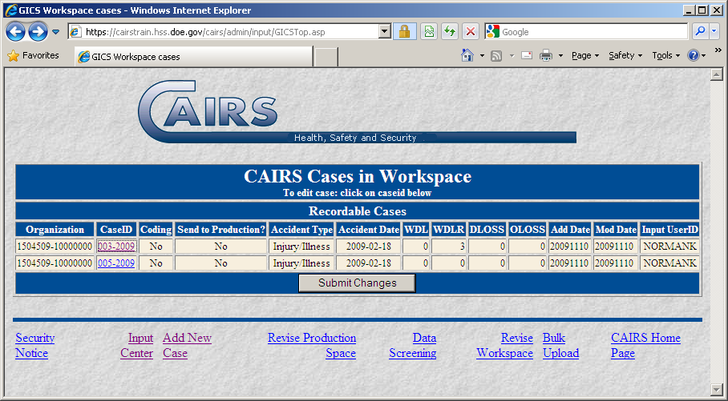

**Revise Case in Workspace Data Entry – page 1**

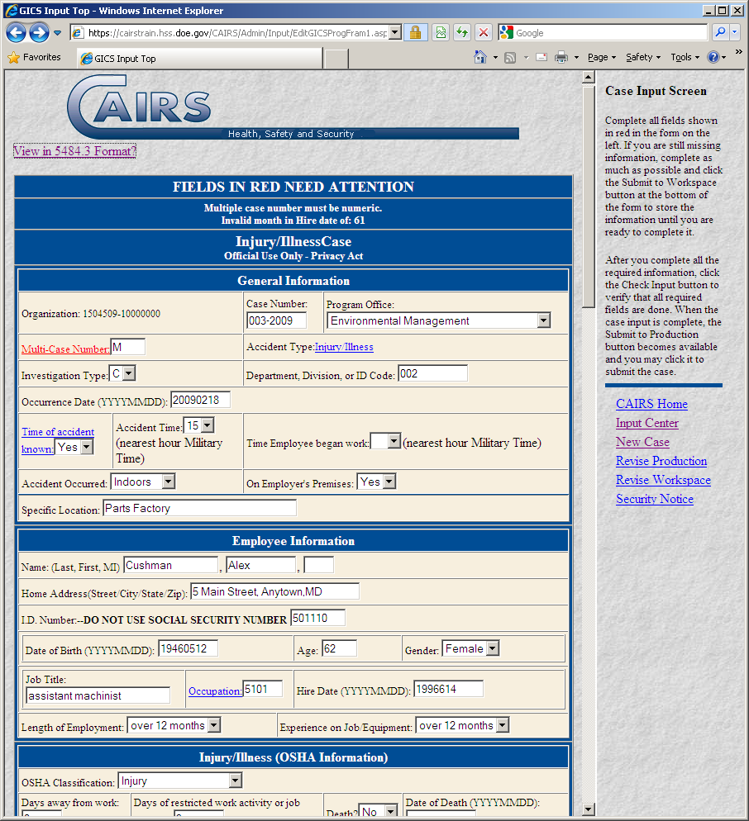

**Revise Case in Workspace Data Entry – page 2**

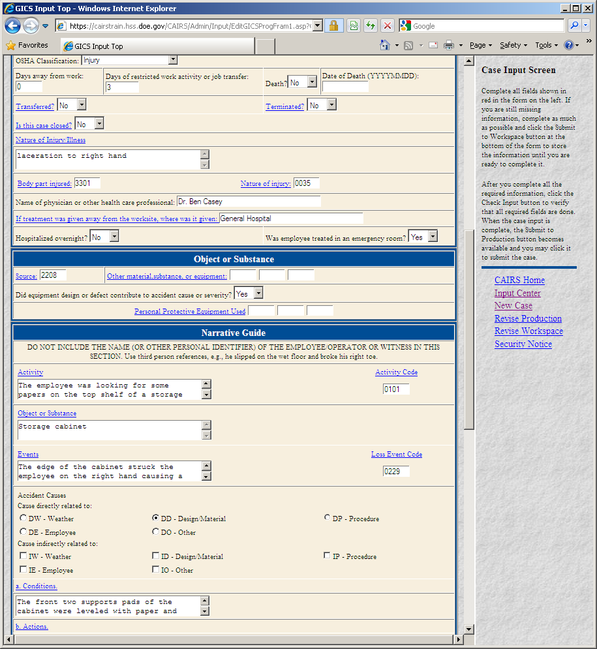

**Revise Case in Workspace Data Entry – page 3**

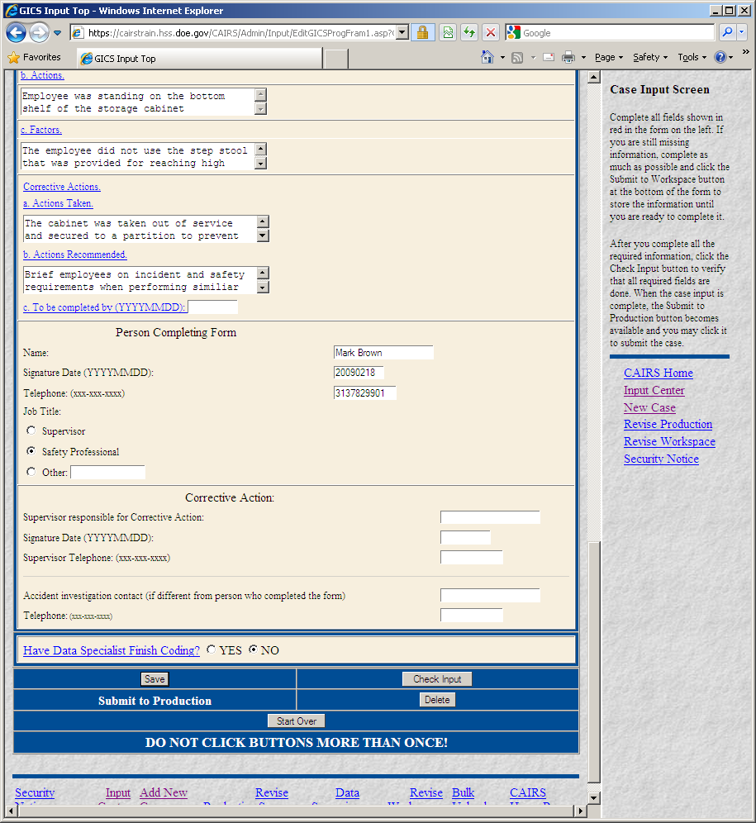

**Revise Case in Production – Data Entry Select Case Screen**

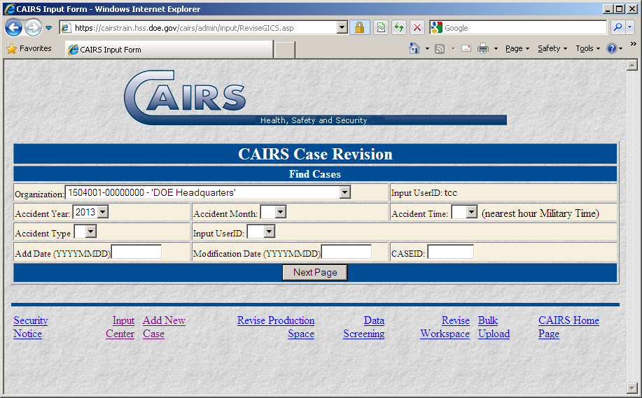

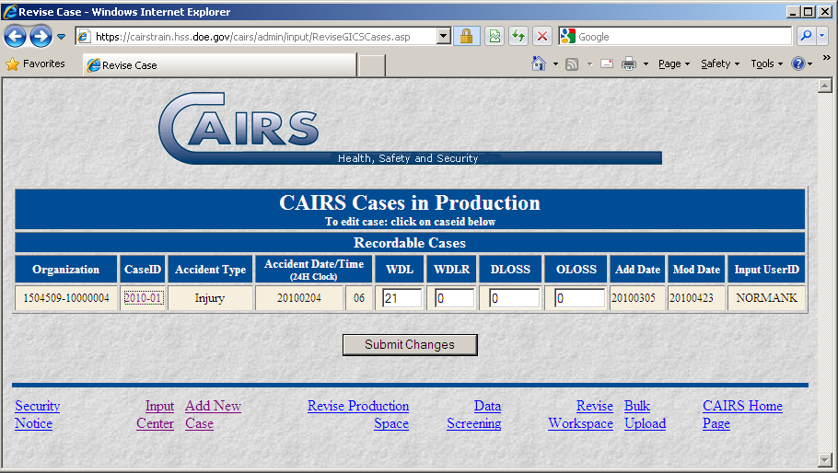

**Revise Case in Production Data Entry – page 1**

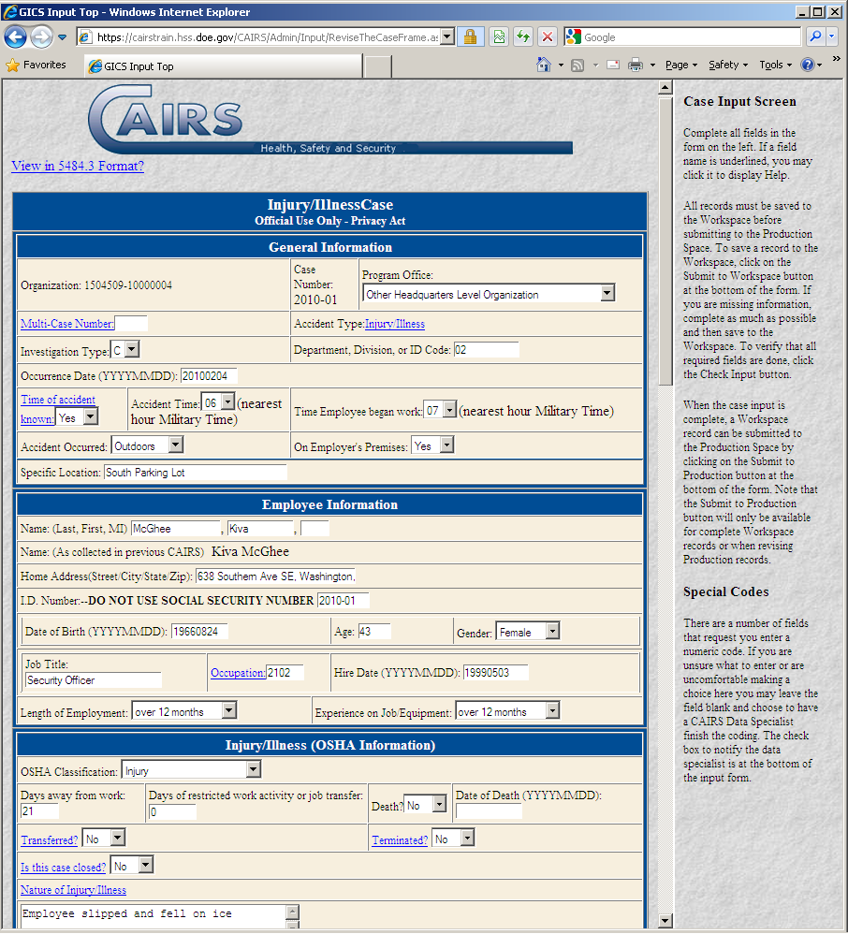

**Revise Case in Production Data Entry – page 2**

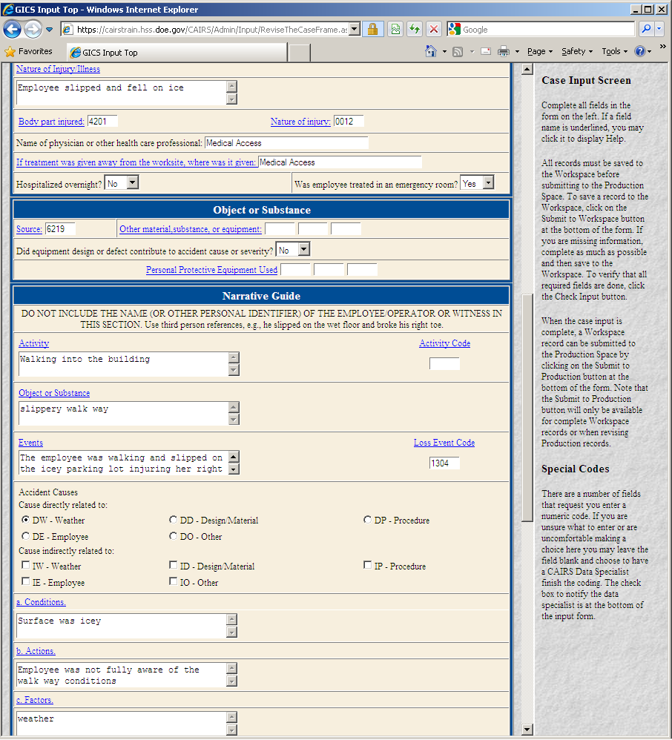

**Revise Case in Production Data Entry – page 3**

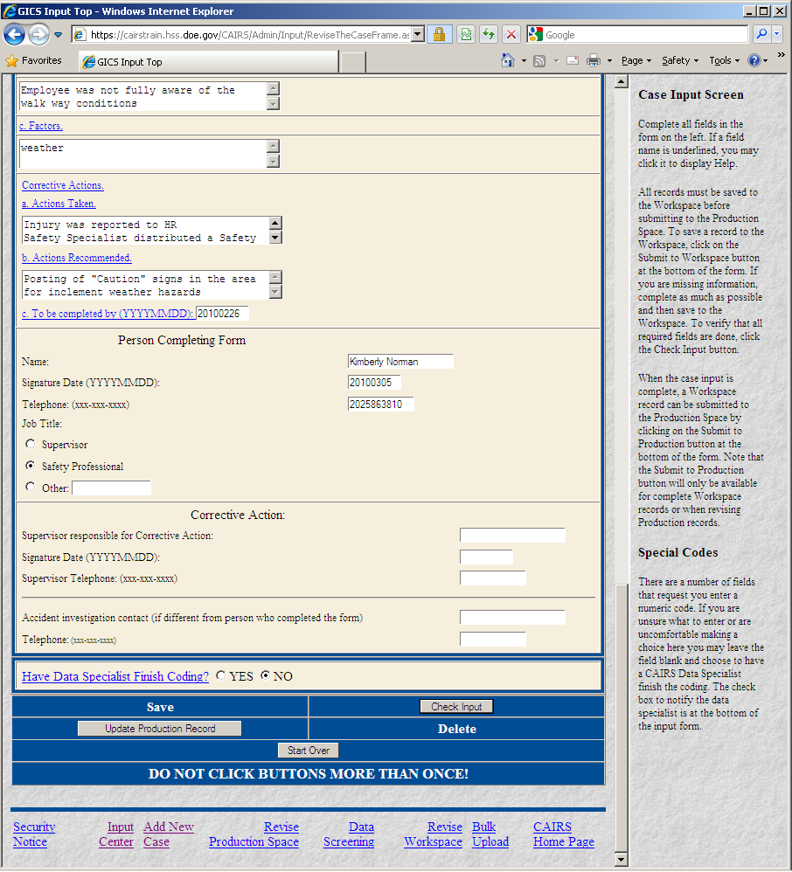

**Enter Work Hours - Data Entry Entrance Screen**

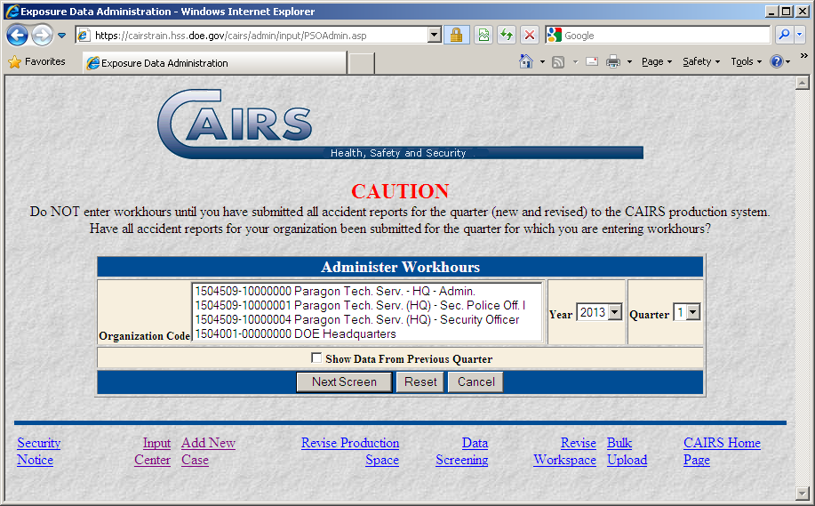

**Enter Work Hours - Data Entry**

