Fire Protection (FP)

Loss Summary Data Entry

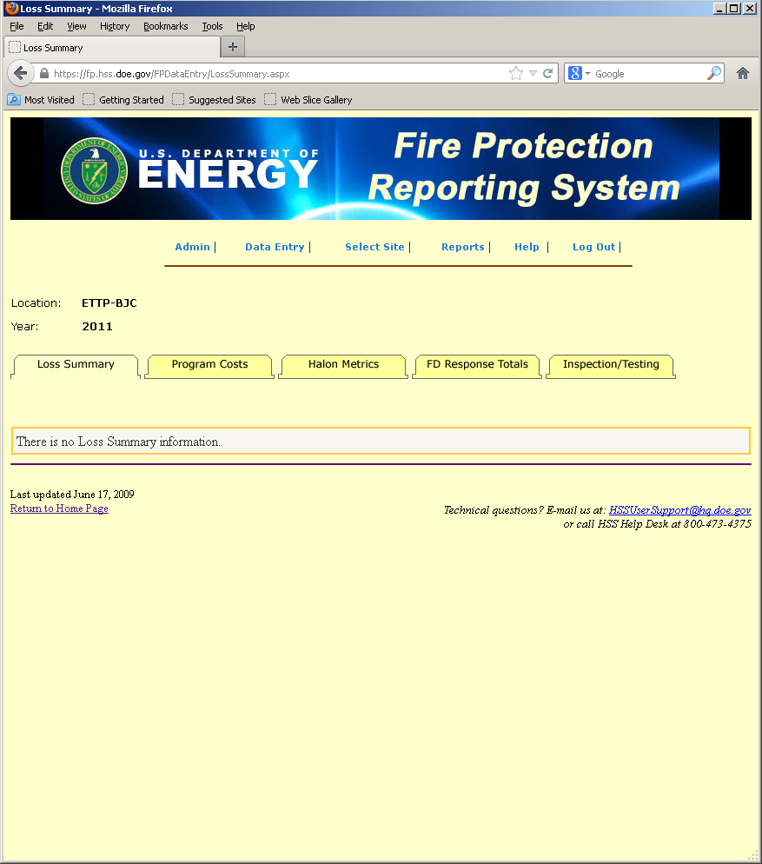

Program Costs Data Entry

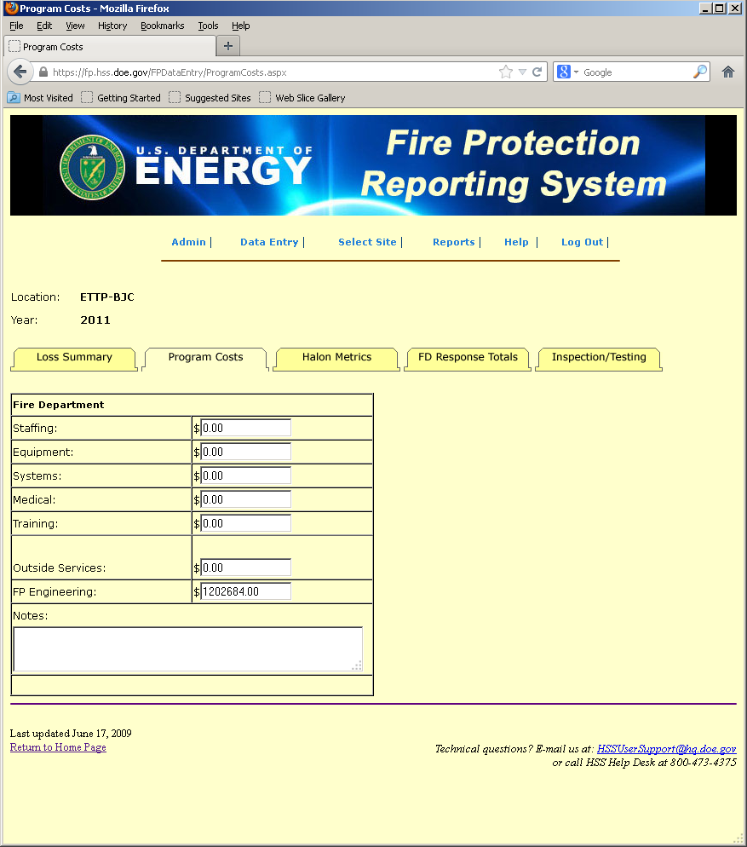

Halon Metrics Data Entry

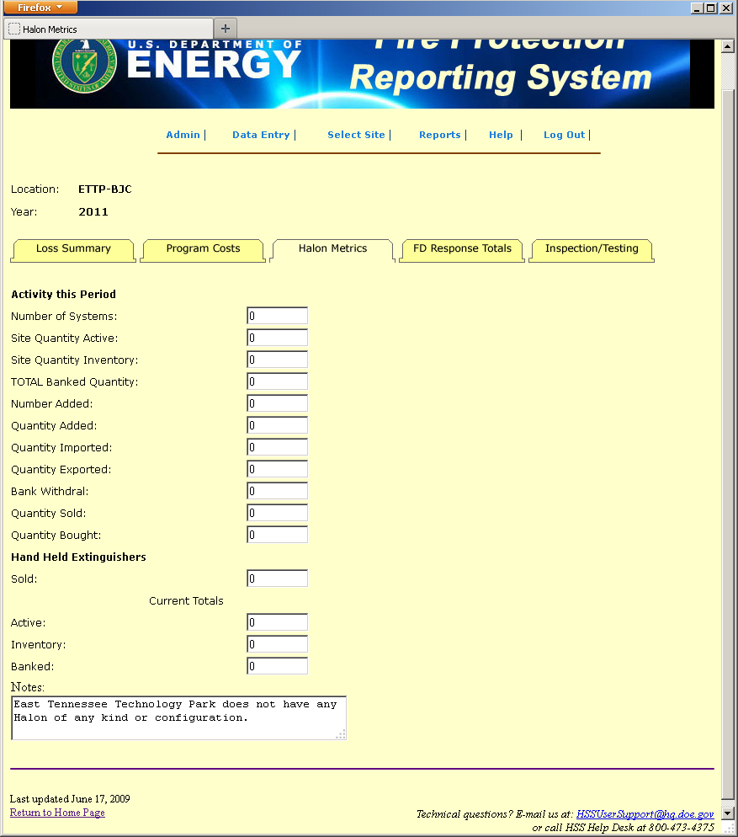

FD Response Totals Data Entry

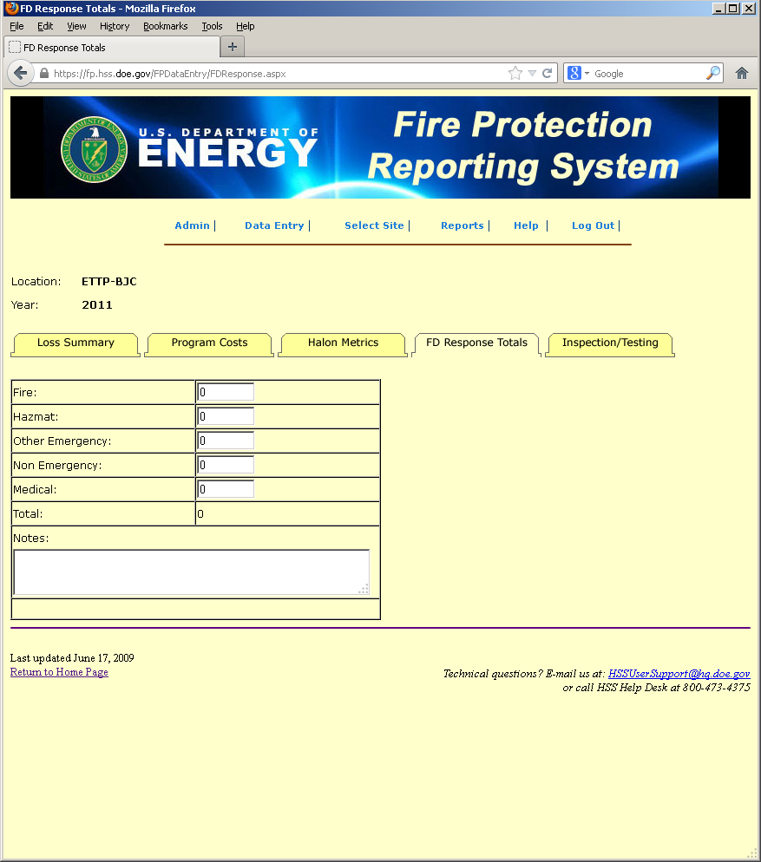

Inspection/Testing Data Entry – page 1

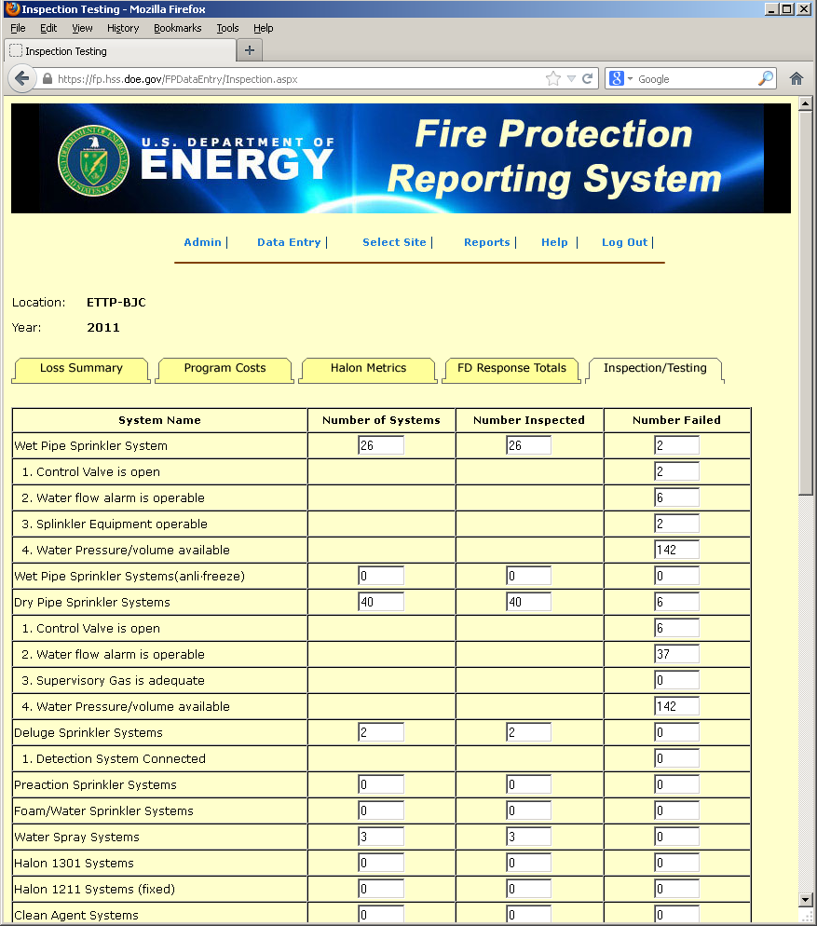

Inspection/Testing Data Entry – page 2

