Safety Basis Information System (SBIS)

JCO Data Entry

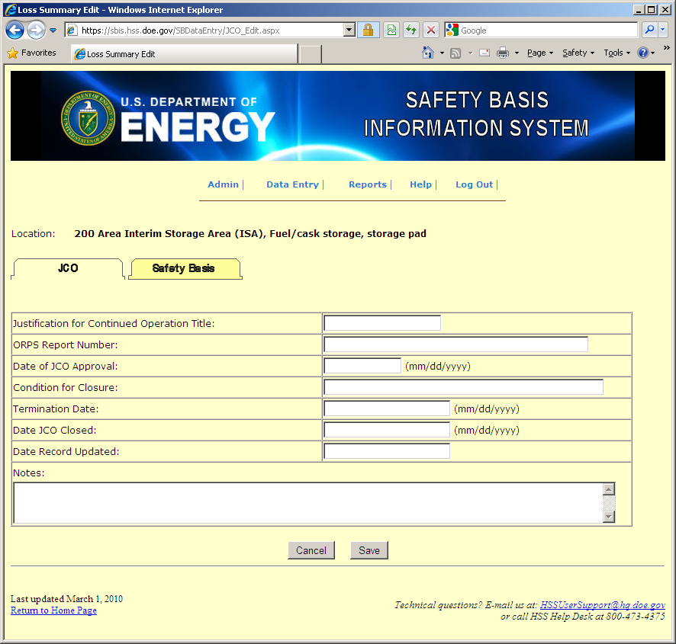

Safety Basis Data Entry

