OMB Control No. 2127-0682
Expiration Date 02/28/2015

Thank you for taking this survey. Your opinions are important to us! Please be honest when answering the survey. Your answers are anonymous and confidential, and none of your information will be shared with any third parties.

A federal agency may not conduct or sponsor, and a person is not required to respond to, nor shall a person be subject to a penalty for failure to comply with a collection of information subject to the requirements of the Paperwork Reduction Act unless that collection of information displays a current valid OMB Control Number. The OMB Control Number for this information collection is 2127-0682. Public reporting for this collection of information is estimated to be approximately 10 minutes per response, including the time for reviewing instructions, completing and reviewing the collection of information. All responses to this collection of information are voluntary. Send comments regarding this burden estimate or any other aspect of this collection of information, including suggestions for reducing this burden to: Information Collection Clearance Officer, National Highway Traffic Safety Administration, 1200 New Jersey Ave, S.E., Washington, DC, 20590

- We are looking for people who work in certain occupations and industries. Do you or does anyone in your household work in any of the following occupations or industries? (Please select all that apply).
- Market Research
- Advertising Agency / Public Relations
- Marketing
- Automobile manufacturing or sales
- Manufacturer, Distributor or Seller of household paper products
- A company that supplies or sells telephone, cellular or Internet services
- Insurance
- Banking
- None of these

IF “MARKET RESEARCH” OR “ADVERTISING AGENCY / PUBLIC RELATIONS” OR “MARKETING” OR “Automobile manufacturing or sales” THEN TERMINATE, OTHERWISE CONTINUE

- Are you the parent or guardian of any children under the age of 18 who are living in your household?
- Yes
- No

MUST ANSWER YES TO CONTINUE

IF CHILD AGE “0-12 MONTHS”, “1-3 YEARS”, “4-7 YEARS” OR “8-12 YEARS” CHECKED, THEN CONTINUE; IF “13 YEARS OR OLDER IS THE ONLY SELECTION CHECKED, TERMINATE.

- What is your gender?
- Male
- Female

- What is your age? _________ PROGRAMMER NOTE: MUST BE 18+

- 18-24 years
- 25-34 years
- 35-44 years
- 45-54 years
- 55+ years

- Are you of Hispanic or Latino origin?
- Yes
- No

- What is your race? Please select one or more. [Add popup option: “Why do we ask this question?”*]
  - White
  - Black or African-American
  - Asian
  - Native Hawaiian or other Pacific Islander
  - American Indian or Alaska Native

- What is the highest level of education that you have completed?
- 8th grade or below
- 9th grade to 11th grade
- High school graduate
- Some college
- Associate's degree
- Bachelor's degree
- Some postgraduate study
- Graduate-school degree
- Trade school
- None of the above/ Prefer not to state

- Which classification best describes your total pre-tax household income? [*Add popup option: “Why do we ask this question?”]
Under $10,000 [0]
$10,000-$19,999 [1]
$20,000-$29,999 [2]
$30,000-$39,999 [3]
$40,000-$49,999 [4]
$50,000-$74,999 [5]
$75,000-$99,999 [6]
$100,000-$124,999 [7]
$125,000-$149,999 [8]
$150,000-$174,999 [9]
$175,000-$199,999 [10]
More than $200,000 [11]
Prefer not to state [12]

PROGRAMMER NOTE: INSTRUCTION 1
[If “Yes” in S2 and ONLY ONE AGE SELECTED in S3:]
“Please answer the rest of this survey with your child age [X] in mind.”
[“X” is the age RANGE of child 0-12 indicated in S3]

[If “Yes” in S2 and MULTIPLE AGES SELECTED in S3:]
“Please answer the rest of this survey with your child age [X] in mind.”
[“X” is the age RANGE of one child 0-12 indicated in S3, randomly selected from all AGES 0-12 indicated in S3]

- How often do you drive with your child age [X] in the car?
- Once a day or more
- A few times a week
- Once a week
- Less often TERMINATE
- I do not drive TERMINATE

IF “LESS OFTEN” OR “DO NOT DRIVE” THEN TERMINATE, OTHERWISE CONTINUE

- How often does your [X] year-old currently use each of the following types of passenger safety restraints when he/she is in the car with you? (An example of what each might look like has been provided.)

 | Always | Sometimes | Never | Not sure
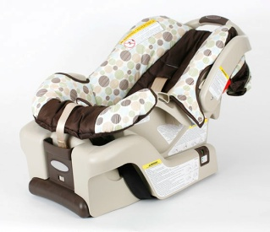

Rear-facing car seat
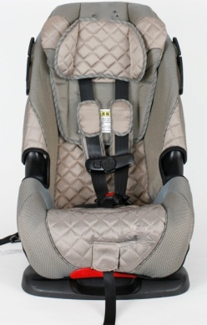
Forward-facing car seat
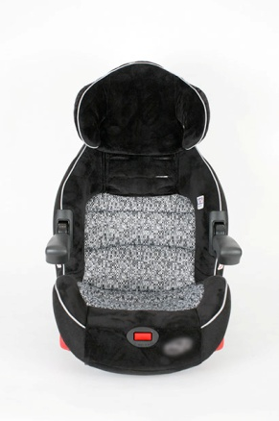
Booster Seat
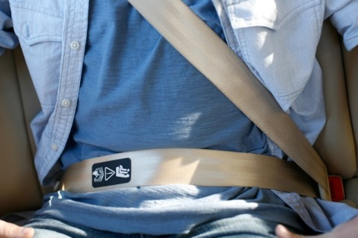
Adult Seat Belt

- Have you recently seen, heard, or read messages about using child passenger safety restraints in advertising, publicity, the media, the Web or other places?

- Yes
- No
- Not sure

[IF YES TO Q]
14b. Where was that…? (Accept multiple responses.)
[PROGRAMMER: SET UP AS A GRID BUT IF THE USER SELECTS NO FOR “SOME OTHER PLACE” THEY SHOULDN’T HAVE TO PROVIDE AN OPEN END ANSWER]

TV program | Yes | No
TV ad | Yes | No
Radio program | Yes | No
Radio commercial | Yes | No
Magazine article | Yes | No
Magazine ad | Yes | No
Newspaper article | Yes | No
Newspaper ad | Yes | No
Website content | Yes | No
Web ad | Yes | No
Outdoor billboards or outdoor posters | Yes | No
From friends or family | Yes | No
Car seat or vehicle owner’s manual | Yes | No
Hospital or physician’s office | Yes | No
Car seat fitting station | Yes | No
Automobile dealer | Yes | No
Some other place (Specify)__________ | Yes | No

- In the past year, have you sought information about which car safety restraint to use for your child?

- Yes
- No
- Not sure

- [IF YES] Where did you seek information about which car safety restraint to use for your child?
Please list all sources of information below. [Open-ended]

____________________________________________________________________________________________________

- Have you ever heard of a website called SaferCar.gov/TheRightSeat?

  - Yes
  - No
  - Not sure

[RANDOMZIE ORDER OF AD RECOGNITION QUESTIONS: KEEP TV AND RADIO ADS TOGETHER IN BLOCKS & RANDOMIZE ADS WITHIN BLOCKS]

Below is a video of a public service ad you might see on TV or some other place. After you view the ad, please indicate if you have seen it before.

[INSERT VIDEO_REAL KNOW IT ALLS :30]

- Have you seen this ad?

- Yes
- No
- Not sure

[INSERT VIDEO_CHAIRS :30]

- Have you seen this ad?

- Yes
- No
- Not sure

[INSERT VIDEO_FLASHBACK:30]

- Have you seen this ad?

- Yes
- No
- Not sure

Below is an audio file of a public service ad you might hear on the radio. After you listen to the ad, please indicate if you have heard it before.

[INSERT AUDIO FILE_BASEBALL :60]

- Have you seen this ad?

- Yes
- No
- Not sure

[INSERT AUDIO FILE_PARTY :30]

- Have you seen this ad?

- Yes
- No
- Not sure

- Have you seen any of these ads in a newspaper or magazine?
[INSERT PRINT AD MONTAGE]

- Yes
- No
- Not sure

- Have you seen any of these ads online?
[INSERT BANNER AD MONTAGE]

- Yes
- No
- Not sure

- Have you seen any of these ads someplace, such as on a poster, billboard, or phone kiosk?
[INSERT OUTDOOR AD MONTAGE]

- Yes
- No
- Not sure

The following background questions will help us divide the interviews into groups.

- What is your marital status?
- Single (never married)
- Living together but not married
- Married
- Separated
- Divorced
- Widowed
- Prefer not to state

- Do you live in the city, suburbs, or some other area?
- City
- Suburbs
- Some other area

- What state do you live in?
[CHECK BOX]
CODE FOR REGION

* These questions about [race/income] are important so that we make sure the voices of people in all different populations are represented. In this way, we can be fair and objective by adjusting our results based on the proportions of the various groups in the larger population. Collecting data from all respondents on this question is important so that we can better and more reliably report differences and similarities between people of different backgrounds. We understand that you might be concerned about sharing this information. Please be assured that the responses you provide are kept completely confidential. Any identifying information will be separated from your answers. Results are reported using the average, or pooled answers to the questions, instead of the responses of any one individual.

