OMB Control No. 2127-0682
Expiration Date 02/28/2015

NVS Tagline & Logo Research
Discussion Guide for Qualitative Focus Groups

This collection of information is VOLUNTARY and will be used for formative purposes only so that we may develop and evaluate programs designed to reduce the number of traffic-related injuries and deaths. A federal agency may not conduct or sponsor, and a person is not required to respond to, nor shall a person be subject to a penalty for failure to comply with a collection of information subject to the requirements of the Paperwork Reduction Act unless that collection of information displays a current valid OMB Control Number. The OMB Control Number for this information collection is 2127-0682. Public reporting for this collection of information is estimated to be approximately 135 minutes per response, including the time for reviewing instructions, completing and reviewing the collection of information. All responses to this collection of information are voluntary. Send comments regarding this burden estimate or any other aspect of this collection of information, including suggestions for reducing this burden to: Information Collection Clearance Officer, National Highway Traffic Safety Administration, 1200 New Jersey Ave, S.E., Washington, DC, 20590

Research Objectives
- Understand where consumers currently get vehicle safety information;
- Gauge familiarity with NHTSA and SaferCar.gov;
- Determine what information and materials consumers are looking for from an agency like NHTSA;
- Identify motivators for using NHTSA communication channels; and
- Evaluate potential new taglines and logos.

Discussion Guide
- Introduction (Approx. 5 minutes)
- Welcome, Group Rules, Privacy
- Before we start I’d like to go around the room and have you introduce yourselves. Please tell us,
  - Name
  - How often do you drive?
  - What is your primary purpose for driving?

- Information Gathering (Approx. 25 minutes)
- When you’re looking to purchase a new vehicle, what factors do you consider? [MODERATOR LISTEN FOR SAFETY]
- Let’s talk more about one of these factors – safety. By a show of hands, how many of you have looked for information on vehicle safety recently?
- If you were looking for information on vehicle safety, what are some sources you might go to?
  - Thinking specifically of online sources, where would you go for information on vehicle safety?
  - [MODERATOR PROBES:] Dealership, mechanic, car manual, manufacturers website, family, friends, search engine results, traditional & social media (Facebook, Twitter, etc.), government sources
  - What sources do you trust to provide you vehicle safety information?
    - What is it about these sources that make them trustworthy?
  - Are there sources that are available that you don’t trust to provide you with vehicle safety information?
    - What reasons do you have for not trusting these sources?
- We’re going to do a quick activity. I’d like you to take these index cards and on each, write me the things that come to mind when I say “vehicle safety”. One topic per index card. Write as many as come to mind, then we’ll review as a group.
  - [MODERATOR GIVE 3 MINUTES FOR EXERCISE, THEN HAVE RESPONDENTS READ INDEX CARDS AND HAND TO MODERATOR]
  - Having gone through everyone’s index cards, is there anything else that comes to mind? [MODERATOR WRITE ADDITIONAL ITEMS ON INDEX CARDS]
  - PROBE: What safety information comes to mind when thinking about purchasing a vehicle? Driving a vehicle? Maintaining your vehicle? Driving with your children? Teaching your children to drive?
  - [TOPICS TO ADD IF NOT MENTIONED: CRASH RATINGS, FUEL ECONOMY, TIRE INFORMATION, SEAT BELTS, DISTRACTED DRIVING, IMPAIRED DRIVING, TEEN DRIVERS, SENIOR CITIZENS, CHILD PASSENGER SAFETY, DEFECTS, RECALLS, THEFT PREVENTION, TIRE MAINTENANCE, MOTORCYCLES]
- [MODERATOR SPREADS INDEX CARDS ON TABLE] Now that we have all these topics listed, I’d like you to organize these items into groups or categories. Think of the categories like dropdown menus on a website – which topics should be included in the same section? I’m going to give you 5 minutes as a group to organize these on the table – it is up to you how the categories are defined.
  - Can I have a volunteer talk me through how you categorized these items?
  - What would you call category 1? What other words do you associate with this category? [MODERATOR WRITE ON FLIP CHART, REPEAT FOR EACH CATEGORY CREATED]
  - For what reasons would you organize these items together?
  - For what reasons would you organize these items separately?
  - Does anyone disagree with where an item was placed?

CATEGORIES
- Buy Safe
- Drive Safe
- Ride Safe
- Buy Smart
- Save Gas
- Stay Protected

TESTING ORDER
Group 1: A, B, C, D, E, F
Group 2: E, D, F, B, C, A
Group 3: D, A, F, C, B, E
Group 4: F, C, A, E, D, B

- Looking at all the index cards, if I told you to make a category called “[FIRST CATEGORY]” which of these topics could go into that category? Why/why not?
  - Which topics definitely would not go in that category? Why/why not?
  - What does “[FIRST CATEGORY]” mean to you?
- And if I told you to make a category called “[SECOND CATEGORY]” which of these topics could go into that category? [REPEAT AS NECESSARY FOR ALL CATEGORIES]
- I have one final category I’d like you to group the topics into. This category is called “[LAST CATEGORY].” Which of these topics could go into that category? Why/why not?
  - Which topics definitely would not go in that category? Why/why not?
  - What does “[LAST CATEGORY]” mean to you?

- Tagline Testing (Approx. 25 minutes)
- Moving on. We’ve talked about a number of different safety topics, so I’d like you to imagine an organization focused on vehicle safety. Do you know of any organizations like this?
  - What do you know about that organization?
- So thinking about this type of organization that provides vehicle safety information to consumers like you, I have some taglines here that I’d like us as a group to evaluate. I’m going to pass out a piece of paper with a potential tagline. Before we discuss it as a group, I’d like you to individually read the tagline and jot down your initial thoughts. Then please give this tagline a grade, from A to F, based on how appealing it is to you personally. [MODERATOR HANDS OUT PAPER WITH FIRST TAGLINE]

TAGLINES
- Ride Safe. Walk Safe. Drive Safe.
- Buy Safe. Drive Safe. Ride Safe.
- Buy Smart. Drive Safe. Stay Safe.
- Buy Safe. Drive Smart. Stay Protected.
- Shop Smart. Drive Safe.
- Keeping You Safe Through Life.
- Life’s Journeys Start With Safety.
- Safety at Every Turn.
- Together at Every Turn.

TESTING ORDER
Group 1: A, B, C, D, E, F, G, H, I
Group 2: B, A, D, E, C, G, F, I, H
Group 3: C, E, A. B, D, H, I, F, G
Group 4: D, C, B, A, E, I, H, G, F

- [MODERATOR ALLOWS A MOMENT FOR PARTICIPANTS TO REVIEW; MODERATOR READS THE TAGLINE ALOUD TO THE GROUP]
- What do you like about this tagline?
- What don’t you like about this tagline?
- Where can you picture seeing or hearing this tagline?
- When you see or hear this tagline, what type of organization do you think of?
- Does this tagline make sense for an organization focused on vehicle safety?
- To what extend does this tagline encompass all of the types of vehicle safety information that we discussed earlier? [MODERATOR REFERS TO INDEX CARDS]
  - How would you change this tagline to make it more encompassing?
  - Is this tagline a better or a worse fit for these categories than the words you used earlier to describe them? What makes you say that?
- [PLACEHOLDER FOR TAGLINE-SPECIFIC QUESTIONS]
  - [TAGLINES A-E] Does it make sense for the tagline to map back to the site layout that we discussed earlier?
  - [TAGLINES F-I] Does it make sense for the tagline to be more of an emotional appeal?
  - [TAGLINES F-I] Does it make more sense for the tagline to be a few short phrases or one longer phrase?
- I have another example of a potential tagline. Again, I’d like you to individually jot down your initial thoughts and then give the tagline a grade A-F based on how appealing it is to you personally. [MODERATOR HANDS OUT PAPER WITH SECOND TAGLINE; REPEAT AS NECESSARY FOR ALL TAGLINES]
- [MODERATOR PINS UP ALL TAGLINES] Thinking of all the taglines we’ve reviewed, which stand out to you as more compelling?
- Better at capturing your attention?
- Better for an organization focused on vehicle safety?
- Better at encompassing all the types of vehicle safety information that we discussed earlier? [MODERATOR REFERS TO INDEX CARDS]
  - Is there another tagline what would be more encompassing?

- SaferCar.gov (Approx. 20 minutes)
- By a show of hands, how many of you have you heard of the website SaferCar.gov?
  - What have you heard about it?
  - What kind of information would you expect to find at SaferCar.gov?
    - Would all the topics we listed on those index cards be included on SaferCar.gov?
    - Would any of these topics not be included?
    - Is there anything that we haven’t mentioned tonight that you believe would be included on SaferCar.gov?
    - [MODERATOR PROBES:] What about five-star safety ratings? / Earlier you mentioned five-star safety ratings. Would you expect to find five-star safety ratings at SaferCar.gov?
  - What group or organization do you believe runs SaferCar.gov?

SAFERCAR.GOV LOGOS

A | B
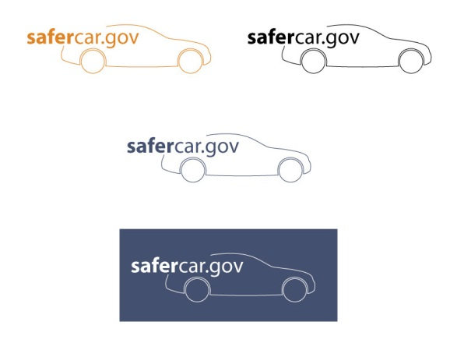 | 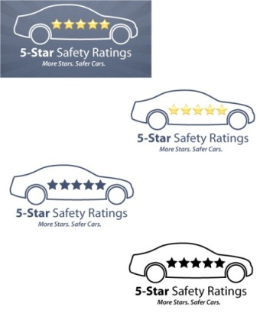
C
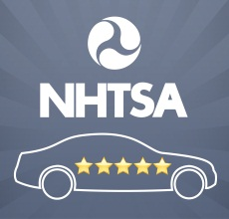

- As a group, I’d like us to evaluate some logos that are currently used on the SaferCar.gov website. Just like what we did with the taglines, I’m going to pass out a piece of paper with a logo. Before we discuss it as a group, I’d like you to individually look at the logo and jot down your initial thoughts. Then please give this logo a grade, from A to F, based on how appealing it is to you personally. Some pages might have multiple versions of the same logo. For those pages, please consider all the logos on that page when jotting down your thoughts.
- The first is the current logo for the SaferCar.gov website overall. [MODERATOR HANDS OUT PAPER WITH FIRST SAFERCAR.GOV LOGO]
- [MODERATOR ALLOWS MINUTE FOR PARTICIPANTS TO REVIEW] What did you first notice about this logo?
- What does this logo communicate to you about SaferCar.gov?
- What do you like about this logo? What do you dislike about this logo?
- Can you tell what SaferCar.gov is based on this logo?
- Does this logo make sense for SaferCar.gov?
- What would you change to make it better?
- Here is another example of a logo currently used on a section of SaferCar.gov. Again, I’d like you to individually jot down your initial thoughts and give the logo a grade A-F based on how appealing it is to you personally. [MODERATOR HANDS OUT PAPER WITH SECOND SAFERCAR.GOV LOGO]
- [MODERATOR ALLOWS MINUTE FOR PARTICIPANTS TO REVIEW] What did you first notice about this logo?
- What is this logo telling you? What does it mean?
- What do you like about this logo? What do you dislike about this logo?
- Does this logo make sense to be on SaferCar.gov?
- Where would it make sense for you to see this logo on the SaferCar.gov website?
- What do you know about the 5-Star Safety Ratings?
- Is this something you would’ve expected to find on a site like SaferCar.gov?
- What would you change to make this logo better?
- Here is a final example of a logo currently used on SaferCar.gov. Again, I’d like you to individually jot down your initial thoughts and give the logo a grade A-F based on how appealing it is to you personally. [MODERATOR HANDS OUT PAPER WITH LAST SAFERCAR.GOV LOGO]
- [MODERATOR ALLOWS MINUTE FOR PARTICIPANTS TO REVIEW] What did you first notice about this logo?
- What is this logo telling you? What does it mean?
- What do you like about this logo? What do you dislike about this logo?
  - [MODERATOR PROBES:] Do you know what the image at the top is? Do you know what the acronym in the middle stands for?
  - [IF THE US DOT AND NHTSA ARE NOT IDENTIFIED] The image at the top is the logo for the Department of Transportation, and the acronym in the middle stands for the National Highway Traffic Safety Administration.
- Does this logo make sense to be on SaferCar.gov? Facebook? Twitter? Somewhere else?
- What would you change to make this logo better?

- NHTSA (Approx. 10 minutes)
  - Earlier we mentioned the National Highway Traffic Safety Administration or NHTSA. How many of you have heard of NHTSA?
    - What have you heard about the National Highway Traffic Safety Administration?
  - NHTSA is a federal agency that is part of the U.S. Department of Transportation. This agency maintains the website SaferCar.gov. Knowing this, what types of vehicle safety resources would you expect this agency to provide for consumers like you?
- NHTSA is responsible for setting and enforcing safety performance standards for motor vehicles and motor vehicle equipment.
  - Given this information, what types of vehicle safety resources would you expect NHTSA to provide for consumers?
    - [MODERATOR PROBES:] Website, email alerts/newsletters, text message alerts, 1-800 number, social media pages, an application or “app”
  - What types of vehicle safety materials could the agency provide that would be useful for you?
    - [MODERATOR PROBES:] Research, test results, crash test videos, recall information, 5-Star Safety ratings, safety technology, child safety, equipment safety, maintenance
  - How would you use this information? For what reasons would this information be useful for you?
- Now think back to the taglines we discussed earlier. If I told you the taglines were meant to describe NHTSA, how, if at all does this information change your opinions of what we reviewed earlier?
  - Which makes the most sense for NHTSA? What makes you say that?
  - Which best communicates what NHTSA does? What makes you say that?

- Motivators (Approx. 10 minutes)
- Now that you all know a little more about NHTSA and we’ve considered several vehicle safety resources that they might provide, I’d like to talk about ways to communicate this information to consumers like you. How likely are you to get vehicle safety information from NHTSA?
  - How likely are you to visit SaferCar.gov?
  - How likely are you to sign up for NHTSA email alerts? What information would you expect to receive?
    - What information would be most helpful to receive?
  - How likely are you to call a NHTSA 1-800 number? Why might you call?
  - How likely are you to visit NHTSA social media pages?
    - [MODERATOR PROBES:] Facebook? Twitter? YouTube?
    - What would you expect to find? What other content would you like to see on these pages?
- What would motivate you to get vehicle safety information from NHTSA?
  - And what could NHTSA do to encourage you to visit SaferCar.gov?
- What could NHTSA do to let you know that these resources are available?
  - Through what channels do you learn about new resources like this?
  - Are there companies or organizations that you think of who have done a good job at encouraging you to visit their website for informational or research purposes?
    - What is it that they do?
    - For what reasons is this effective?
    - Would this be effective for an agency like NHTSA?
- What else should NHTSA do to establish themselves as your go-to source for vehicle safety information?

- NHTSA Logo Testing (Approx. 25 minutes)

NHTSA LOGOS

A | B
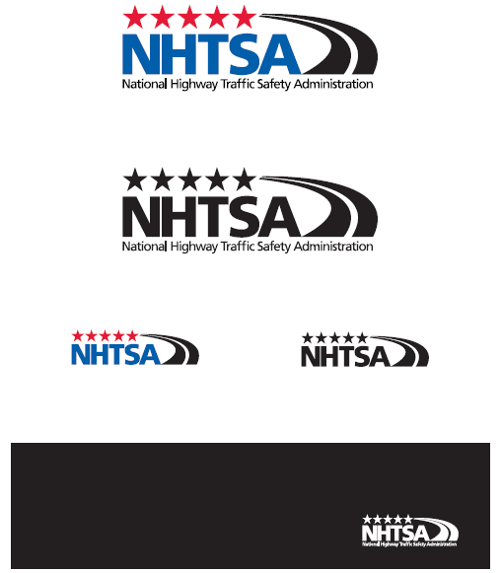 | 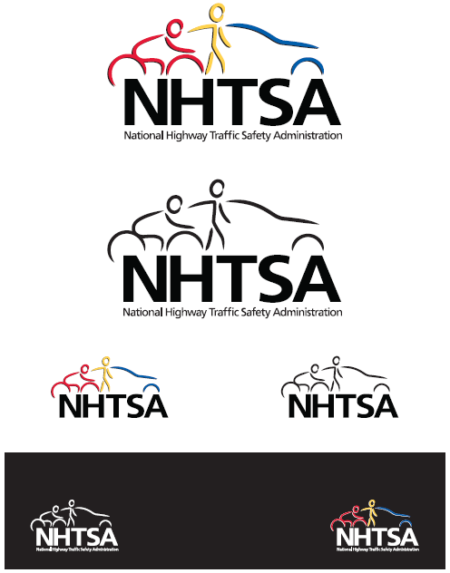
C | D
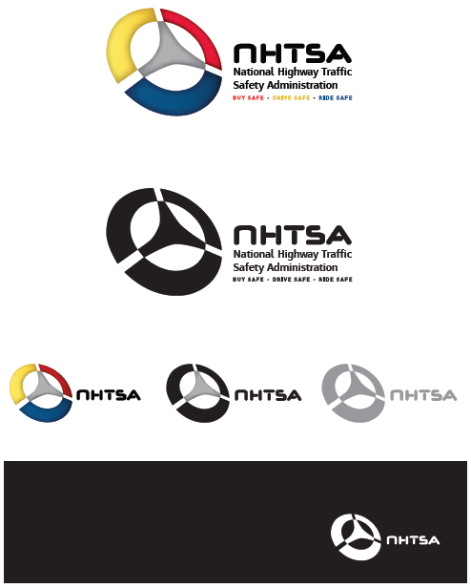 | 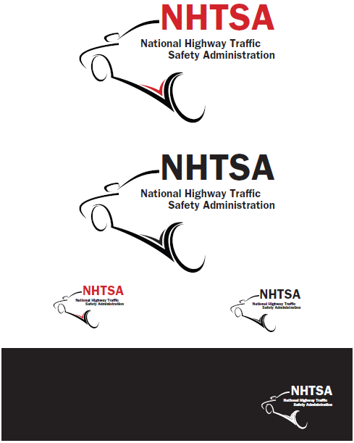

TESTING ORDER
Group 1: A, B, C, D
Group 2: D, C, B, A
Group 3: B, A, D, C
Group 4: C, D, A, B

- Finally, before we finish tonight, I’d like us as a group to evaluate some potential new logos that NHTSA is considering. Just like what we did with the SaferCar.gov logos, I’m going to pass out a piece of paper with a potential NHTSA logo. Before we discuss it as a group, I’d like you to individually look at the logo and jot down your initial thoughts. Then please give this logo a grade, from A to F, based on how appealing it is to you personally. [MODERATOR HANDS OUT PAPER WITH FIRST NHTSA LOGO]
- [MODERATOR ALLOWS MINUTE FOR PARTICIPANTS TO REVIEW] What did you first notice about this logo?
- What is this logo telling you?
- What do you like about this logo? What do you dislike about this logo?
  - [MODERATOR PROBES:] How do you feel about the color(s) used in this logo?
- What does this logo communicate to you about NHTSA?
- Does this logo make sense based on what you know about NHTSA?
  - What other images would you connect with NHTSA?
- To what extent does this logo convey all of the types of traffic and vehicle safety information that NHTSA provides? [MODERATOR REFERS TO INDEX CARDS]
  - What would you change about this logo to make it more encompassing?
- I have another example of how the NHTSA logo might be redesigned. Again, I’d like you to individually jot down your initial thoughts and give the logo a grade A-F based on how appealing it is to you personally. [MODERATOR HANDS OUT PAPER WITH SECOND NHTSA LOGO; REPEAT AS NECESSARY FOR ALL NHTSA LOGOS]
- [MODERATOR PINS UP ALL NHTSA LOGOS] Now looking at all of the potential logos for NHTSA, which stand out to you as more visually appealing?
- Better at capturing your attention?
- Better at visualizing what NHTSA does?
- Better at conveying all of the types of traffic and vehicle safety information that NHTSA provides?

Before we end our discussion, do you have any additional advice you’d like to give NHTSA for communicating traffic and vehicle safety information with consumers like you?

Thank and close group.

Questions in Section B satisfy objective 1: Understand where consumers currently get vehicle safety information
Questions in Section C satisfy objective 5: Evaluate potential new taglines and logos
Questions in Section D satisfy objectives 2 & 5: Gauge familiarity with NHTSA and SaferCar.gov and evaluate current SaferCar.gov logos as well as potential new taglines and logos for NHTSA
Questions in Section E satisfy objectives 2 & 3: Gauge familiarity with NHTSA and SaferCar.gov and determine what information and materials consumers are looking for from an agency like NHTSA
Questions in Section F satisfy objective 4: Identify motivators for using NHTSA communication channels
Questions in Section G satisfy objective 5: Evaluate current SaferCar.gov logos as well as potential new taglines and logos for NHTSA

