RESPONDENT HANDOUTS

“Ride Safe. Walk Safe. Drive Safe.”

NOTES: _________________________________________
_________________________________________

GRADE (CIRCLE ONE): A B C D F

“Buy Safe. Drive Safe. Ride Safe.”

NOTES: _________________________________________
_________________________________________

GRADE (CIRCLE ONE): A B C D F

“Buy Smart. Drive Safe. Stay Safe.”

NOTES: _________________________________________
_________________________________________

GRADE (CIRCLE ONE): A B C D F

“Buy Safe. Drive Smart. Stay Protected.”

NOTES: _________________________________________
_________________________________________

GRADE (CIRCLE ONE): A B C D F

“Shop Smart. Drive Safe.”

NOTES: _________________________________________
_________________________________________

GRADE (CIRCLE ONE): A B C D F

“Keeping You Safe Through Life.”

NOTES: _________________________________________
_________________________________________

GRADE (CIRCLE ONE): A B C D F

“Life’s Journeys Start With Safety.”

NOTES: _________________________________________
_________________________________________

GRADE (CIRCLE ONE): A B C D F

“Safety at Every Turn.”

NOTES: _________________________________________
_________________________________________

GRADE (CIRCLE ONE): A B C D F

“Together at Every Turn.”

NOTES: _________________________________________
_________________________________________

GRADE (CIRCLE ONE): A B C D F

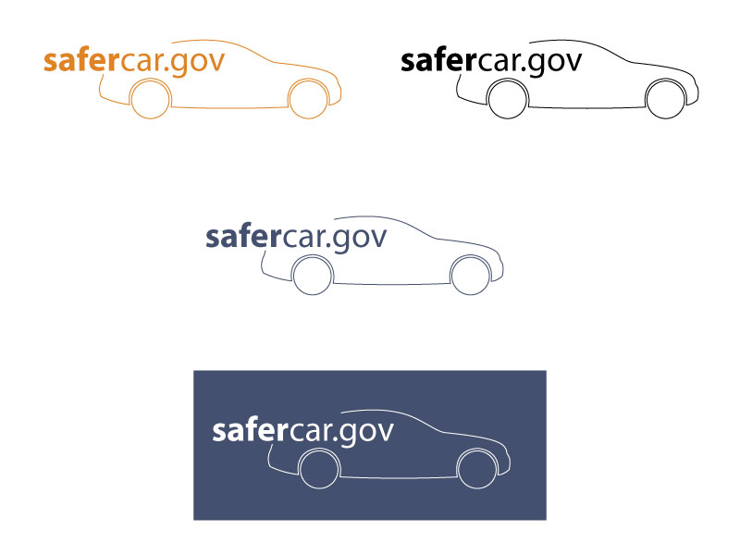

NOTES: ____________________________
____________________________

GRADE (CIRCLE ONE):

A B C D F

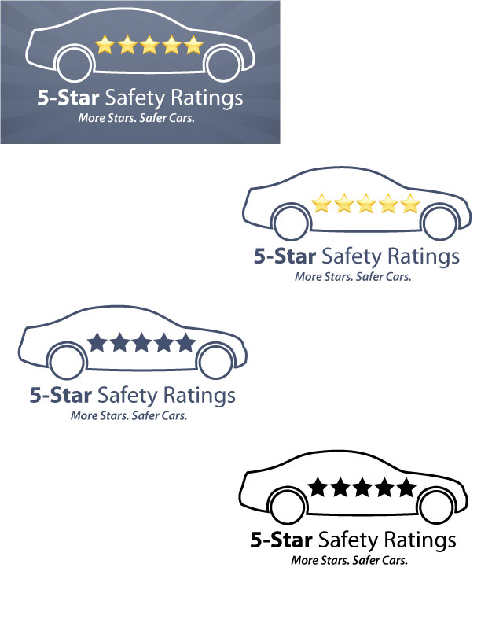
NOTES: ____________________________
____________________________

GRADE (CIRCLE ONE):

A B C D F



NOTES: ____________________________
____________________________

GRADE (CIRCLE ONE):

A B C D F

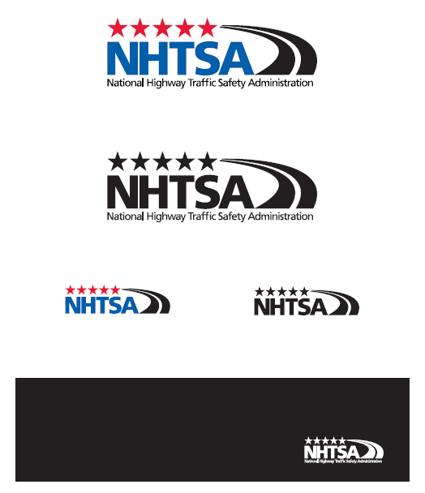

NOTES: ____________________________
____________________________

GRADE (CIRCLE ONE):

A B C D F

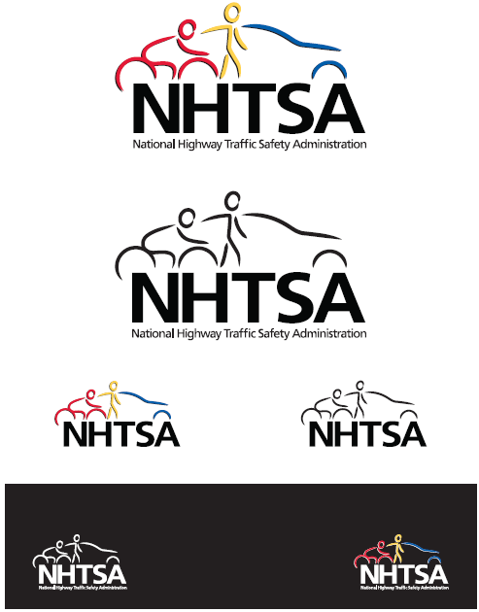

NOTES: ____________________________
____________________________

GRADE (CIRCLE ONE):

A B C D F

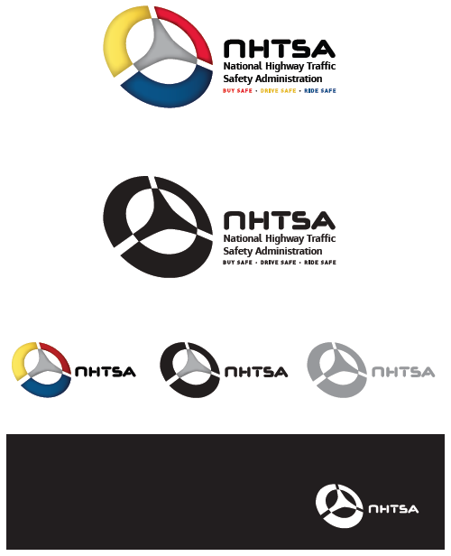

NOTES: ____________________________
____________________________

GRADE (CIRCLE ONE):

A B C D F

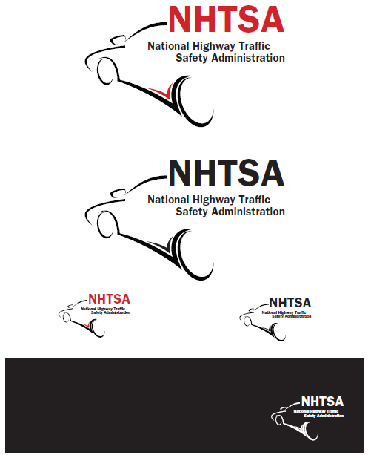

NOTES: ____________________________
____________________________

GRADE (CIRCLE ONE):

A B C D F

