Exhibit 1 – Proposed Agenda for Focused Listening Session

8:00 MARAD facilitator welcomes all, introduces regional officials and welcome by ranking regional officials

8:20 Welcome by Maritime Administrator
Overview/Strategy/Goals of the Breakout Sessions

8:45 Breakout Session 1: The Panama Canal’s Current and Anticipated Effects on the United States Economy
1. Examine Current Cargo Content & Cargo Movements through the Panama Canal
2. Destination and Potential Effects on East/West/Gulf Coasts/Inland Ports

9:30 Breakout Session 2: Cargo, Containers and Capacity
1. Examine the United States’ Ability to Accommodate Expansion of the Canal through Capacity Development.
2. Explore the Status of Capacity Development/Current and Future Bottlenecks (This session will tie-in to Marine Highways)

10:15 BREAK

10:30 Breakout Session 3: Canal Expansion and Costs:
Explore the Necessary Changes/Importance of those Changes
1. Explore How the Expected Changes Will Impact the Cost of Doing Business within the Industry; Who Pays and Benefits
2. The Costs of Canal Expansion: The Importance of Changing to Conduct Business in the Post-Canal Expansion Economy

11:15 Breakout Session 4: Total Trade Effect:
1. Explore the Legal and Policy Factors Affecting the United States’ Ability to Increase Imports and /Exports After the Expansion

12:00 Recap of the Morning Sessions
Closing Remarks

12:15 Adjourn / Lunch

Exhibit 2 – Topics and Questions for Discussions with Ports

- Market analysis showing market areas served
  - Can you provide information about the markets (commodities, industries) served, their locations, and type(s) of services provided?

- Assessment of competitive overlap e.g. feedback on areas served by West Coast
  - Which markets do you believe you competitively contest with the West Coast, and how will the Panama Canal expansion affect these contested markets?

- Confirmation of current port/inland capacity by relevant measures e.g. container handling/storage/rail connectivity etc. and total estimated TEU capacity.
  - Can you provide information about the current and future plans for managing both surge and base load moves through your port complex?

- Status of capacity development e.g. dredging, studies etc.
  - Can you provide us with copies of current plans, capital investments and capacity studies (including forecasts of demand and utilization) based on your current expansion plans?

- Assessment of costs for handling larger ships for ports where this is likely.
  - Where additional capacity for container movements are anticipated, can you provide a schedule of capital costs by category – including off-port improvements and plans by operators serving your port?

- Feedback on cost reduction estimates and impacts on volumes e.g. effects on (2) above.
  - How sensitive are you potential customers in contested markets to costs, and what kinds of response do you expect from shippers if your cost reduction measures take effect?

Exhibit 3 – Shippers Survey

Exhibit 3 is the Shippers Survey, which is included as a separate document.

Exhibit 4 – Federal Register Notice: Information Collection Available for Public Comments and Recommendations - Page 1 (Monday, October 31, 2011)
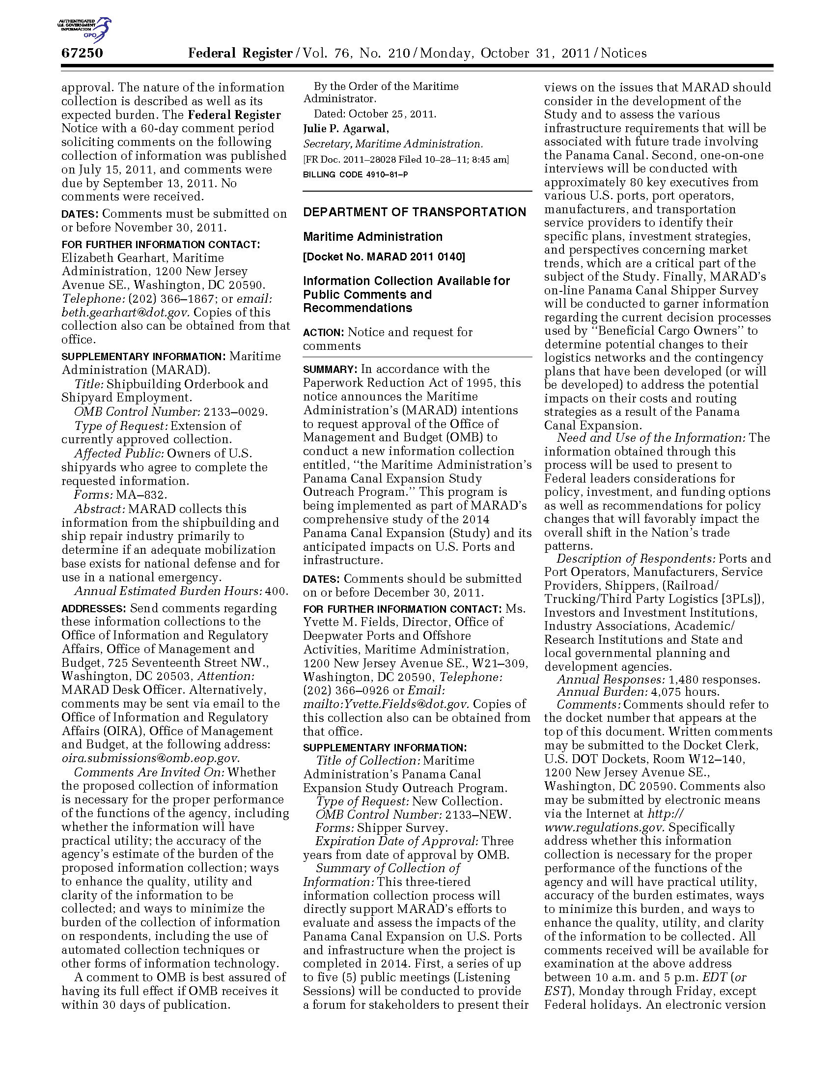
Exhibit 4 – Federal Register Notice: Information Collection Available for Public Comments and Recommendations - Page 2 (Monday, October 31, 2011)
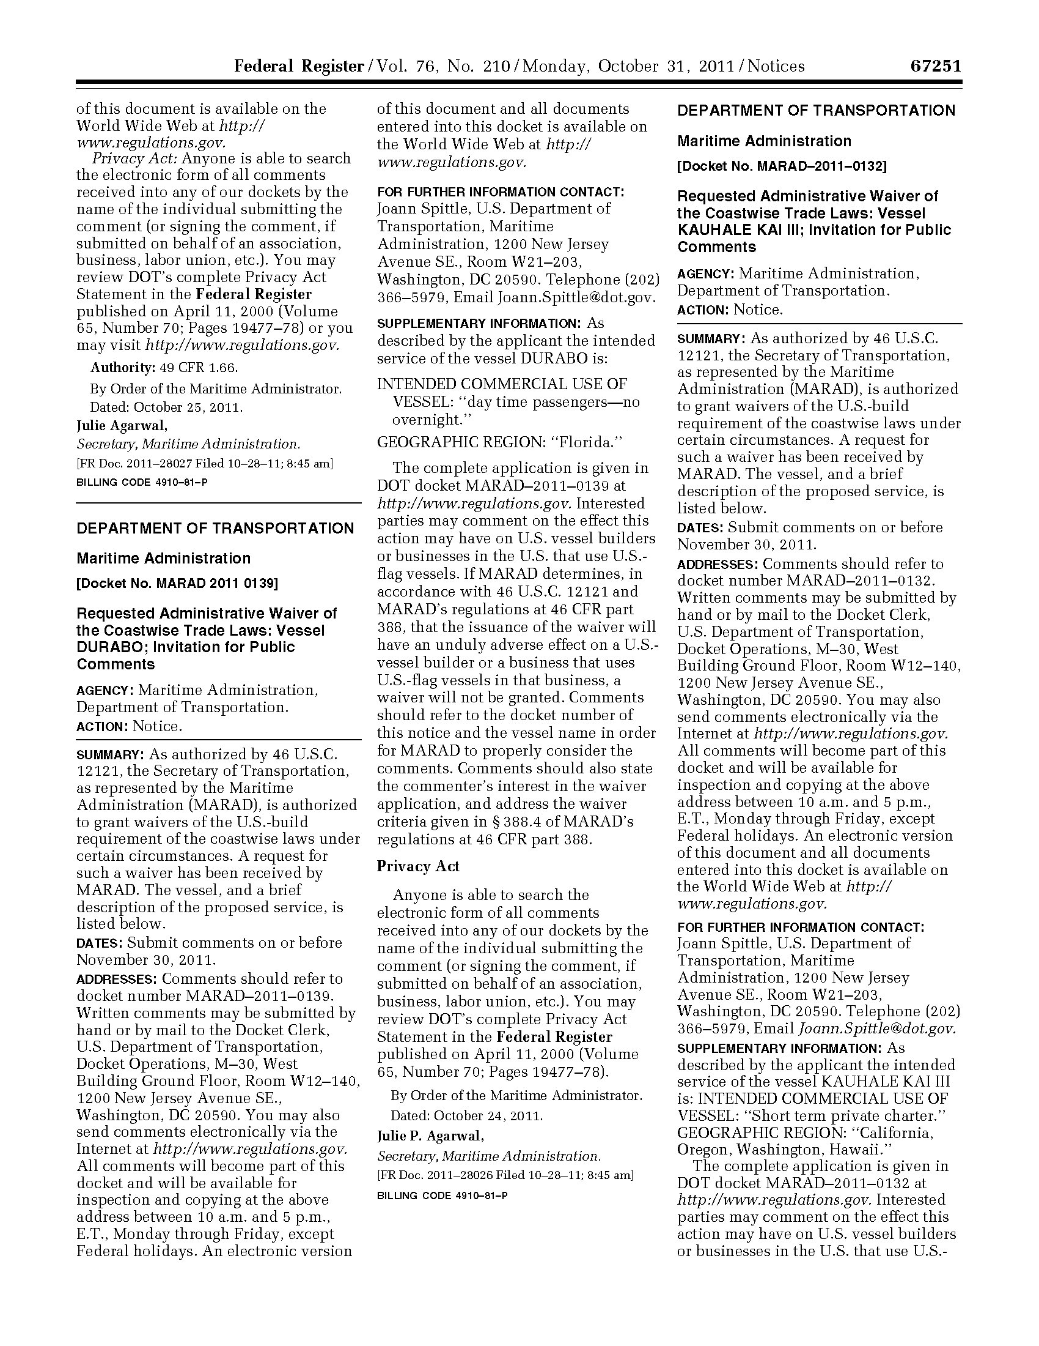

Sample E-mail Notification for the Supply Chain Consortium Survey

Dear <Respondent Name>,

The Tompkins Supply Chain Consortium is seeking to understand the impact of the Panama Canal's expansion in 2015 on overseas shipping patterns and we've already begun to see some surprising trends. Now what we really need is input from you.
Even if your company does not currently import or export product overseas, please take the survey. It will be very brief and will help us understand the types of companies for whom the Panama Canal expansion will have little impact. The survey should take 20 minutes on average. This is an online survey being undertaken by Tompkins Associates on behalf of a client.
The only personally identifiable information associated with each response is a code that is generated to indicate participation in the survey. (This code will be deleted when the online survey campaign is completed.) Participating in the survey will not jeopardize the competitive position of your organization. Further, the client will not have access to the names of respondents that participate in the survey, nor will the name of your organization appear in any publication. The administrators of this survey–Tompkins Associates–have a contractual agreement with the members of the Supply Chain Consortium, which prohibits revealing the identity of any survey respondents.
At the end of this survey campaign, the data generated from the survey will be aggregated, the code will be deleted, and the results will then be reviewed by the client. The client’s input will have direct influence over key future decisions pertaining to the Panama Canal, so your input in this survey will be both influential and critical. In appreciation for your input, Tompkins will send each survey participant a summary of survey highlights.

In order to participate, you may either:
 | 1. | Click on this link
 |  | or
 | 2. | Copy-paste the entire following link between quote marks (NOT including the quote marks) in a web browser  " http://research.zarca.com/k/QsUVVSsRQUsQXWQUTYVTsP "
 |  | or
 | 3. | Click on the following URL and enter the login information provided below:  http://research.zarca.com/static/surveykey.aspx  Key: QsUVVSsRQUsQXWQUTYVTsP

Thank you so much for your participation. If you are not the correct person within your organization to answer a survey about international overseas shipping, this survey may be forwarded for completion. Should you have any questions about the survey, please do not hesitate to contact Chris Ferrell; Director, Tompkins Supply Chain Consortium, at cferrell@tompkinsinc.com or (407) 362-0369.

Kindest Regards,
The Survey Team at Tompkins Associates

This email is sent on behalf of the person/organization whose name appears in the FROM field by Zarca Interactive . If you have any questions about the email, please contact the sender by replying to this email. If you prefer not to receive future reminders about this survey, please click here. If you prefer not to receive future surveys from the organization behind this survey, please click here.

Sample E-mail Follow-Up for the Supply Chain Consortium Survey

Dear <Respondent Name>,

The Tompkins Supply Chain Consortium is seeking to understand the impact of the Panama Canal's expansion in 2015 on overseas shipping patterns and we've already begun to see some surprising trends. Now what we really need is input from you!
Even if your company does not currently import or export products overseas, please take the survey. It will be very brief but still help us understand the types of companies the Panama Canal expansion will impact. For those companies who ship overseas, the survey will take about 20 minutes.

In order to participate, you may either:
 | 1. | Click on this link
 |  | or
 | 2. | Copy-paste the entire following link between quote marks (NOT including the quote marks) in a web browser  " http://research.zarca.com/k/QsUVVSsRQUsQXWQUTYVTsP "
 |  | Or
 | 3. | Click on the following URL and enter the login information provided below:  http://research.zarca.com/static/surveykey.aspx  Key: QsUVVSsRQUsQXWQUTYVTsP

When the survey is completed, the data will be summarized and reviewed by the client that has engaged Tompkins Associates to undertake the survey. The client will not be able to access to the names of respondents that participate in the survey, nor will your company’s name appear in any publication. In appreciation for your input, Tompkins will send each survey participant a summary of survey highlights referencing the top-level results.
Thank you so much for your participation. If you are not the correct person within your organization to answer a survey about international overseas shipping, this survey may be forwarded for completion. Should you have any questions about the survey, please do not hesitate to contact Chris Ferrell; Director, Tompkins Supply Chain Consortium, at cferrell@tompkinsinc.com or (407) 362-0369.

Kindest Regards,
The Survey Team at Tompkins Associates

This email is sent on behalf of the person/organization whose name appears in the FROM field by Zarca Interactive . If you have any questions about the email, please contact the sender by replying to this email. If you prefer not to receive future reminders about this survey, please click here. If you prefer not to receive future surveys from the organization behind this survey, please click here.

