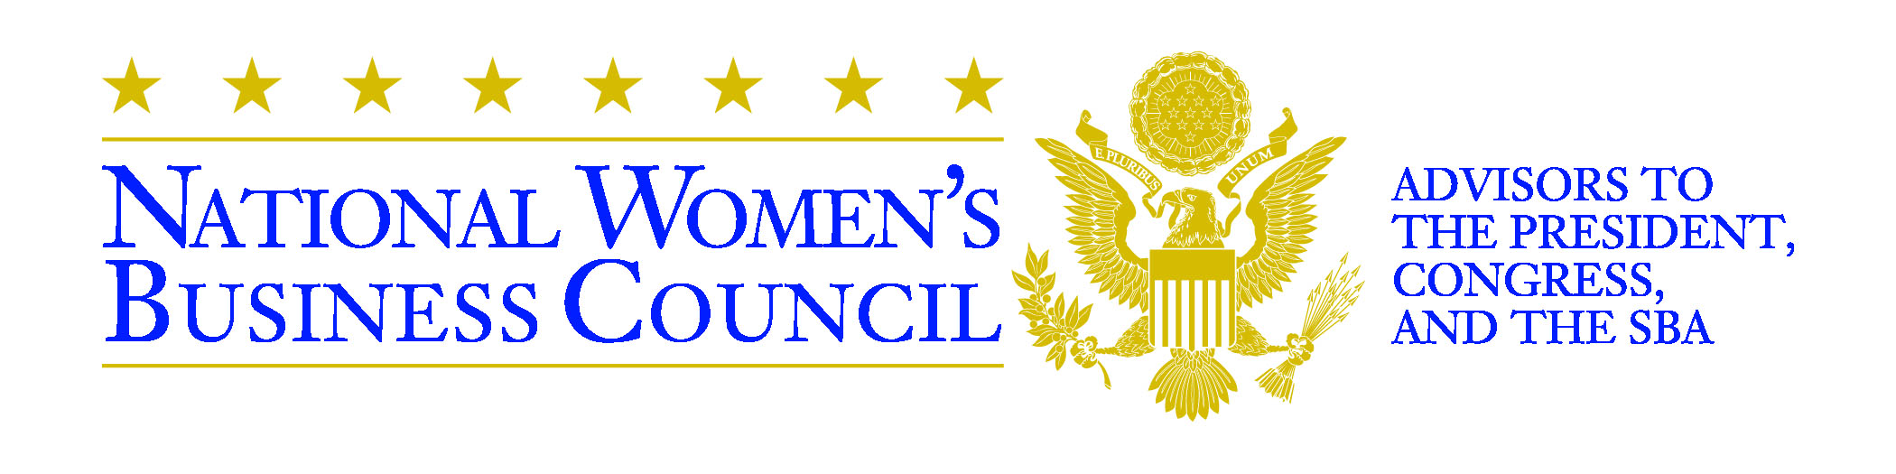

INPUT FOR OMB PRA QUALITATIVE RESEARCH PROCESS
Submitted by Delixus: December 21, 2011

The Invitation
Dear Entrepreneur,
I am writing to invite you to a Focus Group Meeting on “Women Entrepreneurs and Intellectual Property Protection” to be hosted by the National Women’s Business Council, on DATE at the LOCATION, CITY, STATE at TIME pm.
The National Women’s Business Council (NWBC), with its offices located in Washington, D.C., is a non-partisan federal advisory council created to serve as an independent source of advice and counsel to the President, Congress and the U.S. Small Business Administration on issues of importance to women business owners. Members of the Council are prominent women business owners and leaders of women’s business organizations.
The Council’s mission is to promote bold initiatives, policies, and programs designed to support women’s business enterprises at all stages of development in the public and private sector marketplace – from startups to significance.
One of NWBC’s priorities this year is to examine in-depth the relationship between intellectual property and women-owned businesses. There is some information on women and patents; but we would like to dive deeper and cast a wider net in our research project.
As a part of this research, we are conducting a series of focus groups in different parts of the country. You have been selected at random from among those who have either received a patent, trademark or copyright recently or tried to obtain one. [NOTE: This language will vary for groups with different audiences.) The Focus Group Meeting will be attended by a cross section of women entrepreneurs in your area.
This research, along with quantitative research that is going on concurrently, will provide valuable insights in formulating actionable strategies to assist the development of women owned businesses.
Your participation in this group is completely voluntary. If you do choose to participate, your name will be kept confidential. In the final report, your name will never be used but you will instead be represented by a pseudonym or other code. This focus group is covered by OMB Control #3245-XXXX.
An honorarium of $75 is proposed for you to cover transportation and other costs. Please let me know your acceptance by DEADLINE.
PLEASE NOTE: You are not required to respond to a request for information (including participation in a study or focus group) sponsored by the Federal Government unless the government displays a currently valid OMB Control Number. This collection has been assigned Control No. 3245-XXXX. The total estimated time to participate in this focus group is 100 minutes (90 minutes per session, plus 10 minutes to read and respond to the invitation.) Comments or questions on any aspects of this request may be submitted to Small Business Administration, Chief Administrative Information Branch, 409 Third Street SW, Washington, DC 20416; and/or SBA Desk Officer, Office of Management and Budget, New Executive Office Building, Room 10202, Washington, DC 20503.
Sincerely,
Julia Kurnik
Director of Research and Policy
National Women’s Business Council
409 3rd Street, SW, Suite 210
Washington, DC 20416
202-205-6826
www.nwbc.gov

The Questionnaire
Each focus group will probe in-depth the following questions:
- What motivates women entrepreneurs to file for IP protection?
- What hinders women entrepreneurs from filing for IP protection?
- Are these hindrances real or perceived?
- What differences, if any, exist between men and women in their access to IP protection?
- To what extent has IP protection enabled women to grow their businesses?
- What can government and business do to increase the participation by women in patents, trademarks and copyrights activity?
- Is there a recent surge in participation by women in patent, trademarks and copyrights activity? If so, why?

The Sample

The sample of respondents will be drawn from the dataset supplied by the USPTO. A list of people who have applied for and received patents is publicly available from the USPTO. This list will be used, sorted by geography, in order to contact potential participants.

