Project Code 122 QID 060041 February 2010 DEALERS |  | OMB No. 0535-0002 Approval Expires 6/30/2012
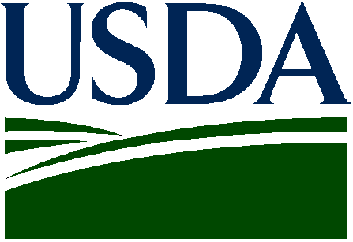 | NON-OIL SUNFLOWER  2011 Crop |  |  |  | 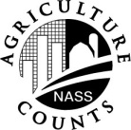 | NATIONAL  AGRICULTURAL STATISTICS  SERVICE
North Dakota Field Office
P.O. Box 3166
Fargo, ND 58108-3166
701-239-5306
Fax: 701-239-5613
E-mail: nass-nd@nass.usda.gov
Plantings intentions for the 2011 non-oil sunflower crop will be released March 31. Please help us collect the information by reporting your contracted acreage.

Information requested in this survey is used to prepare estimates of selected agricultural commodities. Under Title 7 of the U.S. Code and CIPSEA (Public Law 107-347), facts about your operation are kept confidential and used only for statistical purposes in combination with similar reports from other producers. Response is voluntary.

PLEASE REPORT FOR YOUR OPERATION
(Include acres contracted through agents)
STATE | ACRES CONTRACTED  AND TO BE CONTRACTED
North Dakota
Minnesota
South Dakota
Nebraska
Kansas
Colorado
Oklahoma
Texas
Other (___________________)

Please Return by March 16

Reported by ______________________________________________________ Date _______________________________________

According to the Paperwork Reduction Act of 1995, an agency may not conduct or sponsor, and a person is not required to respond to, a collection of information unless it displays a valid OMB control number. The valid OMB number is 535-0002. The time required to complete this information collection is estimated to average 10 minutes per response, including the time for reviewing instructions, searching existing data sources, gathering and maintaining the data needed, and completing and reviewing the collection of information.

