School District Review Program:
2013-2014
General Guidelines for All Participants

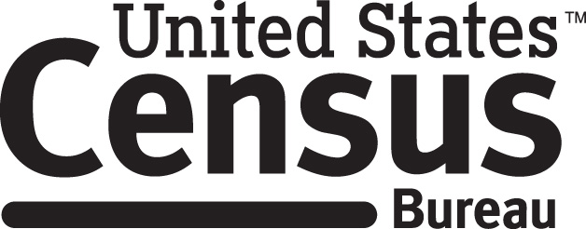

TABLE OF CONTENTS

- GENERAL INFORMATION……………………………………..... 3
  - Background……………………………………………………... 3
  - Purpose of the School District Review Program………………... 3
  - Mapping Coordinator Responsibilities…………………….......... 4
- School District Review Program Flowchart…………...5
  - Schedule……………………………………………….………...6
  - Contact Information……………..……………………………... .6
  - Web Sites…………………………………………………….......7

- DESCRIPTION AND USE OF FILES PROVIDED………….….... 8
  - Inventory and Grade Range Files………………………..….…....8
    - Grade Ranges…………………………………….….…9
    - Examples of Financial Responsibility…………..……...9
    - Official School District Names…………………….…10
    - How to Submit Inventory & Grade Range Changes….10
  - County Coverage Files …………………………………………10
  - SD/GEO Relationship Files.…….………………….…………...10
  - Legal Entity Coextensive File……………………….…….…….11
  - Spatial Files……………………………………………..….…....12
    - MAF/TIGER Partnership Software (MTPS)…….….…12
Disclosure to Respondents…………………………………………..13

ADDITIONAL GUIDELINES:
Attachment A: Guidelines for the MAF/TIGER Partnership Software (MTPS)
Attachment B: Guidelines for Completing the Submission Log
Attachment C: How to add a Line in the MTPS
Attachment D: Data Dictionary/Record Layout for School District Listings
Attachment E: Guidelines for Special Situations: Parcels, Shorelines, and Pseudos
Attachment F: Review Your School Districts Online

I. GENERAL INFORMATION

A. Background

The School District Review Program (SDRP) is a U.S. Department of Education (DoED) National Center for Education Statistics (NCES) sponsored program conducted by the U.S. Census Bureau every two years. It is of vital importance for your state’s allocation under Title I of the Elementary and Secondary Education Act as amended by the No Child Left Behind Act of 2001, Public Law (P.L.) 107-110. The updated school district boundary information submitted through this program, along with the Census 2010 population and income data and current population estimates, are used in forming the Census Bureau’s estimates of the number of children aged 5 through 17 in low-income families for each school district. These estimates are the basis of the Title I allocation for each school district in your state.

The SDRP consists of two phases – the Annotation Phase and the Verification Phase. In the Annotation Phase, the Census Bureau provides mapping coordinators with materials containing the most current school district boundaries and information for their state. The annotation materials you receive for SDRP 2013-2014 reflect the school district names, Federal Local Education Agency (LEA) identification (ID) numbers and boundaries updated during the 2011-2012 SDRP. The states review this data and report any changes in the school district boundaries or attributes to the Census Bureau.

The Verification Phase is when the results of any changes submitted during the Annotation Phase for the 2013-2014 SDRP are reviewed by the mapping coordinators, after the Census Bureau has incorporated those changes into the Master Address File (MAF)/Topologically Integrated Geographic Encoding and Referencing (TIGER) System (MAF/TIGER) database (the Census Bureau’s geographic database).

B. Purpose of the School District Review Program

The purpose of the 2013-2014 SDRP is for state officials to review the Census Bureau's 2011-2012 school district information and to provide updates and corrections to the school district names, Federal LEA ID numbers, boundaries, and grade ranges. The review encompasses only Type 1 and Type 2 school districts as defined by the NCES.

- Type 1 is a local school district that is not a component of a supervisory union.
- Type 2 is a local school district component of a supervisory union sharing a superintendent and administrative services with other local school districts.

This document and its attachments provide state education officials with all information needed for responding to the 2013-2014 SDRP.

C. Mapping Coordinator Responsibilities

The mapping coordinators are the primary liaisons between the Census Bureau and the local school district officials. It is your responsibility to initiate and maintain contact throughout the program with your local school district officials. You must ensure that reviews and submissions are completed within the time frame of the SDRP.

When you receive updates from your local school district officials, you must review them for accuracy and completeness before submitting them to the Census Bureau. This review includes all types of changes submitted: boundary changes, consolidations, dissolutions, grade range updates, etc.

When you receive a boundary change from a school district, it is your responsibility to contact all the other school districts that would be affected by the boundary change to ensure this change is valid and all affected parties agree to said change. It is also the mapping coordinator’s responsibility to resolve any problems found in these submissions or discrepancies between school district boundaries.

Once you feel certain that all of the information submitted is correct and in the proper format, etc., submit this information by county to the Census Bureau. You have then completed the Annotation Phase of the program.

After the Census Bureau processes your changes, we will create new materials for you to review. This the Verification Phase. The mapping coordinator is responsible for reviewing these materials and notifying the Census Bureau if there are any additional changes or corrections, or if the information is correct.

The program flowchart shown below is to help you understand how the process should flow.

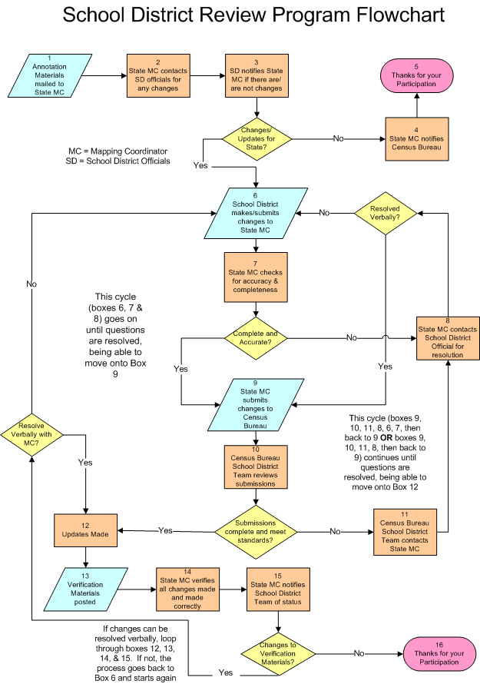

D. Schedule

We request that the school district information you submit reflect the school districts as they exist, or will exist, on January 1, 2014. Please contact us immediately if you are concerned that you may not be able to meet deadlines as outlined below.

Program Timetable
- July 2013 - National Center for Education Statistics letter is sent to Title I coordinators asking for designation of a school district mapping coordinator for each state and the District of Columbia.
- August 2013 - Mailout of program instructions and annotation materials to designated state school district mapping coordinators begins.
- February 28, 2014 - Deadline (extended) for submitting school district changes during the Annotation Phase. We strongly encourage our partners to submit changes as soon as possible rather than waiting until this deadline. If your state is submitting a large number of changes, please send them on a flow basis by county, rather than waiting to send the entire state. In order to participate in the 2013-2014 SDRP’s Verification Phase, the Census Bureau must receive all your school district Annotation updates before February 28, 2014.
- March 2014 – Delivery and review of Verification materials begins.
- April 2014 – Deadline for submitting school district changes during the Verification Phase.
- November 2014 - Release of preliminary estimates based on the updated school district geographic framework.

E. Contact and Shipping Information

We encourage you to contact any of the following Census Bureau geographic staff with any questions about the SDRP at 301.763.1099:

- Mr. Ian Millett
- Ms. Pat Ream
- Mr. Nathan Jones
- Mr. Ryan Short

E-mail: geo.school.list@census.gov
Fax number: 301.763.4710

F. Web Sites

2013-2014 School District Review Program (SDRP) Web Page

http://www.census.gov/geo/www/schdist/sch_dist.html

Links to the Annotation Phase materials will be available on the 2013-2014 SDRP website soon after you receive your CDs/DVDs. You may want to use this website to distribute review materials to local school district superintendents or others who may be able to participate by reviewing their local areas online.

Your CD/DVD contains various Annotation Phase materials that you will need to participate in the program (explained in section II below.) All of the text files, Excel files, shapefiles, and MTPS software provided on the CDs/DVDs will also be available on, and able to be downloaded from, the web site (go to www.census.gov and click on “Geography”, then “Geographic Partnerships”, then “School District Review Program”, then “Annotation Phase Program Materials”). You will need to contact the Census Bureau for a password in order to download the MTPS software.

After we have completed processing your submissions, Census Bureau staff will notify you via e-mail when the verification materials for your state are ready for review so you can verify we have processed all your state’s changes correctly. Participants will be able to download and review their verification shapefiles using the MTPS or other GIS software. Participants will also be using the Census Bureau's online TIGERweb Map Viewer to review and verify school district boundaries for the 2013-2014 SDRP. The Census Bureau will provide instructions for verifying your boundaries at the same time we notify you that your Verification Phase materials are available.

Reviewing Current School District Boundaries Online

All current school district boundaries can be reviewed online using the Census Bureau's TIGERweb Map Viewer application at: http://tigerweb.geo.census.gov/tigerweb/. Instructions for using the TIGERweb Map Viewer are described in Attachment F.

II. DESCRIPTION AND USE OF FILES PROVIDED

The data CD/DVD contains a number of important files. Depending on the particulars of your state’s school district geography and how your state participates in this program, some files may not be included in the package sent. The Readme.txt on the data CD/DVD contains a complete list of materials your state will receive. You will see that for convenience purposes, we have provided both a text file and an Excel file for each listing on your CD/DVD. The potential files include:

Listings
- Inventory and Grade Range File (All States)
- County Coverage File (All States)
- Relationship Files (Limited States)
- Legal Entity Coextensive File (Limited States)

Spatial Files
- Shapefiles (All states)
- MAF/TIGER Partnership Software (MTPS) (All states)

A description of each file and how each one should be used to report updates/corrections are below.

NOTE: Due to the formatting of the text documents, please use a text viewer such as WordPad (located in Microsoft Office/Accessories) to open them. Otherwise, the margins and page orientation will have to be changed to accommodate the text.

Inventory and Grade Range File (All States)

The Inventory and Grade Range files are named "<ST>_SD_Inventory_A.txt" and "<ST>_SD_Inventory_A.xls" (see Attachment D for record layout). This file is a listing of all the 2011-2012 school districts that the Census Bureau has in its database and includes the school district name, Federal LEA ID number (SDLEA), level, type, and grade range. We request that you carefully review the information contained on this listing and provide us with updates and corrections.

Please Note: Because the Census Bureau requires complete school district coverage in its geographic database, this file may contain school districts that are not Type 1 or Type 2. These are flagged in the file as follows: Pseudo (A) (See Attachment E for more information on pseudo school districts), Department of Defense (B), Interstate (C), and Bureau of Indian Affairs [BIA] (D). This file also flags school districts within a state or county that have the same name but different Federal LEA ID (SDLEA) numbers with an E. In these situations, the SDLEA numbers are the means to identify unique school districts that share the same name.
In addition, we have discovered that some states contain elementary school districts without secondary coverage. We request that these states pay special attention to the grade ranges on the list and let us know what the secondary coverage should be or let us know why there is no secondary coverage. Those states are:

    - Arizona
    - California
    - Connecticut
    - Illinois
    - Michigan
    - Missouri
    - New Hampshire
    - North Dakota
    - Oklahoma
    - Oregon
    - Rhode Island
    - Vermont
    - Virginia

Grade Ranges
The grade ranges included in this file indicate the grade ranges for which each school district is financially responsible. We use original obligation, not the provision of educational services, to define financial responsibility. We use this set of grades, based on financial responsibility, to assign the data for each child to exactly one school district.

Examples of Financial Responsibility:

A school district is financially responsible for the education of all children in a geographic area if it is the only district serving that area. It may meet that responsibility by 1) operating schools that provide education to children in all grades, or 2) by operating schools that provide education for children in some grades and paying another school district to provide education for the children in the remaining grades, or 3) not operating any schools, but paying another school district to provide education to all the school district's children.

If the children in a geographic area are served by an elementary school district, and also served by a separate high school district that receives no payment from the elementary district, then the two school districts share the geographic area and financial responsibility is divided between them. The grade ranges on the listing should show which district is financially responsible for the children in each grade. The grade ranges listed for each of the two school districts must not overlap, and every grade must be assigned to one of the school districts.

Responsibility for a particular grade exists even if, from time to time, there are no children in that grade living in the service area of the school district. Thus, a school district that is responsible for providing 6th grade schooling should appear on the listing with the "6th grade" in its grade range, even if there are no actual 6th grade students living there.

Official School District Names

The official school district name should be its legal name including any state-used descriptive wording, such as "Independent School District", "Consolidated School District" or "Supervisory Union."

How to Submit Inventory and Grade Range Changes

Submit grade range and name changes to the Census Bureau as follows: (Do not include these changes in any shapefile.)

- Include all changes in the Submission Log (see Attachment B), or

- Update either the School District Inventory and Grade Range text or Excel file, not both, with all grade range changes, additions (new school districts) and deletions (deleted school districts) making clear what you are changing by either highlighting, changing text color, text bolding, adding, crossing out, etc. the changes.

- Send the Submission Log or updated file by e-mail to geo.school.list@census.gov.

IMPORTANT: Please contact the Census Bureau if you have a significant number of name and/or grade range changes.

- County Coverage File (All States)

The County Coverage files are named "<ST>_County_Coverage_A.txt” and "<ST>_County_Coverage_A.xls” (see Attachment D for record layout). The files are sorted by county and list the school districts that are located in each county. There is a separate record for each unique school district/county combination.

The County Coverage file reflects the boundaries of the 2011-2012 school districts as shown in the shapefiles and online school district maps. Use this file to locate each school district and to review the extent of the areas of each school district as they relate to counties.

- SD/GEO Relationship File (Limited States)

Connecticut, Maine, Massachusetts, New Hampshire, New Jersey, Pennsylvania, Rhode Island, and Vermont are states where school districts are commonly coextensive with one or more incorporated places and/or county subdivisions (towns, townships, boroughs, etc.). Please review the relationships listed in the file named: <ST>_SD_GEO_Relationship_A.txt or <ST>_SD_GEO_Relationship_A.xls to ensure that your school districts are maintaining the correct relationships with the aforementioned legal governmental entities (See Attachment D for record layout). Similar to the County Coverage files, this file contains records for each school district/incorporated place and school district/county subdivision combination.

Both the <ST>_SD_GEO_Relationship_A.txt and the <ST>_SD_GEO_Relationship_A.xls files are sorted by Federal LEA ID number (SDLEA) for use in reviewing the geographic relationship between the local governments (towns, townships, boroughs, etc.) and each school district.

Currently, the Census Bureau maintains these relationships without the need for states to submit boundary corrections for the listed school districts. All changes to incorporated places and county subdivisions are obtained through the Census Bureau's Boundary and Annexation Survey (BAS). If you believe that a legal boundary is incorrect, please notify the Census Bureau via email at geo.bas@census.gov. Boundaries of these school districts are updated accordingly. Please review these listings and notify us where we should no longer maintain a relationship, or where we should create and maintain a new relationship.

- Legal Entity Coextensive File (Limited States)

The Legal Entity Coextensive files named "<ST>_Coextensive_Coverage_A.txt," and "<ST>_Coextensive_Coverage_A.xls," (see Attachment D for record layout) are being provided to Alabama, Alaska, Georgia, Kentucky, Louisiana, Mississippi, North Carolina, South Carolina, Tennessee, Utah, and Virginia because some of their school districts are coextensive with legal entities such as counties, county equivalents, or incorporated places.

The Census Bureau maintains these coextensive relationships without the need for states to submit boundary corrections for the listed school districts. All changes to counties, county equivalents and incorporated places are obtained through the Census Bureau's BAS. Boundaries of these school districts are updated accordingly. Please review these listings and notify us where we should no longer maintain a coextensive relationship, or where we should create and maintain a new relationship.

Please Note: If your state did not receive an SD/GEO Relationship File or a Coextensive Coverage file, we also would like to know if there are school districts in your state that are legally coextensive with local governments.

How do I make corrections to the “County Coverage”, “Relationship” and/or “Legal Entity Coextensive” Files?

- Update either the text file or the Excel file, not both, with all changes,
additions, and deletions making clear what you are changing by either highlighting, changing text color, text bolding, adding, crossing out, etc. the changes.

  - Send the updated file(s) by e-mail to geo.school.list@census.gov.

Spatial Files (All states)

MAF/TIGER Partnership Software (MTPS)

You will receive a customized software application created by the Census Bureau called the MTPS.
The MTPS uses spatial and tabular data from the MAF/TIGER Database, (the Census Bureau’s geographic database) enabling participants to review and modify their school district boundaries and return a file to the Census Bureau in a pre-approved, standard digital format.

Included in the MTPS application is a “Computer Based Training (CBT)” module. This tutorial provides an automated overview of the software’s basic functionality along with some additional tools, such as how to select and edit features. Detailed instructions for using the MTPS are included in Attachment A.

Please do not hesitate to contact the Census Bureau if you encounter any technical questions/issues. You can send an email to geo.school.list@cenus.gov or call any of the census geographic staff listed in the “Contacts” section on page 6 of this document.

Disclosures to Respondents

The Geography Division manages programs to continuously update features, boundaries, addresses, and geographic entities in the Master Address File / Topologically Integrated Geographic Encoding and Referencing System (MAF/TIGER) database (MTDB) that is used to support programs and to conduct the census and surveys. The SDRP program is a U.S. Department of Education, National Center for Education Statistics (NCES) sponsored program, conducted by the U.S. Census Bureau every two years. The updated school district boundary information obtained through this program allows the Census Bureau to create estimates of the number of children in low-income families residing within each school district which NCES uses as the basis of the Title I allocation for each school district.

Public reporting burden for this collection of information is estimated to average 60 hours per respondent, including time for reviewing instructions, assembling materials, organizing and reviewing the information, and reporting any needed changes. We anticipate that an estimated 34 participants will respond. For larger states or states with many changes, however, the respondent burden may be 120 hours or longer to complete. Please send comments regarding this burden estimate or any other aspect of this collection of information, including suggestions for reducing this burden to:

Paperwork Project
0607-0795
U.S. Census Bureau
4600 Silver Hill Road
Room 3K138
Washington, D.C. 20233

You may e-mail comments to Paperwork@census.gov. Use “Paperwork Project 0607-0795” as the subject.

Responses to this survey are voluntary. The authority for conducting these activities is covered under the legal authority of Title 13 U.S.C. Sections 141 and 193.

No agency may conduct and no person may be required to respond to a collection of information unless it displays a valid Office of Management and Budget (OMB) approval number. The OMB approval number for this information collection is 0607-0795.

