Attachment 6a. Draft CTG Cost Study Instrument (CSI)
CTG Cost Study Instrument (CSI)

Log In Screen:

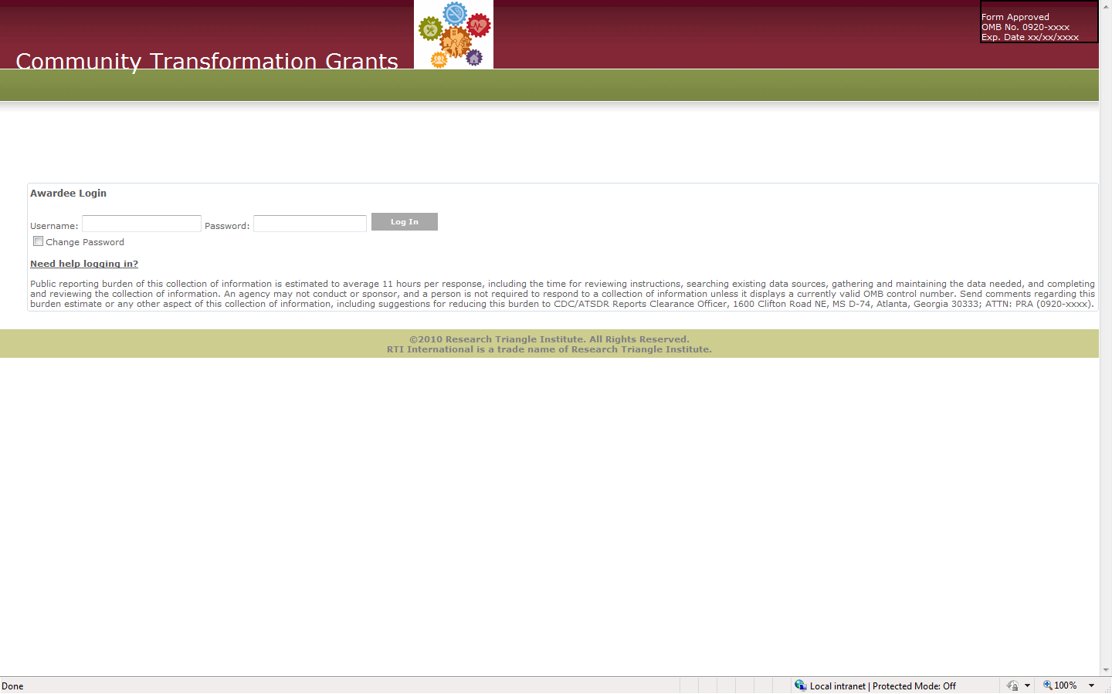

Home Page:

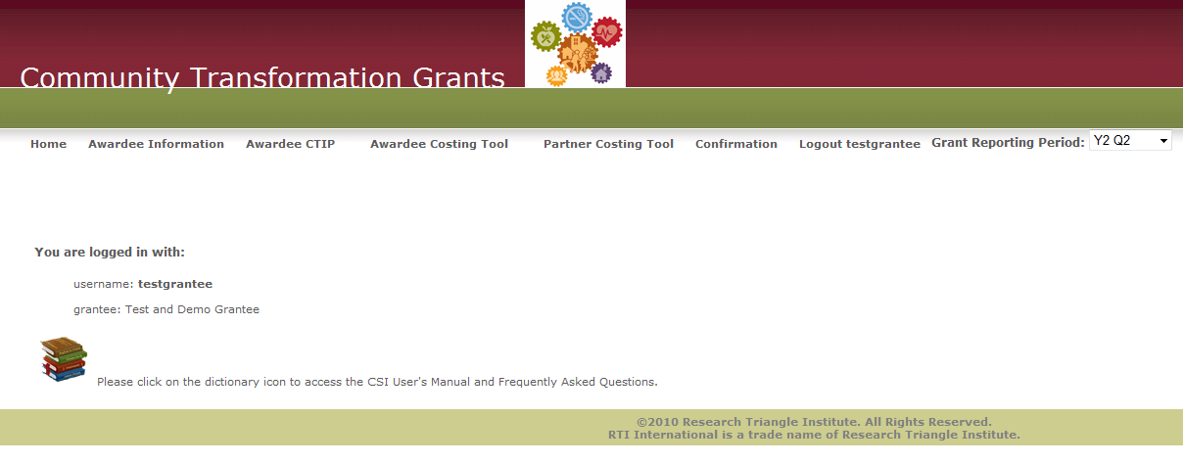

Awardee Information:
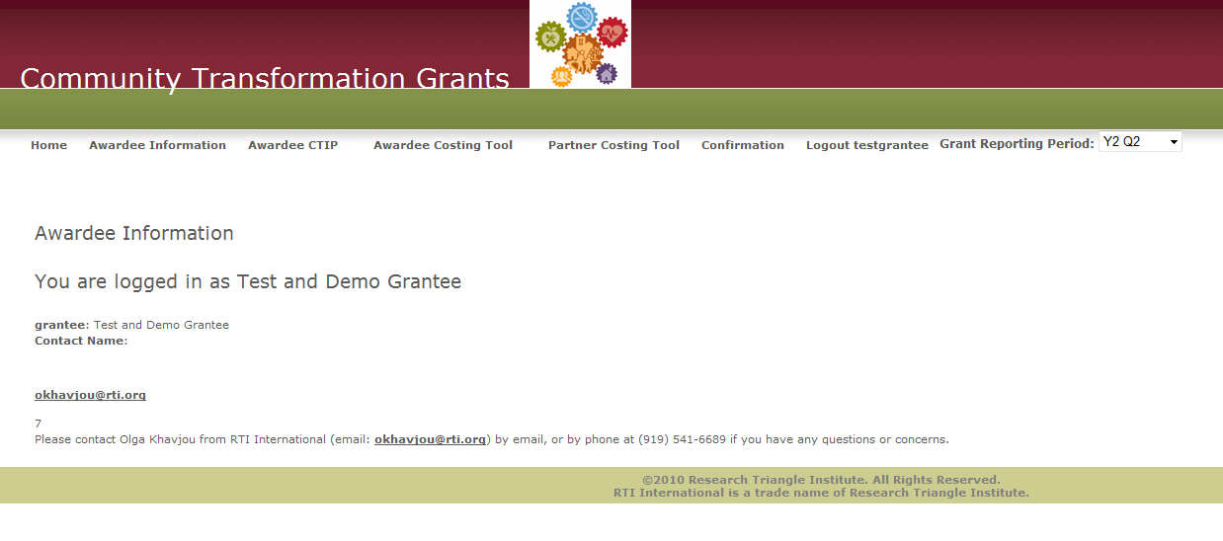
Awardee CTIP:

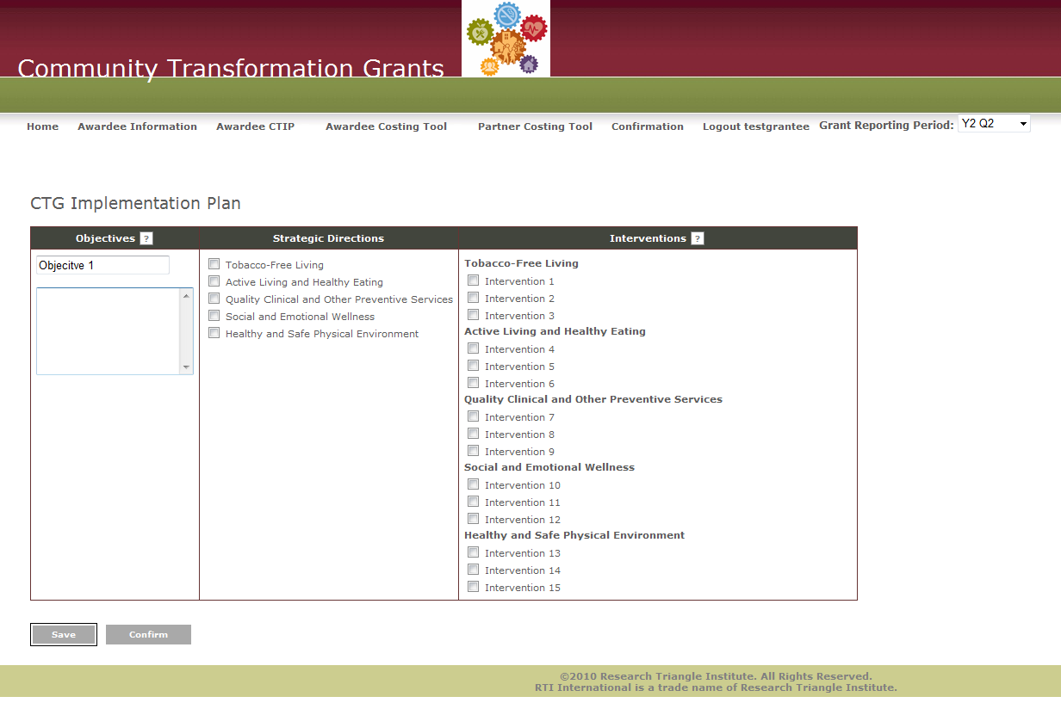

Manage Partners:
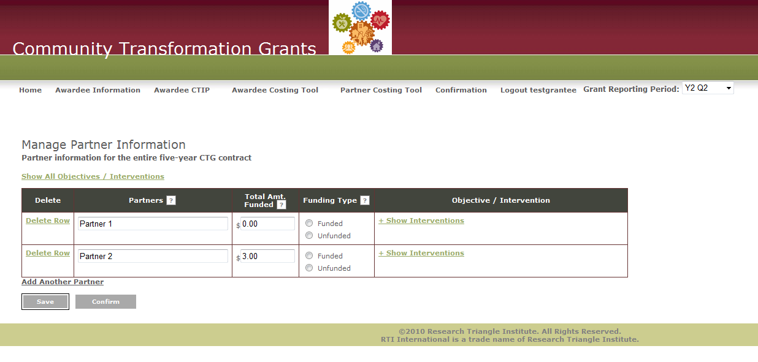

Awardee Costing Tool: Labor/Personnel Expenditures
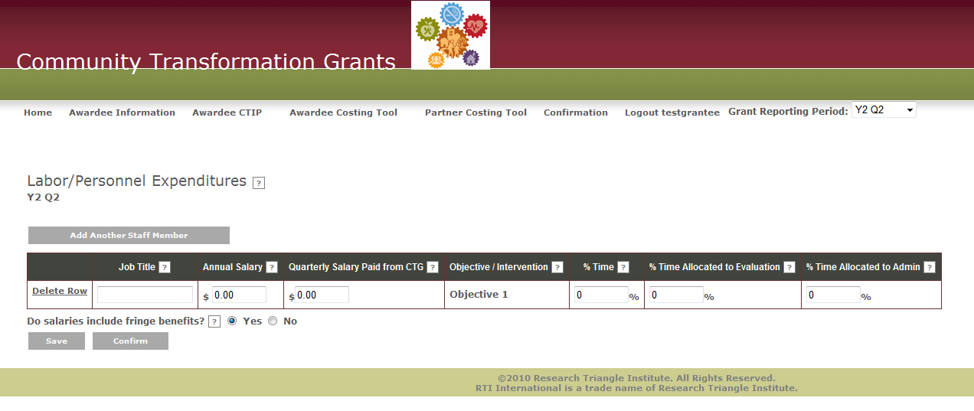

Consultant Expenditures:
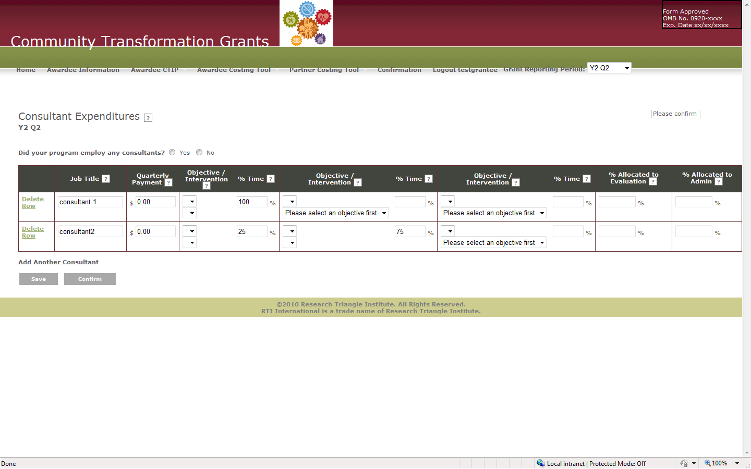

Materials, Travel, Services:

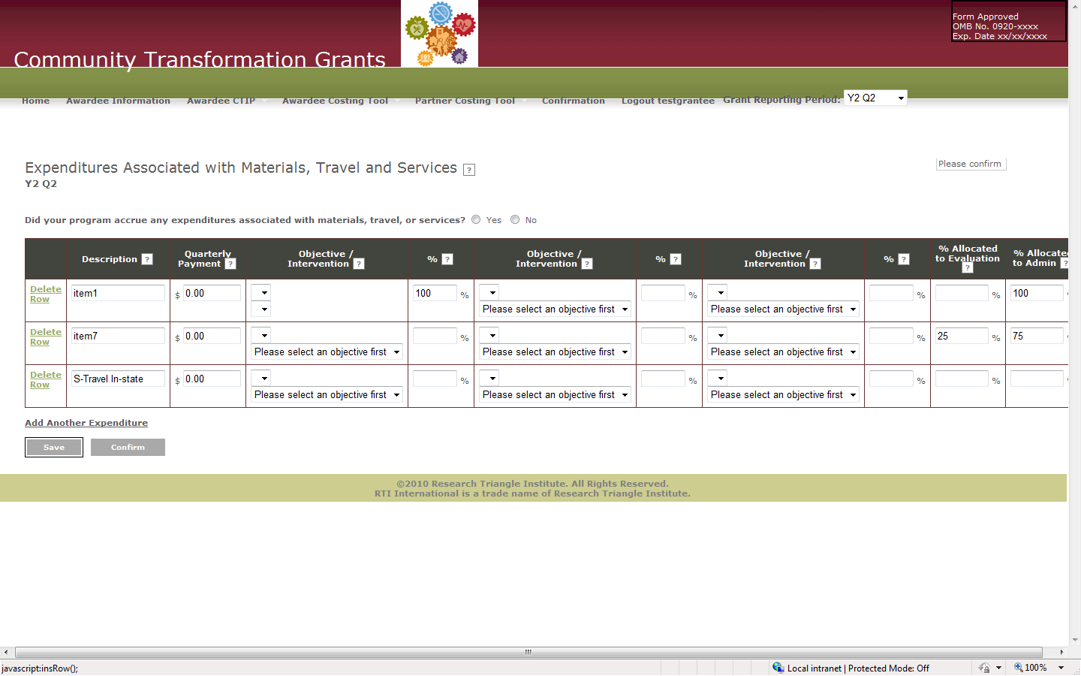

Administrative Expenditures:
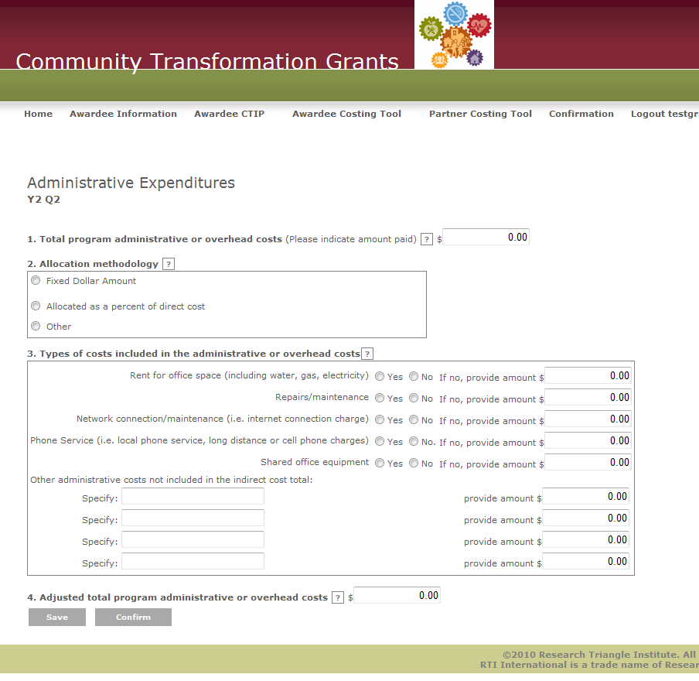

In-Kind Contributions:
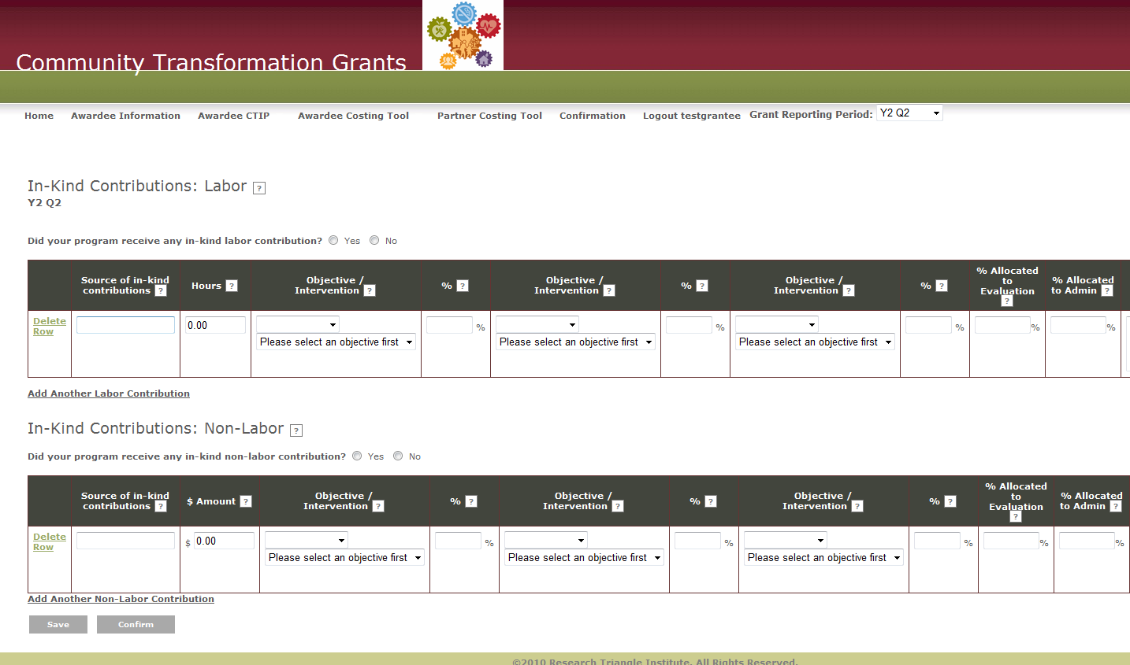

Partner Costing Tool:
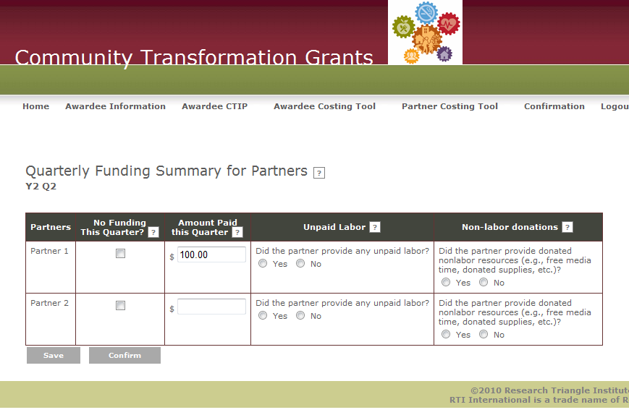

Partner Costing Allocation:
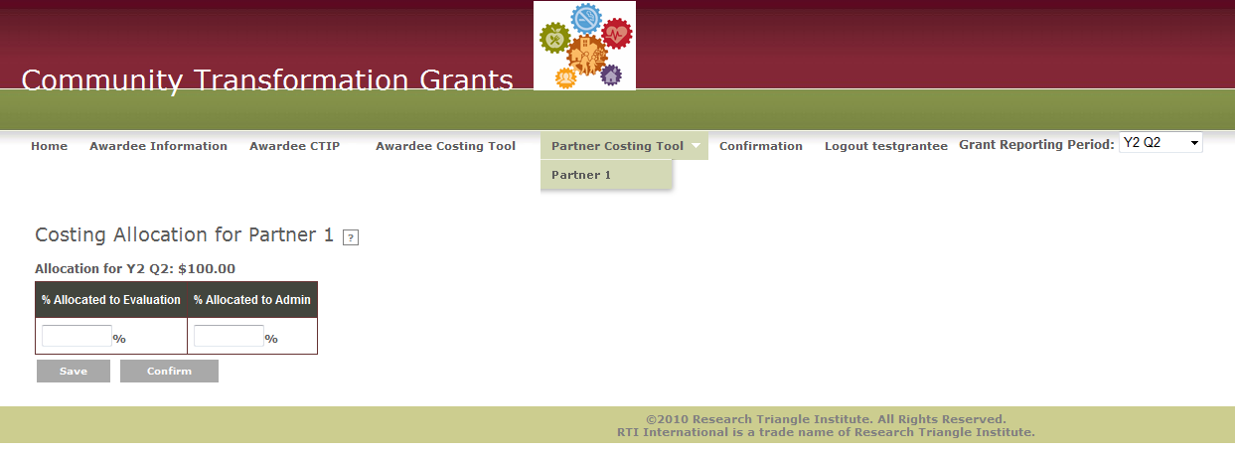
Attachment 6b. CTG Cost Study Instrument User’s Manual
Under Development

