From: Lidia Bernik [mailto:LBernik@mhaofnyc.org]
Sent: Wednesday, February 15, 2012 10:30 AM
To: Naturale, April
Cc: John Draper
Subject: RE: quick but urgent question

Hi, April.

You are correct – many of our crisis centers use staff/volunteers to answer calls that are NOT licensed mental health professionals. In fact, many use lay persons who receive extensive training (~40 hours) before answering calls.

I cannot tell you the percentage of centers that use non-mental health professionals to answer calls, but from our recently completed survey, you can see that a substantial portion of our centers use a combination of staff/volunteers to answer calls.

Best,
Lidia

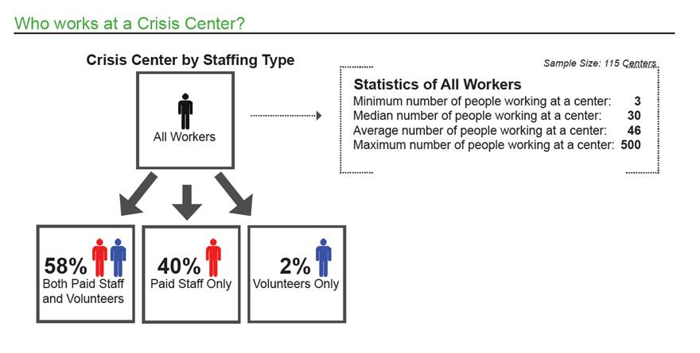

Best,
Lidia

Lidia S. Bernik, M.H.S., C.P.H. | (212) 614-5776 | lbernik@mhaofnyc.org
Associate Project Director | National Suicide Prevention Lifeline – 800-273-TALK (8255)

