0960-0767
ERE Third-Party Screen Shots

NOTE: The first page, “Acknowledgement,” appears to be blank. In actuality, the screen shot was so big that it moved on to the next page. The first page entitled “Acknowledgement” is only meant to be a title page.

TABLE OF CONTENTS

Acknowledgement Screen 1

Case Documents Screen 3

Exhibit List Screen 4

Access Denied (Unsuccessful) Screen 5

Access Denied (Access Blocked) Screen 6

Unable to Process Your Request Screen 7

Pickup Files Screen 8

Privacy Act Statement 9

Acknowledgement Screen 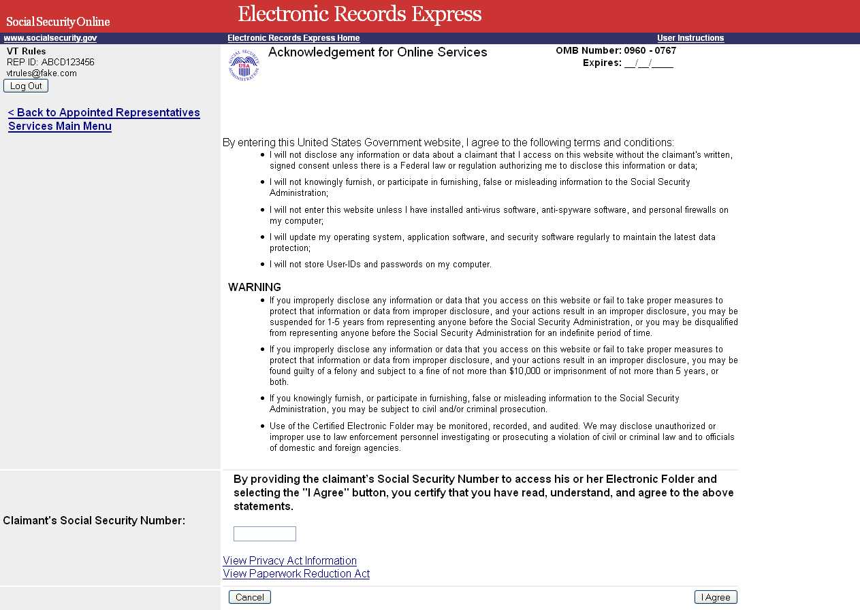

Case Documents Screen
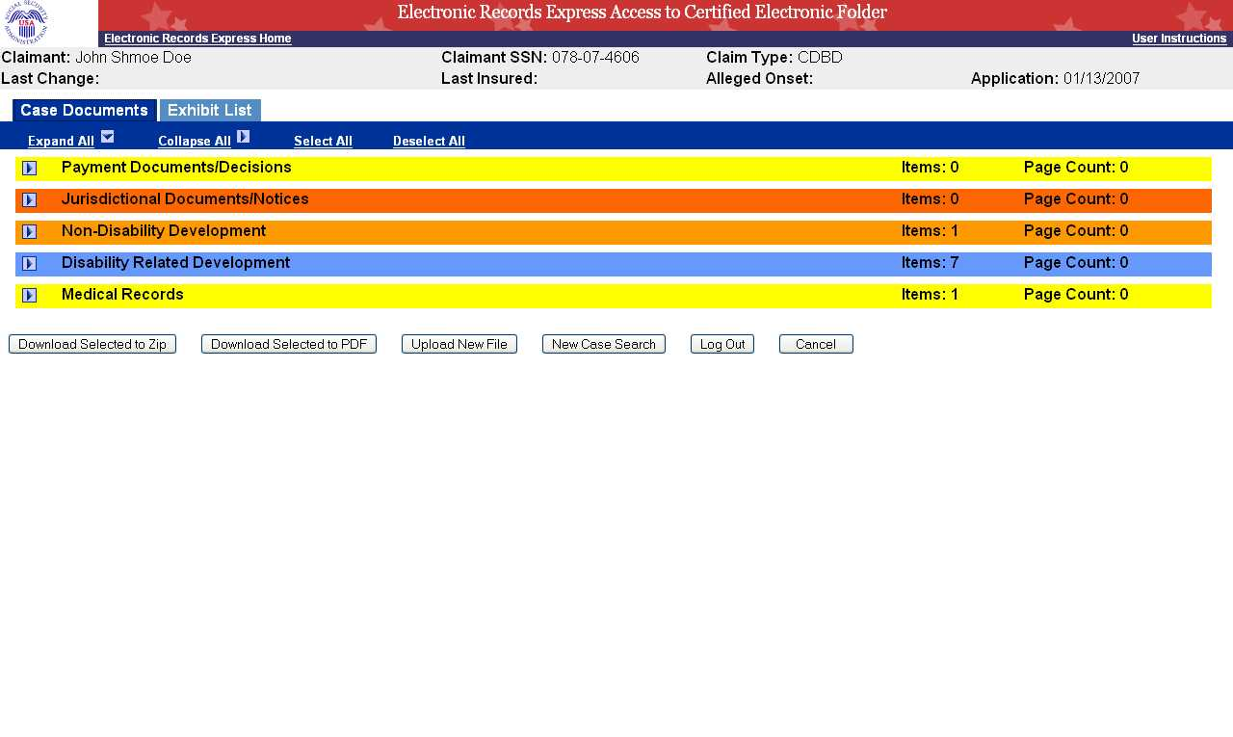

Exhibit List Screen
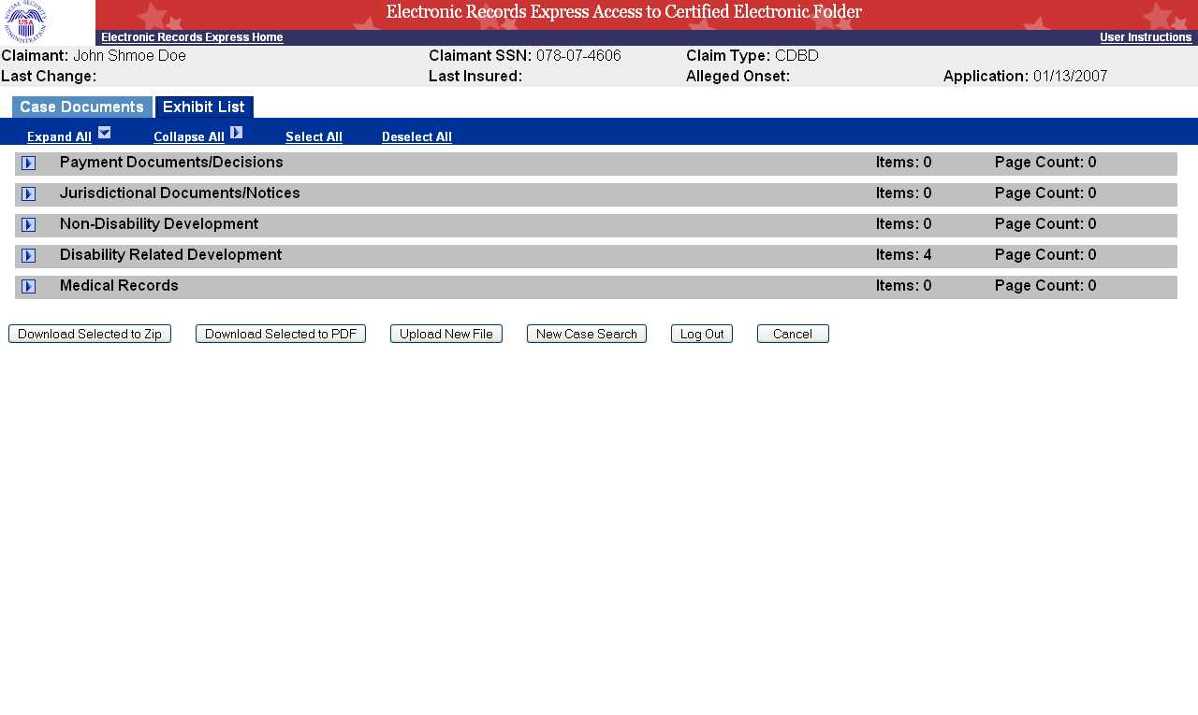

Access Denied (Unsuccessful) Screen
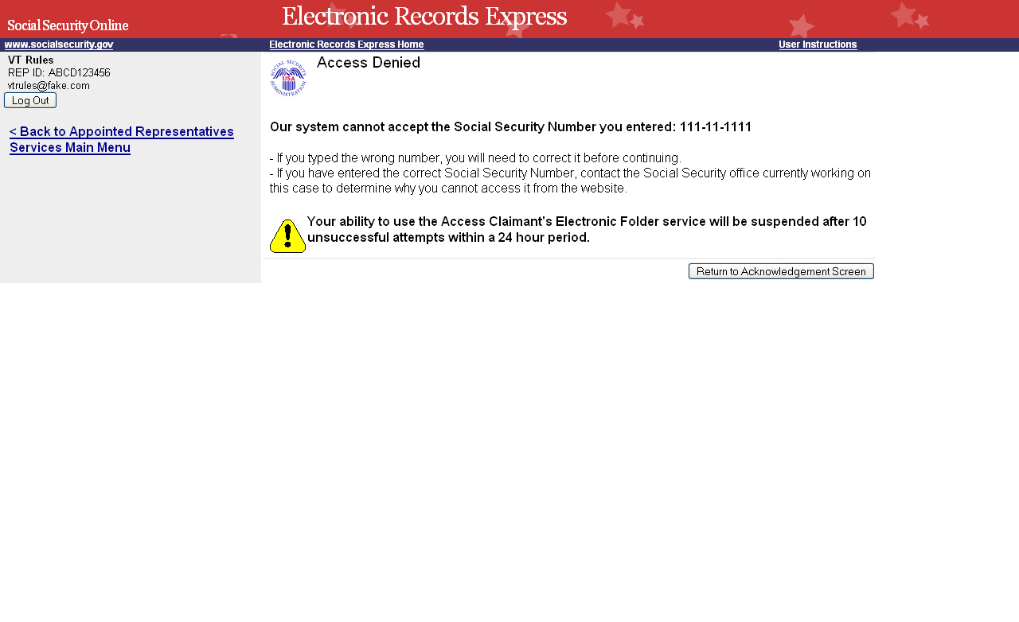

Access Denied (Access Blocked) Screen
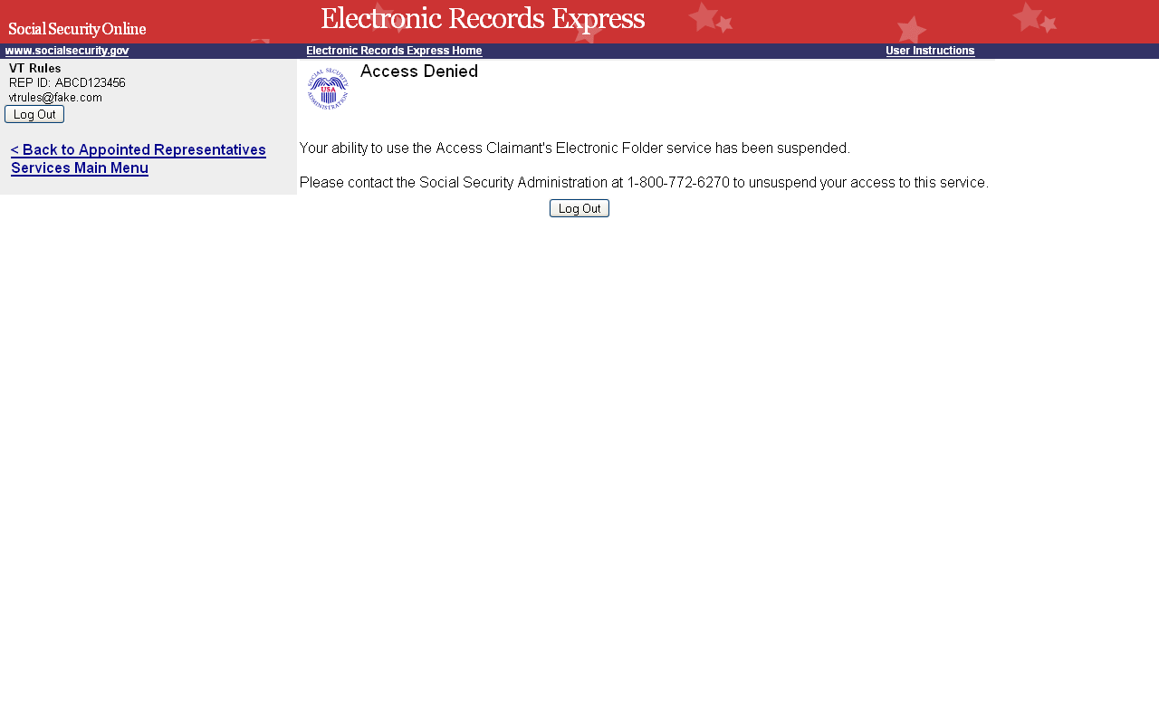

Unable to Process Your Request Screen
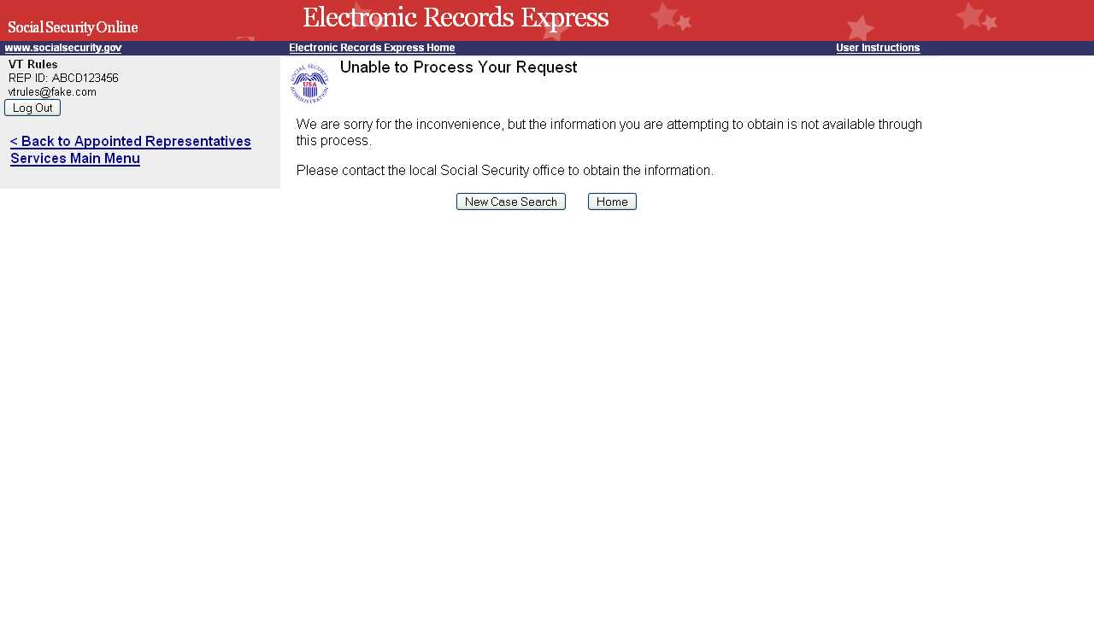

Pickup Files Screen
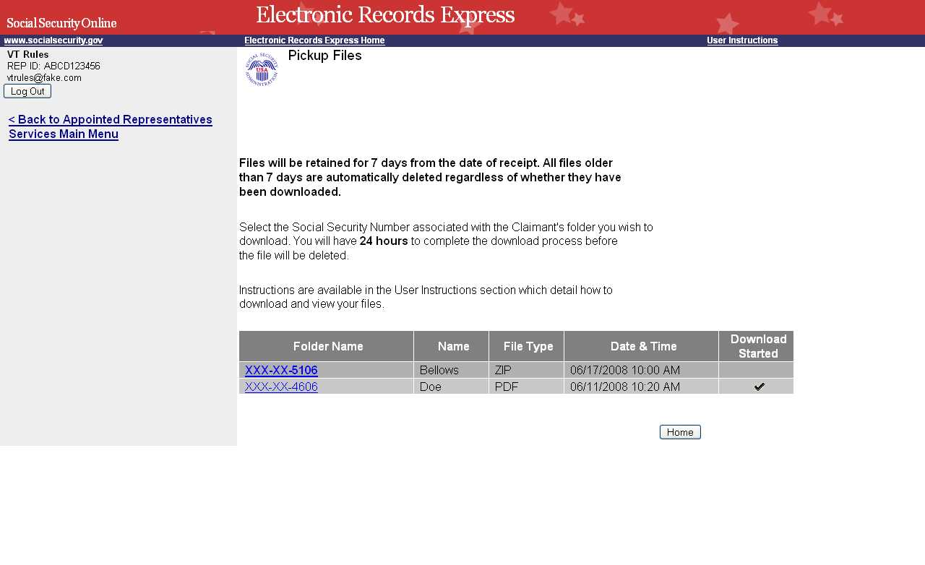

Privacy Act Statement
