We would like your input for expectations of hydro feature extraction from LiDAR/IfSAR datasets and for thoughts on an integrated elevation-hydro data structure prototype. The following questions may help guide future research efforts at the USGS for these topics
Thank you for taking the time to complete this survey. No personal information is collected and all responses will remain anonymous. If you are uncomfortable answering any question for any reason, please feel free to skip it.

- What is your primary use of the NHD (choose one)?
  - Flood risk management
  - Infrastructure and construction management
  - Natural resources conservation
  - Agriculture and precision farming
  - Water supply and quality (analyses and modeling)
  - Wildfire management, planning, and response
  - Geologic resource assessment and hazard mitigation
  - Forest resources management
  - River and stream resource management
  - Aviation navigation and safety
  - Mapping
  - Fisheries management
  - Hydrology
- Please rate these NHD features in importance to your work: (most important, important, least important)
NHD Feature | Most Important | Important | Least Important
Streams/Rivers with width < 50ft.
Streams/Rivers with width > 50ft.

Canal/Ditch

Lake/Pond

Sea/Ocean

Swamp/Marsh (wetlands)

Engineered features (dams, levees, diversion gates)

Coastline

Bays and Estuaries

Fish passage barriers

- For braided stream situations, please rate the following options of representation:

NHD Feature | Most Important | Important | Least Important
  - All individual channels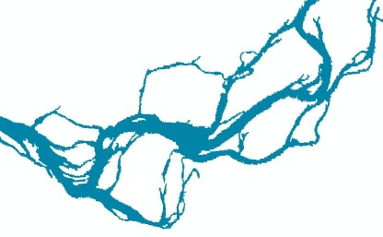

  - An all-encompassing Complex Channel polygon with a single artificial path
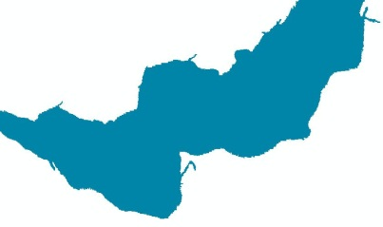
- A Complex Channel polygon with major individual channels
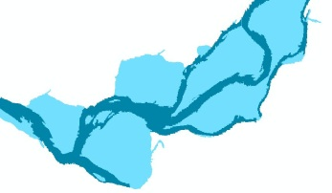

- What, if any, issues/challenges do you currently encounter working with NHD and NED together?

- Do you use the NHDPlus:
Yes or No
If yes, which characteristics do you utilize? (Please check any that apply.)
☐1:100K National Hydrography Dataset (NHD)
☐ 30 meter National Elevation Dataset (NED)
☐ Nationally complete Watershed Boundary Dataset (WBD)
☐ Value added attributes to enhance stream network navigation, analysis and display
☐ Elevation-based catchment for each flowline in the stream network
☐ Catchment characteristics
☐ Headwater node areas
☐ Cumulative drainage area characteristics
☐ Flow direction, flow accumulation and elevation grids
☐ Flowline min/max elevations and slopes
☐ Flow volume & velocity estimates for each flowline in the stream network
☐ Catchment attributes and network accumulated attributes
☐ Gridded data from the hydro-enforcement process (e.g. hydro-enforced DEM)
- Is there a need for a new integrated high resolution (1:24,000 or larger scale) product that contains both elevation and hydrography from the USGS?
Yes or No
Please explain your answer above.

- Which resolution of a dataset best meets your needs?
- 1:100,000-scale level of detail
- 1:24,000-scale level of detail
- 1:12,000-scale level of detail
- 1:4,800-scale level of detail
- 1:2,400-scale level of detail
- A multi-scale level of detail
- If an integrated high resolution product existed (assuming high-resolution elevation measurement adequate to support the proposed resolution are available), which spatial resolution for the elevation grid would you prefer:
- 1 meter
- 3 meter
- 10 meter
- Other (specify)
- Is there any other format (DTM, etc) that you would like for the elevation data, besides DEM?
Yes or No
- Do you have any use for hydrography delivered as a raster?
Yes or No
- Should catchment size in the dataset be:
  - Variable based on reach
  - Fixed size
- Should stream periodicity (perennial/intermittent/ephemeral) be included in the dataset?
Yes or No
- Should derived channels from elevation datasets that are not field-verified be identified differently than known streams in the dataset?
Yes or No
- Would you like to have catchments as a part of the NHD?
Yes or No
- Please rate the following options for inclusion in a possible integrated dataset: (most important, important, least important)
Option | Most Important | Important | Least Important
Raw elevation (e.g. point clouds, intensity images, etc)

Hydrologically enforced elevation

Flow direction/accumulation grids

Hydrography

Drainage Catchments

Channel Cross-sections

Floodplains

Reach-based channel slope

Hydrography with z-values

Flow volume and velocity

Breaklines (vendor-provided used for hydro-flattening of the elevation data)

- If you would like to make any other comments or suggestions, please do so in the box below.

