Request for Approval under the “DOI Generic Clearance for the Collection of Qualitative Feedback on Agency Service Delivery”
OMB Control Number: 1090-0011

TITLE OF INFORMATION COLLECTION: Feedback from Web Chat Customers

ATTACHMENT 1 -- WEB CHAT CUSTOMER SERVICE FEEDBACK FLOW CHART

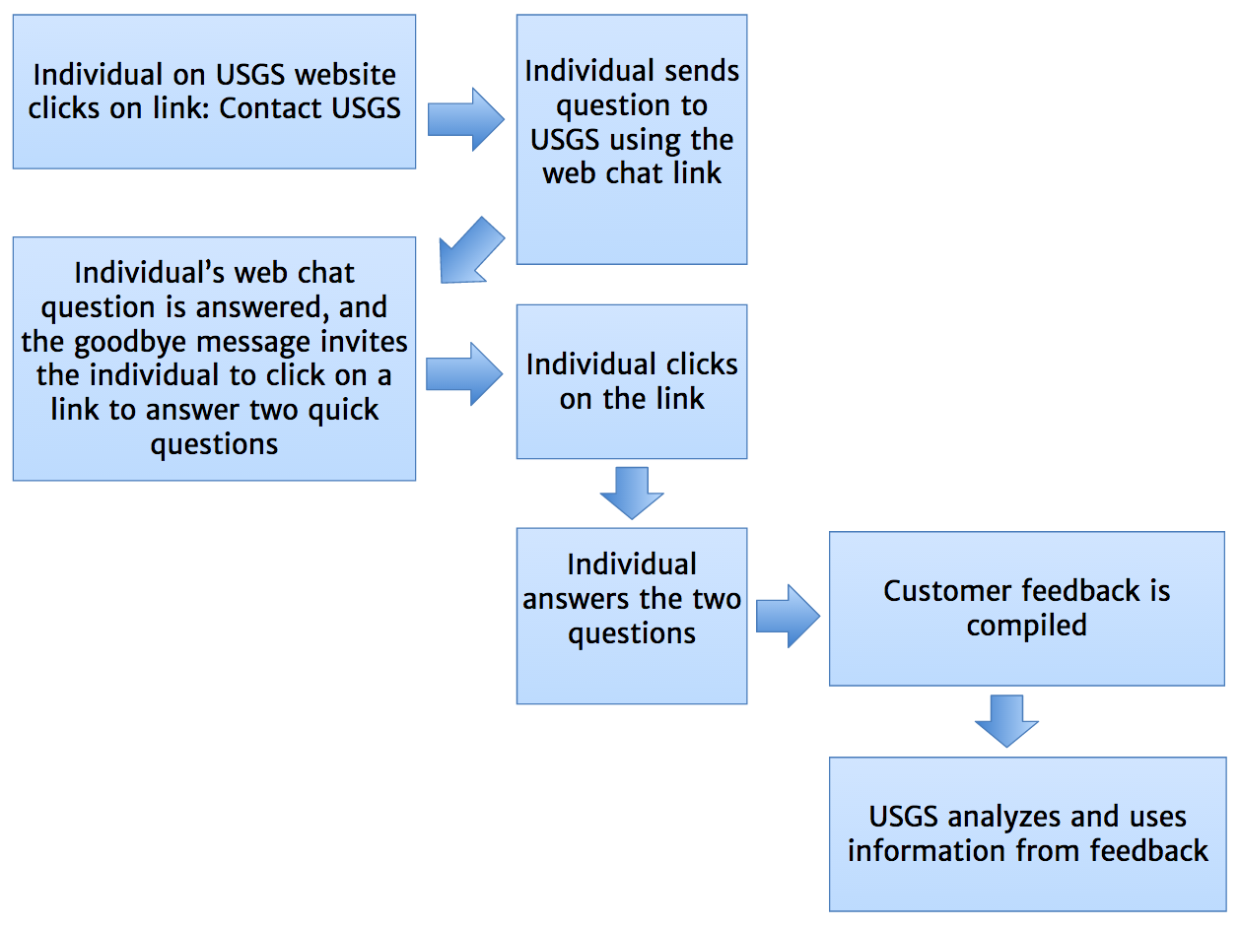

ATTACHMENT 2 -- WEB CHAT CUSTOMER SERVICE FEEDBACK PROCESS OVERVIEW

This is a brief description of the proposed process in which USGS will ask customers who contact USGS using web chat about science questions to rate their service and provide ideas for improvements. Note that this process is low-cost, completely anonymous for the customer, and easy to implement. USGS will benefit by having an aggregate “score” to measure how well we are doing with web chat customer service. USGS will also have open-ended suggestions for improvements from real customers.

1. An individual with a question about USGS science comes to the USGS website and clicks on Contact USGS in the upper right of the page (first image below), which provides several options for contacting the USGS, including a link to web chat (second image below).

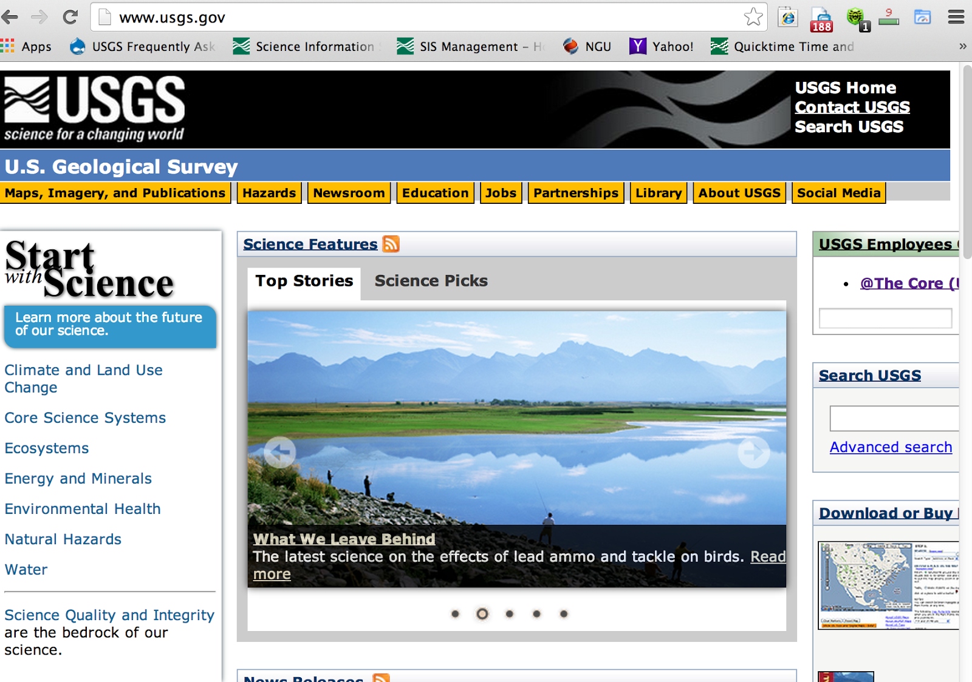

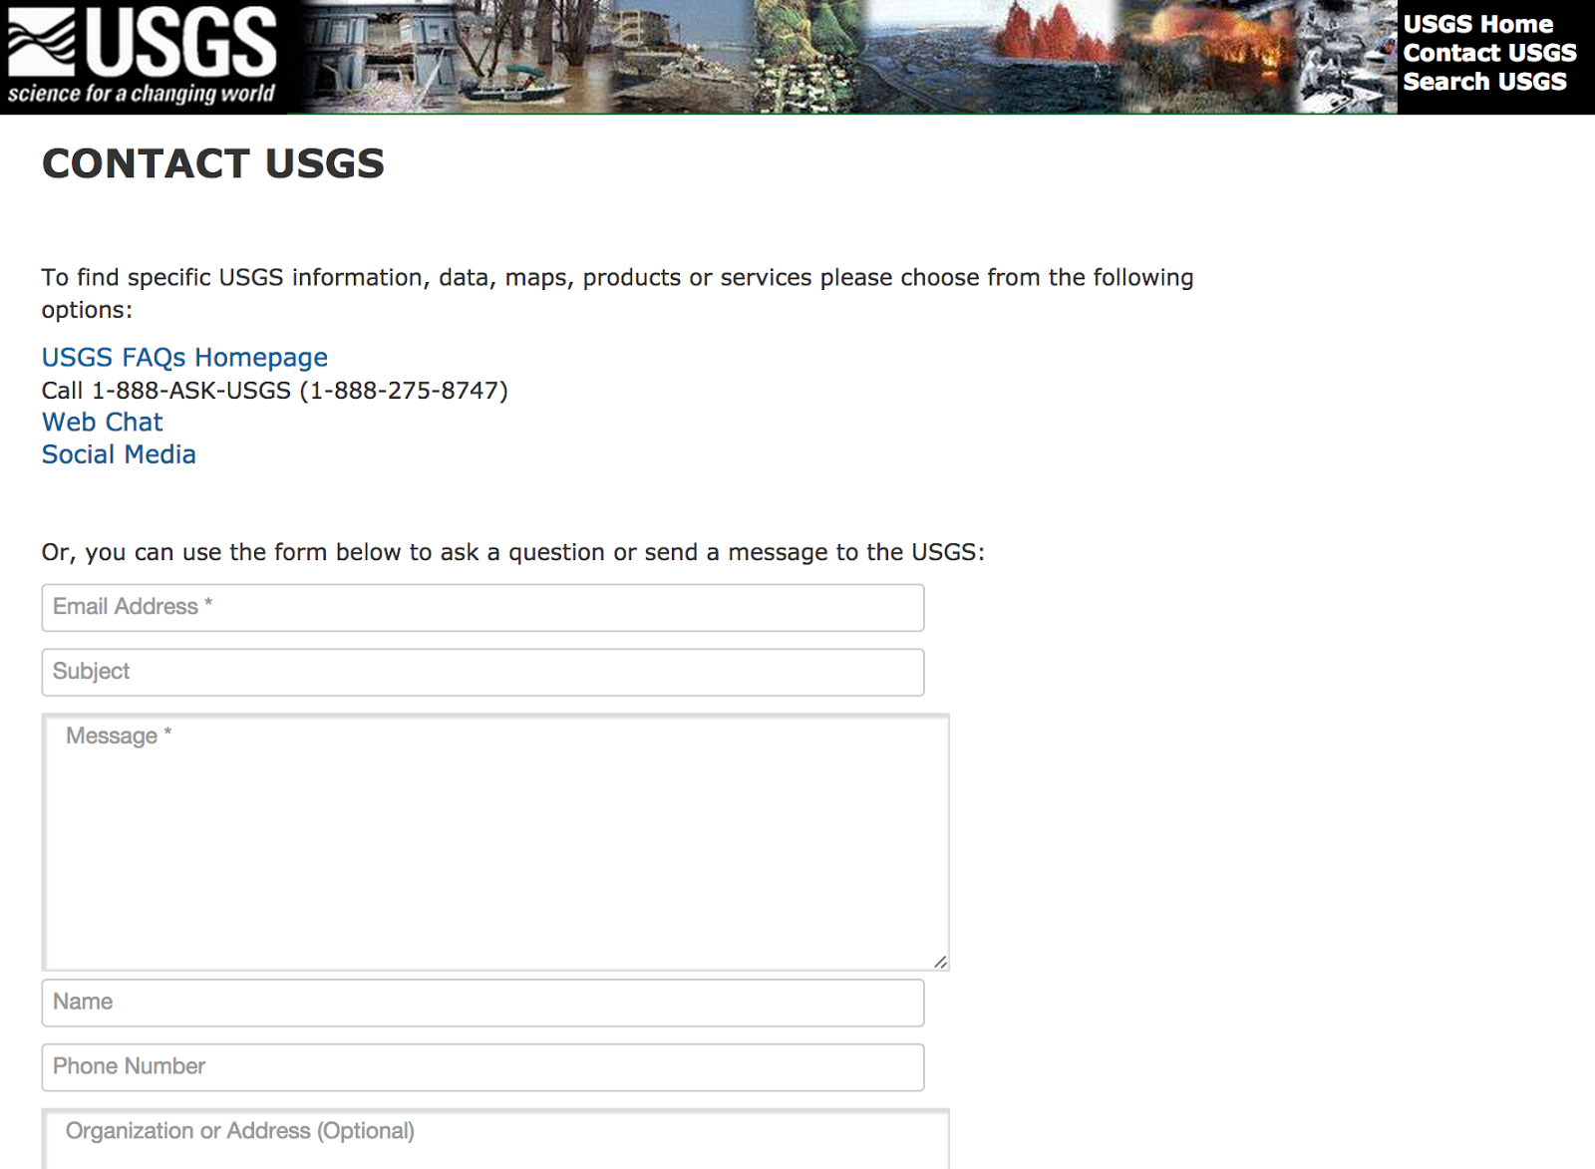

2. The individual clicks on Web Chat and chats their inquiry to the USGS. (The USGS currently receives about 1500 such webchats each year.)

3. The chat is received by the Science Information Services (SIS), and a customer service representative responds to the individual.

4. The response includes a phrase at the end saying, “HOW DID WE DO? Please answer 2 quick questions. https://www.surveymonkey.com/s/chatUSGS” (See image below.)

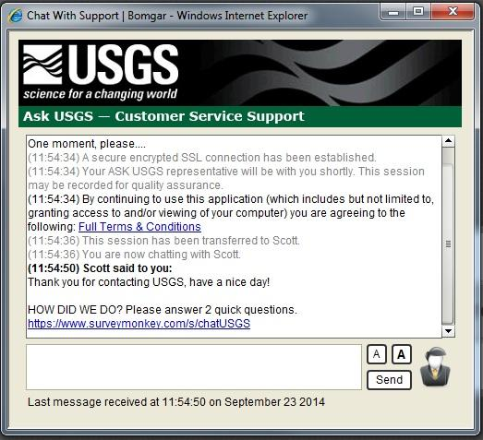

5. The individual clicks on the link to provide feedback. (We expect that only a small percentage of people will click on the link; a 10% response rate is probably a good guess. This will provide about 150 responses per year, about 10 each month.)

6. The individual goes to the webpage (below), and answers the two questions.
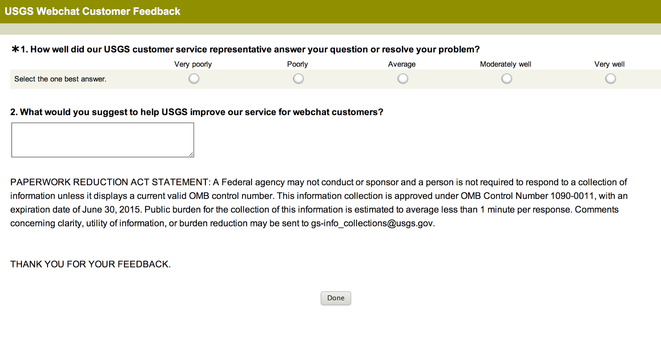
The individual clicks on Done when they are done.

7. Data from all the respondents are compiled in the Survey Monkey online tool.

8. USGS analysts routinely monitor the feedback and download the open-ended suggestions for evaluation and prioritization.

