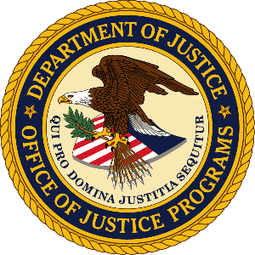

U.S. Department of Justice

Office of Justice Programs

Bureau of Justice Statistics

Washington, D.C. 20531

MEMORANDUM TO: Lynn Murray
DOJ Clearance Officer
Justice Management Division

FROM: James P. Lynch
Director
Bureau of Justice Statistics
Office of Justice Programs

SUBJECT: Submission of changes to the 2012 National Crime Victimization Survey

Attached please find OMB Form 83-c requesting changes to the 2012 National Crime Victimization Survey (NCVS). These changes will result in a decrease of-1,342 hours of the current burden. The decrease in burden results from the removal of identity theft questions asked of the household respondent on the NCVS-1.

The household identity theft questions are being removed from the NCVS-1 because the Bureau of Justice Statistics plans to conduct an Identity Theft Supplement (ITS) to the NCVS biannually, beginning in July of 2012. The decision to routinely implement the ITS, which will collect person-level data on consequences of and responses to identity theft, is in response to recommendations from the OIG Audit of the Department of Justice Efforts to Combat Identity Theft that the “NCVS be expanded to collect greater information about identity theft victims” (Audit Report 10-21). The data collected though the ITS will cover and expand upon the household level identity theft data collected through the core NCVS, rendering the household identity theft questions unnecessary and duplicative.

If there are any questions concerning this request, please contact William Sabol, Deputy Director, Bureau of Justice Statistics, at (202) 514-1062 or by email at William.Sabol@usdoj.gov.

