Attachment 16

Inserts

Survey on Crime and Victimization
Sponsored by:
Bureau of Justice Statistics
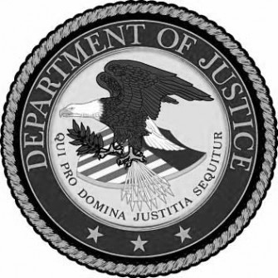

Have the adult with the next birthday in the household complete the survey by calling:
1-800-251-3456
Your unique household ID:
246810

Your participation will help the Bureau of Justice Statistics in our effort to produce accurate and representative results of crime in communities like yours.

Important!
Your household has been selected to participate in a study on crime in your community

Have the adult with the next birthday in the household complete the survey by calling:
1-800-251-3456
Your unique household ID:
246810

Survey on Crime and Victimization
Sponsored by:
Bureau of Justice Statistics

