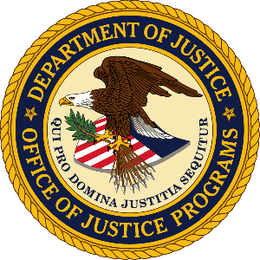

**U.S. Department of Justice**

Office of Justice Programs

*Bureau of Justice Statistics*

*Washington, D.C. 20531*

MEMORANDUM TO: Lynn Murray

DOJ Clearance Officer

Justice Management Division

FROM: James P. Lynch

Director

Bureau of Justice Statistics

Office of Justice Programs

SUBJECT: Change Request: Research to Support the National Crime Victimization Survey Generic Clearance (OMB 1121-0325)

Attached please find OMB Form 83-c requesting changes to the Research to Support the National Crime Victimization Survey (NCVS) Generic Clearance (OMB 1121-0325). The Bureau of Justice Statistics (BJS) is submitting this change request that will result in an increase in burden hours. The increase in burden results from a correction between the burden hours initially requested and the burden hours allocated. Initially, BJS projected and requested a total of 16,340 person-hours for the three-year NCVS generic clearance based on current and future activities. The largest annual burden was anticipated to fall within the first year with an estimated 6,280 annual burden hours. Inadvertently, the OMB clearance was only approved for the first year (6,280 hours) and not for the full 3 year amount (16,340 hours). This discrepancy was not discovered until the most recent generic clearance was submitted and BJS was notified that they had exceeded this burden hour allocation.

Therefore, BJS is submitting this change request to reconcile the differences between the initial request and the approval and to increase the approved burden hours from 6,280 to the full three-year amount of 16,340 (a difference of 10,060 hours). If there are any questions concerning this request, please contact Allen Beck, Senior Statistician, Bureau of Justice Statistics, at (202) 616-3277 or by email at [Allen.Beck@usdoj.gov](mailto:Allen.Beck@usdoj.gov).