

Background information about the origin of the Nationwide Cyber Security Review (NCSR)

Committee Reports

111th Congress (2009-2010)

House Report 111-298

NATIONWIDE CYBER SECURITY REVIEW
The conferees note the importance of a comprehensive effort to assess the security level of cyberspace at all levels of government. To accomplish this, cyber network security assessment tools must first be in place; however, the conferees understand that no such tools currently exist. Given this, the conferees do not require the Secretary to provide a report by June 1, 2010, on the status of cyber security measures in States and large urban areas, as proposed in the Senate report. Instead, NPPD, in cooperation with FEMA and relevant stakeholders, shall develop the necessary tools for all levels of government to complete a cyber network security assessment so that a full measure of gaps and capabilities can be completed in the near future. NPPD, in conjunction with FEMA, shall brief the Committees within 60 days after the date of enactment of this Act on the specific timeframes and deliverables necessary to complete the development and execution of such tools in order to complete such an assessment by June 2011.

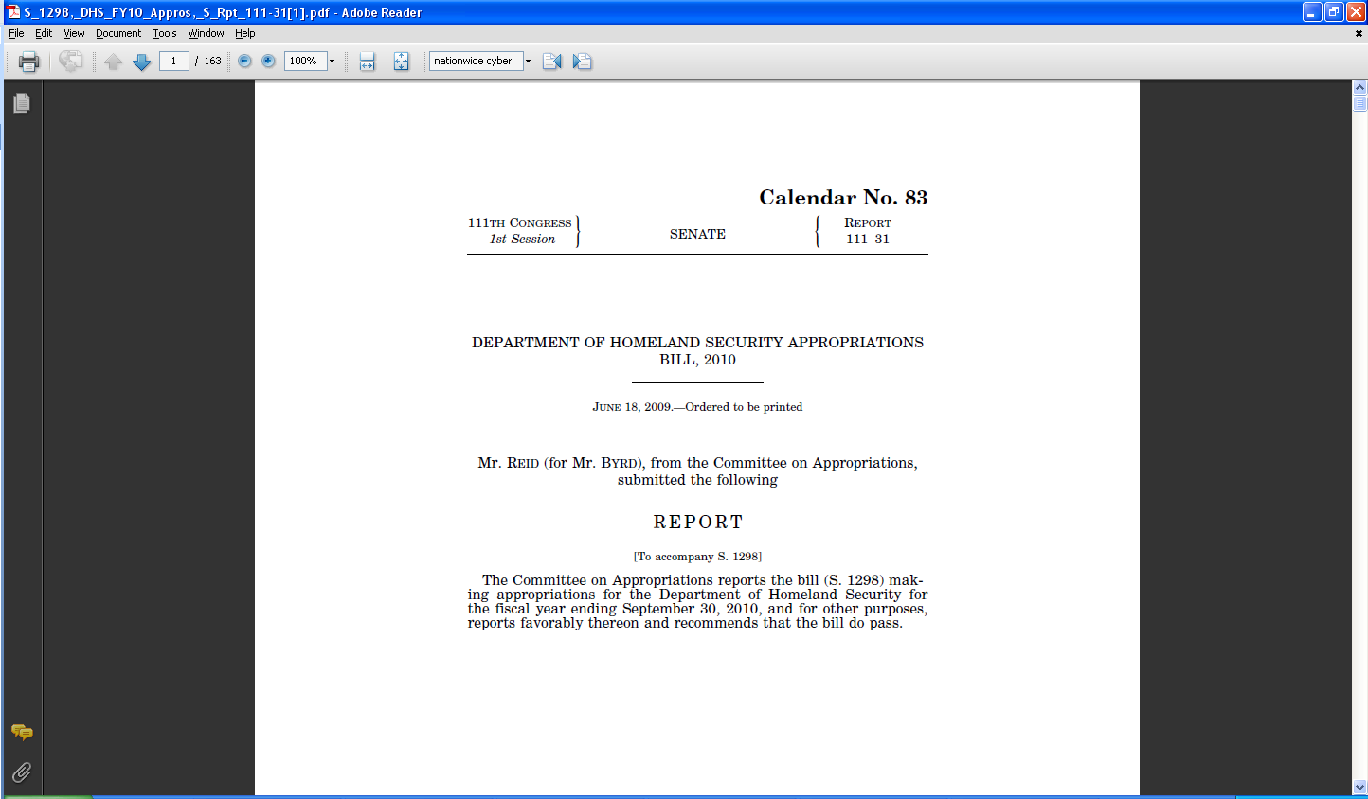
NATIONWIDE CYBER SECURITY REVIEW

The security of State and local information technology networks has serious implications for homeland security, as network security affects both the continuity of Government and the operations of critical infrastructure. Cyber attacks have disrupted State government networks, systems, and operations. Despite its importance, there is not a comprehensive effort to evaluate the security level of State or local information technology networks, as it pertains to cyberspace. The Committee directs the Secretary, in coordination with the Federal Emergency Management Agency [FEMA] and NPPD, to report on the status of cyber security measures in place, and gaps in all 50 States and the largest urban areas by June 1, 2010. The report should include certifications from each State and urban area as to the exact status of cyber security measures in place, when the date security plans were last updated, the dates contingency exercises were last conducted, and plans for disaster recovery. Similar language is included in the FEMA section of this report.

Page
91…

As a result of our briefing to Congress in May 2010…

Committee Reports

111th Congress (2009-2010)

Senate Report 111-222

Senate Report 111-222 - DEPARTMENT OF HOMELAND SECURITY APPROPRIATIONS BILL, 2011 [July 19, 2010- Ordered to be printed]

NATIONWIDE CYBER SECURITY REVIEW
The explanatory statement accompanying the Department of Homeland Security Appropriations Act, 2010, required NCSD to develop cyber network security assessment tools so that a comprehensive effort to assess the security level of cyber space at all levels of government could be completed. The Committee is pleased with the vigor with which NCSD has approached implementation of this important effort. The establishment of specific timeframes for outcomes and the inclusivity of Federal, State, and local partners, as well as other stakeholders, has put this effort on a positive path for results. The Committee directs NCSD to continue implementation of this important effort, in conjunction with FEMA, at least at the same level as in fiscal year 2010.

