Survey Login – First of Seven (7) Screens Seen by Survey Participant

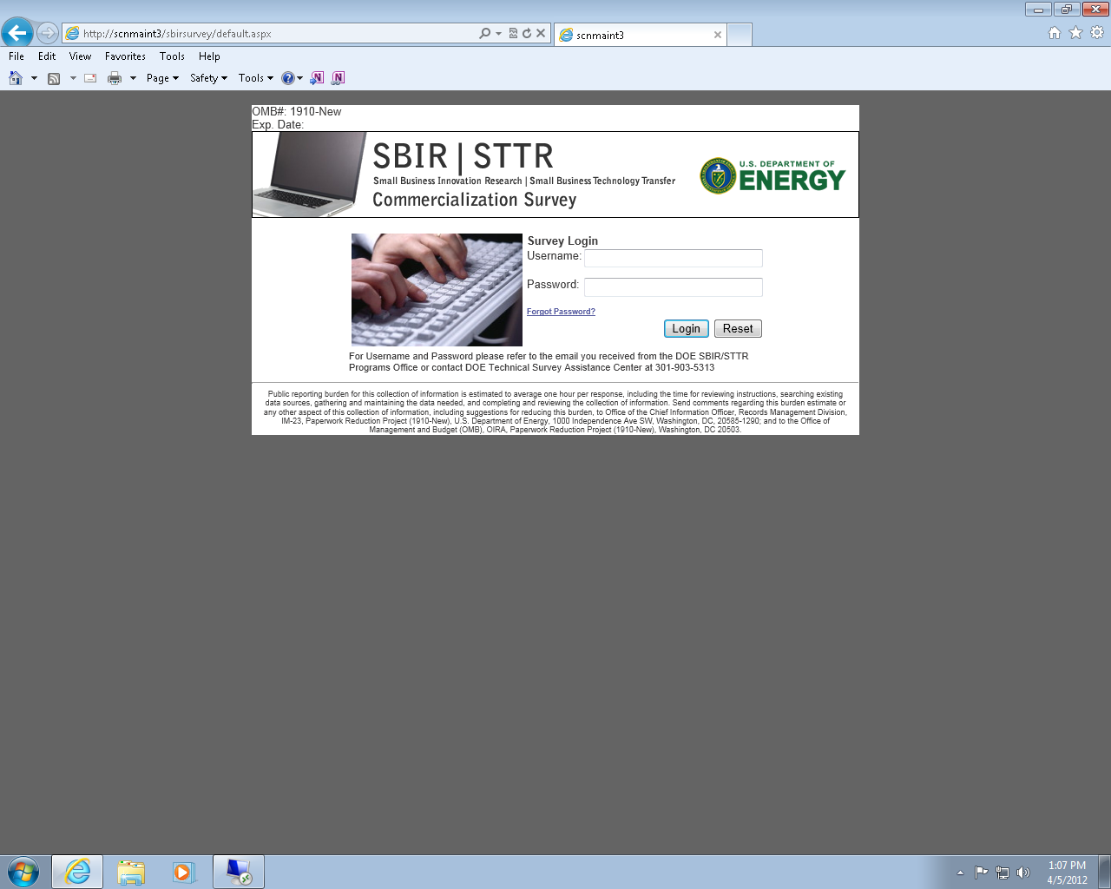

Survey Instructions and Company Page – Screen 2 of 7

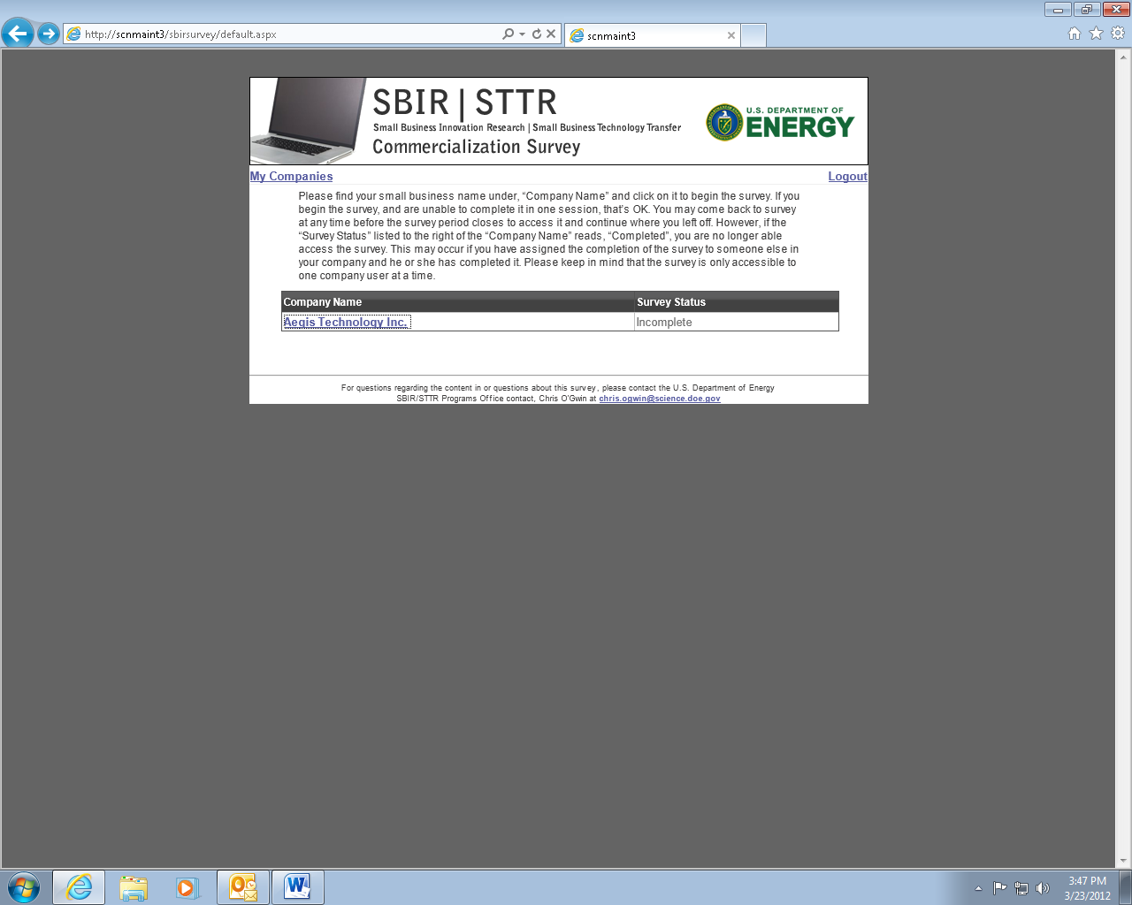

General Information & Instructions Page – Screen 3 of 7

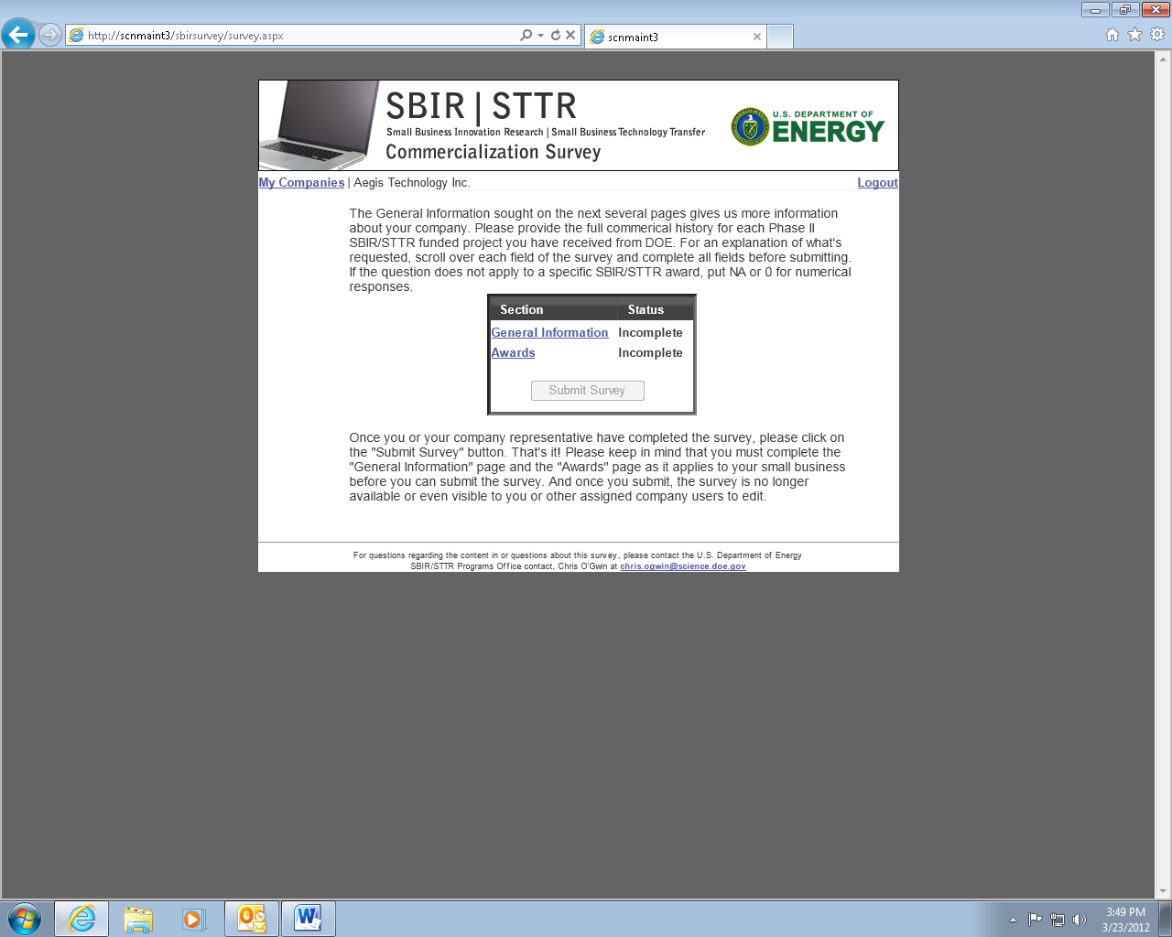

General information – Survey Screen 4 of 7 (pre-populated data)

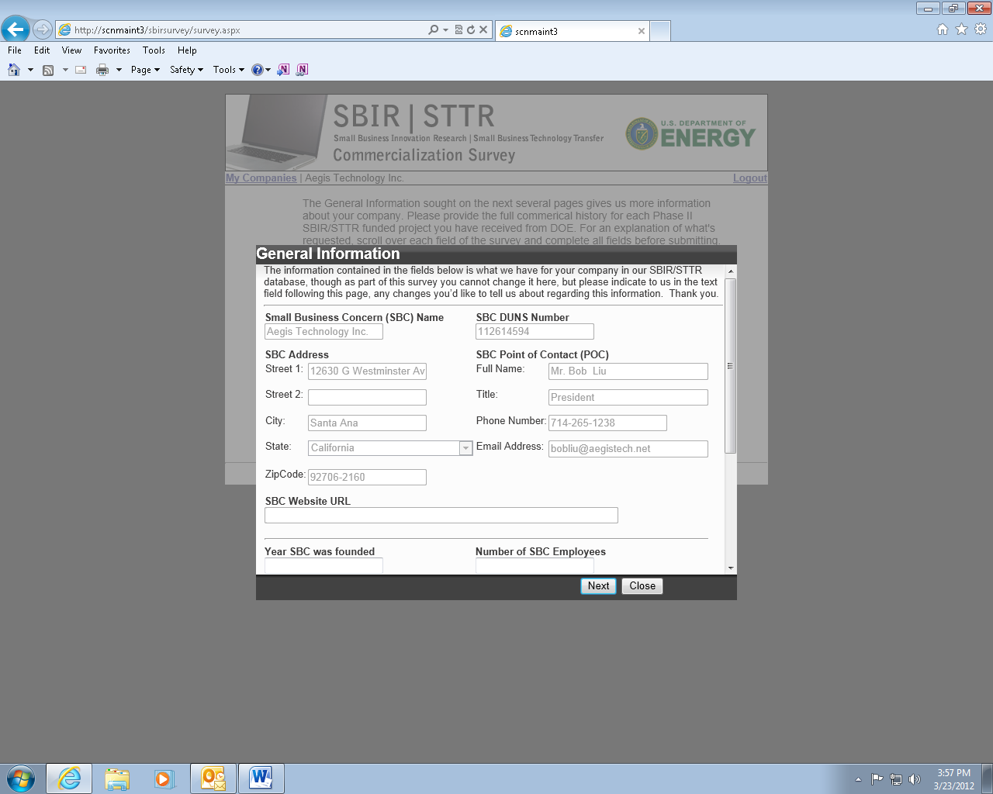

General Information – Survey Screen 5 of 7

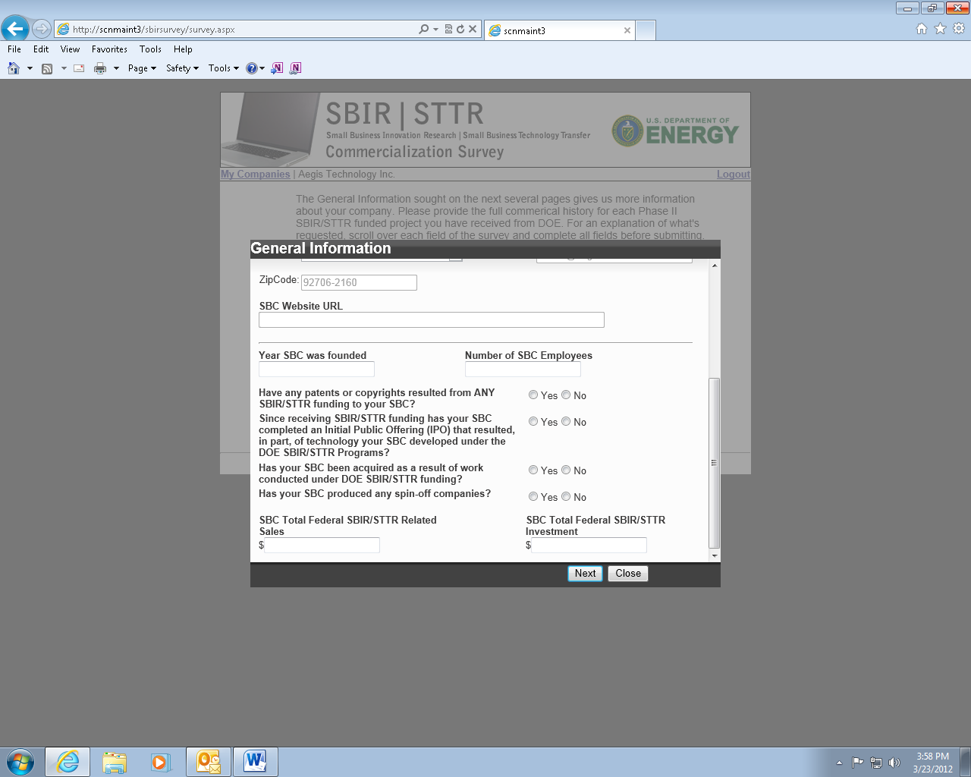

Grants – SBIR/STTR Project Screen 6 of 7

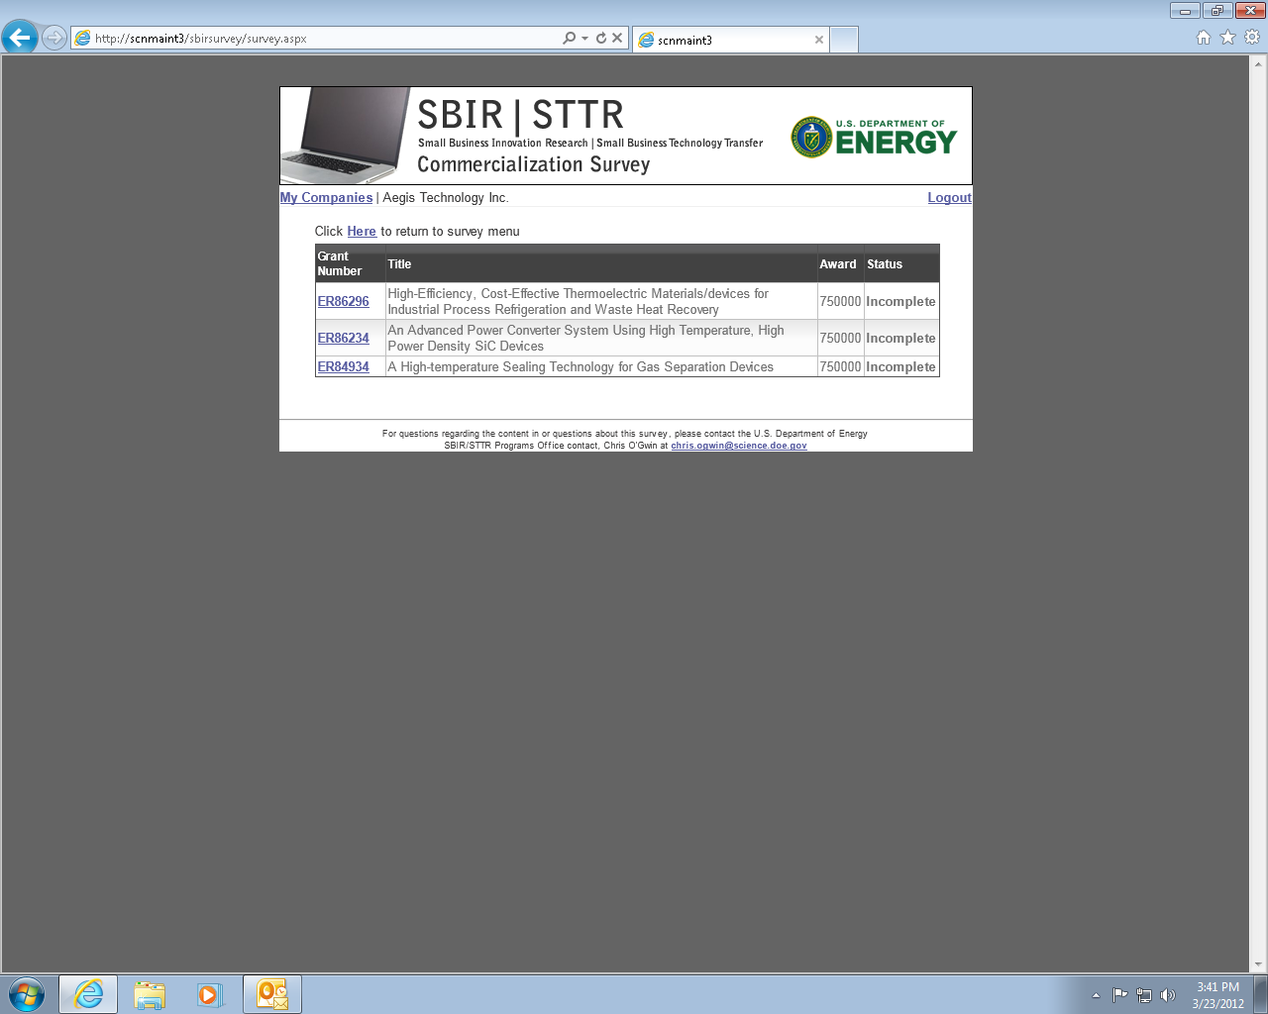

Project Related Information – Screen 7 of 7 (Pages 7 – 23 show one Survey Screen 17 times to depict theC:\Documents and Settings\ogwinc\Local Settings\Temporary Internet Files\Content.IE5\GC2G56WI\MC900441428[1].png information buttons and content)

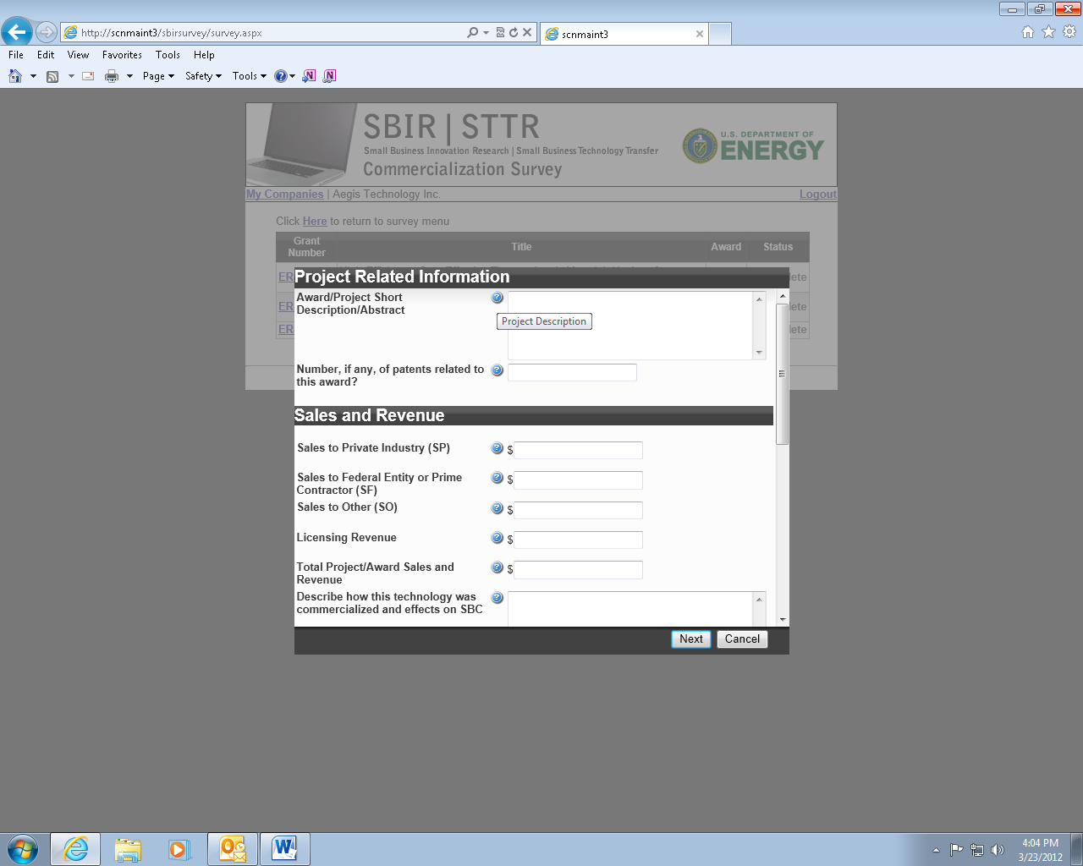

Project Related Information – Screen 7(2)

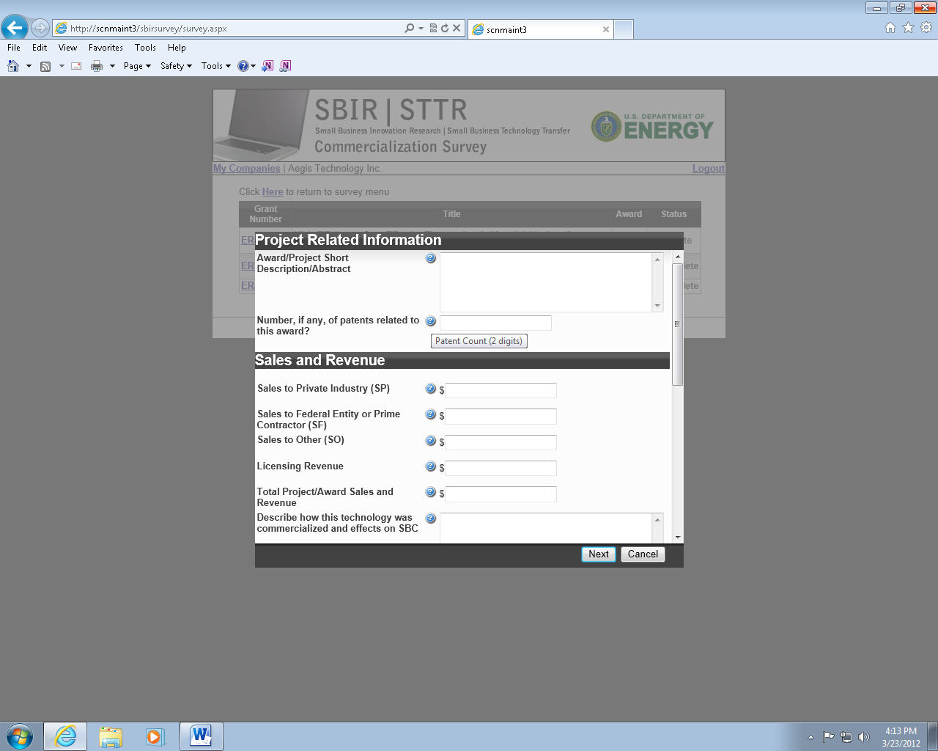

Project Related Information – Screen 7(3)

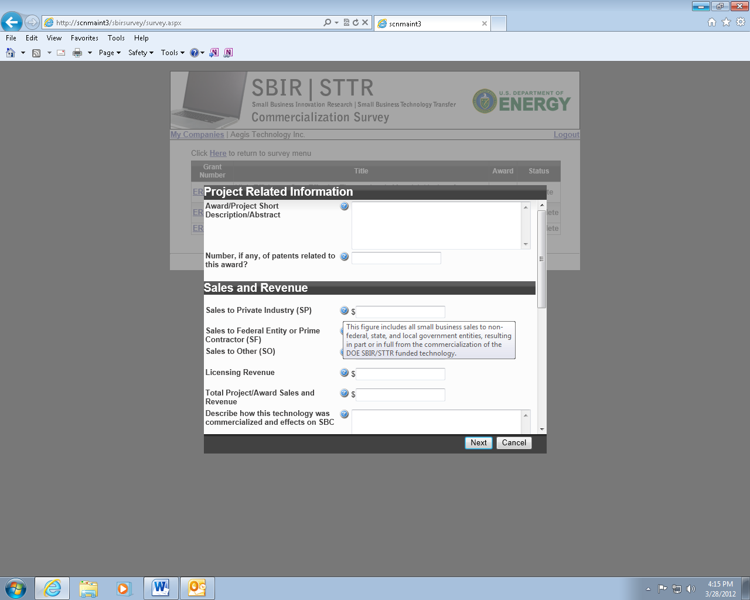

Project Related Information – Screen 7(4)

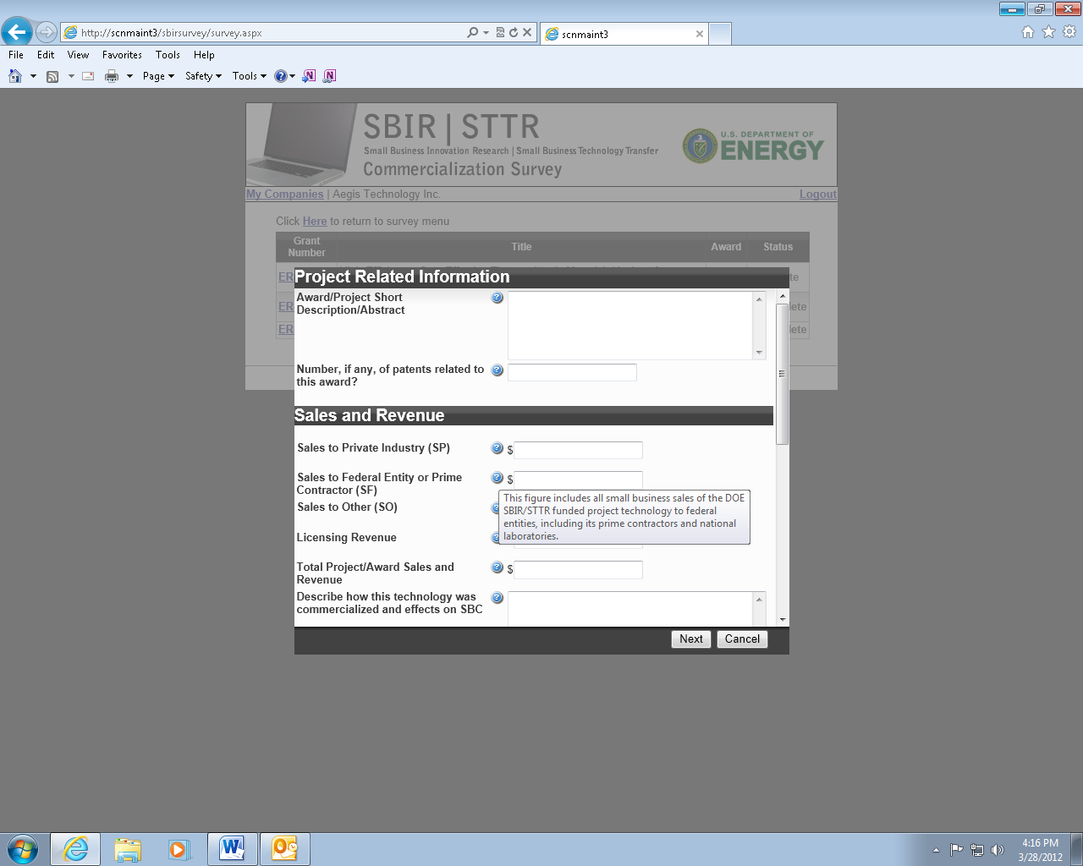

Project Related Information – Screen 7(5)

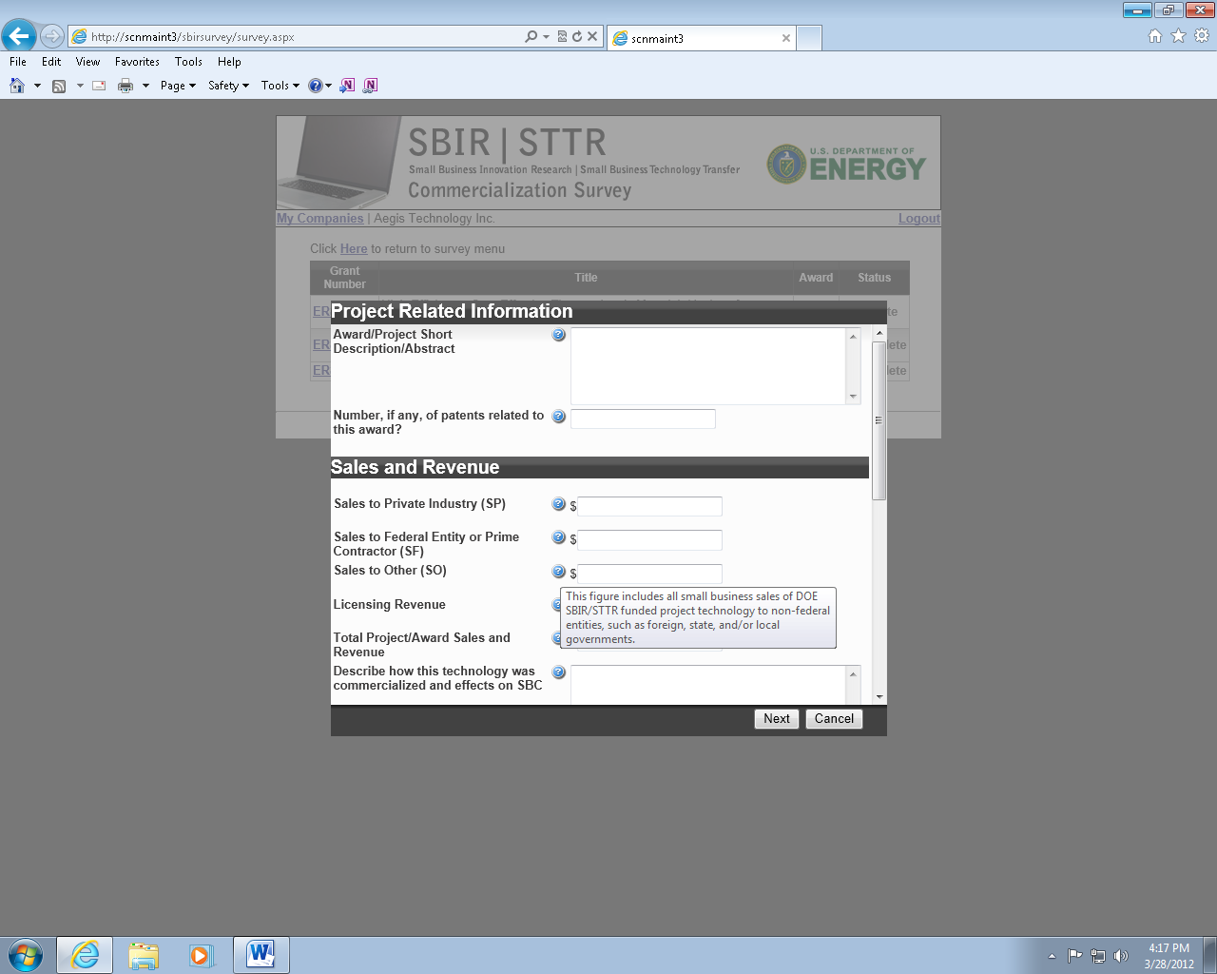

Project Related Information – Screen 7(6)

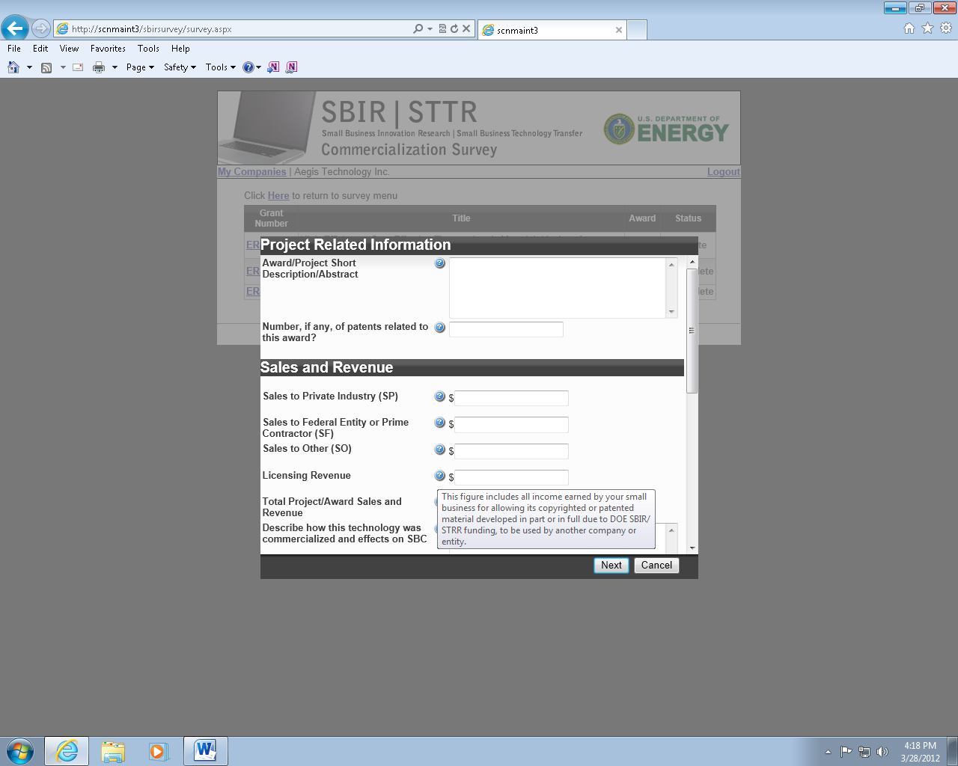

Project Related Information – Screen 7(7)

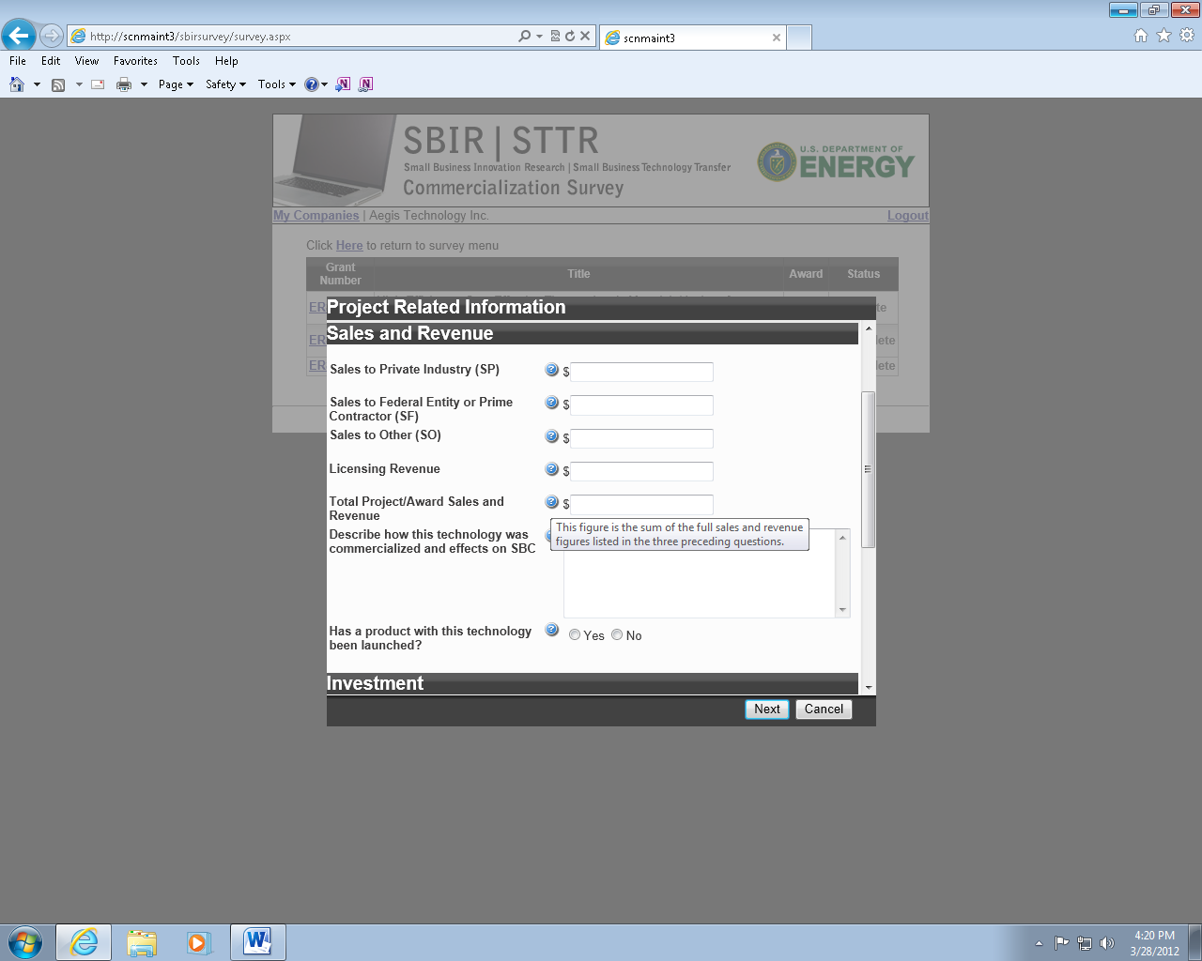

Project Related Information – Screen 7(8)

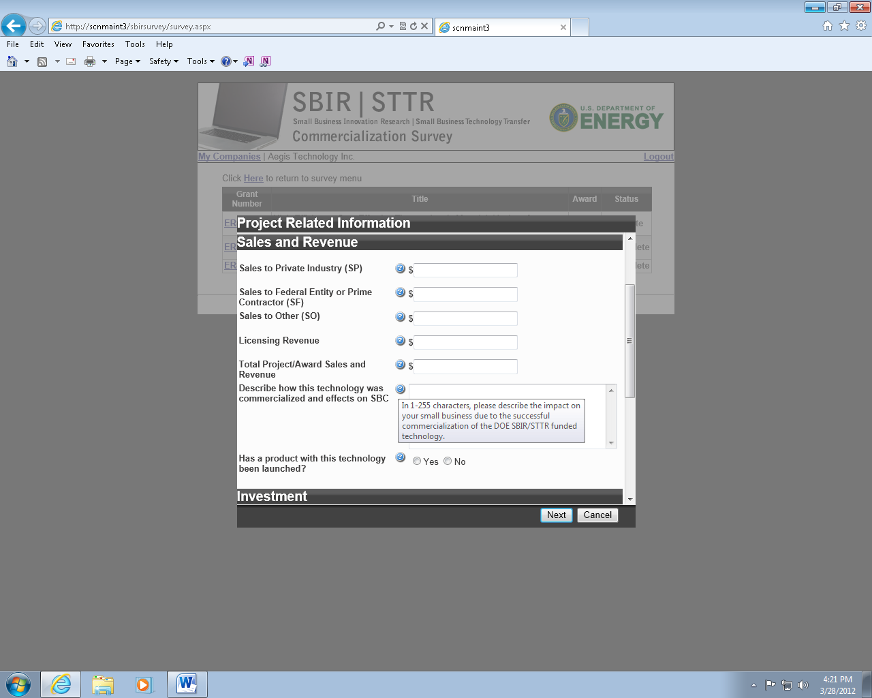

Project Related Information – Screen 7(9)

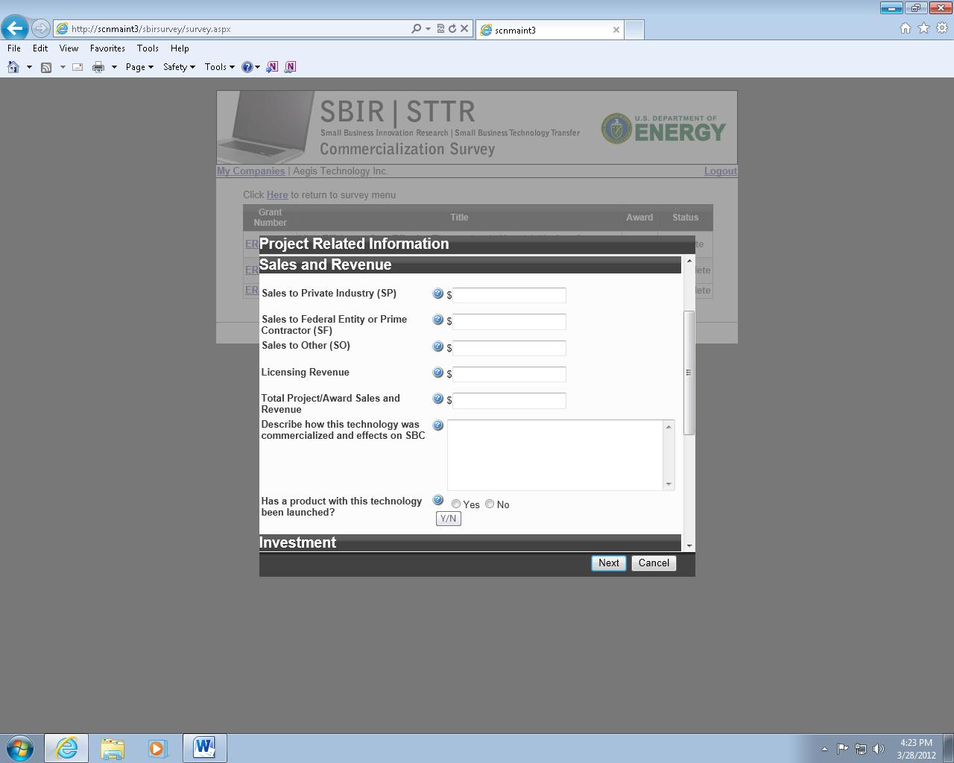

Project Related Information – Screen 7(10)

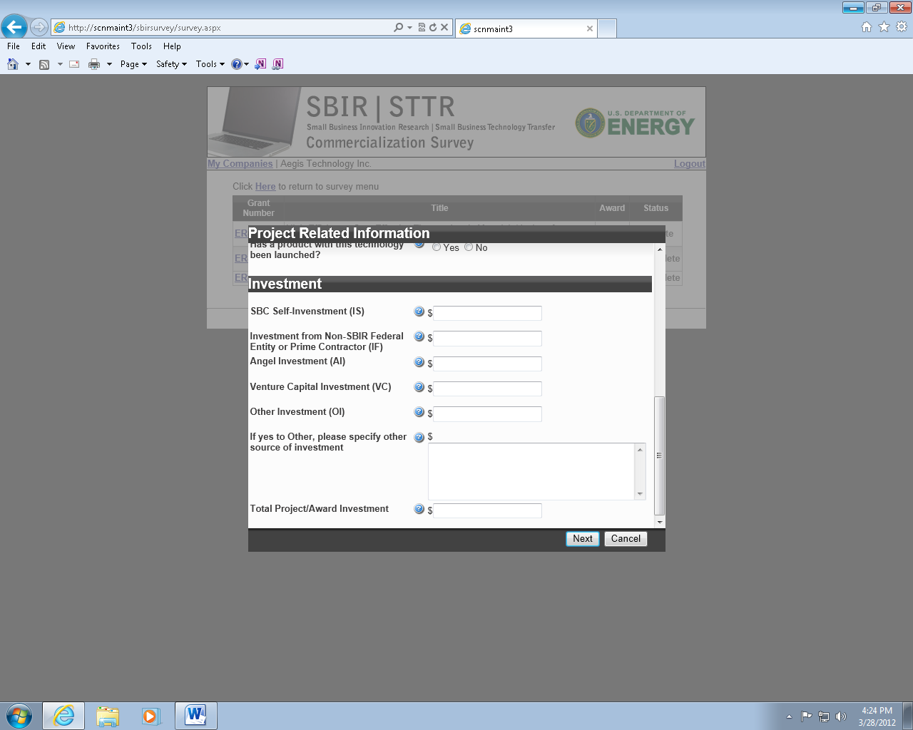

Project Related Information – Screen 7(11)

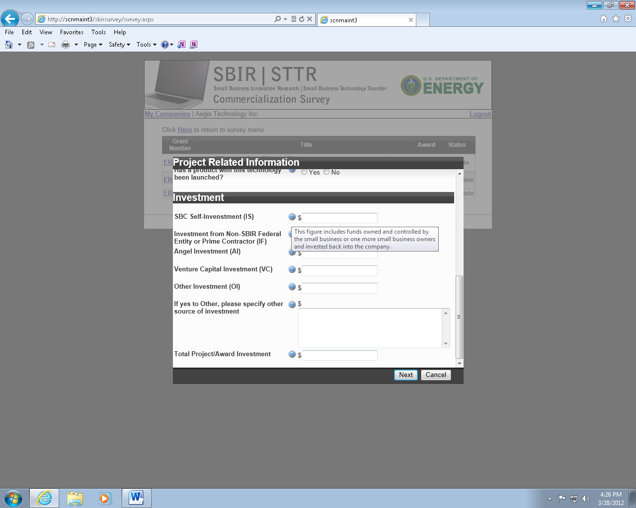

Project Related Information – Screen 7(12)

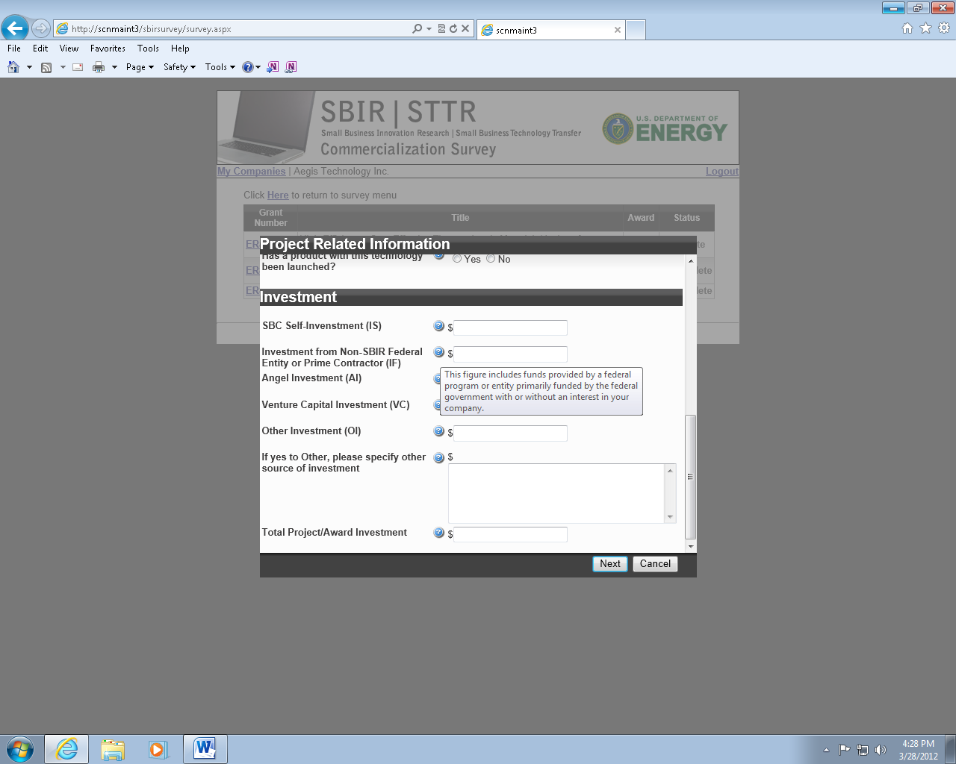

Project Related Information – Screen 7(13)

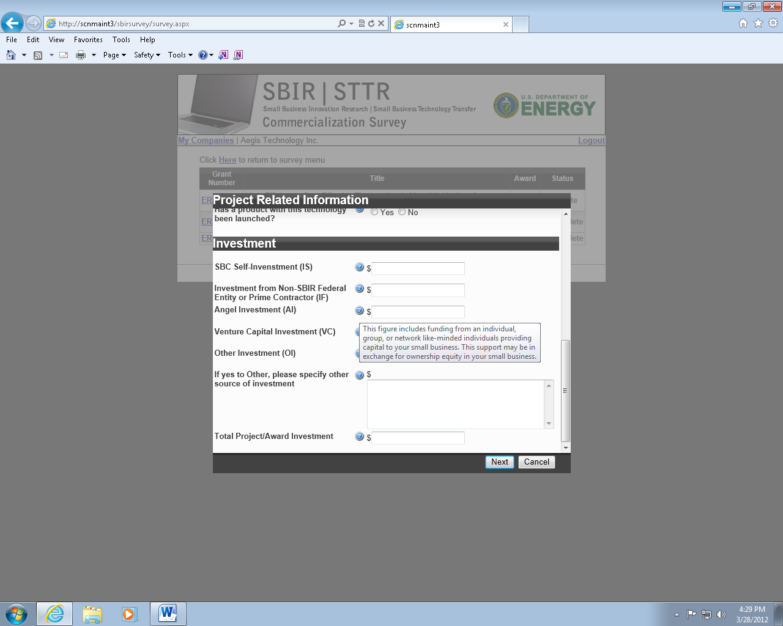

Project Related Information – Screen 7(14)

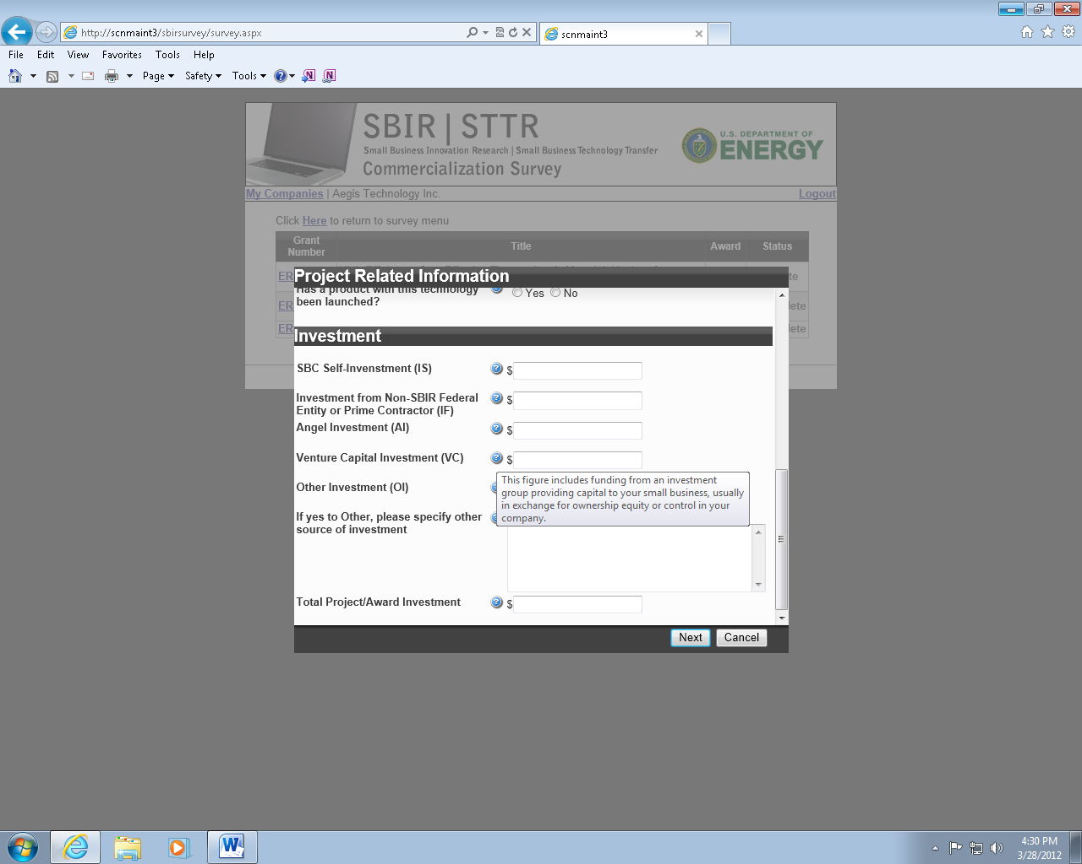

Project Related Information – Screen 7(15)

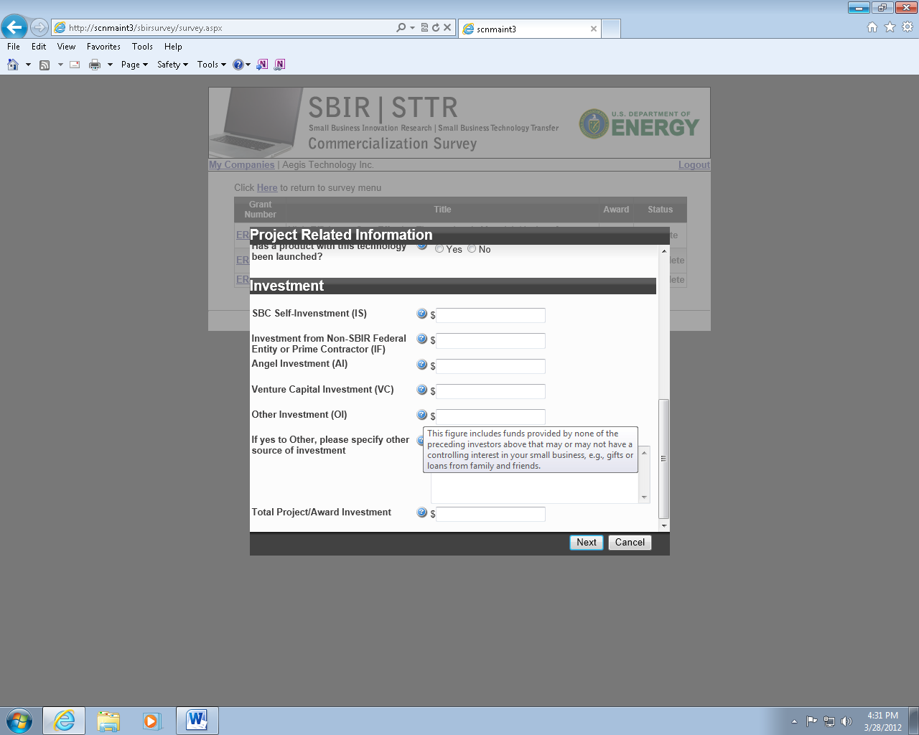

Project Related Information – Screen 7(16)

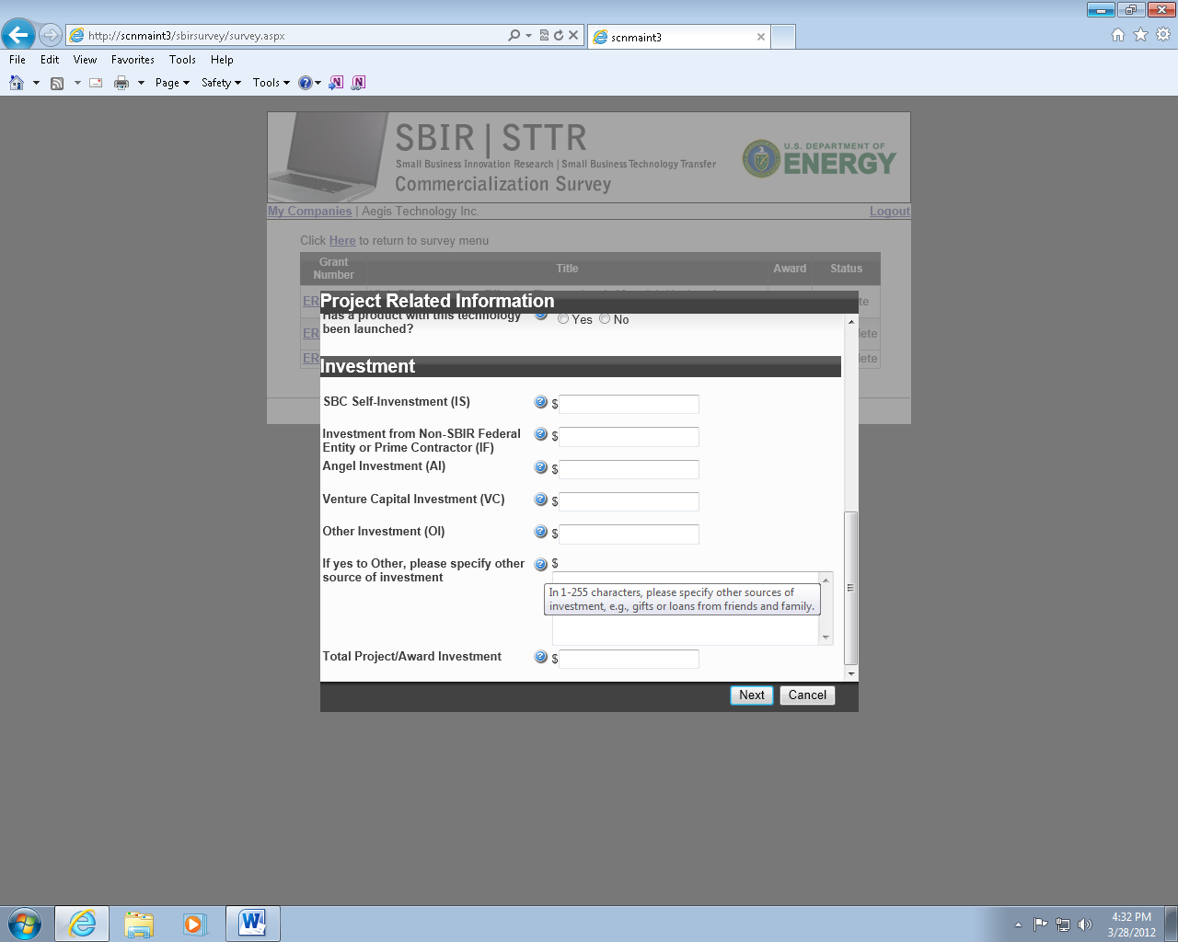

Project Related Information – Screen 7(17)

