New Outreach Materials

School Information Card
Community Information Card
Community Poster
News Print Ad
Radio Public Service Announcement

School Information Card

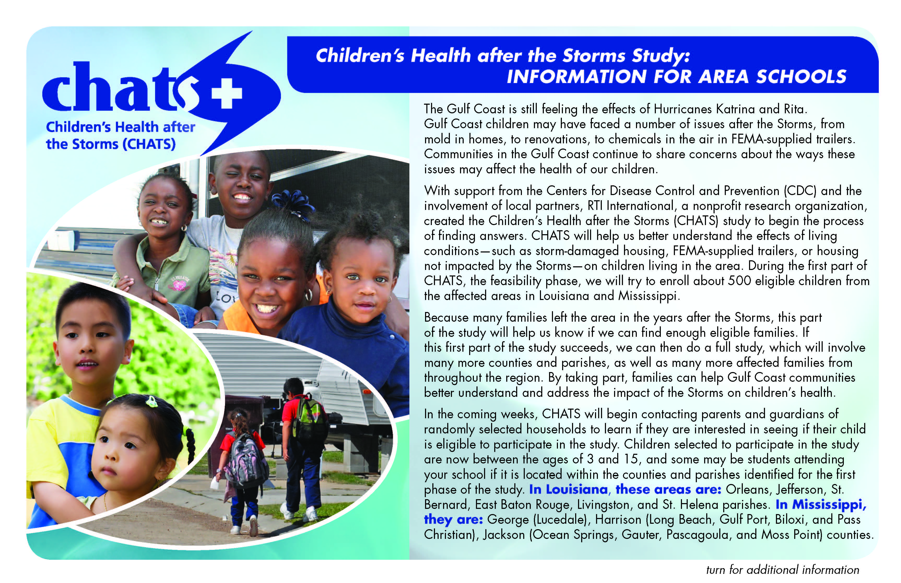

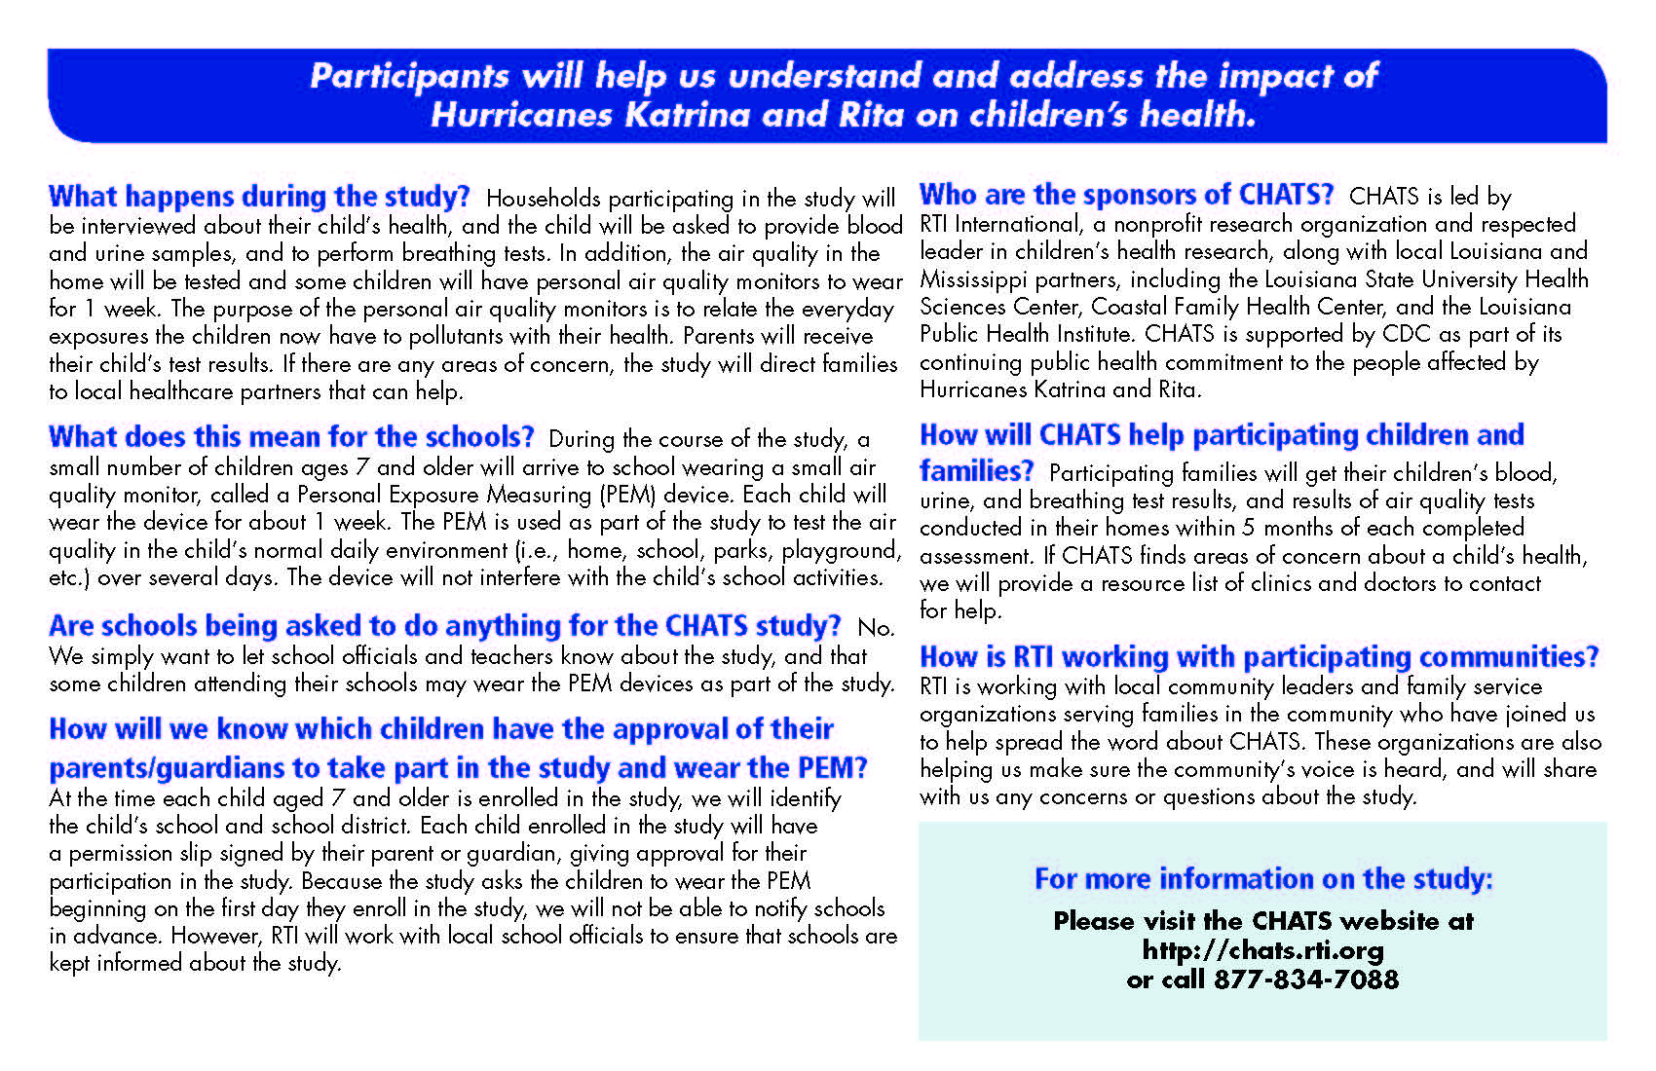
Community Information Card

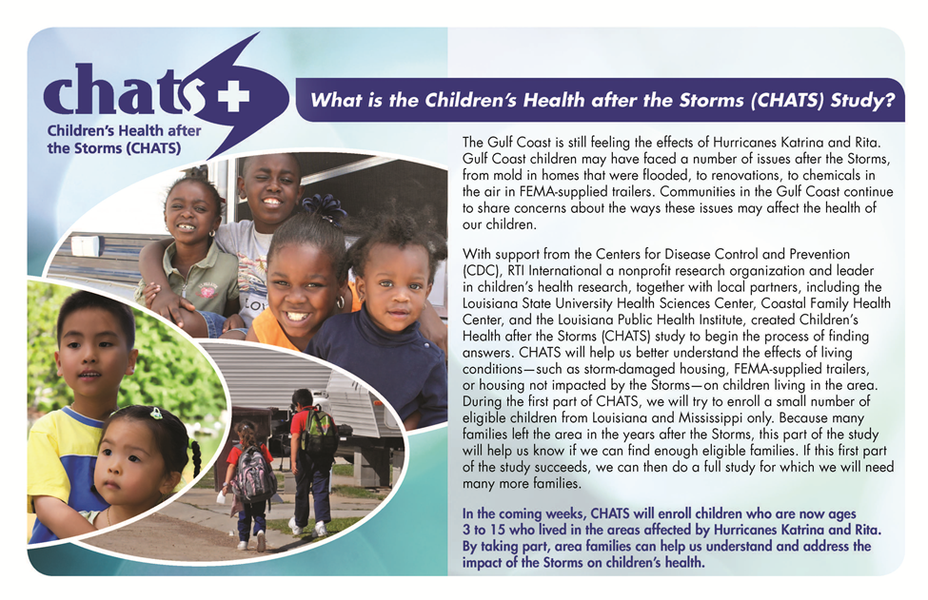

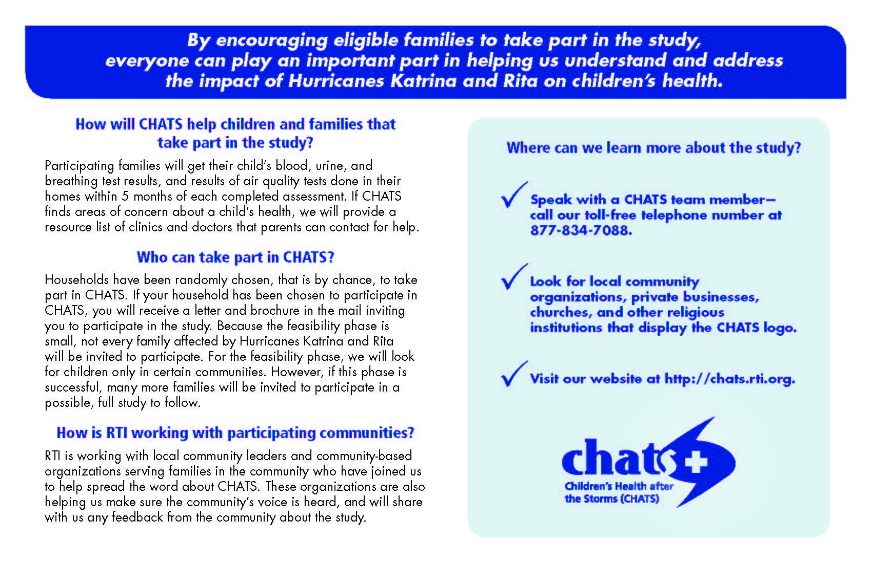

Community Poster

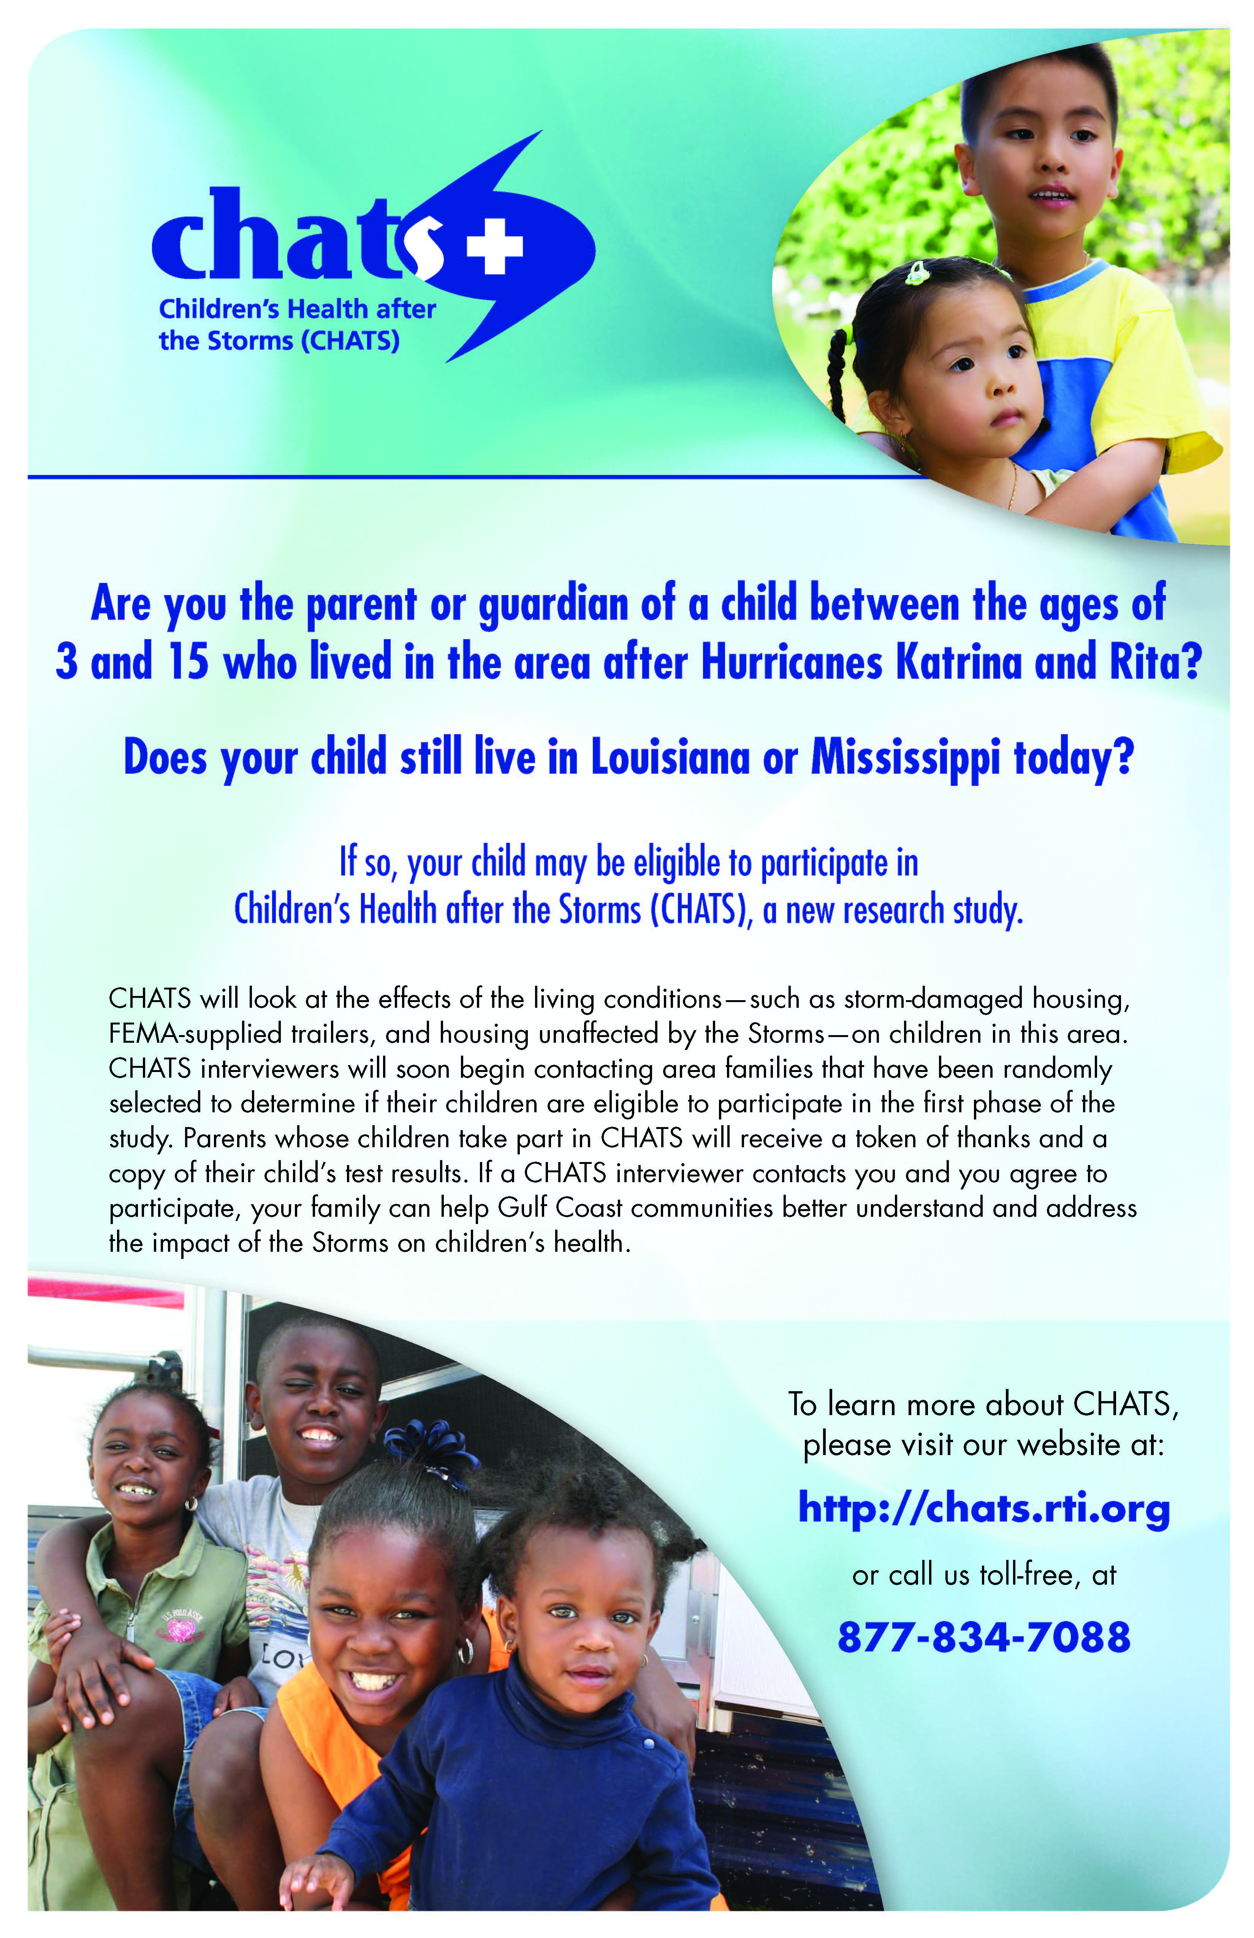

News Print Ad

Children’s Health after the Storms/CHATS

Are you the parent or guardian of a child between the ages of 3 and 15 who lived in Louisiana or Mississippi after Hurricanes Katrina and Rita? If so, your child may be eligible to participate in Children’s Health after the Storms or CHATS, a new research study. In its first phase, CHATS will look at the effects of living conditions—such as storm damaged housing, FEMA-supplied trailers, and housing unaffected by the storms—on children in this area.

Soon, CHATS interviewers will begin contacting area families that have been randomly selected to determine if their children are eligible to participate in the study. If you are among those contacted and agree to participate, your family can help Gulf Coast communities better understand and address the impact of the storms on children’s health. For more information about CHATS, please visit our website at: http://chats.rti.org.

Radio Public Service Announcement

Children’s Health after the Storms/CHATS

Are you the parent or guardian of a child between the ages of 3 and 15 who lived in Louisiana or Mississippi after Hurricanes Katrina and Rita? If so, your child may be eligible to participate in Children’s Health after the Storms or CHATS, a new research study. In its first phase, CHATS will look at the effects of living conditions—such as storm damaged housing, FEMA-supplied trailers, and housing unaffected by the storms—on children in this area.
Soon, CHATS interviewers will begin contacting area families that have been randomly selected to determine if their children are eligible to participate in the study. If you are among those contacted and agree to participate, your family can help Gulf Coast communities better understand and address the impact of the storms on children’s health. For more information about CHATS, please visit our website at: http://chats.rti.org.

