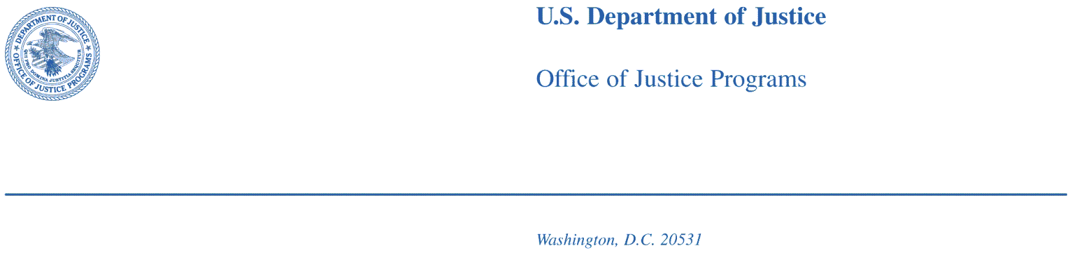

{DATE}

Dear Resident:

Please complete the enclosed survey from the U.S. Department of Justice, Bureau of Justice Statistics. This survey is about safety and crime in your community and results from this survey will be used to better understand the experiences of residents in U.S. communities.

Your address is part of a random sample of addresses in the United States. This is part of a scientific study and your answers represent not only you and your household, but also hundreds of households like yours. For this reason, your voluntary cooperation is very important.

As a small token of appreciation, we are including $2 for your time. Residents can keep the money even if you decide not to take part in the survey.

The information you provide will be used for statistical purposes only and may not be disclosed, or used, in identifiable form for any other purpose as required by law (Title 42, U.S. Code, Sections 3789g). Your responses will be combined with those of others to produce statistical summaries about crime and safety.

Answers to the most frequently asked survey questions are included in the questionnaire. Section 3732 of the Justice Systems Improvement Act of 1979 authorizes the Bureau of Justice Statistics to conduct this survey. If you would like further information, you can contact our survey support at 1-xxx-xxx-xxx or you can visit the BJS website at www.bjs.gov/xxxxx.

Crime affects all Americans. Thank you for your generous cooperation. The U.S. Bureau of Justice Statistics appreciates your help in this very important survey.

Sincerely,

Michael Planty, Ph.D.

Chief of Victimization Statistics

Bureau of Justice Statistics

Office of Justice Programs

U.S. Department of Justice

**FAQ List for the back of Letters**

**U.S. Department of Justice Survey of Neighborhoods**

***What is the U.S. Department of Justice Survey of Neighborhoods?***

The U.S. Department of Justice (DOJ) Neighborhood Crime Survey is a survey of households in major U.S. metropolitan areas to obtain information about safety in our nation’s communities.

***Who is the sponsor of this study?***

The survey is sponsored by the Bureau of Justice Statistics (BJS), U.S. Department of Justice (DOJ). The survey is conducted under the authority of Title 42, United States Code, Section 3732. To learn more about BJS, you can visit them on the web at [www.ojp.usdoj.gov/bjs](http://www.ojp.usdoj.gov/bjs).

***How long will it take to complete this survey?***

We anticipate that most households will be able to complete the mailed survey in about 5-6 minutes. For those experiencing crimes in the past year, the survey will take longer to complete, depending on the number of crimes and the number of household members involved. We believe the average time for households with crimes to report will be between 15-20 minutes.

***Am I required to complete this survey?***

Participation is voluntary and there are no penalties for refusing to answer. However, your household was randomly selected for this scientific sample survey, and you cannot be replaced with another household. Your cooperation is extremely important to help ensure the completeness and accuracy of this much needed information.

***Who will use this information?***

Results from this survey (and similar surveys conducted by The U.S. Department of Justice) are used by local citizens, by legislators, and by policymakers to develop programs to aid crime victims and to help prevent crime.

***Who can I call with questions?***

If you would like further information, you can contact Westat at 1-800-xxx-xxxx.

***How was my household chosen for this study?***

Households were selected at random. By selecting households randomly, we will be able to create scientific estimates about households in your metropolitan area. It's important to participate, so that we have an accurate picture of your community.

***How do I know you'll keep my information confidential?***

The information you provide will be used for statistical purposes only and may not be disclosed, or used, in identifiable form for any other purpose as required by law (Title 42, U.S. Code, Sections 3789g). Your responses will be combined with those of others to produce statistical summaries about crime and safety. After the study is completed, identifying information - your address and phone number - are destroyed.