This screen shot represents the first page the user will see to complete a CA-7.

The OMB/Expiration Date will be identified in the red box below, followed by a hyperlink in which the user will click to view the Privacy Act and Public Burden Statements.

OMB No. 1240-0046 (Expires: 10-31-2014) Privacy Act and Public Burden Statements

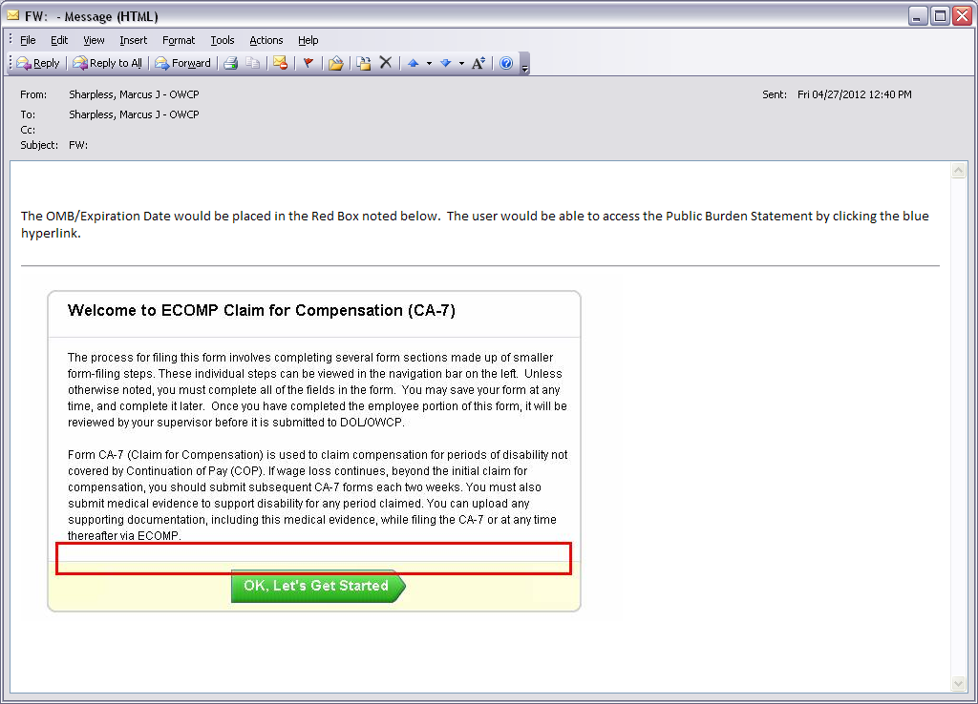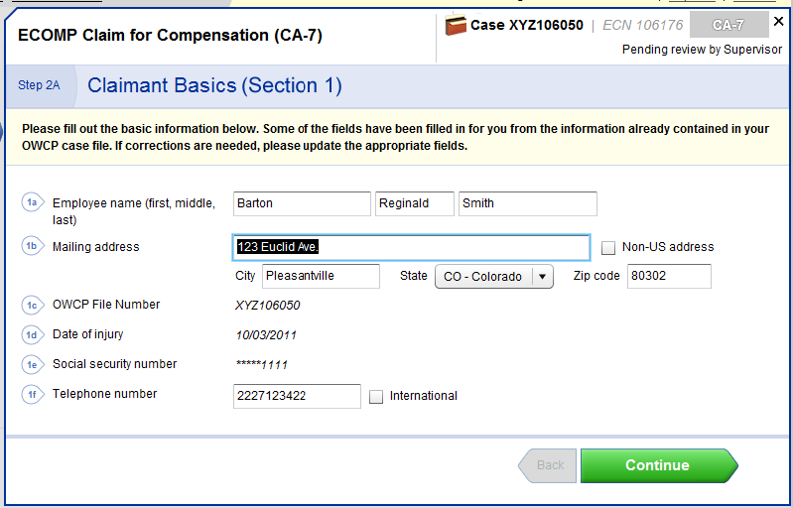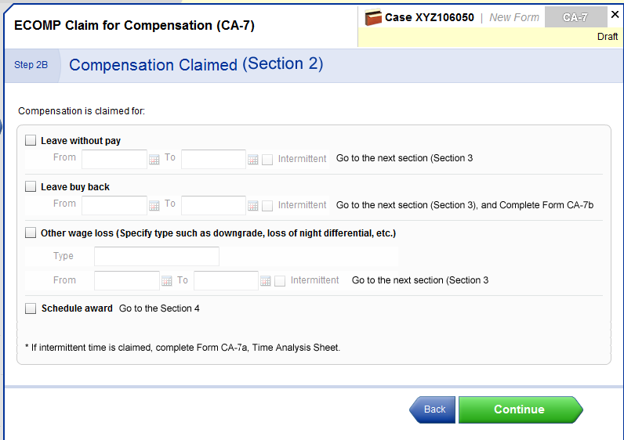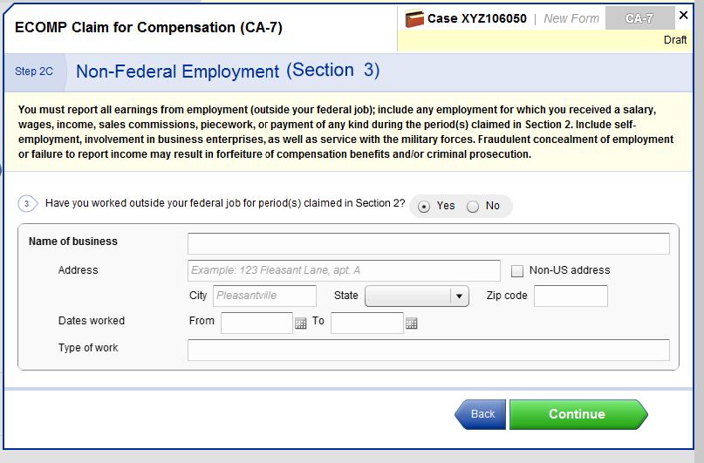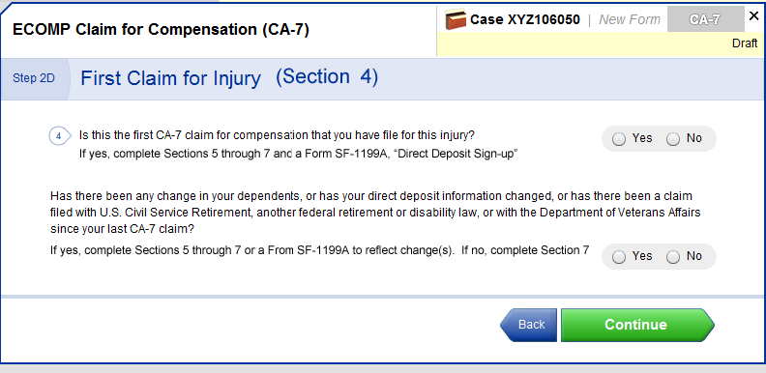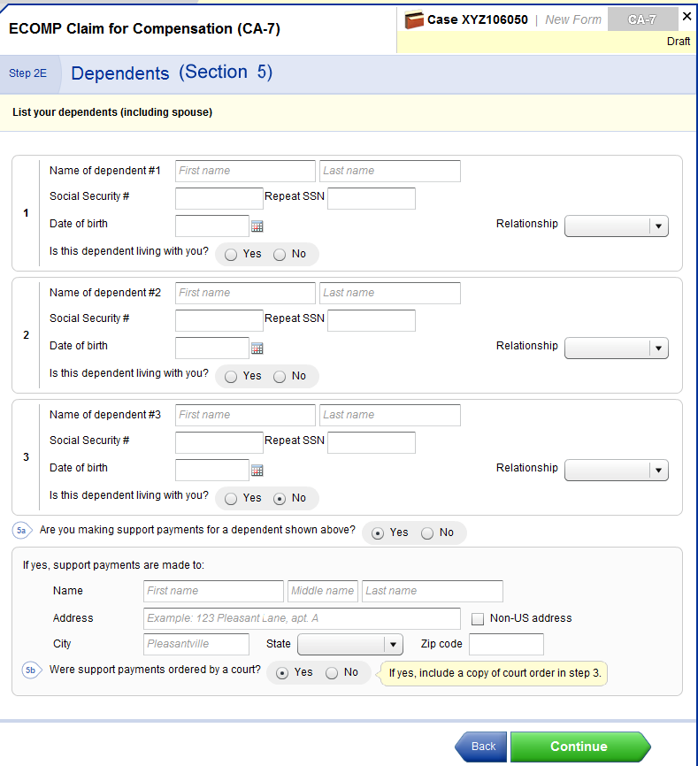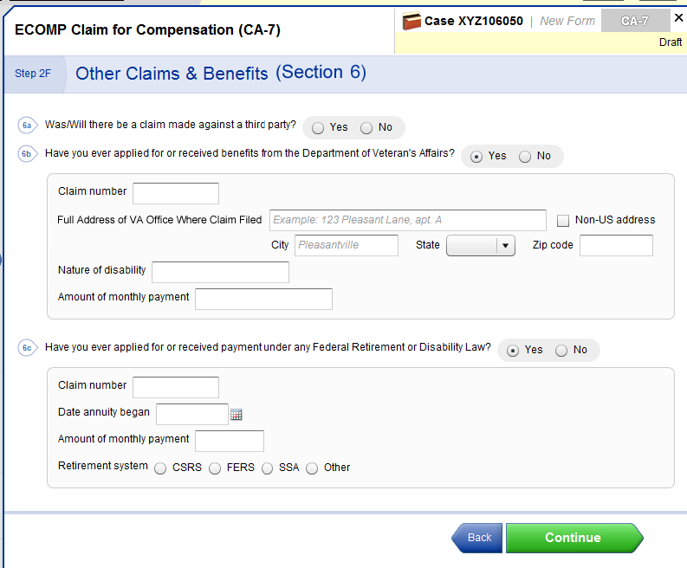

(THIS STEP IS NOT PART OF ACTUAL CA-7, BUT THIS ALLOWS CLAIMANT TO SUBMIT ADDITIONAL DOCUMENTAION WITH THE CLAIM, i.e. A MEDICAL REPORT OR ONE OF THE DOCS MENTIONED IN PREVIOUS STEPS. IF THEY DON’T WANT TO UPLOAD IT HERE, THEY CAN SUBMIT LATER VIA THE ECOMP SYSTEM ,OR VIA MAIL/FAX LIKE USUAL.)

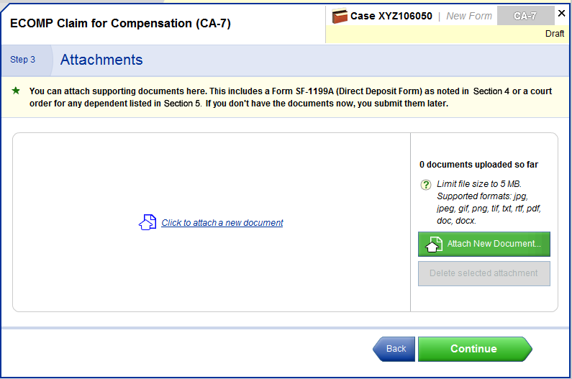

(NOT PART OF ACTUAL CA-7, BUT THIS STEP ALLOWS CLAIMANT TO REVIEW INFORMATION ENTERTED AND MAKE ANY CHANGES NEEDED.)

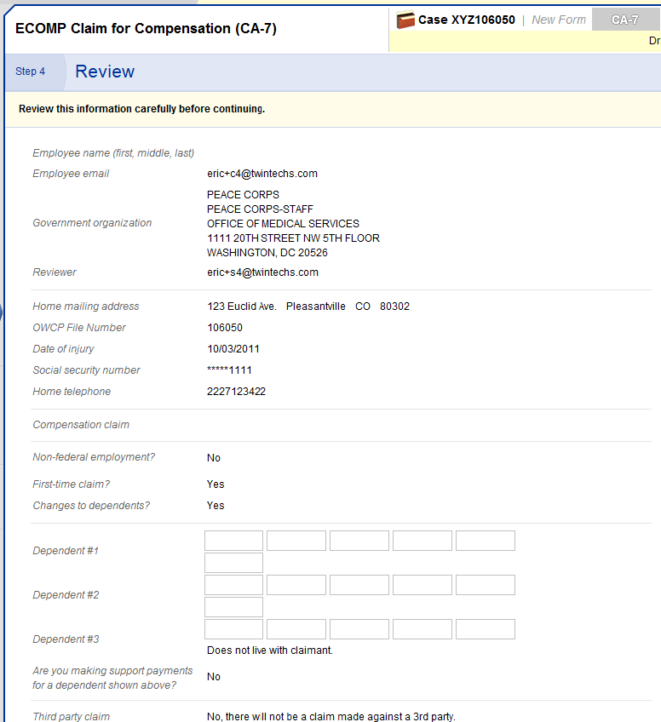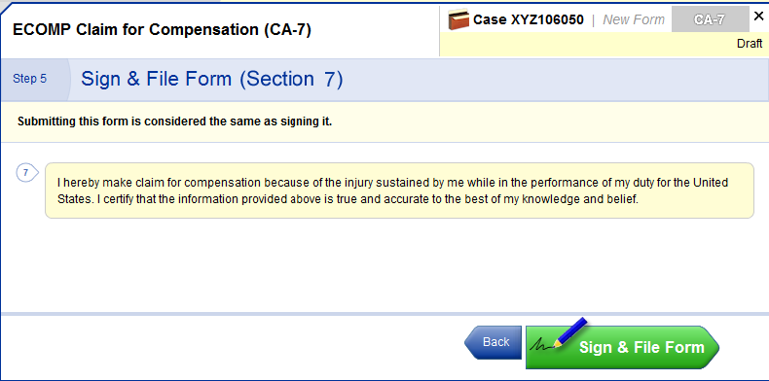

And then the clmt clicks on I Agree to finalize form.

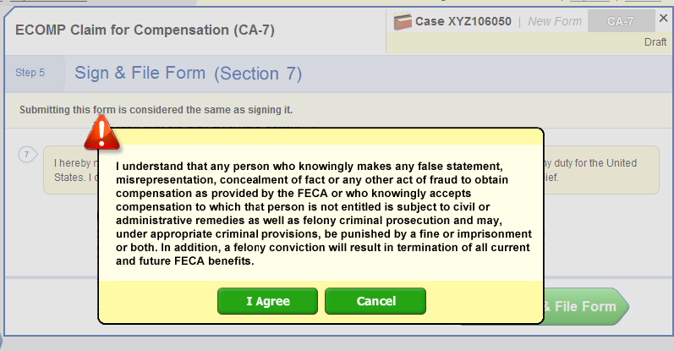

After this step, all of the information is input into a **regular CA-7 form** that is submitted. The form is the **EXACT same CA-7**. The claimant can print this form also.