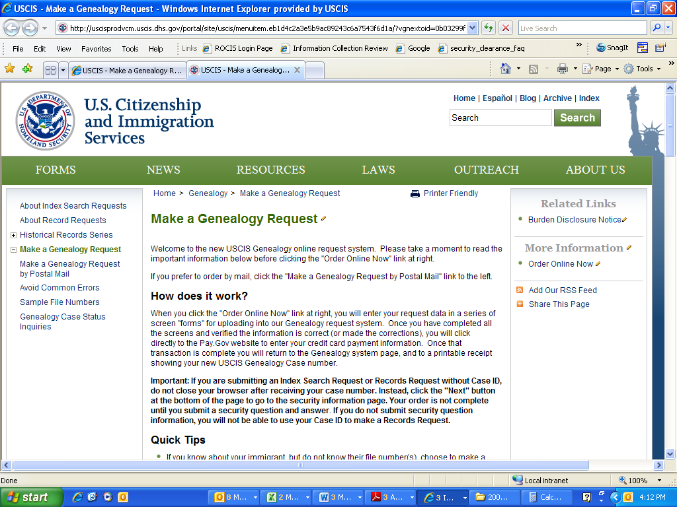
Burden Disclosure Notice
An agency may not conduct or sponsor an information collection and a person is not required to respond to a collection of information unless it displays a currently valid OMB Control Number. The public reporting burden for the G-1041 and G-1041A forms is estimated at 30 minutes per response, including the time for reviewing the instructions and completing and submitting the form. Send comments regarding this burden estimate or any other aspect of this collection of information, including suggestions for reducing this burden, to: U.S. Citizenship and Immigration Services, Regulatory Coordination Division, Office of Policy and Strategy, 20 Massachusetts Ave, N.W., Washington, D.C., 20529-2020 and include OMB Control Number 1615-0096 for reference. Please do not mail your completed G-1041 or G-1041A forms to this address.

