Current approved CTP programs
02/10/12
http://studentaid.ed.gov/PORTALSWebApp/students/english/CTPProgramList.jsp

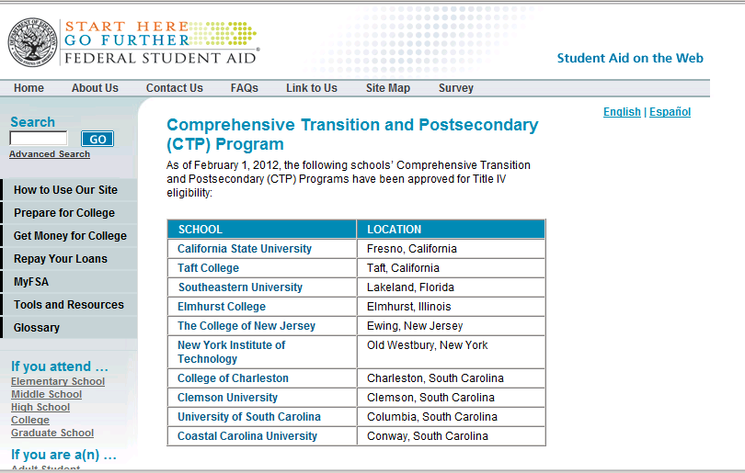
 | Public Institutions | Private Institutions
1 | California State University | Southeastern University
2 | Taft College | Elmhurst College
3 | The College of New Jersey
4 | New York Institute of Technology
5 | College of Charleston
6 | Clemson University
7 | University of South Carolina
8 | Coastal Carolina University
9
10
11
12

