**Letter to Chief Academic Officer**



October 19, 2010

Dear Chief Academic Officer:

The National Center for Education Statistics (NCES) conducts a biennial survey of all libraries serving degree-granting colleges and universities in the fifty states and the District of Columbia. In the next few weeks, instructions for survey participation will be sent to the library director at your institution. On-line registration and web data collection opens November 9, 2010 and web data collection closes on February 28, 2011.

The Academic Libraries Survey (ALS) 2010 form and instructions will be posted on the NCES Web site (<http://nces.ed.gov/surveys/libraries/AcaRRQuestDefs.asp>) for your review. An online analysis tool for comparing academic libraries and other survey information is available on the Academic Libraries Survey Web page (<http://nces.ed.gov/surveys/libraries/academic.asp>).

The collection of salary and benefits data is an important component of this voluntary library survey. NCES and the Census Bureau take steps to protect potentially individually identifiable information such that when there are only one or two FTEs within a staffing category, salary and benefits data for that category will not be shown.

The cooperation of your institution is important to the success of this national survey of academic libraries. If you have questions about the Academic Libraries Survey, please contact Tai Phan at Tai.Phan@ed.gov.

Sincerely,

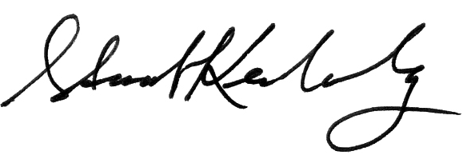

Stuart Kerachsky, Ph.D.

Deputy Commissioner, Delegated the Authority of Commissioner

National Center for Education Statistics

Institute of Education Sciences

cc: Library Director