

October 26, 2010

Dear Library Director:

The National Center for Education Statistics conducts a biennial survey of all libraries of degree-granting colleges and universities. Please designate a Key Holder to be responsible for data entry and forward the enclosed survey information to that person as soon as possible.

Registration and data collection for the FY 2010 Academic Libraries Survey (ALS) begins November 9, 2010, and the URL for the survey is http://surveys.nces.ed.gov/libraries/als. The Key Holder should register beginning on November 9 using the enclosed registration guide, user ID, and password. Data collection ends on February 28, 2011.

When reporting data for an institution, the Key Holder should include data for all branch and independent libraries on the campus. Libraries on branch campuses (i.e., located in other communities) should be included if those campuses are registered under the same NCES UNIT-ID number as the main campus. Your institutional research representative can provide the UNIT-ID number for any branch campus.

NCES produces national and state tabulations of the final data in a report and also releases the final data file online. For more information about the survey, go to the ALS home page at http://nces.ed.gov/surveys/libraries/.

Congress uses the data to assess the need for revisions to existing legislation concerning postsecondary libraries and the allocation of Federal funds. Federal agencies use the data to evaluate and administer library programs. State education agencies, library associations, and researchers use the survey data to determine the status of academic library operations and the profession, and to analyze national and regional trends in academic library resources.

The collection of salary and benefits data is an important component of this voluntary library survey. NCES and the Census Bureau take steps to protect potentially individually identifiable information such that when there are only one or two FTEs within a staffing category, salary and benefits data for that category will not be shown.
Changes to the survey have been reviewed by the ALS Steering Committee. A copy of the FY 2010 ALS survey, instructions, and survey changes will be posted on the ALS Web site at http://nces.ed.gov/surveys/libraries/AcaRRQuestDefs.asp.

A network of Library Representatives (LRs), one in each state, has agreed to work with NCES to promote survey response. A list of the LRs can be found at http://www.ala.org/ala/ors/natlctrforedstats/lrsals.cfm.

Thank you for your cooperation and support of this survey.

Sincerely,
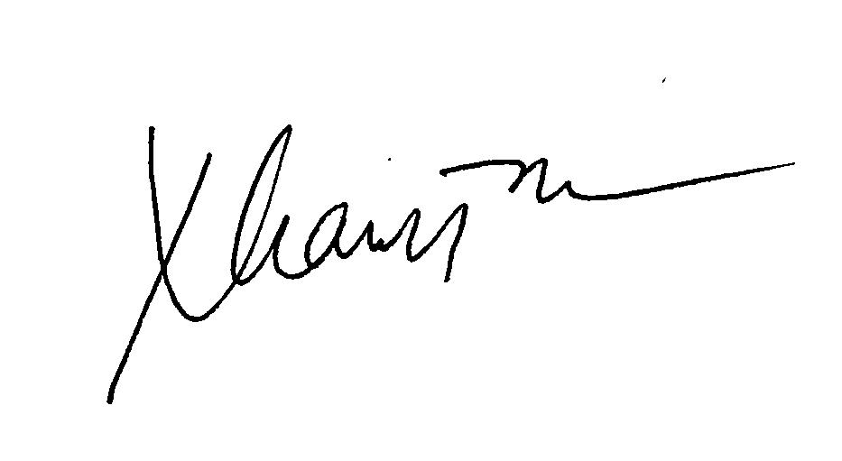

Tai Phan
Program Director, Library Statistics Program

Enclosure

October 26, 2010

Dear ALS Key Holder:

As Key Holder for the FY 2010 Academic Library Survey (ALS), you play an important role in this national data collection effort sponsored by the National Center for Education Statistics (NCES). You are responsible for your institution’s data submission and for “locking” the data on time. Only designated staff with assigned ALS user IDs and passwords can access the survey system, located at http://surveys.nces.ed.gov/libraries/als. Data collection begins on November 9, 2010 and ends on February 28, 2011. Registration can begin on November 9 and should be completed as soon as possible.

This packet contains the following information to help you register and submit data for your institution:

Registration Guide (Attachment A) – This document provides general instructions for completion of the on-line Web registration process.

Key Holder Certificate (Attachment B) – This document contains your ALS user ID number, personal password, UNIT-ID, institution name, FY 2008 respondent name, as well as critical dates and ALS Help Desk Information. Please keep this document in a safe place, and do not share this password with anyone.

You will register using the Key Holder Certificate, FY 2010 ALS (Attachment B). The Web registration form asks for specific contact information, which will then be used by NCES and Census, the data collection agent for NCES, in all further contacts with your library during this data collection. If more than one staff person will need to enter data into the Web-based survey form, you may request additional passwords for them. However, all further contacts will flow through you as the ALS Key Holder, and only you can lock your data. Once your data have been entered, edited and locked, the Census Bureau will review your submission and may contact you with questions about the data.

Report data for all branch and independent libraries on the campus and for libraries on branch campuses (i.e., located in another community) if those campuses are registered under the same NCES UNIT-ID number as the main campus. Your Institutional Research Office will know the NCES UNIT-ID number of any branch campus.
The collection of salary and benefits data is an important component of this voluntary library survey. NCES and the Census Bureau take steps to protect potentially individually identifiable information such that when there are only one or two FTEs within a staffing category, salary and benefits data for that category will not be showne.
Changes to the survey have been reviewed by the ALS Steering Committee. A copy of the FY 2010 ALS survey, instructions, and survey changes will be posted on the ALS Web site at http://nces.ed.gov/surveys/libraries/AcaRRQuestDefs.asp.

A network of Library Representatives (LRs), one in each state, has agreed to work with NCES to promote survey response. A list of the LRs can be found at http://www.ala.org/ala/ors/natlctrforedstats/lrsals.cfm.

Technical assistance for your data submission will be available from the Census Bureau at govs.aclib@census.gov or by calling (877) 749-4925. If you have questions or comments about the survey program, you may contact me, Tai Phan at NCES at Tai.Phan@ed.gov or call (202) 502-7431.

Thank you for your cooperation and support of this survey.

Sincerely,

Tai Phan
Program Director, Libraries Statistics Program

Enclosures

ATTACHMENT A
ACADEMIC LIBRARIES SURVEY
Registration Guide

You have already found the Academic Libraries Survey (ALS) Welcome page that provides general information about the ALS.

From the Welcome screen:
Click on the Login link at the top or bottom of the page to navigate to the Login page.
Enter the Key Holder User ID and Password that was printed on your Key Holder Certificate.
Click on the Login button or press the enter key to navigate to the registration site.

The Registration site:
Enter the contact information on the registration screen and click the Save button. Note that several fields are required. These are marked with two asterisks at the end of the line. Once you have completed the update, click the Continue button to advance to the Library Director Information screen.
If more than one person will be entering data for your academic library during the survey,
You can request additional User IDs and passwords by clicking the Additional Users/Passwords link
under Tools.
Give these passwords to the people who will be using them for data entry. If you later decide you need more User IDs and passwords, you can return to the registration screen and request more,
up to a limit of six User IDs in addition to the Key Holder.

The Library Director Information screen:
Enter the library director information on the screen and click the Save button. Once you have completed the update, click the Continue button to advance to the Eligibility screen.

The Eligibility screen:
This screen consists of four criteria questions, which are used to determine if your institution meets our definition of a library. If defined criteria are satisfied, you will have access to complete the ALS.
Click on the Yes or No radio buttons as appropriate and click on the Save button. If you answered “Yes” to all four questions and you have completed the update, click the Continue button to advance to the data entry screens.
If you confirm your responses after answering No to any of the four eligibility questions, your registration is complete.

Attachment B

Key Holder Certificate
FY2010 Academic Libraries Survey (ALS)

Please keep this certificate in a safe place and
do not share the password with anyone

Institution UNITID: <UNIT ID>

<Institution Name>

ALS USERID: <USERID>

ALS Password: <Password>

(Note: Passwords are case sensitive)

2008 Respondent: <Respondent Name>

ALS HELP DESK: govs.aclib@census.gov

1-877-749-4925

On-line Registration and Data Collection Period

November 9, 2010 through February 28, 2011

http://surveys.nces.ed.gov/libraries/als

