Request for Approval under the “Generic Clearance for the Collection of Routine Customer Feedback” (OMB Control Number: 1910-5160)
TITLE OF INFORMATION COLLECTION:
DOE Information Management Conference Feedback

PURPOSE:
Collect feedback from attendees of the DOE Information Management Conference (IMC) regarding their experience at the 2012 conference. The responses will be used by the IMC Committee to help improve upcoming conferences.

DESCRIPTION OF RESPONDENTS:
Respondents to the DOE IMC feedback form will be primarily Industry attendees who directly support DOE as contractors or vendors. Attendees will have attended up to 4 days of the conference and will be uniquely able to provide real-time feedback of the key aspects of the conference. Most attendees will have attended education-focused sessions as well as the ‘Town Hall’ presentations. You can access the feedback form at: http://apps.technologyforums.com/survey/index/1?force=true

TYPE OF COLLECTION: (Check one)

[ ] Customer Comment Card/Complaint Form [ ] Customer Satisfaction Survey
[ ] Usability Testing (e.g., Website or Software [ ] Small Discussion Group
[ ] Focus Group [X] Other: _Customer feedback __________________

CERTIFICATION:

I certify the following to be true:
- The collection is voluntary.
- The collection is low-burden for respondents and low-cost for the Federal Government.
- The collection is non-controversial and does not raise issues of concern to other federal agencies.
- The results are not intended to be disseminated to the public.
- Information gathered will not be used for the purpose of substantially informing influential policy decisions.
- The collection is targeted to the solicitation of opinions from respondents who have experience with the program or may have experience with the program in the future.

Name: TheAnne Gordon 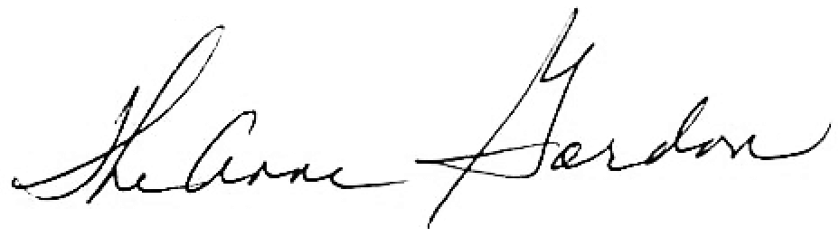

To assist review, please provide answers to the following question:

Personally Identifiable Information:
- Is personally identifiable information (PII) collected? [ ] Yes [X] No
- If Yes, will any information that is collected be included in records that are subject to the Privacy Act of 1974? [ ] Yes [ ] No
- If Yes, has an up-to-date System of Records Notice (SORN) been published? [ ] Yes [ ] No

Gifts or Payments:
Is an incentive (e.g., money or reimbursement of expenses, token of appreciation) provided to participants? [ ] Yes [X] No

BURDEN HOURS

Category of Respondent | No. of Respondents | Participation Time | Burden
Private Sector Conference Attendee | 400 | 5 minutes | 33 hours
Totals | 400 |  | 33 hours

FEDERAL COST: The estimated annual cost to the Federal government is $3,200

If you are conducting a focus group, survey, or plan to employ statistical methods, please provide answers to the following questions:

The selection of your targeted respondents
- Do you have a customer list or something similar that defines the universe of potential respondents and do you have a sampling plan for selecting from this universe? [] Yes [X] No

If the answer is yes, please provide a description of both below (or attach the sampling plan)? If the answer is no, please provide a description of how you plan to identify your potential group of respondents and how you will select them?

N/A

Administration of the Instrument
- How will you collect the information? (Check all that apply)
[ X ] Web-based or other forms of Social Media
[ ] Telephone
[ ] In-person
[ ] Mail
[ ] Other, Explain
- Will interviewers or facilitators be used? [ ] Yes [ X ] No

Please make sure that all instruments, instructions, and scripts are submitted with the request.
Submit all instruments, instructions, and scripts are submitted with the request.

