Chemical Information Submission System – 8(a) PAIR
The ‘Chemical Information Submission System’ screen provides a list of Submission Types for the user to choose. Based on the selected Submission Type, the system directs the user to the appropriate application ‘Home’ screen.
The following exhibit shows the screen capture for the ‘Chemical Information Submission System’ screen for 8(a) PAIR submissions:
Exhibit 1-1 Chemical Information Submission System - 8(a) PAIR
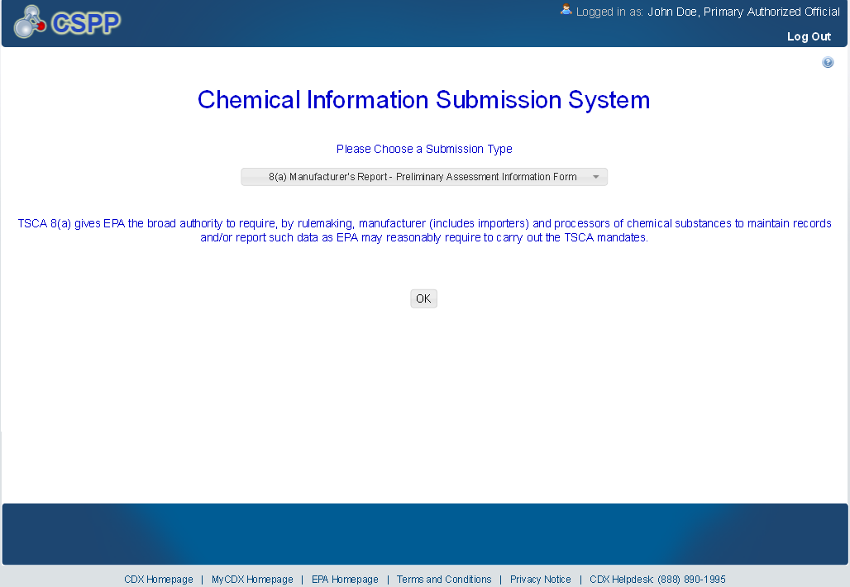

Home
The ‘Home’ screen presents the user with links to access various screens within the 8(a) PAIR application as well as links and tabs to access information regarding the form type, user management, and resources. This screen also displays information relevant to the logged in user’s role.
The following exhibit shows the screen capture for the ‘Home’ screen for 8(a) PAIR submissions:
Exhibit 1-2 8(a) PAIR Home Screen
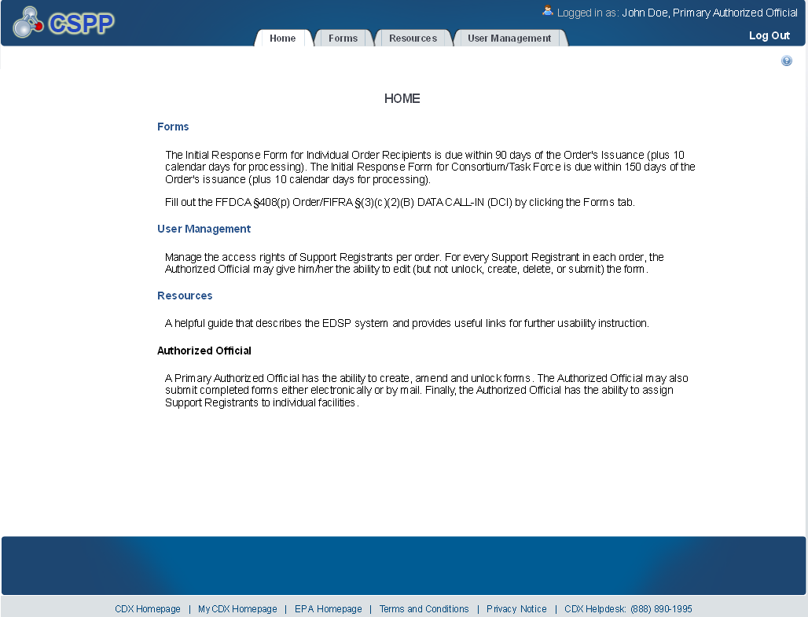

User Management
The ‘User Management’ screen allows the Primary Authorized Official to manage the access rights of Support Registrants to the appropriate forms within the 8(a) PAIR application. For every SR, the Authorized Official may give him/her the ability to edit (but not unlock, create, delete, or submit) the form.
The following exhibit shows the screen capture for the ‘User Management’ screen for 8(a) PAIR submissions:
Exhibit 1-3 User Management Screen
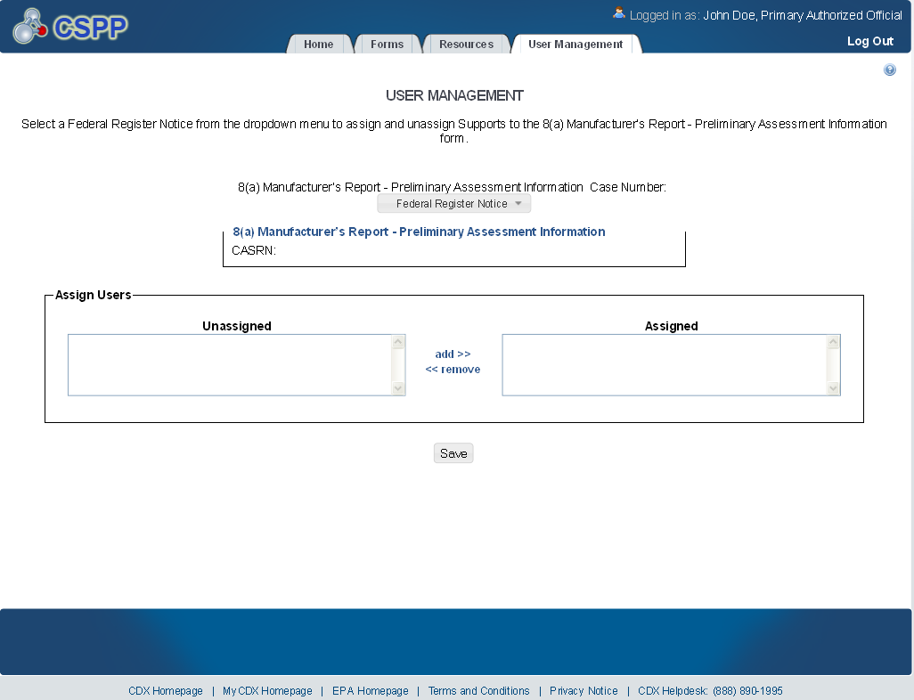

8(a) Manufacturer’s Report – Preliminary Assessment Information Forms
The ‘8(a) Manufacturer’s Report – Preliminary Assessment Information’ form screen presents the user with a list of forms submitted or started during the current reporting cycle. This screen also allows the user to start a new submission and access previously started submissions.
The following exhibit shows the screen capture for the ‘Forms’ screen for 8(a) PAIR submissions:
Exhibit 1-4 Forms Screen
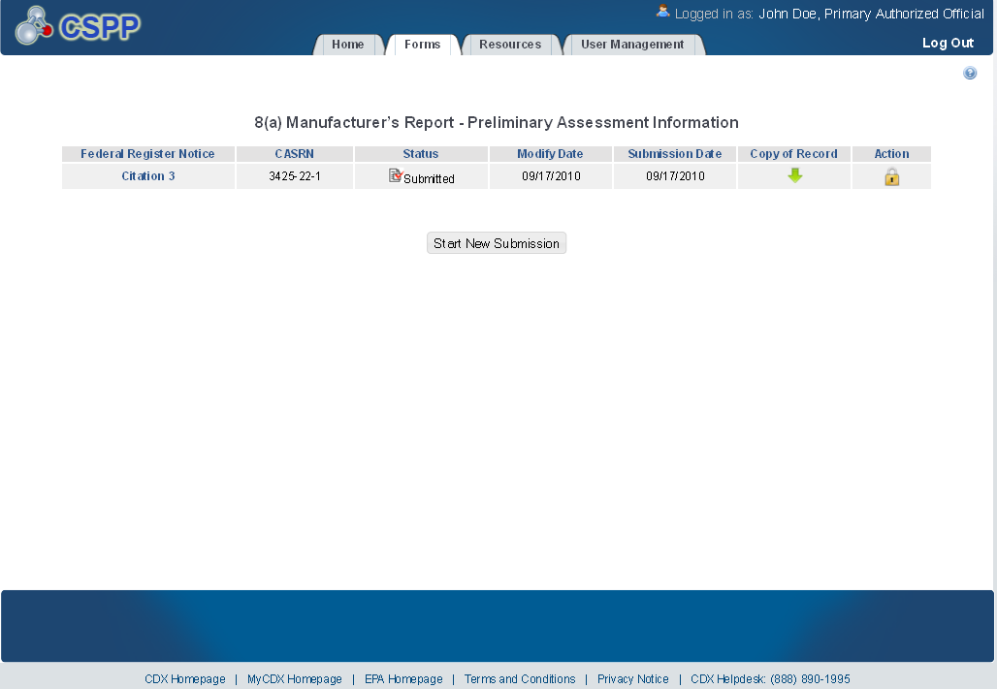

Create Passphrase
The ‘Create Passphrase’ screen allows a user with the AO role to start a new submission and associate a passphrase with the submission. The screen also provides instruction about selecting a valid passphrase.
The following exhibit shows the screen capture for the ‘Create Passphrase’ screen for 8(a) PAIR submissions:
Exhibit 1-5 Create Passphrase Screen
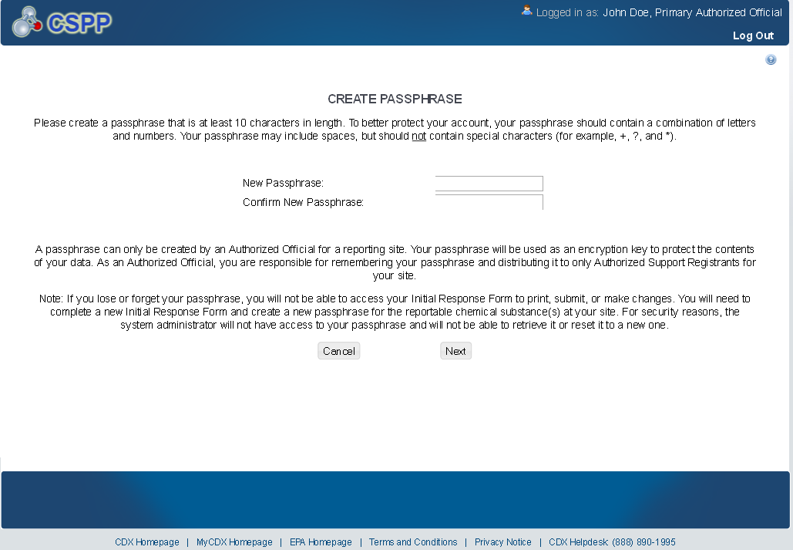

Submitting Official Information
The ‘Section A – Submitting Official Information’ screen allows the user to confirm their contact information. The screen is pre-populated with the information previously entered by the user during CDX registration.
The following exhibit shows the screen capture for the ‘Submitting Official Information’ screen for 8(a) PAIR submissions:
Exhibit 1-6 Submitting Official Information Screen
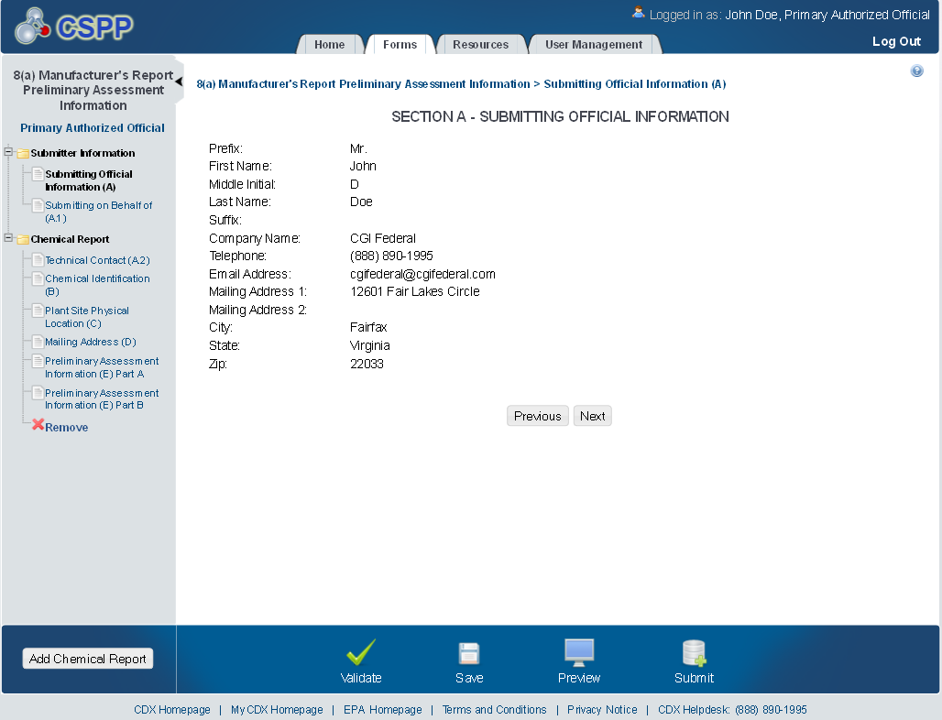

Submitting on Behalf of
The ‘Section A.1 – Submitting on Behalf of’ screen allows the user to submit forms on behalf of another company covered under the reporting requirement. The screen displays a list of text fields that allows the user to input contact information of the manufacturing or processing establishment on whose behalf the submission is made.
The following exhibit shows the screen capture for the ‘Submitting on Behalf of’ screen for 8(a) PAIR submissions:
Exhibit 1-7 Submitting on Behalf Of Screen
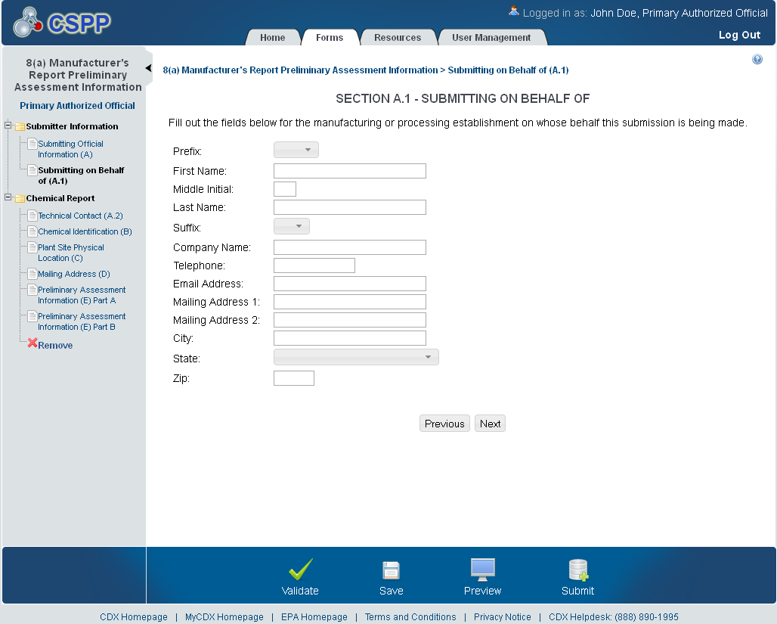

Technical Contact
The ‘Technical Contact’ screen allows the user to add multiple technical contacts, if needed. The system will provide a virtual rolodex address book dropdown menu listing all added technical contacts.
The following exhibit shows the screen capture for the ‘Technical Contact’ screen for 8(a) PAIR submissions:
Exhibit 1-8 Technical Contact Screen
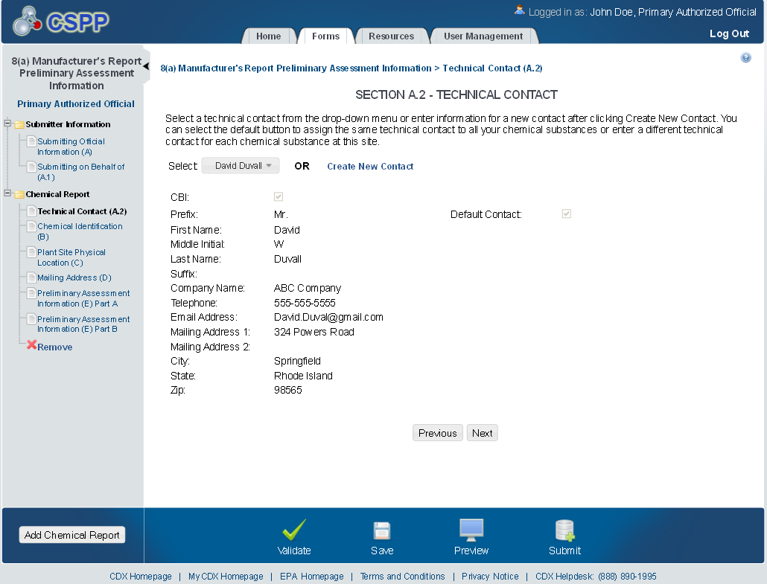

Plant Site Physical Location
The ‘Plant Site/Physical Location’ screen displays information pertaining to the physical location of a test site. Its information is populated and displayed based on the information currently housed in CDX.
The following exhibit shows the screen capture for the ‘Plant Site Physical Location’ screen for 8(a) PAIR submissions:
Exhibit 1-9 Plant Site Physical Location Screen
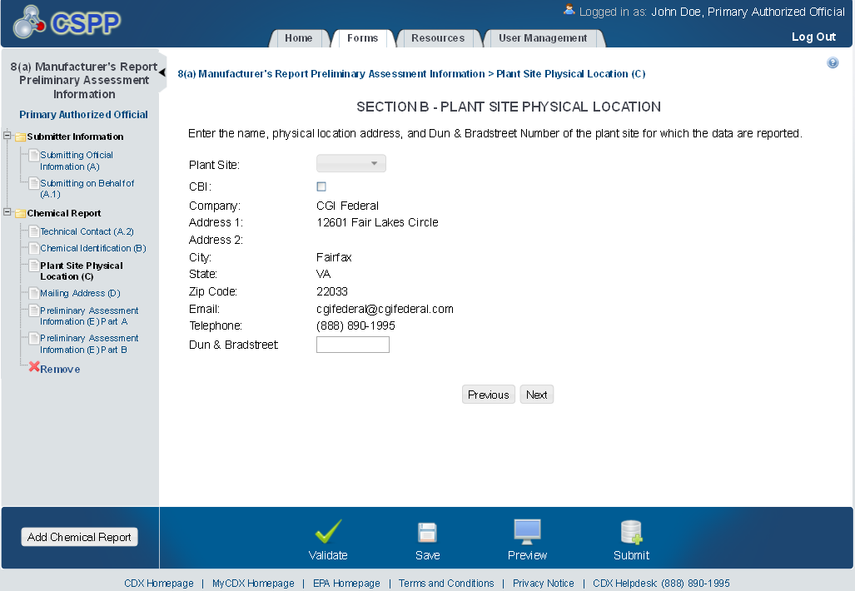

Mailing Address
The ‘Section C – Mailing Address’ screen allows the user to manually enter mailing address information for the plant site or corporate headquarters.
The following exhibit shows the screen capture for the ‘Mailing Address’ screen for 8(a) PAIR submissions:
Exhibit 1-10 Mailing Address Screen
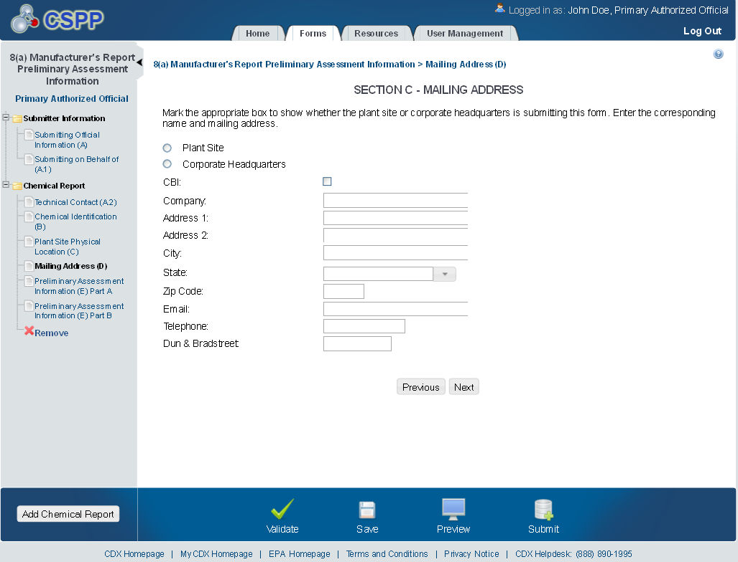

Plant Site Activities
The ‘Section D - Plant Site Activities’ screen allows the user to manually enter activity information for the plant site detailed in the submission.
The following exhibits show the screen captures for the ‘Plant Site Activities’ screen for 8(a) PAIR submissions:
Exhibit 1-11 Plant Site Activities Screen (Scroll 1)
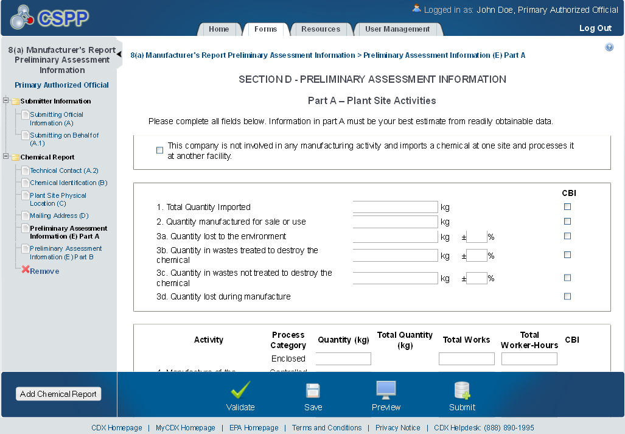

Exhibit 1-12 Plant Site Activities Screen (Scroll 2)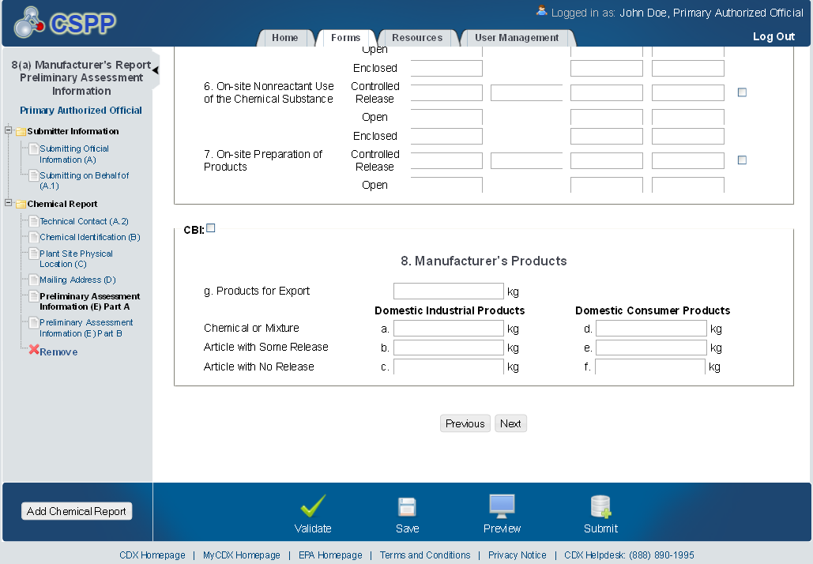

Chemical Substance Processing by Customers
The ‘Section E – Chemical Substance Processing by Customers’ screen allows the user to manually enter consumer use and processing information for the plant site detailed in the submission.
The following exhibits show the screen captures for the ‘Chemical Substance Processing by Customers’ screen for 8(a) PAIR submissions:
Exhibit 1-13 Chemical Substance Processing by Customers (Scroll 1)
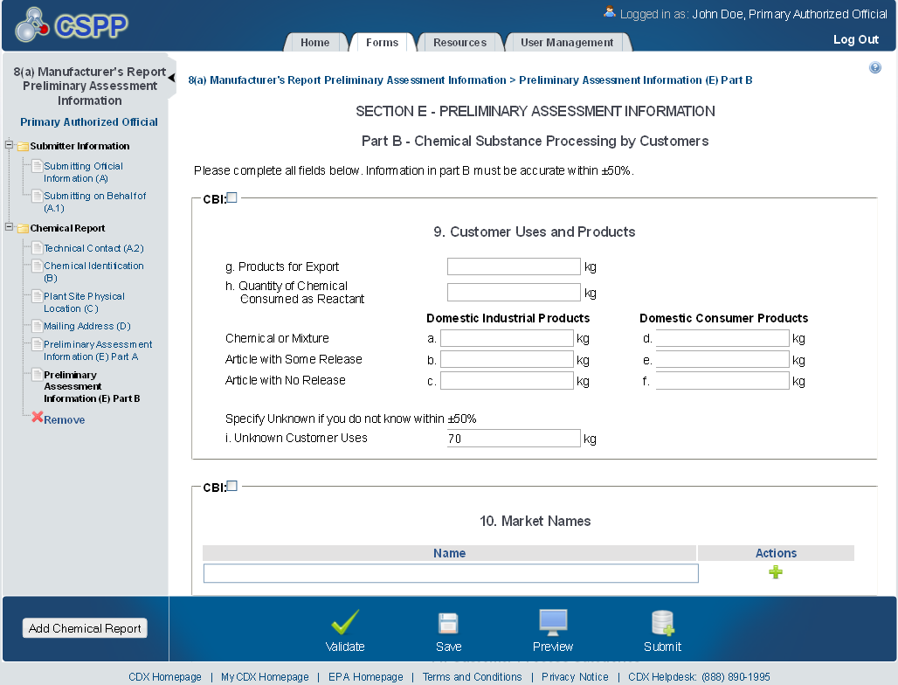

Exhibit 1-14 Chemical Substance Processing by Customers (Scroll 2)
