Chemical Information Submission System
The ‘Chemical Information Submission System’ screen provides a list of submission types from which the user can choose. Based on the selected submission type, the system directs the user to the appropriate application ‘Home’ screen.
The following exhibit shows the screen capture for the ‘Chemical Information Submission System’ screen:
Exhibit 1-1 Chemical Information Submission System – 8(d)
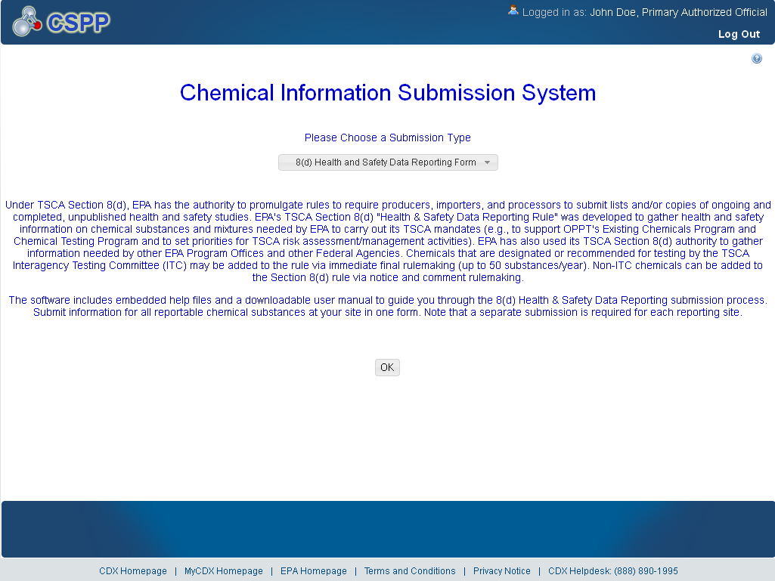

Home
The ‘Home’ screen provides the user with links and tabs to access information for the form type, user management, and resources. Additionally, the system provides the user with information relevant to the logged in user’s role.
The following exhibit shows the screen capture for the ‘Home’ screen:
Exhibit 1-2 Home Screen
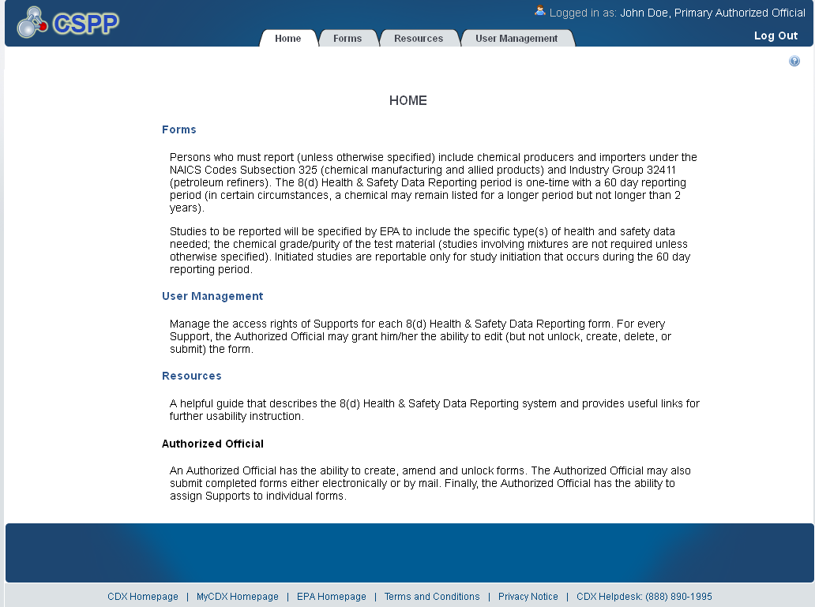

User Management
The ‘User Management’ screen allows the Authorized Official to manage the access rights of Supports to the appropriate forms within the 8(d) Health & Safety Data Reporting application. For every Support, the Authorized Official may give him/her the ability to edit (but not unlock, create, delete, or submit) the form.
The following exhibit shows the screen capture for the ‘User Management’ screen:
Exhibit 1-3 User Management Screen
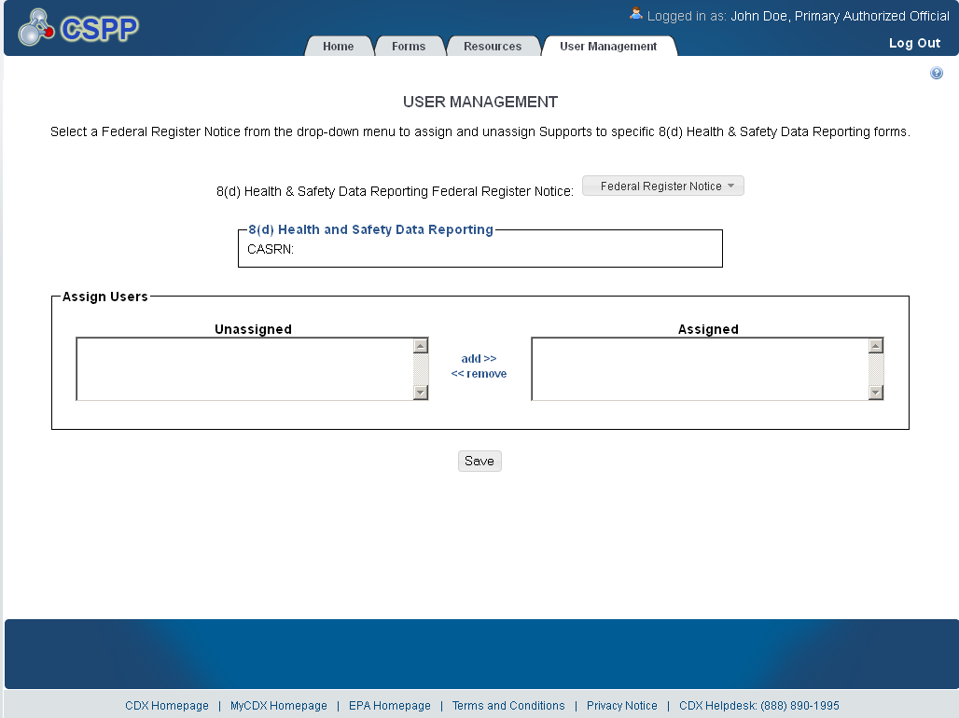

Resources
The ‘Resources’ screen provides the user with the user guide and helpful web links pertaining to 8(d) Health & Safety Data Reporting requirements. The 8(d) Health & Safety Data Reporting User Guide document provides all necessary information for using the 8(d) Health & Safety Data Reporting web application.
The following exhibit shows the screen capture for the ‘Resources’ screen:
Exhibit 1-4 Resources Screen
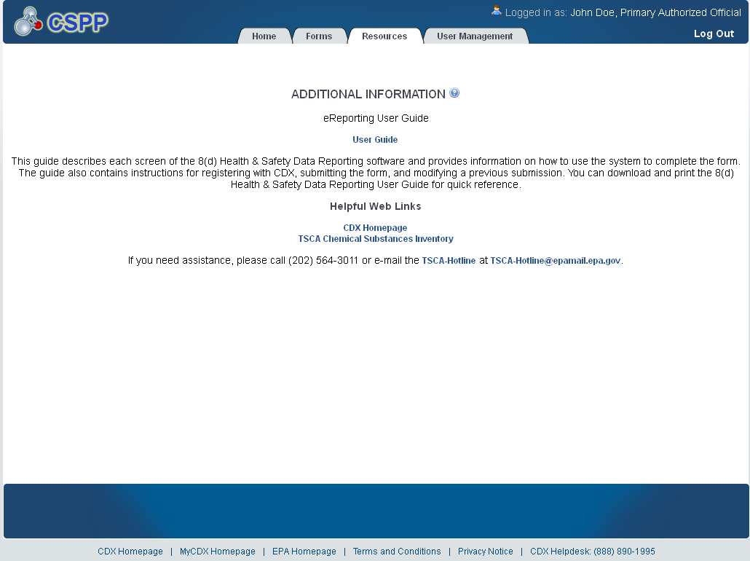

8(d) Health & Safety Data Reporting Forms
The ‘8(d) Health & Safety Data Reporting’ form screen presents the user with a list of forms submitted or started by the AO during the current reporting cycle. Additionally, AOs may begin a new submission from this screen.
The following exhibit shows the screen capture for the ‘Forms’ screen:
Exhibit 1-5 Forms Screen
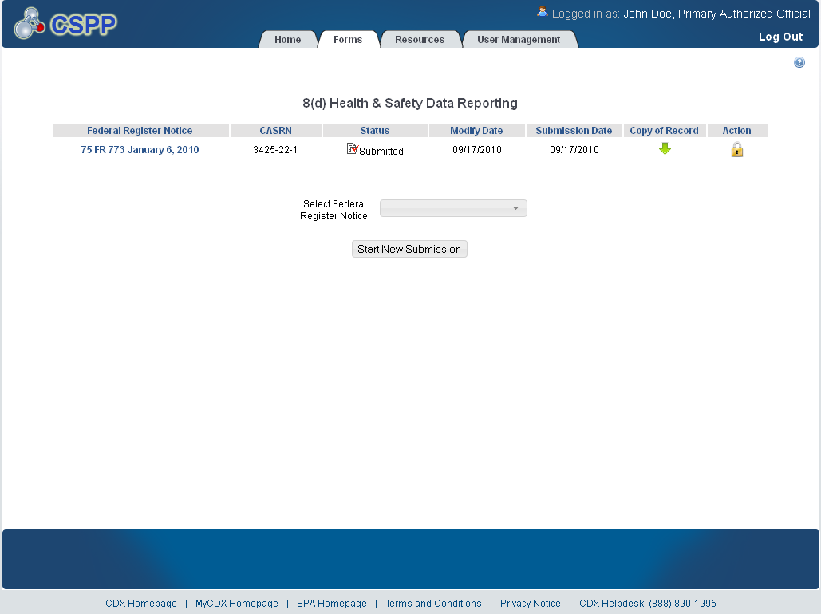

Create Passphrase
The ‘Create Passphrase’ screen allows a user with the AO role to start a new submission and associate a passphrase with the submission. The screen also provides instruction about selecting a valid passphrase.
The following exhibit shows the screen capture for the ‘Create Passphrase’ screen:
Exhibit 1-6 Create Passphrase Screen
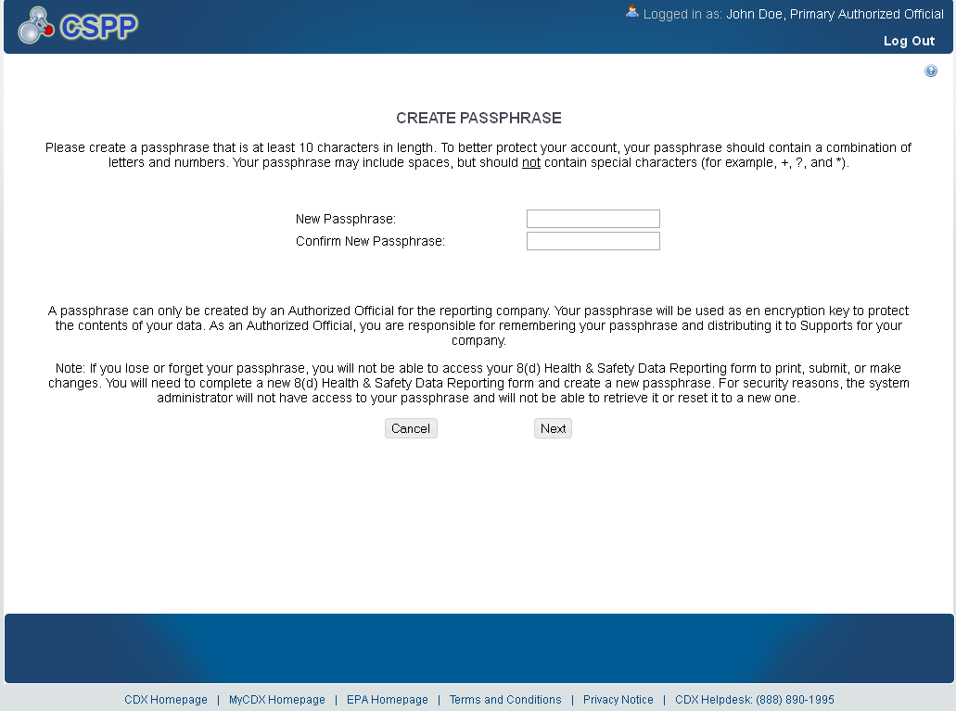

Enter Passphrase
The ‘Enter Passphrase’ screen requires the user to enter the passphrase associated with the selected form. The user will have access to the requested form once the entered passphrase has passed validation.
The following exhibit shows the screen capture for the ‘Enter Passphrase’ screen:
Exhibit 1-7 Enter Passphrase Screen
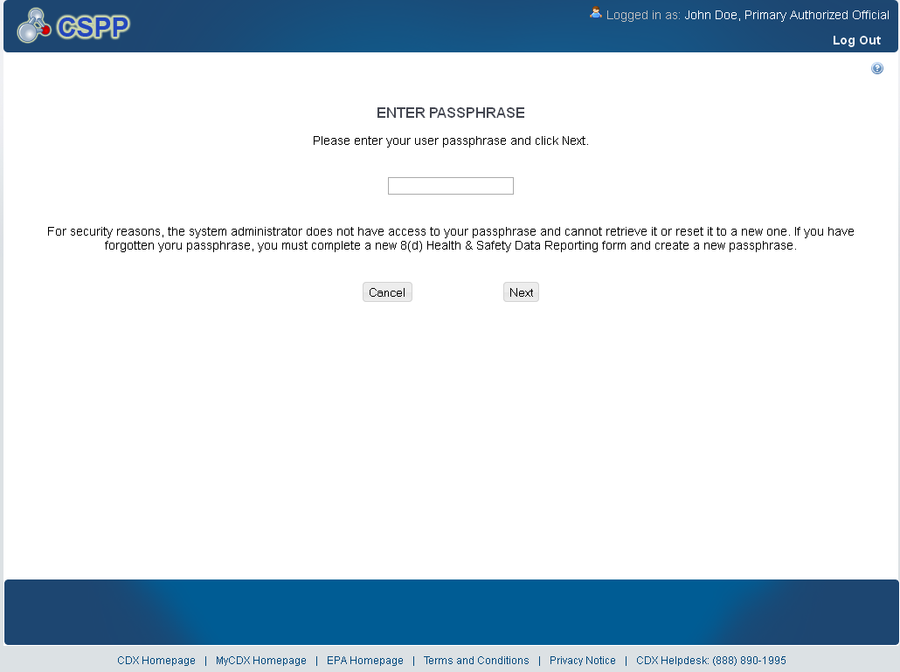

Submitting Official Information
The ‘Section A – Submitting Official Information’ allows the user to confirm their contact information. The screen is pre-populated with the information previously entered by the user during CDX registration, but requires the user to enter a response in the ‘Job Title’ field.
The following exhibit shows the screen capture for the ‘Submitting Official Information’ screen:
Exhibit 1-8 Submitting Official Information Screen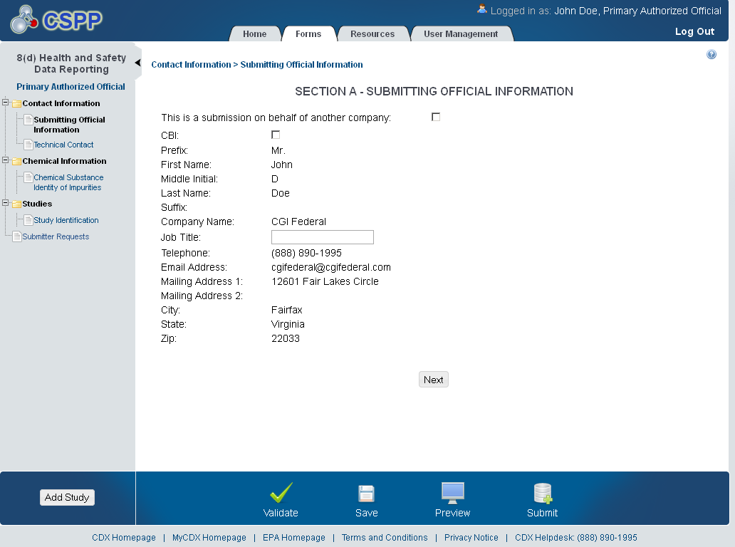

Submitting on Behalf of
The ‘Section A.1 – Submitting on Behalf of’ screen allows users to submit TSCA Section 8(d) Health & Safety Data Reporting forms on behalf of another company covered under the reporting requirement. The ‘Section A.1 – Submitting on Behalf of’ screen presents a list of text fields that allows the user to input contact information of the manufacturing or processing establishment on whose behalf the submission is made.
The following exhibit shows the screen capture for the ‘Submitting on Behalf of’ screen:
Exhibit 1-9 Submitting on Behalf Of 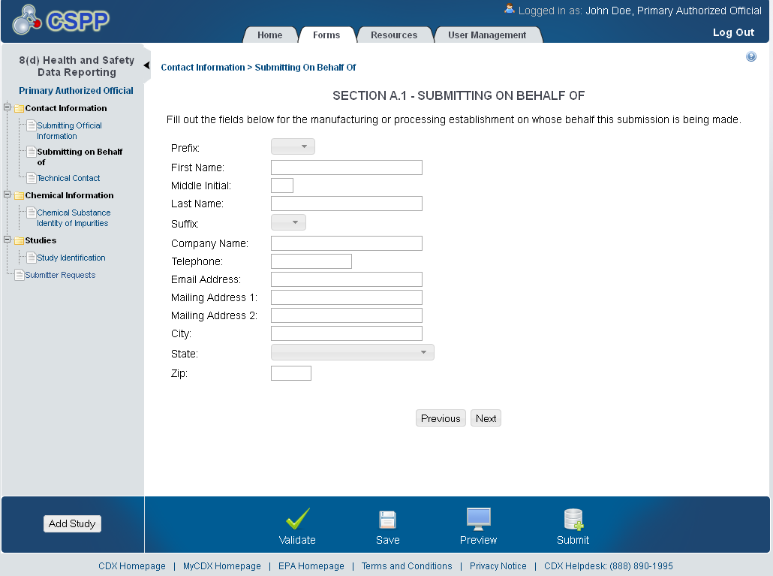

Technical Contact
The ‘Technical Contact’ screen allows the user to add multiple technical contacts, if needed. The system will provide a virtual rolodex address book dropdown menu listing all added technical contacts.
The following exhibit shows the screen capture for the ‘Technical Contact’ screen:
Exhibit 1-10 Technical Contact Screen
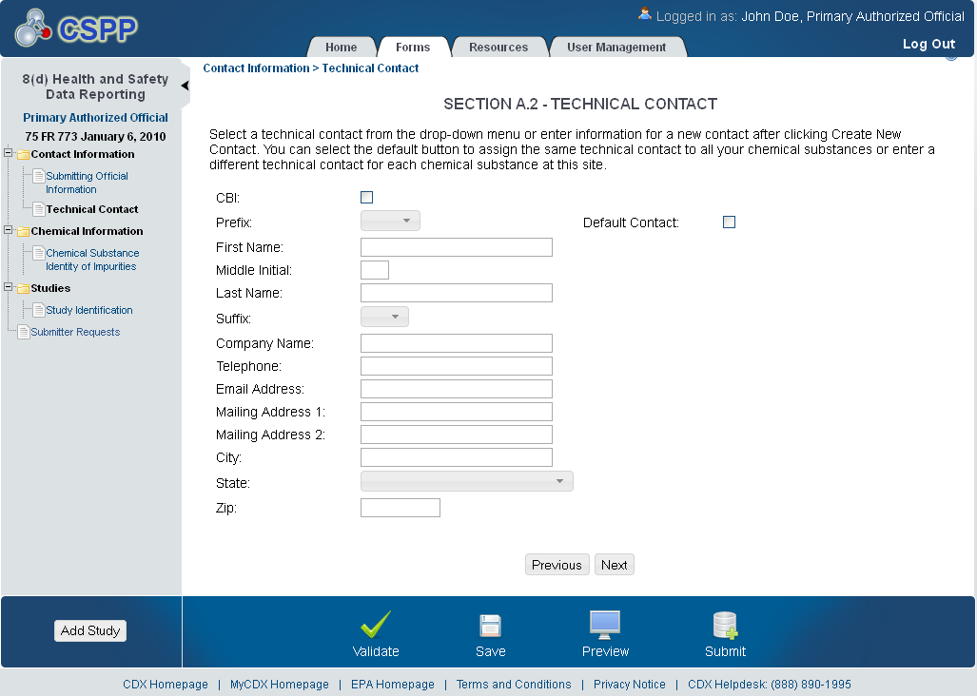

Chemical Substance Identity of Impurities
The ‘Section B – Chemical Substance Identity of Impurities’ screen allows the user to identify any impurities or additives known to have been present in the substance or listed mixtures as studied. The system provides access to Substance Registry Services Search (SRS) to perform this task.
The following exhibit shows the screen capture for the ‘Chemical Substance Identity of Impurities’ screen:
Exhibit 1-11 Chemical Substance Identity of Impurities Screen
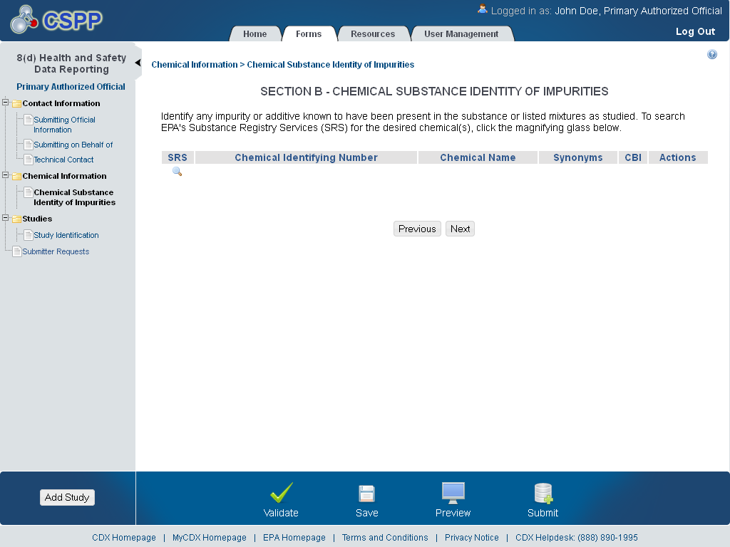

Substance Registry Services Search
The ‘Substance Registry Services Search’ pop-up helps the user identify chemical impurities in ‘Section B - Chemical Substance Identity of Impurities.’ The user can search for the chemical(s) being reported either by the ‘CASRN’, ‘CAS Index Name or Synonym’, ‘Accession Number’, or ‘Generic Name’.
The following exhibits show the screen captures for the ‘Substance Registry Services Search’ pop-up screen:
Exhibit 1-12 Substance Registry Services Search Pop-Up (Scroll 1)
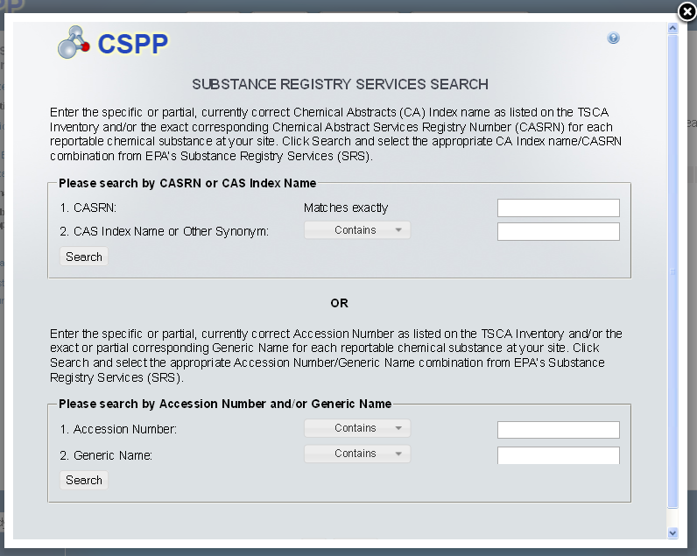

Exhibit 1-13 Substance Registry Services Search Pop-Up (Scroll 2)
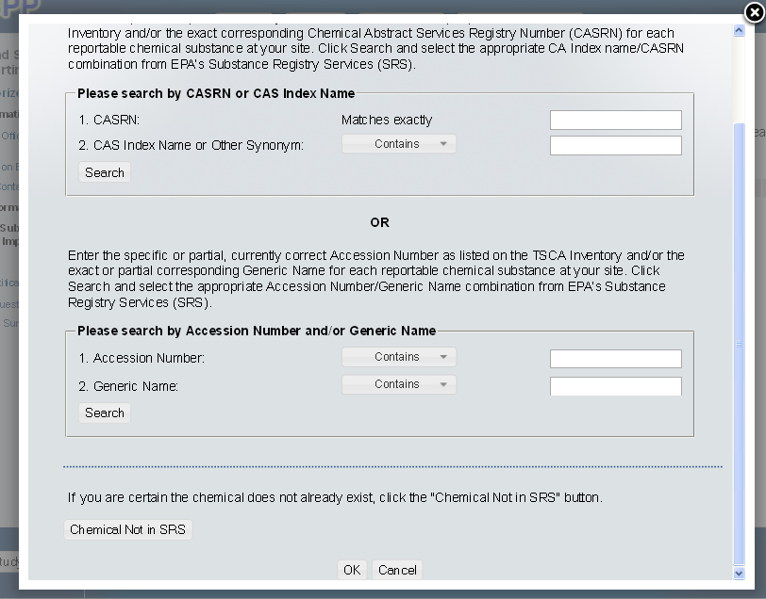

The ‘Chemical Not Found in SRS’ pop-up allows users to submit information for chemicals not identified in SRS.
Only one of the four fields identified by a blue boundary box is required. Once one of those four fields is populated, the rest become optional.
Exhibit 1-14 Chemical Not Found in SRS Pop-Up
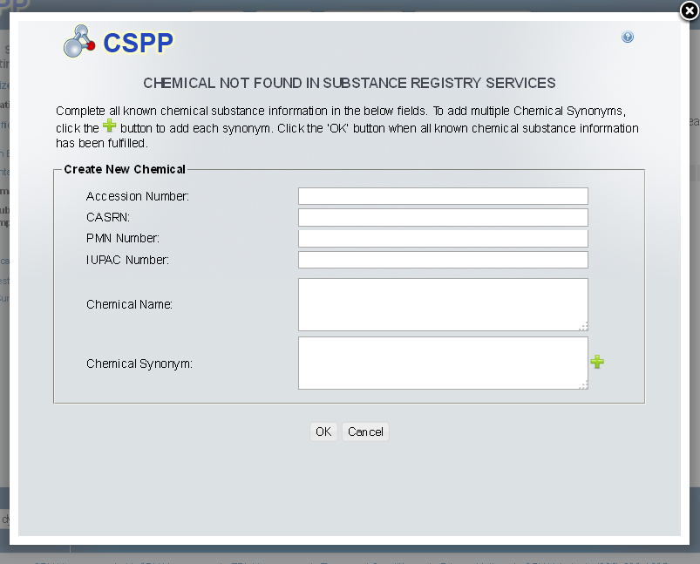

Chemical Substance Identity of Impurities
The ‘Section B – Chemical Substance Identity of Impurities’ screen allows the user to identify any impurities or additives known to have been present in the substance or listed mixtures as studied. This screen capture displays how submitted chemical information will display.
The following exhibit shows the screen capture for the ‘Chemical Substance Identity of Impurities’ screen when it is populated:
Exhibit 1-15 Chemical Substance Identity of Impurities Screen (populated)
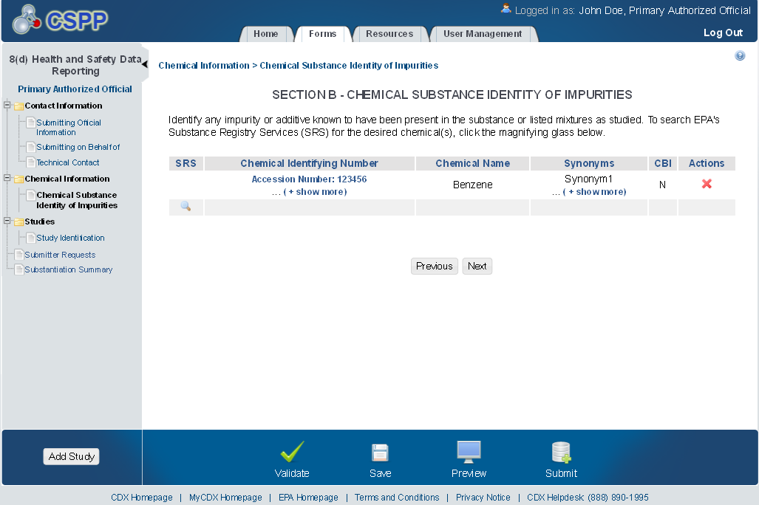

Study Identification
The ‘Study Identificaiton’ screen allows the user to identify and manage documentation related to TSCA Section 8(d) Health & Safety Data Reporting. To identify the submission study type(s) to be reported, the user will check all applicable study types.
Exhibit 1-16 Study Identification Screen
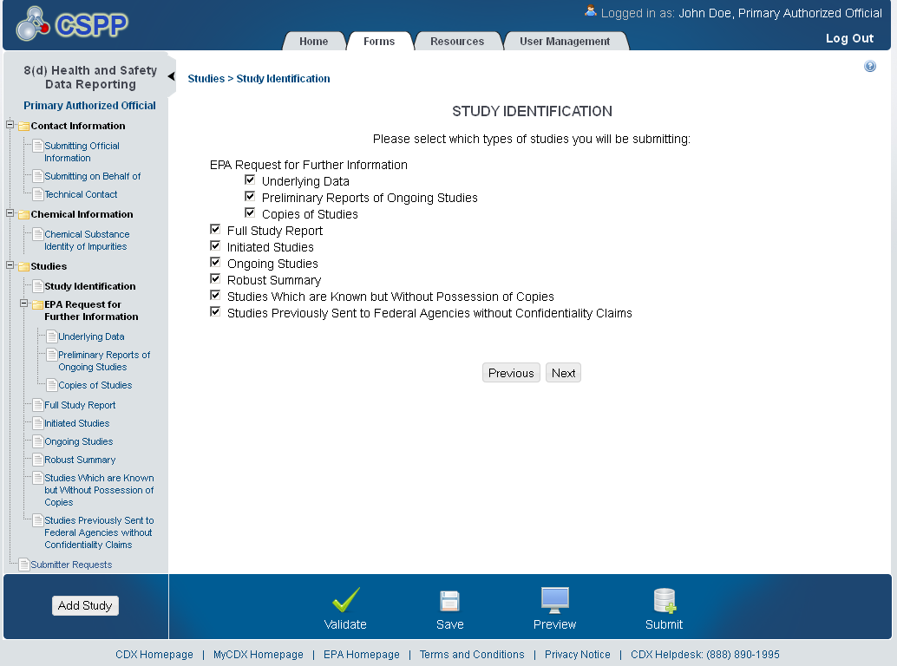

Submission of Studies – EPA Request for Further Information
The following exhibits show the screen captures for the ‘Submission of Studies – EPA Request for Further Identification’ screens:
Exhibit 1-17 EPA Request for Further Information – Underlying Data Screen
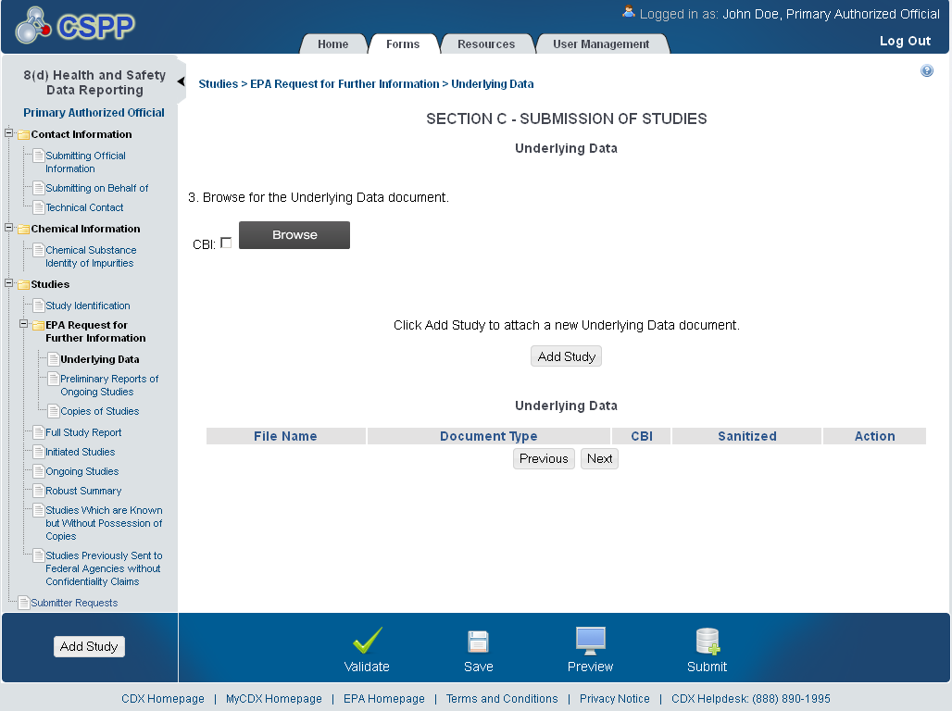
.

Exhibit 1-18 EPA Request for Further Information – Preliminary Reports of Ongoing Studies Screen (Scroll 1)
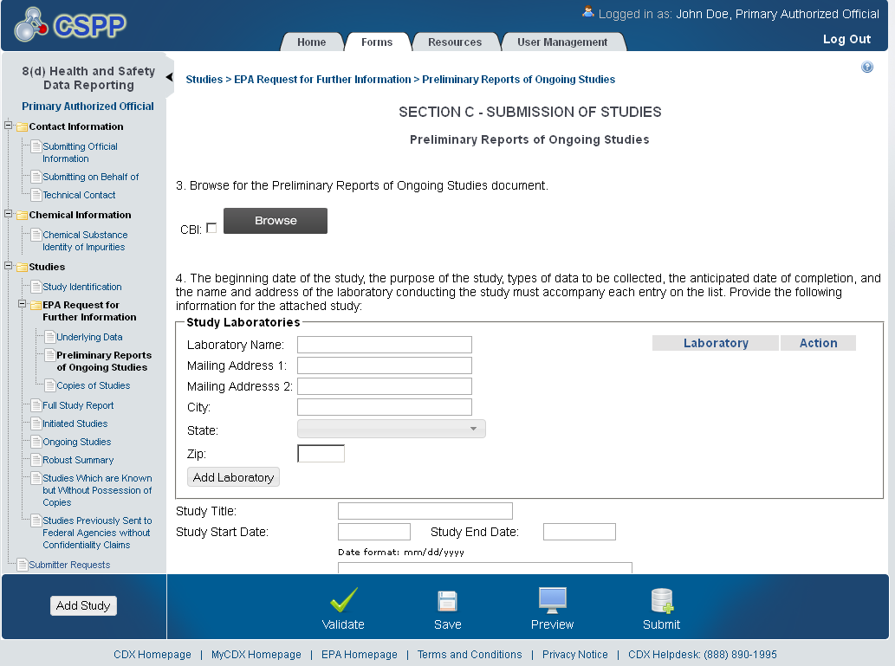
Exhibit 1-19 EPA Request for Further Information – Preliminary Reports of Ongoing Studies Screen (Scroll 2)
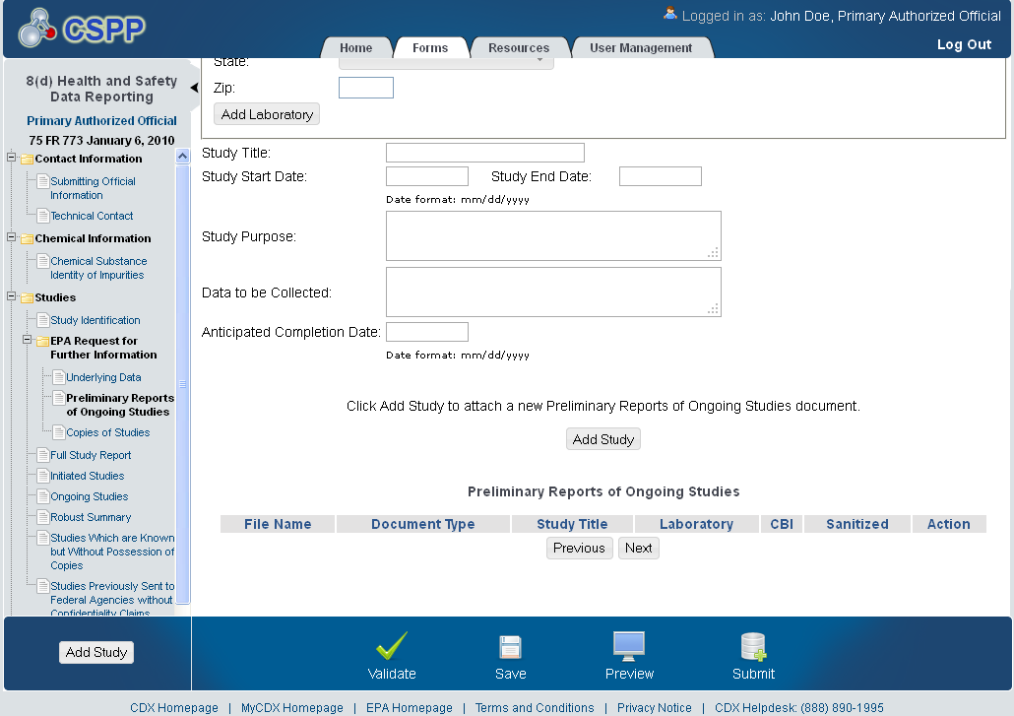

Exhibit 1-20 EPA Request for Submission of Further Information – Copies of Studies Screen (Scroll 1)
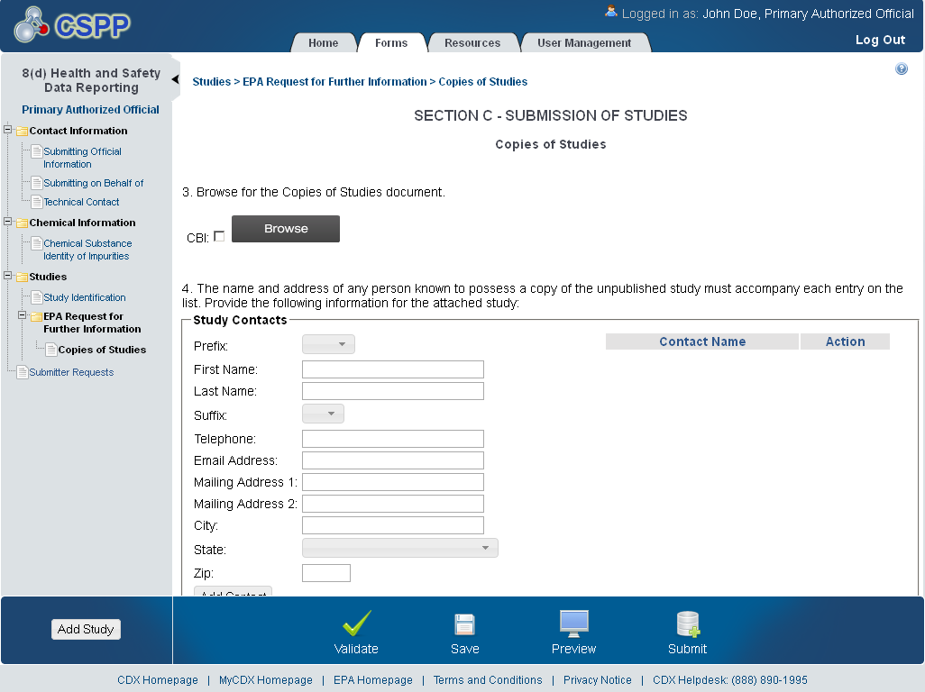
Exhibit 1-21 EPA Request for Submission of Further Information – Copies of Studies Screen (Scroll 2)
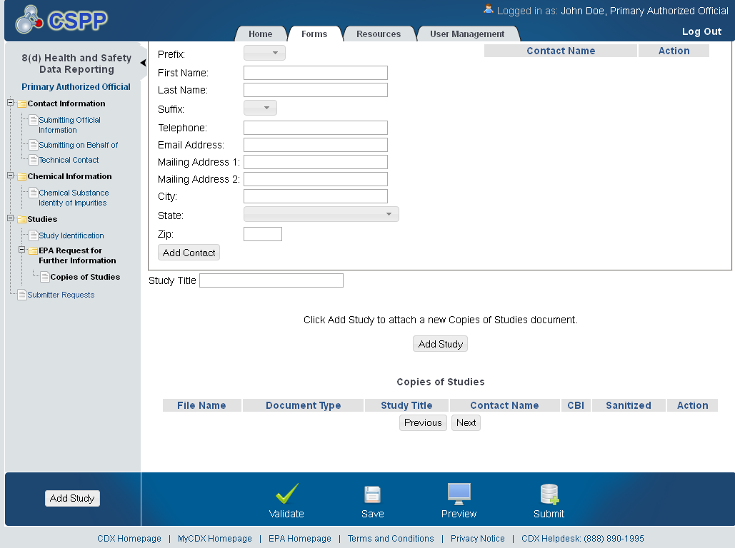

Full Study Report
The ‘Full Study Report’ screen allows the user to submit or make available for review entire, completed studies that have been requested by the EPA. This screen capture displays how submitted ‘Full Study Reports’ will display.
The following exhibit shows the screen capture for the ‘Full Study Report’ screen:
Exhibit 1-22 Full Study Report Screen
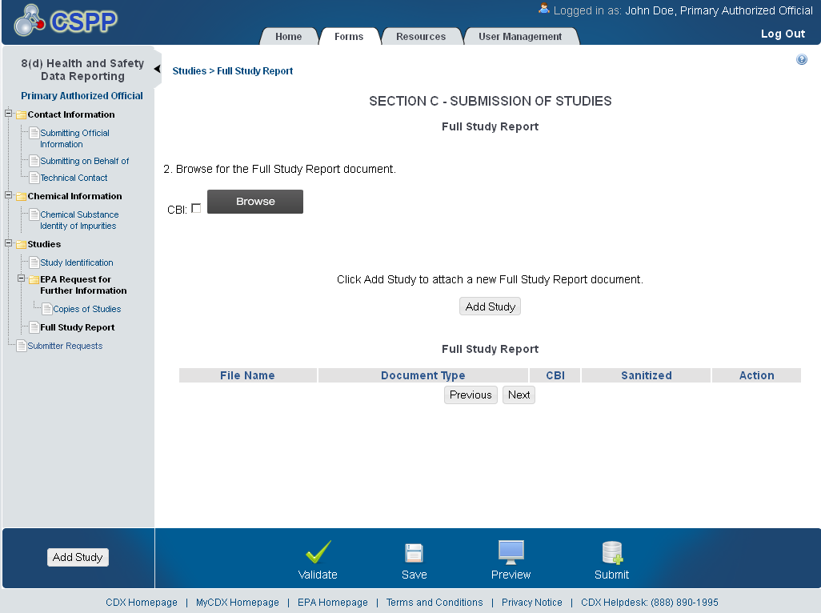

Initiated Studies
The ‘Initiated Studies’ screen allows the user to submit a list of ongoing health and safety studies being conducted by or initiated for them to the EPA for each of the listed substances or mixtures called for in the issued Federal Register Notice Citation.
The following exhibits show the screen captures for the ‘Initiated Studies’ screen:
Exhibit 1-23 Initiated Studies (Scroll 1)
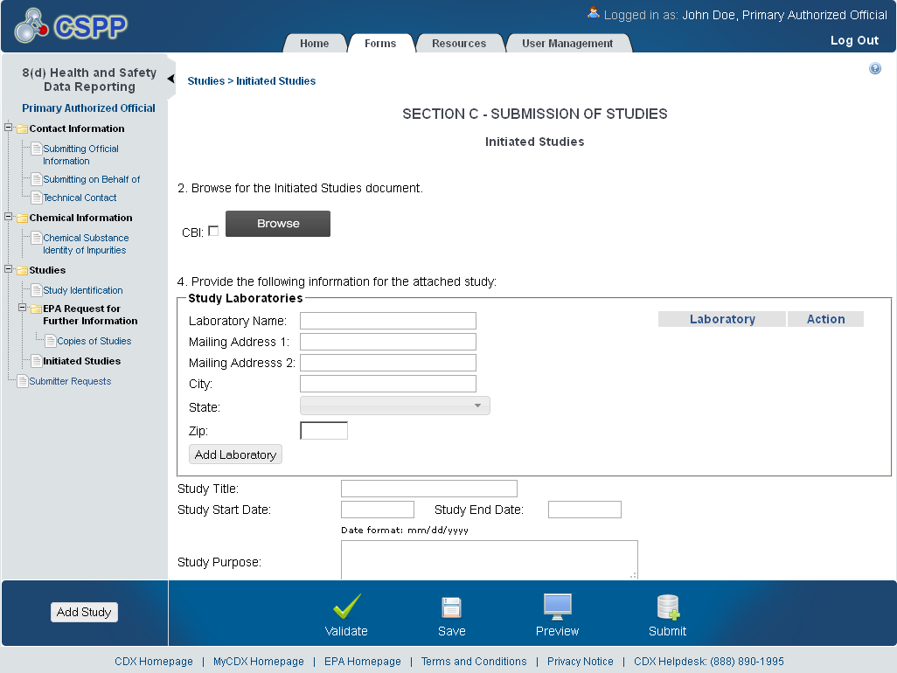
Exhibit 1-24 Initiated Studies (Scroll 2)
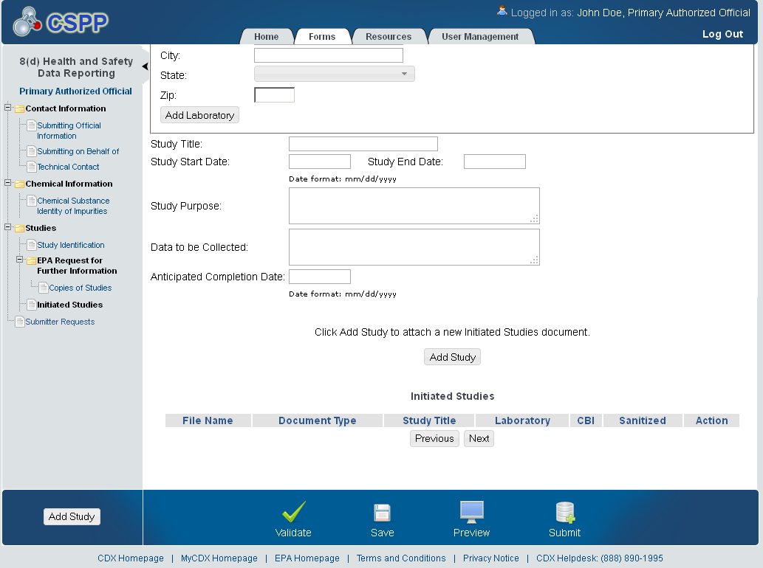

Ongoing Studies
The ‘Ongoing Studies’ screen allows the user to submit a list of ongoing health and safety studies being conducted by or initiated for them to EPA for each of the listed substances or mixtures called for in the issued Federal Register Notice Citation.
The following exhibits show the screen captures for the ‘Ongoing Studies’ screen:
Exhibit 1-25 Ongoing Studies (Scroll 1)
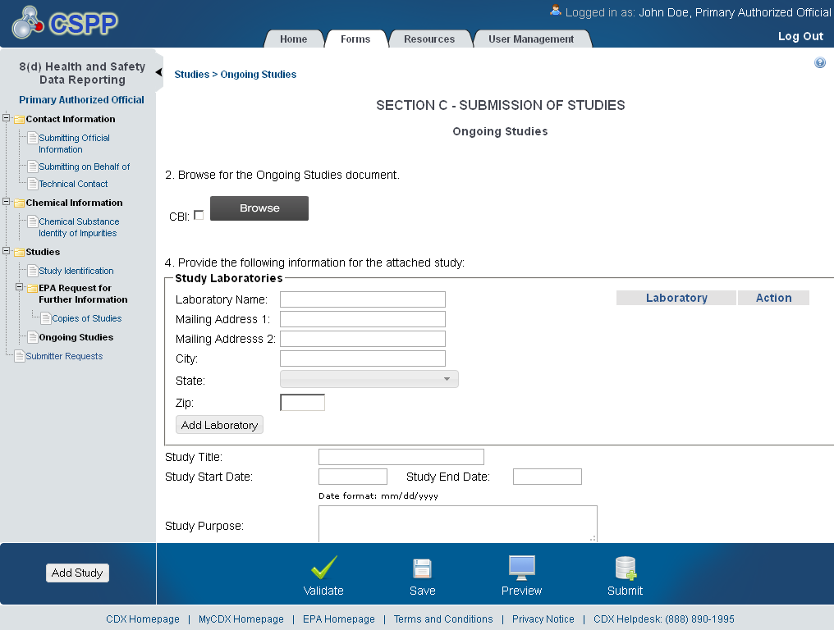

Exhibit 1-26 Ongoing Studies (Scroll 2)
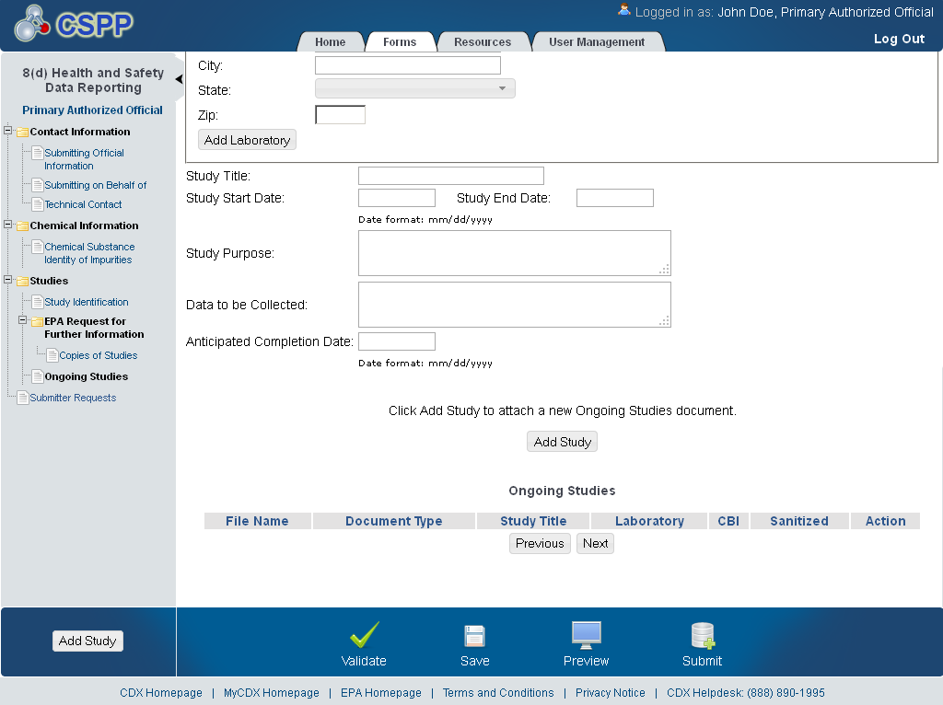

Submission of Studies - Robust Summary
The ‘Robust Summary’ screen allows the user to upload a Robust Summary list for Full Study Reports. The system allows the user to upload a Robust Summary and/or the Full Study Report. This screen capture displays how a submitted ‘Robust Study’ will display.
The following exhibit shows the screen capture for the ‘Submission of Studies – Robust Summary’ screen:
Exhibit 1-27 Robust Summary Screen
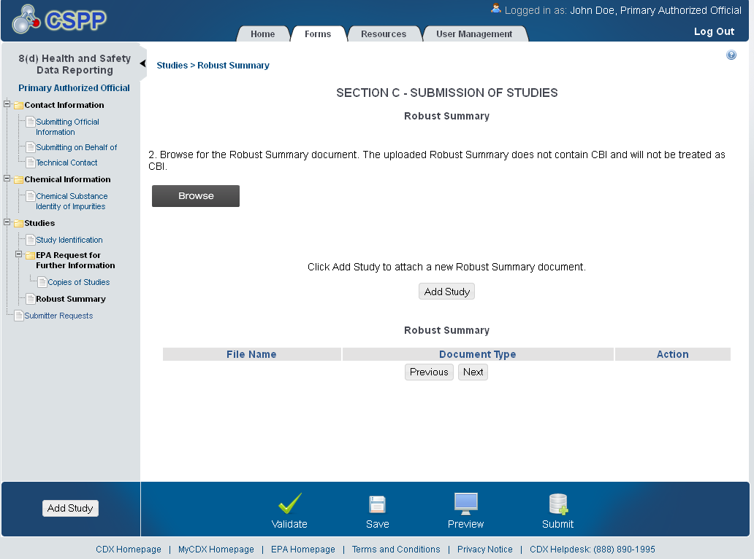

Submission of Studies – Studies which are known but are without Possession of Copies
The ‘Studies Which are Known but are without Possession of Copies’ screen allows the user to submit a list of unpublished health and safety studies known to them , but which they do not have copies.
The following exhibits show the screen captures for the ‘Submission of Studies – Studies which are known but are without Possession of Copies’ screen:
Exhibit 1-28 Studies Which are Known but are without Possession of Copies (Scroll 1)
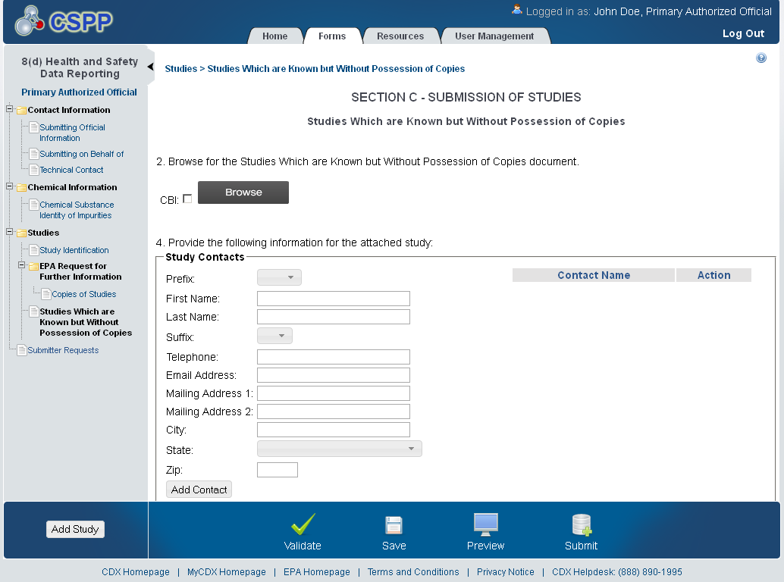

Exhibit 1-29 Studies Which are Known but are without Possession of Copies (Scroll 2)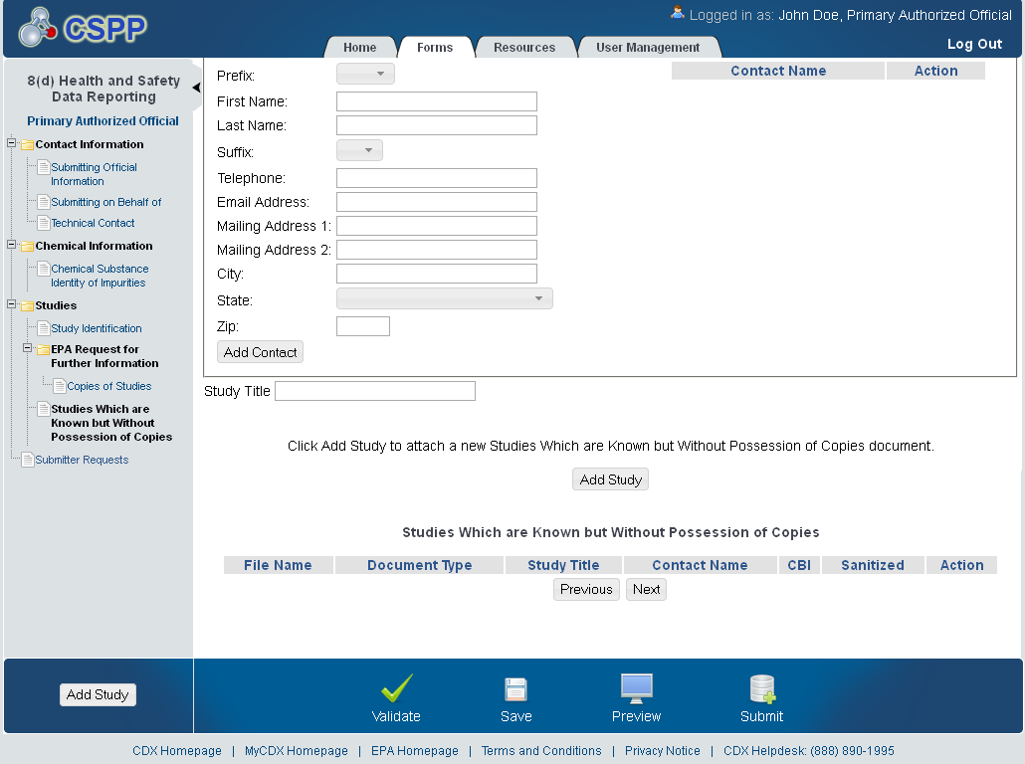

Submission of Studies – Studies previously sent to Federal Agencies without Confidentiality Claims
The ‘Studies Previously Sent to Federal Agencies without Confidentiality Claims’ screen allows the user to submit a list of unpublished studies which have been sent to a Federal Agency without claims of confidentiality to EPA.
The following exhibits show the screen captures for the ‘Submission of Studies – Studies Previously Sent to Federal Agencies without Confidentiality Claims’ screen:
Exhibit 1-30 Studies Previously Sent to Federal Agencies without Confidentiality Claims (Scroll 1)
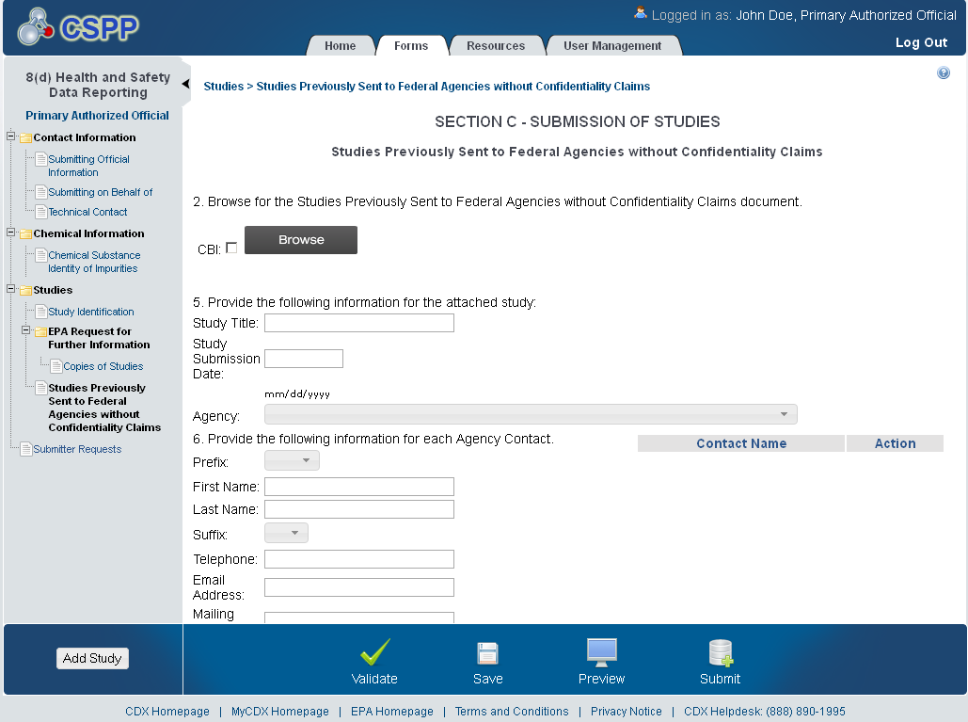
Exhibit 1-31 Studies Previously Sent to Federal Agencies without Confidentiality Claims (Scroll 2)
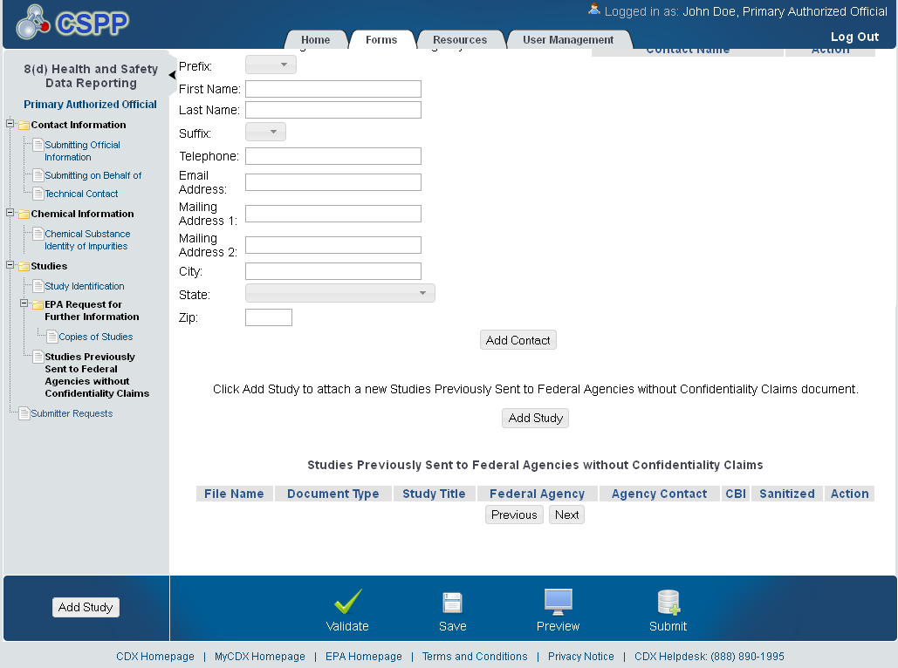

Submitter Requests
The ‘Submitter Requests’ screen allows the user to request an ‘Extension of Time’ or a ‘Withdrawal of Chemical.’ The user can select one or more of the option(s) that apply such as, ‘Request for Extension of Time’, or ‘Request for Withdrawal of Chemical’ and upload supporting documentation.
The following exhibit shows the screen capture for the ‘Submitter Requests’ screen:
Exhibit 1-32 Submitter Requests Screen
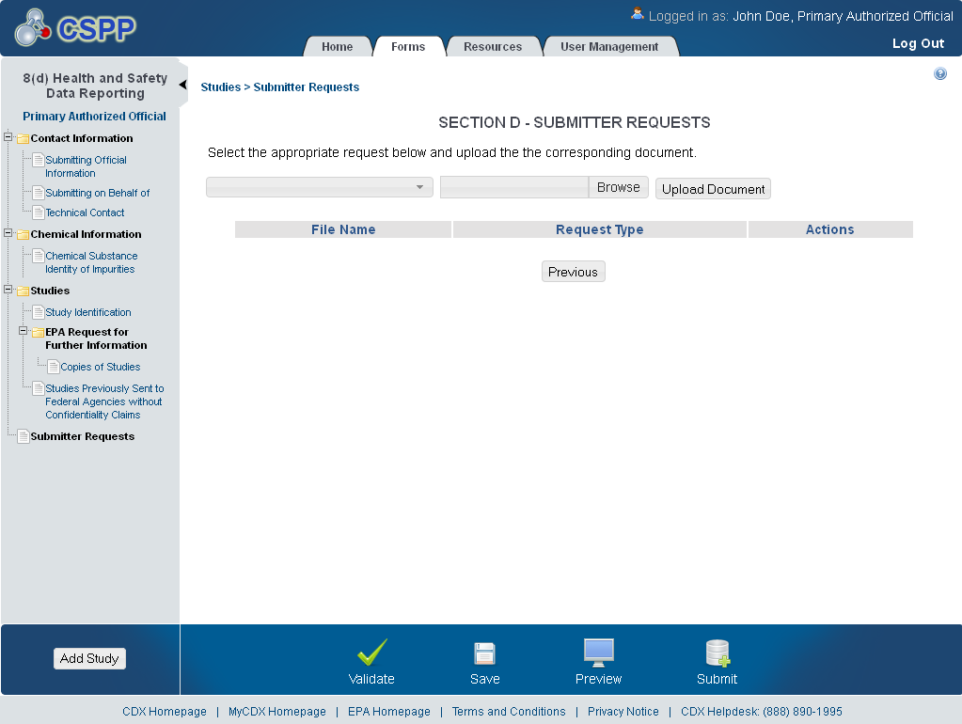

Substantiation Summary
The ‘Substantiation Summary’ screen allows the user to clearly identify the material subject to CBI for each document. The user will manually enter such information into the text box displayed within the ‘Substantiation’ screen.
The following exhibit shows the screen capture for the ‘Substantiation Summary’ screen:
Exhibit 1-33 Substantiation Summary Screen 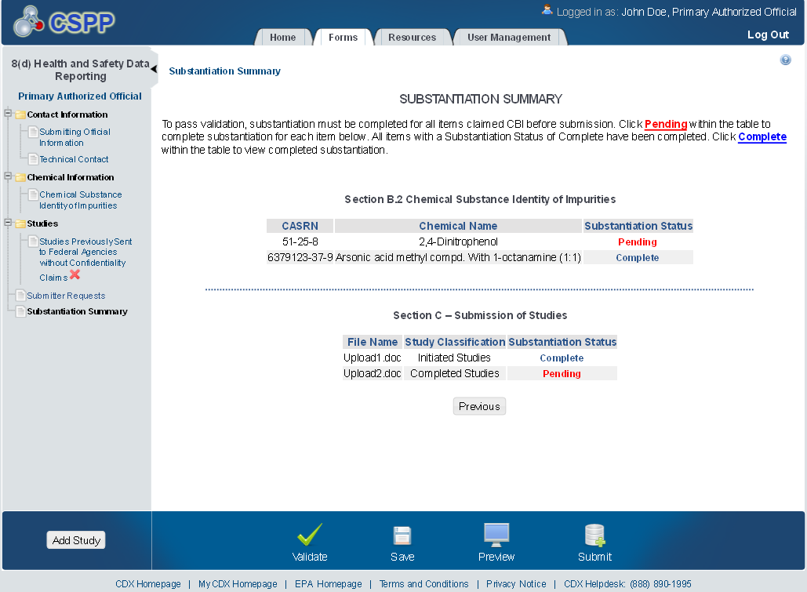

Submission of Studies Substantiation
The ‘Substantiation screen allows the user to clearly identify the material subject to CBI for each document. The user will manually enter such information into the text box displayed within the ‘Substantiation’ screen.
The following exhibit shows the screen capture for the ‘Submission of Studies Substantiation’ screen:
Exhibit 1-34 Submission of Studies Substantiation Screen 